Unit Name
2020-21 DOSA Learning Assessment Plan and Data List
Date
Prepared by: Author(s)

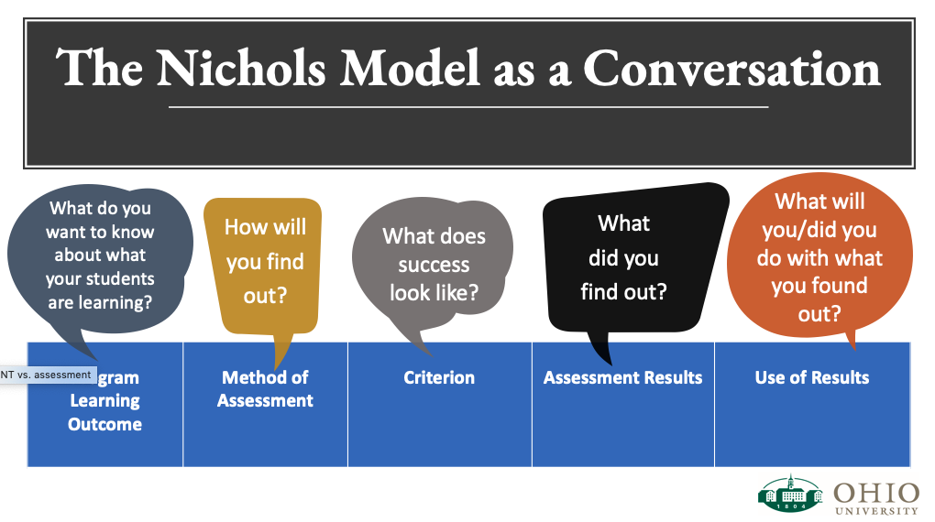

Ohio University
Departmental/Office Learning Assessment Plan 2020-21
Department/Office:  Prepared by: |  |  |  | Name and Briefly describe the program(s):
Which DOSA Learning goal? | What is the Learning Outcome (LO) statement? | How will the students learn the information for the learning outcome? | Method of Assessment (How will you know they mastered this LO?) |  | Criterion  (What does success look like? How many of the students will master the LO?) |  | Assessment Results (What did you find out? Did you meet the criterion target?) | Use of Results  (What will you do/did you do with what you found out?)

Additional Questions on the Learning Assessment Plan

- Please use this space to describe in greater detail what program/service/student population the assessment plan addresses.
- When does this program/service take place?
- How many participate in it, (historically and/or expected)?

- Please summarize what you learned from the evidence of student achievement of the learning outcomes.
Attach a sample of the evidence when you submit this document.

- List and describe how you are responding to what you learned from the evidence.

Data Inventory
We are creating a complete list of all available data sources within DOSA. Please share below a complete list of what data your unit plans to collect throughout the 2020-21 year, add rows as necessary.
Name/purpose of this data collection | How will you be collecting data? (What method) | Where will the results be stored? | When will you collect this data? | Once you have collected this information, what do you plan to do with it? How will you use it? Who will you share the results with? | Contact person for this data collection
If someone were available to help with a more complex analysis of the data your office/unit has or plans to collect, what would you ask them to do?

