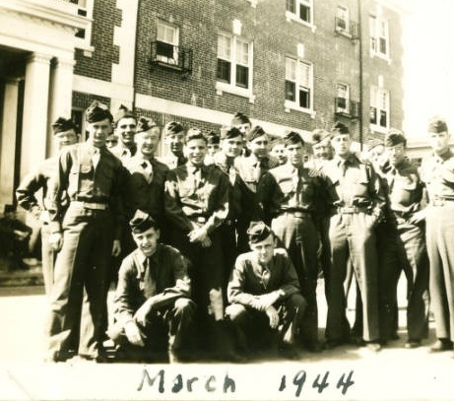
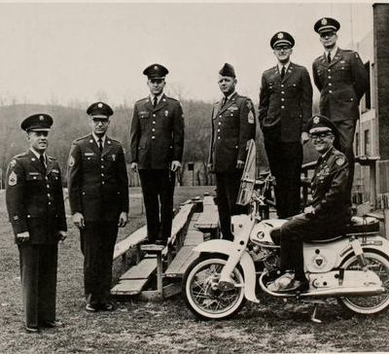
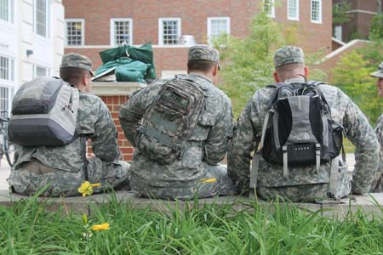
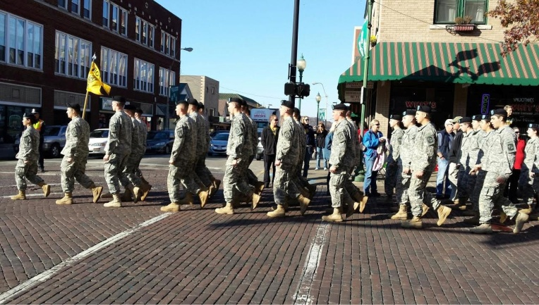
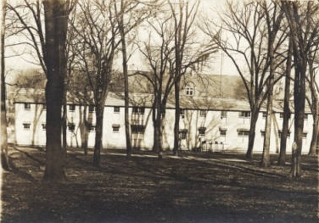
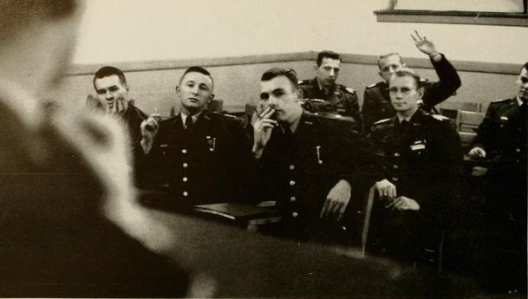
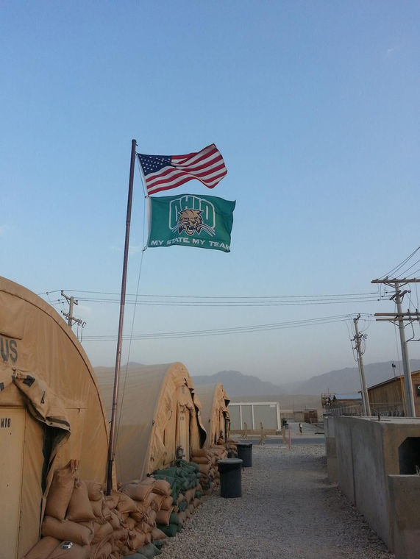
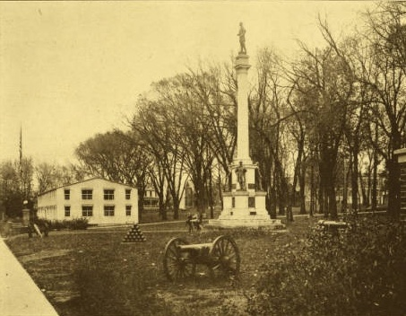
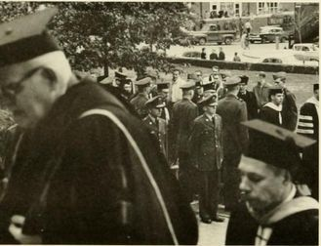
Ohio University Chillicothe Campus
Veteran and Military Dependent Guide
2020-20201

Welcome to Ohio University - Chillicothe

Welcome to Ohio University--home of the Bobcats! Congratulations on your acceptance to Ohio University, and thank you for your service to our nation. We are proud to have you join us in a tradition of excellence that is over 200 years old. At Ohio University we take great pride in serving current and former members of the military and their dependents. We look forward to the contributions you will make on campus because of the leadership, discipline, and knowledge gained through your experiences and we appreciate the value of the training that the military has provided you.
Ohio University is making great strides to meet the needs of the rising number of veteran and military dependent students on campus. Our school has been recognized by G.I. Jobs as one of the top “Military-Friendly Schools” in the nation for ten consecutive years and we also participate in the “Principles of Excellence Program”, the “Got Your Six Pledge”, and the “Service members Opportunity Colleges Consortium”. The Fiske Guide to Colleges 2015 ranks us as “No. 14 Best College for Your Money”; and we are ranked 464th in the world out of 22,000 degree-granting institutions by the Center for World University Ratings for 2015. The Ohio University Student Senate and Graduate Student Senate both have a Veterans’ Affairs Delegate position, and these seats help ensure that student-veterans are represented on campus government and committees and have their voices heard because only veterans truly understand the challenges that we face when leaving the military and transitioning to an academic environment.
Available to always assist student veterans who have any questions or concerns are Terry St. Peter (LTC-US Army Ret.), the Director of the Brigadier General James M. Abraham – Colonel Arlene F. Greenfield Veterans and Military Student Services Center, and his staff. The Veterans and Military Student Services Center holds a plethora of knowledge when it comes to veterans’ benefits and programs, and other questions about the campus community. If you ever have questions don’t hesitate to ask. This manual was designed to assist you during your transition at Ohio University. We have included many things you can expect to experience as a student at Ohio University as well as many resources to help you along your way. Never hesitate to use the many valuable resources that are available to you. You already have many of the tools and skills needed to succeed at Ohio University.
The Age Difference: A Student Veteran’s Perspective

As you may be aware, the campus life you are about to become a part of is quite different than the military life you left. Depending on how long you were in the service you may find yourself older than your fellow students. There is nothing to be nervous about because there are many other non-traditional students in attendance here. There are approximately 900 student-veterans, National Guard/Reserve members, and military dependents enrolled at Ohio University using G.I. Bill benefits right along with you.
Even if you are close in age to the traditional students, you may find that you are very different from your fellow students. You may have dealt with scenarios and had experiences that have very likely forced you to become a more mature person than many your age. Most of your fellow students have not experienced anything close to this; college is, for many, the initial learning and growing experience, so please keep this in mind when interacting with your fellow students. You may find that they sometimes become very interested when they learn that you are a veteran, and may even want you to share some of your experiences with them. You will also encounter people who have negative comments or opinions of the military, but they are few and far between. Many of us left the service having been to various hotspots around the world and experienced things that many people never will; so, if you are comfortable talking about it then take the time to share some stories with your peers. If not, don’t ever hesitate to just walk away.
You may have been stationed in places that allowed drinking for service members under 21; however, remember you are now back in the states! If you go out on the town with your peers, please remember that you should be setting a positive example. If you are going to drink do so responsibly and try to help keep your peers squared away. That being said, you might be out with people that are underage, so make sure you are out with people that are old enough to drink so you do not get charged with contributing to a minor.

Veteran Groups

Ohio University has three student-Veteran organizations on campus. These clubs exist to provide support, camaraderie, motivation, and to give back to the community through different service events throughout each year. The main annual event is the Christmas fundraiser and the proceeds go to providing Christmas dinner and gifts for children of local Veterans that are in need of assistance. The three of these clubs contain a wealth of information, so don’t hesitate to show up at a meeting and ask any questions you may have. If you’re interested in joining, simply attend one of the meetings.

- The combined Student Veterans of America (SVA) chapter and the Combat Veterans Club (CVC) is comprised of students who have military service, including Reserves and National Guard and comprised of student veterans who have served in a combat zone, respectively, and meet every Thursday at 6pm. The 2019 President of the SVA/CVC is Rye Bennett and can be reached at rb509316@ohio.edu or (253 830-4868.

- Military Dependents Club is comprised of spouses, children, and other dependents of military service members regardless of whether they are eligible for GI Bill benefits. For more information, contact Ms. Janet Russell at 740.566.VETS (8387).
Athens city has the Disabled American Veterans (DAV), American Veterans (AMVETS), American Legion, and the Veterans of Foreign Wars (VFW) organizations. These groups are open to all honorably discharged American Veterans and provide assistance to Veterans and the local community. For example, AMVETS offers classes free of charge that can normally cost a couple hundred dollars each. You do not have to be a member of any of the organizations to approach them for assistance. You will find phone listings and addresses for these organizations listed in this packet.

IMPORTANT CONTACTS
Administrative Department w/Point of Contact | For Assistance with
Terry St. Peter  Director, General Abraham and Colonel Greenfield Veterans and Military Student Services Center  Baker University Center Room 350  www.ohio.edu/military  (740) 566-VETS (8387)  veteranscenter@ohio.edu | Academic advising and success  Concerns/ideas in regards to campus policies or procedures  Programming  Withdrawal  Re-enrollment  Post-deployment issues
David Edwards  Coordinator of Veterans Resources/Academic Advisor,  General Abraham and Colonel Greenfield Veterans and Military Student Services Center  Baker University Center Room 350  www.ohio.edu/military  (740) 566-VETS (8387)  veteranscenter@ohio.edu | Academic advising and success  Concerns/ideas in regards to campus policies or procedures  Programming  Withdrawal  Re-enrollment  Post-deployment transition issues
Janet Russell  School Certifying Official, General Abraham and Colonel Greenfield Veterans and Military Student Services Center  Baker University Center Room 350  www.ohio.edu/military  (740) 566-VETS (8387)  veteranscenter@ohio.edu | Applying for and maintaining your VA Educational benefits  Withdrawal  Re-enrollment  Other questions regarding your GI Bill benefits
Tricia Barrick  Office of the Bursar  Chubb Hall Room 010  www.ohio.edu/bursar  (740) 593-4130  barrick@ohio.edu | Third-party contracts for students using GoArmyEd, ROTC Scholarships, National Guard Scholarships, Navy College, MyCAA.  Miscellaneous Fees
Campus Involvement Center  Baker University Center Room 355/339  (740) 593-4025  involvement@ohio.edu | Resources for people who live off-campus  Landlord questions  City Codes  Noise and House Party Restrictions  Student Organization Information  Campus Events

Administrative Department w/Point of Contact | For Assistance with
Christy Perez  Student Accessibility Services  Baker University Center 348  www.ohio.edu/university-college/student-accessibility-services  (740) 593-2620  Jenkinc1@ohio.edu | - Accommodations for students with:  -Disabilities  -ADD/ADHD  -Psychological, Physical, or Chronic conditions
Sandi Krivesti  Financial Aid & Scholarships  Chubb Hall 020  www.ohio.edu/financialaid  (740) 593-4141  krivests@ohio.edu | - Financial Aid (Pell Grant, Federal Aid)  - Scholarships
Equity and Civil Rights Compliance  Lindley Hall 006  www.ohio.edu/equity-civil-rights/discrimination  (740) 593-9140 | - Discrimination  - Harassment  - Affirmative Action  - University Policy Recommendations  - ADA Compliance
eCampus  Haning Hall Room 102  ohio.edu/ecampus  ecampus@ohio.edu | - Online Courses  - Correspondence
Residential Housing  111 South Green Drive  www.ohio.edu/housing  (740) 593-4090  housing@ohio.edu | - On-Campus Housing
Paul Castelino  Counseling and Psych Services  Hudson Health Center, 3rd Floor  www.ohio.edu/counseling  (740) 593-1616  Counseling.services@ohio.edu | - Individual/Group Counseling  - Psychiatric Consultation  - Workshop Development Available
Undergraduate Admissions  Chubb Hall 120  www.ohio.edu/admissions  (740) 593-4100  admissions@ohio.edu | - Applying to Ohio University  - Transfer of Military Credit  - Credit by Examination

Veteran Contacts in the Surrounding Area

- Chillicothe VA Medical Center (Hospital)
17273 State Route 104
Chillicothe, OH 45601
(740) 773‐1141

- Ross County Veterans Service Office
475 Western Ave., Ste. #C
Chillicothe, OH 45601-2291
740/772-1600
Fax: 740/772-1614

- Veterans of Foreign Wars (VFW Post 108)
115 E Main St
Chillicothe, OH 45601
(740) 772-1939

- American Legion Post 62
53 W MAIN ST
CHILLICOTHE, OH 45601
740-772-1929

- American Legion Post 757
289 COOKS HILL RD
CHILLICOTHE, OH 45601
740-775-6933

- Disabled American Veterans (Nearest Locations)
170 Pearl St.
Jackson, OH 45640
(740)286-4200
35 East Chestnut St.
Columbus, Oh 43215
(614) 221-3582

- AMVETS
317 E Main St
Chillicothe, Oh 45601
(740)835-1912

Guide to G.I. Bill Educational Benefits

Welcome to Ohio University! This portion of the packet is intended to help you use your Veterans Educational Benefits at Ohio University to your full advantage. We urge you to read through it carefully. Ohio University submits all certifications to the VA electronically in order to ensure their receipt and to reduce processing time for your claim. If you have questions, stop by the Veterans and Military Student Services Center at Baker University Center Room 350 or call us at (740) 566-VETS. Hours are 8 a.m. – 5 p.m., Monday through Friday.

UNIVERSITY VS. VETERANS ADMINISTRATION

Always remember that you are, first of all, a student at Ohio University. All University policies, procedures, rules, and regulations apply to you. Using Veterans benefits to help pay for your education adds to the steps you must take to register for or withdraw from classes. It will add another level of paperwork for you to fill out and a more restrictive set of guidelines for you to follow. VA paperwork does not replace college paperwork, and vice versa. You must always do both, even if you simply report the same information twice.
In some cases, there are differences between what the VA and what the University requires of you as you work toward your degree. Usually, VA requirements are more limiting. It is YOUR responsibility to know and remember these restrictions and to inform your college advisor, the faculty, and anyone else that these additional requirements apply to you. Otherwise their advice, though correct from the University’s viewpoint, may jeopardize your VA benefits.

GI BILL BENEFITS CHAPTERS

Here are brief descriptions of the five most used VA benefit programs, known as Chapters. (If you don’t know your chapter, call 1-888-442-4551 to determine your status.) Since these chapters differ in some very important ways you need to be familiar with your chapter’s benefits and regulations.

Chapter 30: “Active Duty” or “Montgomery GI Bill”

- Must have entered active duty after June 30, 1985.
- A contributory program -- $1200 through a pay reduction during your first year of service
- No allowance for dependents
- 36 months of full-time entitlement; 10 years from date of discharge to use it.
- Discharge must be Honorable
- You must have completed your initial contractual active duty obligation (Typically 2-4 years).

REQUIRED FORMS:

- Certificate of Eligibility for GI Bill benefits
- VA 22-1990: Application for Educational Benefits
- DD-214: Copy of Member-4
- VEAFC: Veterans Educational Assistance File Card (http://www.ohio.edu/registrar/veteran_services.cfm; this initiates your payments)
- VA 22-1995: If transferring from other school or if changing your Major/Program

Chapter 31: “Veteran Readiness and Employment (VR&E)”

- VA must determine whether you qualify.
- Pays a monthly benefit plus tuition, fees, books, and supplies.
- Pays additional money for dependents.
- 48 months of full-time entitlement to be used over a maximum of 12 years.
- You must be enrolled at least half-time to participate.

REQUIRED FORMS:
- Certificate of Eligibility for GI Bill benefits
- VA 28-1905: Used for application of benefits, transferring benefits, and changing Major.
- VEAFC: Veterans Educational Assistance File Card (http://www.ohio.edu/registrar/veteran_services.cfm; this initiates your payments)
- VA 22-1995: If transferring from other school or if changing your Major/Program

Chapter 33: “Post 9/11 GI Bill”

- At least 90 days of aggregate active duty service after Sept. 10, 2001
- Honorably discharged or discharged with a service-connected disability after 30 days
- Allows 15 years from date of discharge to use 36 months of full-time entitlement
- Pays monthly housing allowance (Based on zip code)
- $1,000 annually for books and supplies.
- Rural Benefit - A one-time payment of $500 may be payable to certain individuals relocating from highly rural areas if they reside in a county with 6 persons or less per square mile (as determined by the most recent decennial census) and either:
  - Physically relocate at least 500 miles to attend an educational institution or
  - Travel by air to physically attend an educational institution if no other land-based transportation exists
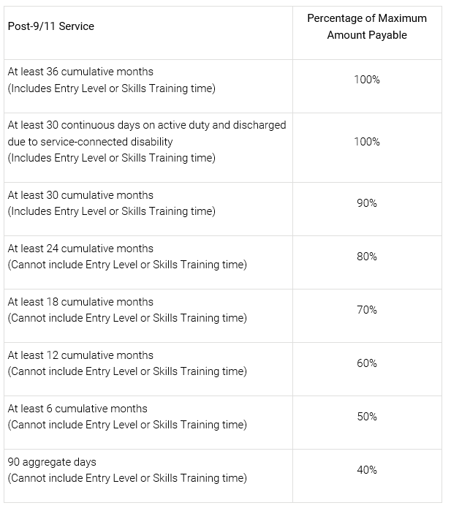
REQUIRED FORMS:
- Certificate of Eligibility for GI Bill benefits
- DD-214: Copy of Member-4
- VEAFC: Veterans Educational Assistance File Card (http://www.ohio.edu/registrar/veteran_services.cfm; this initiates your payments)
- VA 22-1995: If transferring from other school or if changing your Major/Program

Chapter 35: “Survivors/Dependent Educational Assistance”

- For qualified dependents, spouses, and widows of deceased or 100% disabled veterans. VA must determine your eligibility.
- 45 months of full-time entitlement with varying periods of time in which to use them.
- Requires a special file number from VA, which you must record on all VA paperwork.

REQUIRED FORMS:
- Certificate of Eligibility for GI Bill benefits
- VA 22-5490: Application for Educational Benefits
- VEAFC: Veterans Educational Assistance File Card (http://www.ohio.edu/registrar/veteran_services.cfm; this initiates your payments)
- VA 22-5495: If transferring from other school or if changing your Major/Program

Chapter 1606/1607: National Guard/Reserves “Selected Reserve”

- For members of the reserve components of the Armed Forces who agreed to serve 6 years in the Reserves or National Guard beginning after June 30, 1985.
- Must have completed Initial Active Duty Training (IADT) if required.
- Must be a high school graduate or have a G.E.D.
- 36 months of full-time entitlement;
- Will pay for developmental or co-op courses IF you extended your contract to a new six-year period beginning after October 1, 1990.
- Effective October 1, 2002, the delimiting date for certain Selected Reserve Soldiers eligible under Chapter 1606 MGIB (MGIB-SR) was extended from 10 years to 14 years. This change applies only to persons who signed an enlistment/reenlistment contract on or after October 1, 1992.

REQUIRED FORMS:
- Certificate of Eligibility for GI Bill benefits
- DD214 Member-4
- VEAFC: Veterans Educational Assistance File Card (http://www.ohio.edu/registrar/veteran_services.cfm this initiates your payments)
- VA 22-1995: If transferring from another institution where you previously used your GI Bill.

FORMS, FORMS, & MORE FORMS

To put it simply, you must contact the Veterans and Military Student Services Center and fill out the corresponding forms in regards to a change in all of the following circumstances:
- Initial application for benefits.
- Re-enrollment each year.
- Change of place of training from anywhere else to Ohio University (Form VA 22-1995)
- Change of Major or Program of Study (Form VA 22-1995)
- Change of address, name, or benefits status
- Change in the number of dependents, if you are paid for dependents.
- Withdrawal from any or all classes.

WHEN WILL YOU GET YOUR MONEY?

This depends on a variety of factors. A good rule of thumb for first-time users is to assume it will take approximately 6 weeks after the school verifies your enrollment. Chapter 30, 1606 and 1607 students may need to wait even longer, since the Department of Defense must establish your eligibility before VA can react to your application for benefits. VA education benefits follow a post-payment plan. In other words, you are paid around the first of a given month for your period of enrollment in the previous month. If over 8 weeks have passed since the first day of classes for the term in which you applied for benefits, and you have received nothing in writing from the VA, please contact the VA first to find out the status of your money.

Dropping a Class or Other Schedule Changes

If you drop a class or lower the amount of credit hours being taken and the VA has already processed the tuition payment, a status of ‘overpayment’ may occur. VA is immediately notified by the college when you withdraw from a course or courses. Unless you can successfully prove that mitigating circumstances caused this action, you will be required to pay back to the VA all monies you received as a result of that course or courses from the first day of the semester. (Examples of acceptable mitigating circumstances are illness, family or financial emergencies, job transfer and child care problems.) If the VA charged you with an overpayment of benefits at some point in the past, you will not be paid again until they have recovered that debt. A drop in the amount of credit hours you are taking may also lead to changes in your Housing Allowance as well as your Books and Supplies Stipend. Please check with the School Certifying Official if you are unsure of the effects of any potential schedule changes.
NOTE: VA considers auditing a course the same as a withdrawal -- no benefits can be paid.

Chapters 30, 1606, and 1607 MUST verify enrollment every month via the WAVE website: www.gibill.va.gov/wave/index.do, or by phone 1-877-823-2378. The earliest a student can verify their enrollment is the last calendar day of each month. From the WAVE website students can:
- Verify that enrollment has not changed
- Report a change in enrollment
- Change mailing address
- Initiate or change direct deposit information
- View the enrollment period and monthly benefit amount
- View the remaining entitlement
- Sign up for a monthly e-mail reminder

Tuition Assistance

- Check with your specific military branch for information about using Tuition Assistance to pay for your courses.

OTHER FINANCIAL RESOURCES

- Free Application for Federal Student Aid (FAFSA- THIS IS WHERE YOU FIND OUT IF YOU QUALIFY FOR THE PELL GRANT): Fill out this application to find out if you qualify for a FREE government grant--many do! The application is a bit long but very much worth it if you qualify for several thousand dollars extra every semester to aid in your school costs.
- Check out our scholarship compilation on our website, specifically for Veterans and Military dependents.

YOU MUST BE WORKING TOWARDS A DEGREE!

VA expects you to work toward a degree approved by them. They approve all of our associates’ degree programs, all but one of our one-year Certificate programs, and the non-credit Municipal Police Academy. You cannot enroll as a non-degree-seeking student, nor may you enroll in a “Letter of Recognition.” Carefully select your curriculum at the time you apply for admission. The program you select on your application will be forwarded to the VA Office and then every course for which you register will be approved or denied for payment of VA benefits based on whether or not it is required by that curriculum according to the catalog under which you were admitted. (Electives are sometimes certifiable, but only up to the number of elective credits allowed in the published curriculum) If you later wish to change your curriculum, you must go to the University’s Advising Center and complete a Curriculum Change Form. VA will charge you with a “Change of Program” if more than 12 credits are lost when you change either colleges or majors. Since VA reserves the right to approve or disapprove program changes after the second one, make these changes carefully. If you are UNDECIDED the VA will only pay for two semesters as an UNDECIDED major.

Credit for Prior Training

Ohio University requires that you submit transcripts of all prior college work before being accepted into the university. Before submitting documentation of your military training (Joint Services Transcript) to the university for transfer evaluation, stop by or call the Veterans and Military Student Services office to speak to one of the faculty advisors to ensure your training will benefit your degree plan.

Repeating a Course

VA will pay for you to take the same course twice if (A) you failed it the first time, or (B) you passed it but the university catalog states you need a higher grade in order to complete your program or to progress to a higher-level course. While you personally may want to repeat a course you took many years ago or one in which you received a “D” grade, VA will not pay benefits for this choice, no matter how wise your decision may be academically.

Non-punitive Grades (Audit, W, TP, Q)

VA will charge you with an overpayment if you claim a course for benefits and then receive one of these non-punitive grades. The university is required to report such grades to the VA within 30 days of the time the grade is recorded. If you receive an administrative withdrawal for nonattendance (Q grade) the university reports the course as withdrawn as of the end of the third week of the semester. This is the published deadline for awarding this grade.

Tutors

The VA will provide money to help defray the cost of a tutor, with certain limitations. The maximum amount payable per month is $100 with a maximum total amount for any one student of $1200.

Co-op Courses
Co-op courses may be certified for payment so long as you are also enrolled in 6 or more regular credits (3 in the summer). Benefits are paid at the Co-op rate of 80% for the semester for all courses, not just the co-op course. (Note: Chapter 1606 participants may be paid for Co-op courses only if you enlisted or extended an enlistment to a 6 year period on or after Oct. 1, 1990.) No student will be certified for a co-op course that is not in 6 or more credits of regular coursework in the same semester.

Developmental Courses
To be paid for developmental courses, you must get a developmental certification form from one of the university’s advisors and submit it with your other VA paperwork. This form verifies you need the course and must be submitted for every developmental course you take. (Note: Chapter 1606 participants may be paid for Developmental courses if you enlisted or extended your enlistment to a 6 year period beginning on or after Oct. 1, 1990)

BENEFIT AMOUNTS
CHAPTER 30
The following MGIB payment rates are effective Oct. 1, 2022:
Monthly MGIB Rate for Institutional Training
Training Time | Monthly Rate
Full time | $2,210.00
¾ time | $1,657.50
½ time | $1,105.00
less than ½ time more than ¼ time | $1,105.00*
¼ time or less | $562.50*

Correspondence and Flight - Entitlement charged at the rate of one month for each $2,122.00 paid.

* Tuition and Fees ONLY. Payment cannot exceed the listed amount.

CHAPTER 33 (POST 9/11 GI BILL)

Your Monthly Housing Allowance (MHA) is generally the same as the military Basic Allowance for Housing (BAH) for an E-5 with dependents. Your MHA is based on the ZIP code for your school. MHA rate increases based on BAH increases are effective August 1, 2022 (the beginning date of the academic year). This rate is strictly for students who take ALL classes on the Chillicothe Campus.

MHA Rate Exceptions
Type of School | MHA Rate
Foreign School | $1,833.00
Schools in US Territories | E-5 with dependents OHA Rate for school location (100% MHA is $1,263.00)
Exclusively Online Training (No Classroom Instruction) | $916.50
Attending classes at ½ time or less | NOT PAYABLE
Active Duty Trainee (or transferee spouse of service member) | NOT PAYABLE

Books/Supplies Stipend
You will receive up to $1000 in an annual book stipend, which equals $41.67 per credit hour. For example, if you are taking 15 credit hours in the fall semester you will receive $625.05. In the spring semester you will receive $374.95, even though you may take 12 credit hours or more! The money is paid directly to you at the beginning of each semester. If you are not enrolled for a full year or as a full-time student, you will only receive a portion of the $1000 annual maximum amount.

CHAPTER 1606

Educational Assistance Allowance for service members under the Montgomery GI Bill - Selected Reserve (Ch. 1606 of Title 10, U.S.C.). The following basic monthly rates are effective October 1, 2022.

Institutional Training
Training Time | Monthly rate
Full time | $439.00
3/4 time | $329.00
1/2 time | $219.00
Less than 1/2 time | $109.75

CHAPTER 35 (Dependents Educational Assistance)
Following basic monthly rates are effective October 1, 2022.

Institutional Training
Training Time | Monthly rate
Full time | $1,401.00
¾ time | $1,107.00
½ time | $812.00
less than ½ time and more than ¼ time | $812.00**
¼ time or less | $350.25**
** Tuition and Fees ONLY. Payment cannot exceed the listed amount.

As you can see, we have provided you with a tremendous amount of information that we feel you will benefit from during your time at Ohio University. Please do not hesitate to contact the General Abraham and Colonel Greenfield Veterans and Military Student Services Center if you have any questions that are not answered in this packet. We are located in Baker University Center 350 and open for business Monday – Friday 8 a.m. to 5 p.m. (excluding holidays). Also, expect emails from your Veterans’ Center containing information about upcoming activities and events and for important updates in changes in legislation that may affect your G.I. Bill benefits. Remember, if you make any changes to your course schedule you need to inform us as soon as possible to avoid incurring possible fees or debts to the VA. We wish you all of the best in your time here at Ohio University and cannot wait to see you achieve your goals.

