CITY OF ATHENS
and
OHIO UNIVERSITY

ATHENS STORMWATER POLLUTION PREVENTION TEAM

STORMWATER MANAGEMENT PROGRAM

JUNE 2017
Revised: APRIL 2022

Table of Contents

LIST OF ABBREVIATIONS iii
Section A – Overview 1
A.1. Introduction 1
A.2. Demographic Data 2
A.3. Stormwater Requirements 2
A.4. Historical Stormwater Management 2
A.5. Watersheds 3
A.6. Impaired Receiving Streams 3
A.7. Description of Current Best Management Practices (BMPs) 4
A.8. List of Facilities Regulated under the Stormwater Management Program 4
A.9. Funding 4
A.10. Stormwater Partners 5
A.11. Management Structure 5
Section B - Stormwater Minimum Control Measures 6
B.1.1. Web 9
B.1.3. Public Service Announcements 11
B.1.5. Educational Programs – City of Athens 14
B.1.7. Social Media Announcements – Ohio University 15
B.1.8. Newsletter Articles – Ohio University 16
B.1.10. Celebrate Pollution Prevention Week – Ohio University 17
B.2. Public Involvement/Participation Minimum Control Measure 18
B.2.1. Litter Clean-up 20
B.2.2. Yard Waste and Leaf Pick-up Programs– City of Athens 21
B.2.3. Composting 22
B.2.4. Recycling 23
B.2.5. River Sweep 24
B.2.6. Stormwater Inlet Marking 25
B.2.7. Public Concern Process 26
B.3. Illicit Discharge Detection and Elimination Minimum Control Measure 27
B.3.1. Storm Sewer System Map 28
B.3.2. Home Sewage Treatment Systems (HSTS) Discharging into the MS4 System – City of Athens 30
B.3.3. Cross Connections – City of Athens 31
B.3.4. Other Illicit Connections to MS4 System 32
B.3.5. Illicit Discharge/Illegal Dumping Public Concern Process – City of Athens 33
B.4. Construction Site Stormwater Runoff Control Minimum Control Measure 34
B.4.1. Regulatory Authority - City of Athens 35
B.4.2. Environmental Coordinator – City of Athens 36
B.4.3. Construction Stormwater Permitting Program 37
B.4.4. Construction Stormwater Best Management Practices/Design Standards - City of Athens 39
B.4.5. Construction Stormwater Inspection Program 40
B.5. Post-construction Site Stormwater Runoff Control Minimum Control Measure 42
B.5.1. Regulatory Mechanism – City of Athens 43
B.5.2. Low Impact Development and Green Infrastructure Controls Measures – Ohio University 44
B.5.3. Post-construction Plan Review and Inspection Process 45
B.5.4. Operational and Maintenance Plans for Structural BMPs 47
B.6. Pollution Prevention and Good Housekeeping Minimum Control Measure 49
B.6.1. Maintenance Activities, Schedules, and Inspection of the Storm Sewer System 50
B.6.2. Controls for Minimizing Pollutants 55
B.6.3. Annual Training of City Maintenance Personnel 65
APPENDIX I HYROLOGEOLOGICAL UNIT CODE (HUC) MAP 67
APPENDIX II HYDROGEOLOGIC UNIT CODE (HUC) WATERSHED ASSESSMENT UNITS (WAU) 71
APPENDIX III STORMWATER STRUCTURES WITHIN THE CITY OF ATHENS 83

LIST OF ABBREVIATIONS
Ohio EPA | Ohio Environmental Protection Agency
MS4 | Municipal Separate Storm Sewer System
NOI | Notice of Intent
SWMP | Stormwater Management Program
NPDES | National Pollutant Discharge Elimination System
SWPPT | Stormwater Pollution Prevention Team
Athens SWCD | Athens Soil and Water Conservation District
MCM | Minimum Control Measures
ACC | Athens City Code
ODOT | Ohio Department of Transportation
USDA/NRCS | US Department of Agriculture/National Resource Conservation Service
USACE | US Corps of Engineers
PSA | Public Service Announcements
BMP | Best Management Practices
ODNR | Ohio Department of Natural Resources
LID | Low Impact Development
HUC | Hydrologic Unit Code
WAU | Watershed Assessment Units
USGS | US Geologic Survey
HSTS | Home Sewage Treatment System
LID | Low Impact Development
GI | Green Infrastructure
O&M | Operation and Maintenance
EC | Environmental Coordinator
COA | City of Athens

Section A – Overview

A.1. Introduction

On December 23, 2016, the City of Athens received notice from the Ohio Environmental Protection Agency (Ohio EPA) designating Athens as a regulated small Municipal Separate Storm Sewer System (MS4). The notice required Athens to prepare an approvable Notice of Intent (NOI) and a satisfactory Storm Water Management Program (SWMP) to obtain coverage under Ohio EPA’s National Pollution Discharge Elimination System (NPDES) General Permit for authorization for small MS4s to discharge stormwater. Athens was given 180 days to complete and submit the NOI and SWMP. This SWMP is designed to comply with Athens City Code Section 5.07 for stormwater management and Ohio EPA’s MS4 NPDES permit.

The City of Athens has formed the Stormwater Pollution Prevention Team (SWPPT) to implement this SWMP, as prescribed in Athens City Code Section 5.07. This team oversees stormwater compliance and maintains the SWMP. The team consists of representatives from the Service-Safety Director's Office, Engineering and Public Works, Athens Soil and Water Conservation District (Athens SWCD), Athens Office of Code Enforcement, and Ohio University. The team meets monthly to discuss stormwater issues. The SWPPT has provided input and has approved this SWMP.

The City of Athens SWMP is designed to address the six Minimum Control Measures (MCM) identified in the Ohio EPA’s MS4 NPDES permit. Each of the MCMs will be discussed in Section B of this document and corresponds to the MS4 MCM requirements contained in Part III B of the MS4 permit. The City has adopted a stormwater ordinance which uses the essential elements of the state regulations as a base and complies with the core standards of the MS4 permit.

The City of Athens contracted with the Athens SWCD to provide the services of a Stormwater Coordinator, through May 2021. The Stormwater Coordinator assisted the SWPPT in implementation of this plan. Also, in conjunction with the SWPPT, the coordinator was responsible for developing this SWMP. The coordinator tracked the data for, and prepared the MS4 annual report. Other duties of the coordinator included assisting in the development of a storm sewer system and outfall map, sampling dry weather discharges, locating illegal discharges, stormwater plan review, construction site inspection, and other stormwater related duties as assigned. In April of 2021, the city developed an internal position, Environmental Coordinator, to assume the responsibilities of Stormwater Coordinator, including the 5-year update of the SWMP, and the city’s contract with Athens SWCD was thus augmented to provide the services to aid in public education, outreach, and participation.

A.2. Demographic Data

Athens is a city in and the county seat of Athens County, Ohio. It is located along the Hocking River in the southeastern part of the state. Founded in 1797, Athens is an historic college town, home to Ohio University (22,000+ students). As of the 2020 census, there were 23,849 people, 6,496 households, and 1,842 families residing in the city. The population density was 2,426.1 inhabitants per square mile.

According to the 2010 census, the city has a total area of 10.05 square miles, of which 9.83 square miles (or 97.81%) is land and 0.22 square miles (or 2.19%) is water. 65.5% of the land within the city is considered green space including several large tracts that are undeveloped. Ohio University occupies 1800 acres (2.81 square miles) within the city limits. [Wikipedia https://en.wikipedia.org/wiki/Athens,_Ohio ]

A.3. Stormwater Requirements

Stormwater regulations are authorized by Section 402(p) of the Federal Clean Water Act, mandated by the US Environmental Protection Agency through 40 CFR Part 122 and executed by the Ohio EPA, Division of Surface Water (see Ohio Revised Code Chapter 3745-39). Stormwater discharges from MS4s in specific urbanized areas are subject to stormwater regulations. The City of Athens received notice to obtain an MS4 permit December 23, 2016.

A.4. Historical Stormwater Management

On May 18, 2005, the City of Athens was notified by Ohio EPA’s Division of Surface Water that an MS4 NPDES Permit application was not required to be submitted at that time as the city did not meet the conditions of then Ohio Administrative Code 3745-39-03. However, the City of Athens officials wished to be prepared for the eventuality of a permit requirement and therefore took action through the 2011 passage of ACC Title 5 Section 07 for the regulation of stormwater and prepared this document, the City of Athens and Ohio University Stormwater Management Program for submission when required. On December 23, 2016, Athens received notice from the Ohio EPA designating the city as a regulated small MS4 and is now required to obtain an MS4 permit.

Prior to 2011, the City of Athens enacted Title 27 Land Development, which contains requirements and standards for water management, and erosion and sediment control. These standards address design storms for runoff control structures, pre- and post-development runoff, and soil stabilization. However, it was decided in 2011 that stormwater aspects of Title 27 were in need of enhancement. City Council passed Ordinance No. 0-52-11 establishing Chapter 5.07 Stormwater Regulations on June 13, 2011. This new set of regulations was based on the example ordinance offered by Ohio EPA for MS4 communities.

The City of Athens and Ohio University determined the most cost-effective and efficient approach to address the MS4 regulations was to develop and implement a joint permit and SWMP. This document will identify areas of commonality and areas where separate plans will be enacted.

Currently Ohio University provides copies of stormwater management plans created for compliance with Ohio EPA’s Stormwater General Permit for Construction to the city for review and will accept comments.

In general, storm sewers on campus are owned and maintained by Ohio University. Similarly, roads on campus belong and are maintained by the University. The University will request assistance on occasion from the city to perform emergency maintenance such as plugged storm drains.

A.5. Watersheds

Athens is situated in an oxbow of the Hocking River with one significant tributary, Margaret Creek, entering the river within the city limits. Coates Run is a smaller stream which runs along Richland Ave. and enters the city from the south. There are several other small streams within the city limits, some of which were culverted many years ago and are now part of the storm sewer system. A small portion of the city to the south, Oakmont Subdivision, lies in the headwaters of the middle branch of the Shade River. The 8-digit hydrogeological unit codes (HUCs) as identified by the US Geological Survey (USGS) National Hydrogeological Database are:

- 05030204 – Hocking River
- 05030202 – Upper Ohio-Shade River

Further, the following HUC 12-digit watersheds contain land inside the city limits:

- 050302040804 Coates Run-Hocking River
- 050302040802 Margaret Creek Headwaters
- 050302040803 Factory Creek-Margaret Creek
- 050302041001 Willow Creek-Hocking River
- 050302020203 Headwaters Middle Branch Shade River

A.6. Impaired Receiving Streams
According to the Ohio EPA 2016 Integrated Report, the following water bodies have an “impaired” status:

- 050302040802 Margaret Creek Headwaters
- 050302040803 Factory Creek-Margaret Creek
- 050302041001 Willow Creek-Hocking River

See Appendix I for the map for the location of the HUCs. The Watershed Assessment Unit (WAU) summaries are included in this plan in Appendix II.

A.7. Description of Current Best Management Practices (BMPs)

Within the city limits there are several city-owned stormwater retention/detention and treatment structures. The city owns 3 vortex type grit removal devices installed on main storm sewer lines to collect grit for removal from the system. In addition, there is a pond at Sells Park, located at the end of Avon Place. It assists in reducing the velocity of runoff from the steep hillsides in the watershed before it enters a residential neighborhood. There are 2 rain gardens installed on city property, one at the Community Center and one at the City Code Office. The city also owns and maintains
a series of biofiltration boxes that were installed along West Union St. and Stimson Ave., and a bioretention basin at US 33 East and East State St., to control street runoff. A list is included in Appendix III.

A.8. List of Facilities Regulated under the Stormwater Management Program

Several facilities will be required to comply with the SWMP. The facilities that will be affected by the SWMP include the following:

Municipal
- Wastewater Treatment Plant
- Water Treatment Plant
- Public Works Department (including road salt facility)
- Parks and Recreation Department

Ohio University
- Compost Facility
- Transportation and Parking
- Energy Management
- Maintenance and Operations
- Custodial and Grounds
- Recycling and Refuse

A.9. Funding

The city has a dedicated source of funding for stormwater program activities. The sources for funding stormwater related administration, operation, maintenance, and capital improvement projects has been established through the Stormwater Utility, storm sewer tap fees, stormwater permit fee, and funds allocated from the city’s General Budget.

A.10. Stormwater Partners

The City of Athens partners with several entities for stormwater management:

Major Partners
Ohio University
Athens Soil and Water Conservation District

Additional Partners
Athens County Public Library system
The Hocking Conservancy District
Athens Public School system
Ohio University Voinovich School of Leadership and Public Affairs
Hocking College
Athens County Auditor’s Office GIS
Keep Southeast Ohio Beautiful
Athens City County Health Department
Athens Hocking Solid Waste District

A.11. Management Structure

The City of Athens and Ohio University have determined that the most efficient approach to the Ohio EPA stormwater regulations is to develop and implement a watershed approach under a joint SWMP. This document provides the details of this joint plan to comply with the Ohio EPA’s MS4 regulations and permitting requirements.

Stormwater management is unique to each of the joint applicants. Each has a different purpose and administrative structure. In order to create an effective combined SWMP for the city and Ohio University, it is important to understand the purpose and limitations of their existing programs as well as their financial, geographical, and technical components.

The nature and extent of any existing water quantity (flooding) or water quality (pollution) problems must also be understood. Detailed information regarding the status of existing stormwater management programs and identified stormwater problems is included in this plan.

Section B - Stormwater Minimum Control Measures

This SWMP is designed to comply with ACC Section 5.07 for stormwater management and Ohio EPA’s MS4 NPDES general permit. The MS4 permit requires the SWMP to address six MCMs identified in the permit:
- Public Education and Outreach
- Public Involvement/Participation
- Illicit Discharge and Elimination
- Construction Site Runoff Control
- Post Construction Stormwater Management
- Pollution Prevention and Good Housekeeping

Each MCM is discussed in Section B, and corresponds to the MS4 MCM requirements contained in Part III B of the Ohio EPA MS4 general permit.
B.1. Public Education and Outreach Minimum Control Measure
City of Athens Specific Education and Outreach
Our educational program will deliver stormwater information, including hazards, through our thematic messaging to the selected target audience(s) while highlighting target pollutant(s), ultimately reaching at least 50% of our population (~12,000 people).
i/ii. The following mechanisms are to be used to inform the residents of Athens of methods to minimize stormwater pollution and communicate opportunities to become involved in the storm water program.
iii. Broadly, the target audience is comprised of individuals or entities residing within the Athens City limits, but were categorized into adult and school-aged minors, businesses, and institutions. These divisions were made based on the messaging differences needed to create significant impacts on stormwater pollution reduction.

The rationale for each of these groups as an individual targets is below.
- Adult residents are the decision makers within a dwelling.
- Teaching young people about their effect on their surroundings is part of the educational process of becoming an adult.
- Businesses could be influencing, or under the influence of, polluted stormwater runoff.
- Institutional organizations are a collection of like-minded members that have a potential to make changes within our community.
iv. Our program is focused on stormwater runoff awareness. This includes: impervious surface effects, chemical pollutants, dissolved oxygen balance, and the hazardous effects of polluted stormwater runoff.
Target pollutants include, but are not limited to: 1) Sediment, 2) Chemicals, 3) Bacteria, and 4) Debris
At least one theme will be incorporated into each mechanism each year.
Potential theme may include:
- “Goes directly to river: We all live down-stream!”
- “Rub A Dub Dub, be aware of your suds!”
- “Do you as you otter; don’t pollute the water!”
- “Slow and low is the way to go.”
- “Water is a resource worthy of protection.”
B.1.1. Web
B.1.2. Print
B.1.3. Public Service Announcements
B.1.4. Educational Displays
B.1.5. Educational Programs
B.1.6. Stormwater Workshops
Ohio University Specific Education and Outreach
The following activities will be used to inform the Ohio University community of methods to minimize stormwater pollution.

B.1.3. Public Service Announcements
B.1.4. Baker Center Digital Displays; Interactive Educational Displays
B.1.7. Social Media Announcements
B.1.8. University Newsletter Public Notices
B.1.10. Celebrate Pollution Prevention Week

B.1.1. Web

B.1.1.1. City of Athens
In 2014, the Athens SWCD developed a website and added a webpage to inform the public on stormwater topics. Much of the information to be provided will be taken from or linked to existing stormwater information sources. Additional materials specific to local needs will also be included. The number of hits on the webpage will be tracked and reported by the Environmental Coordinator on the annual report.

Implementation Schedule
The city’s measurable goal is to pursue the following schedule:
Year 1-5: Maintain the link from the City of Athens website to the Athens SWCD stormwater webpage. Continue QR code to use on print materials to direct the public to the website. Add at least one new article to our network on stormwater each year. Evaluate quality and effectiveness; update if necessary. Increase online traffic by 1%/permit.

Rationale
Providing information via the web is an efficient way of providing access to educational materials and answers to the public’s questions. The city will provide the website address and use the QR code in publications to expand usage beyond current website users.

Responsible Party: Athens SWCD/ City of Athens Environmental Coordinator and City of Athens Webmaster

B.1.2. Print - City of Athens

Printed items such as brochures, hang tags, fact sheets, and mailings will be created and distributed to targeted audiences. These will be distributed in public places, public events, and during educational sessions. A stormwater page will be included every year in the Consumer Confidence Report distributed to every residence in the city. Hang tags with stormwater information will be distributed to each residence during the storm sewer marking projects (see subsequent section). The number of distributed print materials and corresponding target audience, theme, and target pollutant(s) will be reported by the Environmental Coordinator on the annual report.

Implementation Schedule
The city’s measurable goal is to pursue the following schedule:
Year 1-5: Create a plan for education materials annually, decide which audiences to be targeted, how to distribute. Update materials and print. Goal is 1 event per year.

Rationale
Printed materials can be tailored to the audience. The Consumer Confidence Report is required to be distributed every year so including stormwater information occurs at very little additional cost.

Responsible Party: Athens SWCD/City of Athens Environmental Coordinator

B.1.3. Public Service Announcements

B.1.3.1. City of Athens Telecommunication based information dissemination
Example: The City of Athens produces its own TV channel for broadcast on the local cable provider in the city. Programming has been developed to educate the public about stormwater pollution and aired on a regular basis. The number of showings and an estimate of audience size will be tracked by the city and provided to the Environmental Coordinator for the annual report.

Implementation Schedule
The city’s measurable goal is to pursue the following schedule:
Year 1-5: Choose a PSA and transmit it at least 1 time per year.

Rationale
PSA’s are a proven method of information. The government channel is a media source already available to the city to disseminate information. It is available for viewing for anyone in the city who is a customer of the local cable provider.

Responsible Party Athens SWCD/ City of Athens Environmental Coordinator and Government Channel

B.1.3.2. Ohio University
Once a year, a PSA about stormwater management will be publicized to the campus community. Environmental Health & Safety or the Office of Sustainability will pair with faculty members from Journalism and/or Visual Communications or to create guidelines for a student video project for a course. Each year the best student video will be placed on the stormwater website, and a campus-wide announcement will direct the campus community to the video. A teaser may be created and posted on the Baker Digital Displays.

This control measure may or may not be implemented based on personnel availability, budgetary considerations, and student schedules.

Implementation Schedule
The measurable goal will be to pursue the following schedule:
Years 1-5: Create 2 PSAs a year (one each semester). Link to pollution prevention page in bobcat newsletter. Create teaser for Baker Digital Displays for both.

Rationale
Journalism and Visual Communications faculty direct, and students create, video projects and public service announcements already as a learning experience for students. The stormwater video project will allow students to create a real-world PSA while learning about video production and stormwater management.

Responsible Party: Safety and Sustainability
B.1.4. Educational Displays

B.1.4.1. City of Athens
Educational displays will be used to disseminate stormwater information in high traffic areas such as libraries, festivals, and fairs. The number of events will be provided and the number of viewers will be estimated and included by the Environmental Coordinator in the annual report.

Implementation Schedule
The city’s measurable goal is to pursue the following schedule:
Year 1-5: Provide a display at, at least 1, event per year.

Rationale
Displays can be tailored to the subject and audience and can be easily changed to suit the circumstance.

Responsible Party Athens SWCD/City of Athens Environmental Coordinator

B.1.4.2. Ohio University

B.1.4.2.1. Baker Digital Displays
Baker University Center is the activity center of Ohio University. Thousands of faculty, staff, and students travel through Baker Center each day during the academic year. Screen time on digital displays throughout Baker Center is available to Ohio University affiliates for events or announcements associated with Ohio University for a small fee. Stormwater announcements will be placed on the digital displays at a minimum of two times a year, but with a goal of three times per year. During Pollution Prevention week, several stormwater displays may be shown.

Implementation Schedule
The measurable goal will be to pursue the following schedule:
Years 1-5: Post educational material once per year.

Rationale
In general, it is difficult to capture the attention of the campus community. In Baker Center, there is an escalator that travels through the center of the building, past several display monitors. Escalator riders are a captive audience for those displays, so they are an effective way to get community attention. Graphic slides can also be tailored to the audience. During summer, slides can target staff members. During the school year, slides can target faculty and staff.

Responsible Party: Safety and Sustainability
B.1.4.2.2. Interactive Educational Displays
Educational displays will be used to disseminate stormwater information in high traffic areas such as the Student Involvement Fair, Student Research Expo, and any Pollution Prevention Week events. Effective public displays need to be interactive. Themes for this MCM could overlap with those listed in the MCM for Newsletter Articles.

Implementation Schedule
The measurable goal will be to pursue the following schedule:
Year 1: Design interactive display. Buy materials if necessary. Provide an interactive display at 2 events.
Years 2-5: Provide an interactive display at 2 events.

Rationale
Displays can be tailored to the subject and audience and can be easily changed to suit the circumstance. Having an interactive display will capture attention of the audience. Participating in public events will also give a face to the stormwater management staff.

Responsible Party: Safety and Sustainability

B.1.5. Educational Programs – City of Athens

Athens will provide tailored educational content to develop stormwater understanding in those individual that can produce an impact on stormwater runoff pollution to our MS4. The participants of the programs will be tracked and included in the annual report.
Example: School aged children will be engaged in stormwater related programs. The audience will be K-12 with age appropriate activities. The number of students participating in the program will be tracked and included in the annual report.

Implementation Schedule
The city’s measurable goal is to pursue the following schedule:
Year 1-5: Provide at least 1 program per year
Rationale
Starting stormwater education early is more likely to lead to life-long awareness of the issue.

Responsible Party Athens SWCD/City of Athens Environmental Coordinator

B.1.6. Stormwater Workshops – City of Athens

Athens will provide access for residents to stormwater related workshops throughout the year. Topics included will be rain barrel construction and use, rain garden construction and use, proper use of fertilizer, and others. The number of workshops and the number of attendees will be tracked and included in the annual report.

Implementation Schedule
The city’s measurable goal is to pursue the following schedule:
Year 1-5: Schedule at least 1 workshop for city residents per year.

Rationale
Workshops are a good opportunity to engage the public in in-depth education on specific topics.

Responsible Party Athens SWCD/City of Athens Environmental Coordinator

B.1.7. Social Media Announcements – Ohio University

Information is effectively transferred through social media. Twitter, Facebook, and any other new type of social media will be used to transmit messages about stormwater during Pollution Prevention Week and in March. University Communications and Marketing will use social media to inform all University community members of stormwater issues.

Implementation Schedule
The measurable goal will be to pursue the following schedule:
Years 1-5: Send 6 stormwater related social media announcements per year.

Rationale
Social media is an effective method to convey information about stormwater management. Constant announcements will be ignored, so two distinct clusters of social media activity near other stormwater publicity will be targeted.

Responsible Party: Safety and Sustainability (create social media posts); Ohio University Communications and Marketing (re-posting)

B.1.8. Newsletter Articles – Ohio University

Ohio University publishes a weekly e-newsletter, Compass. Articles related to stormwater educational events and stormwater research will be published in Compass at least two times per year. Compass articles are coordinated with other college publications, such as the Russ College Newsletter and the College of Arts and Sciences Newsletter, so stormwater articles may also appear in the college newsletters.

Implementation Schedule
The measurable goal will be to pursue the following schedule:
Years 1-5: Provide University Communications and Marketing with news releases for 1 stormwater related events or research per year.

Rationale
Faculty and staff are often required as part of their job responsibilities to read the university and college e-newsletters, so publishing articles in those platforms is an effective method of reaching the university community. The press releases can also cover events and research listed in other sections of Public Education and Outreach.

Responsible Party Sustainability (content), University Communications & Marketing (distribution)

B.1.10. Celebrate Pollution Prevention Week – Ohio University

Pollution Prevention Week is at the end of September each year. Ohio University, in partnership with Athens SWCD, will use public events for Pollution Prevention Week as an opportunity to raise awareness of stormwater management topics. Several other activities listed in this section of the plan will occur during this week, such as interactive educational displays, Baker digital displays, university newsletter public notices, and perhaps the annual Professional Development Program for Project Managers workshop focusing on stormwater management.

Implementation Schedule
The measurable goal will be to pursue the following schedule:
Years 1-5: Prepare for Pollution Prevention Week activities with Athens SWCD. Attend events, publish Compass article and Baker digital displays.

Rationale
Pollution Prevention Week is a natural platform for stormwater management issues. All university community members will be more likely to pay attention to these issues if they have repeated reminders over the course of a week’s time.

Responsible Party: Safety and Sustainability

B.2. Public Involvement/Participation Minimum Control Measure

City of Athens Specific Public Involvement/Participation

The City of Athens has developed a set of activities to involve the public in implementation of the stormwater program.

The target audience remains individuals and entities that reside within Athens, Ohio.

B.2.1. Litter Clean-up
B.2.2. Yard Waste and Leaf Pick-up
B.2.3. Composting
B.2.4. Recycling
B.2.5. River Sweep
B.2.6. Stormwater Inlet Marking
B.2.7. Public Concern Process

Ohio University Specific Public Involvement/Participation
Over 15 staff members were involved in the creation of this Stormwater Management Program, from various units of the University. The following set of activities will involve the entire campus community in the implementation of the stormwater program.

At least one of the following methods will be used per year to comply with the requirements of NPDES Permit No. OHQ000003. Additional methods may be used depending upon circumstances, developments and budget considerations. As such, all of the implementation schedules listed in this section B.2 may not be applicable for every year covered by this plan.

B.2.1. Litter Clean-up
B.2.3. Composting
B.2.4. Recycling
B.2.5. River Sweep
B.2.6. Stormwater Inlet Marking
B.2.7. Public Concern Process

B.2.1. Litter Clean-up

B.2.1.1. City of Athens
Athens sponsors several events every year that directly or indirectly benefit stormwater management and provide stormwater education. The City Service Safety Director may provide the Stormwater Coordinator with dates, the number of participants and the amount of trash disposed of from the events for inclusion in the annual report.

Implementation Schedule
The measurable goal will be to pursue the following schedule:
Year 1-5: Schedule at least 1 public participation clean-up events per year.

Rationale
Clean up events are a great way to get public buy-in on stormwater management.

Responsible Party City of Athens

B.2.1.2. Ohio University
Ohio University and the City of Athens sponsor events in which litter cleanup is included such as “Athens Beautification Day” every year that directly or indirectly benefits stormwater management by removing potential sources of river debris while also providing stormwater education. Many Ohio University students must fulfill community service requirements and can connect with service opportunities through the Community Engagement Programs within the Campus Involvement Center.

Implementation Schedule
The measurable goal will be to pursue the following schedule:
Years 1-5: Offer student registration for at least 1 public participation clean-up event per year.

Rationale
Clean-up events are a great way to improve student understanding of, and participation in, stormwater management. Number of participants and amount of trash picked up will be tracked.

Responsible Party: Office of Community Engagement Programs within the Campus Involvement Center

B.2.2. Yard Waste and Leaf Pick-up Programs– City of Athens

The City of Athens provides several options for yard waste pick-up. Loose leaves that are raked to the curb are on a schedule to be picked up by the city usually beginning in October and lasting through December. The schedule is adjusted based on need. The city also offers year-round yard waste pickup for yard clippings, leaves, twigs and branches, and Christmas trees, for an additional fee. Recently the city has modified the program to include the use of compostable leaf bags as a step to reduce solid waste in leaf handling. The number of times leaves are picked up and amount of leaves disposed will be tracked by the Director of Public Works and reported to the Stormwater Coordinator to be included in the annual report. The city will provide the number of yard waste bags purchased as a way to track yard waste participation for the annual report.

Yard Waste Pick-Up Implementation Schedule
The city’s measurable goal will be to pursue the following schedule:
Year 1-5: Provide curbside yard waste pick-up to residents.

Leaf Pick-Up Implementation Schedule
The city’s measurable goal will be to pursue the following schedule:
Year 1-5: Provide curbside leaf pick-up to residents in the fall.

Rationale
Curbside yard waste and curbside leaf pick-up remove a significant amount of organic material that contributes to stormwater pollution. This service is provided for all residents.

Responsible Party City Engineer/ Director of Public Works

B.2.3. Composting

B.2.3.1. City of Athens
The City of Athens is committed to utilizing composting for leaf and yard waste disposal as long as those commercial facilities are available. The amount of city leaves and yard waste disposed of at the compost facility will be tracked by the City Engineer and reported to the Environmental Coordinator to be included in the annual report.

Implementation Schedule
The city’s measurable goal will be to pursue the following schedule:
Year 1-5: Utilize a local composting facility for disposal of yard waste as long as those commercial facilities are available.

Rationale
The composting program helps reduce runoff of excess nutrients which are among the main pollutants of concern for the Ohio River. The city has the option of partnering with 3 local composting facilities currently in the Athens area.

Responsible Party City Engineer/ Director of Public Works

B.2.3.2. Compost Operations - Ohio University
Ohio University has both Ohio EPA certified Class II and IV composting facilities on campus. The Class II facility is the largest in-vessel composter of any university in the nation.

Implementation Schedule
The University’s measurable goal will be to pursue the following schedule:
Years 1-5: Compost University food and yard waste as practical.

Rationale:
Leaves and food waste that are disposed of in a compost facility will not end up in the stormwater system; therefore, public participation in composting is a stormwater management initiative.

Responsible Party: Facilities Management and Safety

B.2.4. Recycling

B.2.4.1. City of Athens
The City of Athens provides curbside recycling for its residents. This helps to reduce the amount of litter that ends up in the environment. The city recently upgraded to single stream recycling which will make curbside recycling much easier for the customer. The Athens Hocking Reclamation Center or the current contractor will provide the city with data on amount of materials recycled. The Stormwater Coordinator will include this information in the annual report.

Implementation Schedule
The city’s measurable goal will be to pursue the following schedule:
Year 1-5: Provide curbside recycling to residents.

Rationale
Curbside recycling makes it easier to promote participation in the recycling effort. When waste is properly disposed of it is removed from the potential of becoming stream pollution.

Responsible Party City of Athens /Solid Waste Management District

B.2.4.2. Ohio University
Ohio University provides campus wide single-stream recycling for its students, faculty and staff. Recycling bins are available in all locations across campus, and Athens Hocking Recycling Center has a daily pick up route. The university typically provides an opportunity for the campus to pay special attention to recycling through its participation in Race to Zero Waste and the Game Day Recycling Challenge. The Office of Recycling and Zero Waste regularly educates the campus community about how to recycle and the benefits of recycling through its website and public events.

Implementation Schedule
The measurable goal will be to pursue the following schedule:
Years 1-5: Provide single-stream recycling to campus. Track materials recycled. Participate in 2 recycling events per year. Educate the campus community about benefits of recycling through existing website.

Rationale
When waste is properly disposed of it no longer has the potential to become stream pollution. The services of the University Recycling office and its participation in recycling challenges contribute immensely to the proper recycling of what would otherwise be waste material in our streams.

Responsible Party: Recycling and Zero Waste Manager

B.2.5. River Sweep

B.2.5.1. City of Athens
Athens SWCD will organize a river bank clean-up either during Athens Beautification Day or ORSANCO’s River Sweep. Athens SWCD will use this opportunity to educate the participants on stormwater pollution prevention. The number of participants and amount of trash picked up will be tracked and provided on the annual report by the Stormwater Coordinator.

Implementation Schedule
The city’s measurable goal will be to pursue the following schedule:
Year 1-5: Organize and schedule 1 river sweep for city residents per year.

Rationale
Clean up events are a great way to get public buy-in on stormwater management.

Responsible Party Athens SWCD/ City of Athens Environmental Coordinator

B.2.5.2. Ohio University
Athens SWCD will organize a riverbank clean-up each year. Ohio University students can fulfill community service requirements through the Community Engagement Programs within the Campus Involvement Center and will be directed to sign up for the litter clean up events.

Implementation Schedule
The measurable goal will be to pursue the following schedule:
Years 1-5: Offer student registration for 1 river sweep event per year.

Rationale
Once a year events such as a river sweep accomplish both the physical task of removing potential sources of river pollutants as well as improved awareness of stormwater management issue for participants. Number of participants and amount of trash picked up will be tracked.

Responsible Party: Office of Community Engagement Programs within the Campus Involvement Center

B.2.6. Stormwater Inlet Marking

B.2.6.1. City of Athens
Athens SWCD will organize stormwater inlet marking in the City of Athens. Citizen and student groups will be tasked to perform the marking while the city provides materials and Athens SWCD organizes and supervises the activity. Stormwater education will be provided by Athens SWCD to each marking group. The number of events and participants will be included in the annual report.

Implementation Schedule
The city’s measurable goal will be to pursue the following schedule:
Year 1-5: Schedule at least 1 marking event per year.

Rationale
A physical activity like this in a residential neighborhood will increase understanding of stormwater problems in the community.

Responsible Party Athens SWCD/City of Athens Environmental Coordinator

B.2.6.2. Ohio University
Athens SWCD will organize stormwater inlet marking in the City of Athens. Many Ohio University students can fulfill community service requirements through the Community Engagement Programs within the Campus Involvement Center. Students will be directed to sign up for the marking activity. Citizen and student groups will be tasked to perform the marking while the City of Athens provides materials and Athens SWCD supervises the activity. Stormwater basics will be reviewed with each marking group.

Implementation Schedule
The measurable goal will be to pursue the following schedule:
Years 1-5: Offer 1 stenciling event in which students can participate per year.

Rationale
A hands-on activity like this will increase understanding of stormwater problems in the community for active learners while also aiding the community. Attendance number will be tracked.

Responsible Party: Sustainability

B.2.7. Public Concern Process

B.2.7.1. City of Athens
The City of Athens will expand its existing complaint procedure to include concerns regarding stormwater management within the city. The number of complaints received and addressed will be tracked by the city and included by the Stormwater Coordinator in the annual report.

Implementation Schedule
The city’s measurable goal will be to pursue the following schedule:
Years 1-5: Follow the stormwater complaint procedure.

Rationale
Citizens should be provided with a means to express a concern regarding stormwater management.

Responsible Party City of Athens

B.2.7.2. Ohio University
The university will expand its existing Environmental Health and Safety suggestion procedure to include concerns regarding stormwater management within the campus, through the ehs@ohio.edu email. University Service Center takes phone calls which are converted to work orders via TMA system.

Implementation Schedule
The measurable goal will be to pursue the following schedule:
Years 1-5: Follow the stormwater suggestion procedure.

Rationale
The campus community should be provided with a means to express a concern regarding stormwater management. Number of suggestions received and resolved will be tracked.

Responsible Party: Facilities Management and Safety

B.3. Illicit Discharge Detection and Elimination Minimum Control Measure

Illicit discharges are defined as a discharge that is not entirely composed of stormwater. The following non-stormwater discharges are not considered illicit as long as they are not substantial contributors of pollutants: waterline flushing; landscape irrigation; diverted stream flows; rising ground waters; uncontaminated ground water infiltration (including foundation drains, etc.); uncontaminated ground water; discharges from potable water sources; air conditioning condensate; lawn watering; individual residential car washing; flows from riparian habitats and wetlands; de-chlorinated swimming pool discharges; street wash water; and discharges or flows from fire-fighting activities.

The illicit discharge minimum control measure consists of several components. Each will be addressed.

City of Athens Specific Illicit Discharge Detection and Elimination
Authorization for regulation of illegal discharges to the storm sewer system is found in ACC Chapter 5.07.07 and the MS4 and Construction Stormwater General Permits.

B.3.1. Storm Sewer Map
B.3.2. Home Sewage Treatment Systems Discharging into the MS4 System
B.3.3. Cross Connections
B.3.4. Other Illicit Connections to MS4 System
B.3.5. Illicit Discharge/Illegal Dumping Public Concern Process

Ohio University Specific Illicit Discharge Detection and Elimination
The mechanism for prohibiting illicit discharge will be the Construction Stormwater General Permit and internal Facilities Management and Safety work rules.

B.3.1. Storm Sewer Map
B.3.4. Other Illicit Discharges to MS4 System

B.3.1. Storm Sewer System Map
B.3.1 Illicit Discharge Detection and Identification Program - City of Athens
The illicit discharges elimination program involoves a combination of stormwater discharge location investigation, analysis, and enforcement. Primarily conducted from May through October, dry-weather discharges are tested for indicator parameters of pollution. The locations are recorded. Construction related discharges are dealt with through B4.5. Illicit discharges are traced, or constricted, to the source and elimination is enforced via ACC 5.07. As part of our concerted effort to reduce stormwater pollution, B.1.5 and B.6.2.5 & B.6.3 have a hazards component.

General IDDE SOG

1. Samples are taken and analyzed, internally, from dry-weather discharges.
2. Upon a positive indicator result, samples are then taken above discharge until source is identified; assistance in investigation may include sanitary sewer division.
3. The procedure for removal of source, once identified, begins with communication, and proceeds according to ACC 5.07.13, as needed.
4. Positive reduction in identified sources is the metric.
5. Total elimination of discovered sources ensures against reoffending.

B.3.1.2 Storm Sewer System Map City of Athens
The Stormwater Coordinator had been responsible for data collection and the map, the responsibility of the GIS service provider. Once the map is developed it will be updated as information becomes available. The stormsewer information collected by Stormwater Coordinators is the foundation of the stormsewer map. Currently, the City of Athens is undertaking a comprehensive utilities mapping program, to include this data. The number of outfalls and storm sewer system structure locations will be tracked and included by the Environmental Coordinator in the annual report.

Implementation Schedule
The city’s measurable goal is to pursue the following schedule:
Year 1-2: Continue mapping stormwater outfalls that began in 2013; rectify legacy data; continue mapping internal sewers.
Year 3-5: Add any newly discovered outfalls; continue mapping internal sewers, make updates as technologies develop.

Rationale
As stated before, an accurate storm sewer map system is essential to proper stormwater management.

Responsible Party City of Athens Environmental Coordinator

B.3.1.2. Ohio University
The University is undertaking a comprehensive utilities mapping program, including the mapping of storm sewers. Storm sewers, storm sewer inlet grates, and their outfalls will be located and mapped into a GIS system. System information will be made available for illicit discharge detection and elimination purposes.

Implementation Schedule
The University’s measurable goal is to pursue the following schedule:
Year 1-5: Coordinate with the City of Athens to create a storm sewer map showing storm sewer maintenance responsibilities. Analyze maps to aid in locating suspected cross-connections and illicit discharges.

Rationale
An accurate storm sewer map system is essential to proper stormwater management. Without knowledge of the location and path of storm sewers, it is difficult to determine the source of an illicit discharge.

Responsible Party: Facilities Management and Safety

B.3.2. Home Sewage Treatment Systems (HSTS) Discharging into the MS4 System – City of Athens
The City of Athens sewer use ordinance is contained in ACC Title 5.04 and requires connection to city sewers if the property line of the house, building, or property is within 100 feet of the sanitary sewer. It is estimated that 10-20 homes in the city limits are not connected to city sewers for various reasons. These will be gradually identified and evaluated. The Number of problems corrected will be recorded by the engineer’s office and provided to the Stormwater Coordinator for inclusion in the annual report.

Implementation Schedule
The city’s measurable goal is to pursue the following schedule:
Year 1: Establish a task force consisting of a sewer department representative, a health department representative, and the Athens Environmental Coordinator. Gather information regarding HSTSs. Confirm that the HSTS exists and is not connected to the sanitary sewers. Evaluate the system and alternatives to direct discharge. Map the location. Correct problems.
Year 2-5: Continue to look for and correct problems with HSTSs.

Rationale
HSTSs that are causing pollution problems must be corrected. Number of problems corrected will be tracked.

Responsible Party HSTS Task Force sub-committee

B.3.3. Cross Connections – City of Athens

Occasionally the city sewer crew encounters sanitary and storm sewer cross connections. This is either when doing repairs or when cleaning and photographing sewers. Sampling of dry weather discharges will also help identify areas of concern. As the city storm sewers are mapped, dry weather flow will be logged and sampled, when appropriate, to assist in identifying pollution. When these connections are found they will be corrected where possible. These connections and their corrections will be tracked and reported in the annual report. Illicit sanitary cross connection from industrial, commercial or multi-family sources are to be reported within 24 hours to sedo24hournpdes@epa.ohio.gov with location, general description, date and approximate time illicit discharge was discovered.

Implementation Schedule
The city’s measurable goal is to pursue the following schedule:
Year 1: Evaluate existing data and eliminate cross connections, when found.
Year 2-5: Evaluate new data and eliminate cross connections, when found.

Rationale
Cross connections introduce pollutants into the stormwater and must be eliminated if possible.

Responsible Party City Engineer/Director of Public Works-Environmental Coordinator

B.3.4. Other Illicit Connections to MS4 System

B.3.4.1. City of Athens
It is not anticipated that there are other illicit connections to the storm sewer system within the city. However, dry weather outfall sampling will help identify sections of the sewer that may have illegal connections. ACC Chapter 5.07 provides the authority to prohibit illegal connections and follow-up enforcement if necessary. These connections and their corrections will be tracked and reported in the annual report. . Leaking or broken sanitary sewer lines that are actively contributing sewage to our small MS4 are to be reported within 24 hours to sedo24hournpdes@epa.ohio.gov with location, general description, date and approximate time illicit discharge was discovered.

Implementation Schedule
The city’s measurable goal is to pursue the following schedule:
Year 1: Evaluate existing data and formulate a plan for discovery and elimination. Implement plan.
Year 2-5: Continue to look for and eliminate illicit connections.

Rationale
Illegal connections are prohibited and must be eliminated.

Responsible Party City Engineer/Director of Public Works-Environmental Coordinator

B.3.4.2. Ohio University
It is not anticipated that there are illicit discharges to the storm sewer system on the Ohio University campus, since previous monitoring has not identified any. The University will utilize internal (College of Engineering; Facilities Management & Safety) and external (City of Athens) collaborations to identify and eliminate illicit discharges.

Implementation Schedule
The University’s measurable goal is to pursue the following schedule:
Year 1-5: Inspect all known outfalls for dry weather discharge once each year. Sample and analyze dry weather discharges for selected chemical parameters. Identify potential improper connections. Create plans to eliminate illicit discharges to the MS4 system as practical.

Rationale
Illicit discharges are prohibited and must be eliminated.

Responsible Parties Civil Engineering Department (dry weather inspections; sampling and analysis); Safety (sampling and analysis, elimination plans); Utility Engineering Technician (GIS identification of improper connections)

B.3.5. Illicit Discharge/Illegal Dumping Public Concern Process – City of Athens
Residents will be provided with a complaint process to inform the city of illegal dumping and illicit discharges. The City of Athens will expand its existing complaint procedure mentioned in Section B.2.7 to include these concerns. The number of complaints received and % addressed will be tracked by the city and included by the Stormwater Coordinator in the annual report.

Implementation Schedule
The city’s measurable goal will be to pursue the following schedule:
Year 1: Expand the existing complaint procedure. Implement.
Year 2-5: Review complaint process, update if necessary.

Rationale
Illegal connections and dumping are prohibited and must be prevented.

Responsible Party Athens Deputy Service Safety Director

B.4. Construction Site Stormwater Runoff Control Minimum Control Measure

Construction site stormwater management in areas undergoing new development or redevelopment is necessary because polluted stormwater runoff from construction sites often flows to the city stormwater sewer system and ultimately discharges into receiving waters untreated.

City of Athens Specific Construction Site Stormwater Runoff Control

B.4.1. Regulatory Authority
B.4.2. Environmental Coordinator
B.4.3. Construction Stormwater Permitting Program
B.4.4. Construction Stormwater Best Management Practices/Design Standards
B.4.5. Construction Stormwater Inspection Program

Ohio University Specific Construction Site Stormwater Runoff Control

B.4.3. Construction Stormwater Permitting Program
B.4.5. Construction Stormwater Inspection Program

B.4.1. Regulatory Authority - City of Athens

The City of Athens regulates construction site stormwater management through ACC Titles 5.07 Stormwater Regulations and 27 Land Development. All construction sites within the city’s jurisdiction are subject to regulation. If updates of ACC Titles 5.07 and 27 are needed, they will be drafted by the SWPPT and recommended to City Council. Changes to the city ordinance will be tracked by the city and reported in the annual report.

Implementation Schedule
The city’s measurable goal will be to pursue the following schedule:
Year 1-5: Review current ordinances and update as necessary.

Rationale
The City of Athens has already enacted an ordinance similar to the model ordinance suggested by Ohio EPA.

Responsible Party: City of Athens Environmental Coordinator/Code Enforcement Office and SWPPT

B.4.2. Environmental Coordinator – City of Athens

From 2011, the City of Athens contracted with the Athens SWCD to provide a Stormwater Coordinator to help implement the stormwater program for the city. The Stormwater Coordinator will report any changes to this situation on the annual report as needed. In April 2021, the City of Athens used the last two month this contract as a training opportunity for the City’s Environmental Coordinator.

Implementation Schedule
The city’s measurable goal will be to pursue the following schedule:
Year 1-5:
Provide applicable training and keep Environmental Coordinator position filled.

Rationale
Providing staff is necessary to implement the program.

Responsible Party: City of Athens Service Safety Director

B.4.3. Construction Stormwater Permitting Program

B.4.3.1. City of Athens
The City of Athens regulates construction site stormwater management through a required stormwater permit issued by the Code Enforcement Office. ACC Title 5.07 (stormwater regulations) requires a permit application to be submitted with a stormwater management plan for the site and fee. The Environmental Coordinator reviews the plans utilizing the Ohio EPA guidance and the Ohio Department of Natural Resources Rainwater and Land Development Manual in accordance with the Athens Stormwater Plan Review Policy. The city then issues a permit which is required before construction may begin. All construction sites within the city’s jurisdiction are subject to regulation regardless of size. Currently, Ohio University provides copies of stormwater management plans created for compliance with Ohio EPA’s Stormwater General Permit for Construction to the city for review and will accept comments. The number of permits issued will be tracked.

Implementation Schedule
The city’s measurable goal will be to pursue the following schedule:
Year 1-5: Review current permitting process and update as necessary.
.
Rationale
The City of Athens has already enacted an ordinance similar to the model ordinance suggested by Ohio EPA. The city has a Stormwater Plan Review Policy.

Responsible Party: Athens Code Enforcement Office/Environmental Coordinator

B.4.3.2. Ohio University
Ohio University is not required to submit a stormwater permit application to the City of Athens Code Enforcement Office, but instead is required to submit a Construction Stormwater General Permit application to Ohio EPA for construction activities that disturb 1 or more acres of land. Ohio University project managers will ensure that a Notice of Intent (NOI) for coverage under state general permits is obtained when necessary and prior to construction. The project manager (or their designee, such as the design professional) will forward copies of the NOI and the notice of coverage from the Ohio EPA to Environmental Health and Safety. The project manager is responsible for assuring that a record is kept of the permits issued in the project file. Construction activities that disturb less than one acre will employ stormwater management best practices.

The ODNR Rainwater and Land Development Manual, is a useful guide in developing best management practices for construction site stormwater control.

Review of construction plans, including the Stormwater Pollution Prevention Plan, will occur during each design phase of all applicable projects by representatives from Environmental Health and Safety, Architecture, Design & Construction, and the design professional. Review of schematic design documents will occur by Grounds Maintenance to ensure that BMP maintenance requirements are acceptable.

Environmental Health and Safety will review design and construction projects in design phase and in construction phase and cross reference with permit data to ensure that permits are being obtained as required.

Implementation Schedule
The measurable goal will be to pursue the following schedule:
Years 1-5: Review current permitting process and update as necessary.

Rationale
An understandable permitting process is necessary as the first step in controlling construction stormwater runoff.

Responsible Parties: Design & Construction Project Managers (permitting, plan review, training), Grounds Maintenance (plan review), Safety (plan and permit review)

B.4.4. Construction Stormwater Best Management Practices/Design Standards - City of Athens

ACC Title 5.07 requires that stormwater management plans be designed in accordance with the most current edition of ODNR’s Rainwater and Land Development Manual. Plans are reviewed to these standards in accordance with the Athens Stormwater Plan Review Policy. The number of plans reviewed will be tracked and reported by the Environmental Coordinator on the annual report.

Implementation Schedule
Year 1-5: Review current design standards and update as necessary. Review plans for compliance with standards.

Rationale
The City of Athens has already enacted an ordinance similar to the model ordinance suggested by Ohio EPA.

Responsible Party: Athens Environmental Coordinator

B.4.5. Construction Stormwater Inspection Program

B.4.5.1. City of Athens
In addition to permitting, the City of Athens regulates construction site stormwater management through required compliance with the approved stormwater management plan for each construction site. Sites are inspected during the permitting process then monthly through the life of the permit. Problems are noted by the Stormwater Coordinator and referred to the Code Office for enforcement in accordance with the Athens Stormwater Inspection Policy. Sites that are in blatant violation can be issued a Notice of Violation and can be fined as allowed by ACC Title 5.07. Records of inspections are kept. The number of inspections and Notices of Violation will be included in the annual report.

Implementation Schedule
Year 1-5: Review current inspection process and update as necessary. Perform
inspections.

Rationale
The City of Athens has already enacted an ordinance similar to the model ordinance suggested by Ohio EPA. This allows the city to inspect and enforce the stormwater requirements.

Responsible Party: Environmental Coordinator and Athens City Code Office

B.4.5.2. Ohio University
Construction site inspections will be conducted by Environmental Health and Safety on initial work to verify compliance with permit specifications. Deficiencies, permit violations, or other irregularities will be communicated to the project manager, who is responsible for ensuring that corrective actions are taken.

Inspections may also occur as a follow up to the random inspections conducted as described above, complaints received from stakeholders or the public, or in conjunction with other regulatory agencies.

Implementation Schedule
The measurable goal will be to pursue the following schedule:
Years 1-5: Inspect at least once all projects that have potential to disturb one or more acres of soil. Corrective action will be taken for all projects where corrective action is needed.

Rationale
Inspection is necessary to determine if violations are present. The University does not have staffing to allow for inspection of all construction sites, but can enforce permits through random inspections.

Responsible Parties: Safety (inspections); Design & Construction Project Managers (enforcement).

B.5. Post-construction Site Stormwater Runoff Control Minimum Control Measure

Post-construction stormwater management in areas undergoing new development or redevelopment is necessary because runoff from these areas has been shown to significantly affect receiving water bodies. Many studies indicate that prior planning and design for the minimization of pollutants in post-construction stormwater discharges is the most cost-effective approach to stormwater quality management.

City of Athens Specific Post-construction Site Stormwater Runoff Control
B.5.1. Regulatory Mechanism
B.5.3. Post-construction Plan Review and Inspection Process
B.5.4. Development of an Operational and Maintenance Plan for all Structural Best
Management Practices

Ohio University Specific Post-construction Site Stormwater Runoff Control
B.5.2. Low Impact Development and Green Infrastructure Controls Measures
B.5.3. Development of an Operational and Maintenance Plan for all Structural Best
Management Practices

B.5.1. Regulatory Mechanism – City of Athens
The City of Athens regulates post-construction site stormwater management through ACC Titles 5.07 Stormwater Regulations and 27 Land Development. All construction sites within the city’s jurisdiction are subject to regulation. The main purpose of post-construction stormwater controls is to minimize downstream erosion and flooding due to increased runoff rates and volumes. Title 5.07 mirrors the model post-construction stormwater quality ordinance recommended by the Ohio EPA as a guide. The ordinances also require designs to meet the criteria of Rainwater and Land Development Manual published by ODNR. The number and type of recommended and adopted changes to these regulations will be tracked.

Implementation Schedule
The measurable goal will be to pursue the following schedule:
Year 1-5: Review the ordinance and note any suggested improvements. Update ordinance if necessary.

Rationale
The City of Athens has the regulatory authority to enforce post-construction stormwater controls. Strong enforcement of regulations creates a climate of compliance in the city.

Responsible Party: Athens Code Enforcement Office and City Engineer

B.5.2. Low Impact Development and Green Infrastructure Controls Measures – Ohio University

In addition to the construction permit requirements outlined in section B.4.3., infrastructure design is managed through Architecture, Design & Construction. The University’s Design Standards are included in design contracts, project specifications and project specific requirements, and design professionals are required to incorporate these standards into their project designs. The ODNR Rainwater and Land Development Manual will be referenced in the standards for design of BMPs for stormwater management. Possible BMPs to be utilized at Ohio University include any or all of the following: integrative planning and design, buffer strips, riparian zone preservation, minimization of disturbance and imperviousness, maximization of open space, storage, infiltration and vegetative practices (i.e. wet ponds, dry basins, multi- chamber catch basins with slow release to receiving waters or drainage systems; rain gardens, bioswales, bio filters; use of native plants and appropriate soils).

Implementation Schedule
The measurable goal will be to pursue the following schedule:
Years 1-5: BMPs will be incorporated into new construction and renovation projects over 1 acre. As outlined in the general State permit

Rationale
Viewing stormwater as an asset instead of a liability will encourage behavior and design changes in our stormwater infrastructure.

Responsible Parties: Design & Construction (maintenance and updating of design standards).

B.5.3. Post-construction Plan Review and Inspection Process

B.5.3.1. City of Athens
The post-construction stormwater quality BMP plan review and inspection process is generally described in the ordinance and will be performed in accordance with ACC Titles 5.07 and 27. Plans will be reviewed by the city’s Engineering and Public Works staff (City Engineer, Environmental Coordinator, and Sewer Labor Supervisor), for compliance with the standards contained in ACC Titles 5.07 and 27.

The following is the proposed Post-construction Plan Review and Inspection Program: The City of Athens will develop procedures for plan reviews and application submittals. Plan review will be performed by the Engineering and Public Works Department (EPW). Inspections will be performed both during construction to ensure BMPs are built as designed and after construction is complete to ensure proper operation and maintenance. Inspections may be performed from time to time by EPW Department. The number of plan reviews and inspections will be recorded by the Sewer Labor Supervisor and reported to the City Engineer who will provide the information to the Stormwater Coordinator to include in the annual report.

Implementation Schedule
The measurable goal will be to pursue the following schedule:
Year 1: Develop a Post-construction Plan Review and Inspection Program. Approve the program.
Year 2-5: Review the plan review and inspection process and update as necessary.

Rationale
The City of Athens currently uses standardized review procedures for new subdivisions and for improvement projects. The development of a post-construction stormwater quality site review and inspection plan will complement the existing procedure.

Responsible Party: City Engineer/Director of Public Works

B.5.3.2. Ohio University
Review of construction plans will occur during each design phase of every project by representatives from Environmental Health and Safety, AD&C, and the design professional. Enforcement of design standards is the responsibility of individual AD&C Project Managers. Review of schematic design documents will occur by the Grounds Maintenance Department or Facilities Management & Safety to ensure that BMP maintenance requirements are acceptable.

Implementation Schedule
It will be the University’s measurable goal to pursue the following schedule.
Year 1-5: Reviews will take place for all new construction and renovations over 1 acre. Any violations of Design Standards will be addressed by AD&C Project Managers.

Rationale
Reviews of construction plans will be used to ensure that post-construction storm water BMPs are in place where required.

Responsible Parties: AD&C Project Managers (plan review, enforcement); Grounds Maintenance Department (plan review); Environmental Engineer (plan review).

B.5.4. Operational and Maintenance Plans for Structural BMPs

B.5.4.1. City of Athens
Any post-construction BMP installed by the City of Athens will be maintained by the city’s own maintenance crew. The City Engineer will develop maintenance programs for the city maintenance crew to follow. In situations where the structural BMP is privately owned, the operation and maintenance of the BMP is the responsibility of the private owner. The private owner will be required to properly operate and maintain the BMP in accordance with ACC 5.07.

The Operation and Maintenance (O&M) plan for all city owned post-construction structural stormwater BMPs will include the following:
Major structural stormwater BMPs such as detention and retention basins will be inspected, at the minimum, on an annual basis to document maintenance and repair needs. Maintenance and repair needs identified during inspections will be addressed in a timely manner. These needs may include preventative maintenance activities such as the removal of sediment, litter and other debris, and grass cutting or vegetation removal.
All actions taken as required by this plan will be documented. These actions include, but are not limited to, records of installation or maintenance activities and inspection reports. The documentation will be retained by the city. The number, type, and location of structural BMPs maintained, or improved to function properly will be tracked by the City Engineer and reported to the Stormwater Coordinator for inclusion in the annual report. The plan will be reviewed for adequacy and accuracy at a minimum of once every five years. Any changes to the plan will be documented and incorporated into the annual report.

Implementation Schedule
The city’s measurable goal is to pursue the following schedule:
Year 1-4: Follow current operation and maintenance plan.
Year 5: Review the operation and maintenance plan and note any suggested improvements. Update plan if necessary.

Rationale
An O&M Plan for structural BMPs has been included in the post-construction stormwater runoff control program in order to provide proper guidance to city maintenance personnel. This will help ensure that structural BMPs function properly over the entire structure life.

Responsible Party: City Engineer/Director of Public Works

B.5.4.2. Ohio University
Maintenance is critical to the success of LID and GI controls, as with any system. The University will plan for long term maintenance of any LID and GI. Project managers will coordinate training with Facilities Management & Safety before an LID or GI system is installed to ensure that the appropriate staff is aware of their maintenance responsibilities. Groundskeepers will maintain the plant material in the infrastructure while caring for their areas of the campus, and will keep documentation of the maintenance. Maintenance personnel will maintain the infrastructure and any mechanical systems. Emergencies will be responded to quickly and appropriately.

Implementation Schedule
It will be the University’s measurable goal to pursue the following schedule.
Years 1-5: Maintain per standard operating procedures. Add any new infrastructure to a Grounds Maintenance list to be maintained per existing standard operating procedures.

Rationale
Maintenance is critical to the success of LID and GI BMPs.

Responsible Parties: Grounds Maintenance Department (BMP plant maintenance); Maintenance and Operations (BMP plumbing maintenance), Design & Construction (training for and communications with Maintenance personnel).

B.6. Pollution Prevention and Good Housekeeping Minimum Control Measure

The pollution prevention and good housekeeping minimum control measure is a key element of the stormwater management program. This measure requires the city to examine and subsequently alter their own actions to help ensure a reduction in the amount and type of pollution generated from the city’s operational areas. Areas of concern include streets, parking lots, open spaces, storage areas, and vehicle maintenance areas discharging to the stormwater conveyance system. The pollution prevention and good housekeeping measure is meant to improve or protect receiving water quality by altering municipal facilities operations.

City of Athens Pollution Prevention and Good Housekeeping
B.6.1. Maintenance Activities, Schedules, and Inspection of the Storm water System
B.6.1.1. Stormwater Structure and Conveyance Cleaning, Inspection, and
Maintenance
B.6.1.2. Pavement Sweeping
B.6.1.3. Vortex Grit Removal Tanks
B.6.2. Controls for Minimizing Pollutants
B.6.2.1. Salt Storage and Application
B.6.2.2. Designated Snow Disposal Areas
B.6.2.3. Vehicular Maintenance Areas
B.6.2.4. Accidental Pollution Controls
B.6.2.6. Waste Disposal from Storm Sewer Systems and Operational Areas
B.6.2.7 Flood Management Project Assessment
B.6.3. Annual Training of City Maintenance Personnel
B.6.4. Industrial Facilities List

Ohio University Pollution Prevention and Good Housekeeping
B.6.1. Maintenance Activities, Schedules, and Inspection of the Stormwater System
B.6.1.1. Stormwater Structure and Conveyance Cleaning, Inspection, and
Maintenance
B.6.1.2. Pavement Sweeping
B.6.2. Controls for Minimizing Pollutants
B.6.2.1. Salt Storage and Application
B.6.2.2. Designated Snow Disposal Areas
B.6.2.3. Vehicular Maintenance Areas
B.6.2.4. Accidental Pollution Controls
B.6.2.5. Composting
B.6.2.6. Waste Disposal from Storm Sewer Systems and Operational Areas
B.6.3. Annual Training of University Maintenance Personnel

B.6.1. Maintenance Activities, Schedules, and Inspection of the Storm Sewer System
The following pollution prevention and good housekeeping measures include procedures for inspection, waste material removal, and record keeping for the City of Athens. The intent of this section is to reduce floatables and other pollutants discharged to the storm sewer system.

B.6.1.1. Stormwater Structure and Conveyance Cleaning, Inspection, and Maintenance

B.6.1.1.1. City of Athens
Currently, the City of Athens cleans catch basins on an as needed basis. There are also approximately 20 specific catch basins that clog regularly so are cleaned prior to every rain event when possible. Materials are gathered and disposed of in accordance with Section B.6.2.5.1. of this document.

The following is the proposed Stormwater Structure and Conveyance Inspection, Cleaning, and Maintenance program for all operational areas within the City of Athens.

Cleaning of the stormwater structures, including inlets and outfalls, and conveyances, will occur all year long as weather permits. Approximately one-third of the city’s catch basins and inlet structures are cleaned within a typical year. Once a structure or conveyance has been cleaned, the structure will then be inspected for needed repairs. All material will be disposed of in accordance with Section B.6.2.5.1. of this document.

Repairs or improvements to stormwater structures and conveyances will be performed on an as-needed basis. All maintenance, repairs, and improvements will be recorded, including the location and type of work performed. At the end of the year, the approximate number of structures and conveyances maintained, repaired, or otherwise improved will be reported by the City Engineer to the Environmental Coordinator to be included in the annual report.

Implementation Schedule
It will be the city’s measurable goal to pursue the following schedule.
Year 1: Approve the proposed Stormwater Structure and Conveyance Inspection, Cleaning and Maintenance Program identified above. Implement the program.
Year 2-5: Clean and inspect 1/3 of the catch basins in the city. Routinely clean the 20 known critical structures to prevent flooding. Make repairs and improvements as necessary.

Rationale
Since the current maintenance and repair work is done on an as needed basis, this BMP was chosen as a way to provide a pro-active approach to the storm sewer system upkeep. The number of all structures and conveyances cleaned, inspected, repaired or otherwise improved will be tracked.
Responsible Party: City Engineer/Director of Public Works
B.6.1.1.2. Ohio University
The following is the proposed Stormwater Structure and Conveyance Inspection, Cleaning, and Maintenance program for all operational areas within Ohio University.

Cleaning of the stormwater structures, including inlets and outfalls, and conveyances, will occur all year long, on an as-needed basis, by Grounds Services or the appropriate responsible party. Work orders will be sent to Maintenance and Operations if a problem is observed during cleaning that cannot be solved by Grounds Services. All material removed during cleaning and inspection will be disposed of in accordance with Section B.6.2.6. of this document.

Repairs or improvements to stormwater structures and conveyances will be performed on an as-needed basis. All maintenance, repairs and improvements will be recorded, including the location and type of work performed.

Implementation Schedule
It will be the University’s measurable goal to pursue the following schedule.
Years 1-5: Clean and inspect as needed. Make repairs and improvements as necessary.

Rationale
The current maintenance and repair work is done on an as needed basis.

Responsible Parties: Grounds Maintenance Department (cleaning and inspection), Maintenance and Operations (repairs and improvements).

B.6.1.2. Pavement Sweeping

B.6.1.2.1. City of Athens
The City of Athens currently operates a Pavement Sweeping Program. Sweeping occurs all year long, weather permitting. Main streets are swept approximately twice per month and residential streets are swept approximately once per quarter. An emphasis is placed on cleaning at the end of winter to remove ice control road grit. Streets on the Ohio University campus are not included in the schedule. City parking lots are also swept on an as needed basis. The debris is disposed of in accordance with Section B.6.3. of this document. There is currently no recording process for the amount of waste collected.

The following is the proposed Pavement Sweeping Program:
The City of Athens will continue the current schedule for pavement sweeping. The schedule will be evaluated annually and revised as necessary. The debris will be disposed of as detailed in Section B.6.2.5.1. of this document. The number of days spent sweeping will be recorded. The City Engineer will provide this information to the Stormwater Coordinator, who will include this data in the annual report.

Implementation Schedule
It will be the city’s measurable goal to pursue the following schedule.
Year 1: Approve the proposed Pavement Sweeping Program identified above. Establish procedures for recording and reporting the estimated amount of materials collected. Implement the program.
Year 2-5: Continue with current pavement sweeping program. Evaluate and revise as necessary.

Rationale
Street sweeping is a highly effective method of removing undesirable material from stormwater. This BMP was chosen as a way to analyze the effectiveness of the current plan since the city already has an established procedure and schedule for street sweeping. After data has been gathered on the amount of waste materials collected the city will be able to determine how best to improve upon their existing procedure.

Responsible Party: City Engineer/Director of Public Works

B.6.1.2.2. Ohio University
Pavement sweeping is addressed internally or contracted out on as-needed basis. Usually pavement sweeping occurs prior to graduations.

Any street sweeping debris is disposed of by the city in accordance with their disposal protocols.

The City of Athens Environmental Coordinator will obtain any the data on Ohio University street sweeping from the City of Athens for inclusion in the annual report.

Implementation Schedule
It will be the University’s measurable goal to pursue the following schedule.
Year 1-5: Continue with current pavement sweeping program.

Rationale
Street sweeping is a highly effective method of removing undesirable material from stormwater. After data has been gathered on the amount of waste materials collected the University will be able to determine if it is necessary to improve upon their existing procedure.

Responsible Party: Facilities Management and Safety

B.6.1.3. Vortex Grit Removal Tanks – City of Athens

The City of Athens currently has 3 vortex grit removal tanks in the stormwater collection system. They are located at the Richland Ave. round-a-bout; on Richland Ave. across from the Ohio University Inn; and West Union St. In addition, Ohio University has one located on S. Green Drive Extension between Rufus Drive and Mill St., which the city has agreed to maintain. These tanks collect grit that is transported by stormwater and must be cleaned periodically. The tanks are checked and pumped semi-annually. The debris is disposed of in accordance with Section B.6.2.5.1. of this document.

The following is the proposed Vortex Grit Removal Tank Maintenance Program:
The City of Athens will continue the current schedule for grit removal tank pumping. The schedule will be evaluated annually and revised as necessary. The debris will be disposed of in accordance with Section B.6.2.5.1. of this document. The number of times the tanks are pumped will be recorded. The City Engineer will provide this information to the Environmental Coordinator, who will include this data in the annual report.

Implementation Schedule
It will be the city’s measurable goal to pursue the following schedule.
Year 1: Approve the proposed Vortex Grit Removal Tank Maintenance Program identified above. Establish procedures for recording and reporting the number of times the tanks are pumped. Implement program.
Year 2-5: Continue with current tank maintenance program. Evaluate and revise as necessary.

Rationale
This BMP formalizes the city’s existing efforts for vortex grit tank maintenance to ensure pollution is minimized. Doing so will provide a better picture of where improvements can be made if needed. The number of times the tanks are pumped will be tracked.

Responsible Party: City Engineer/Director of Public Works

B.6.1.4. Industrial facilities list – City of Athens

The City of Athens has sites that under 40 CFR 122.26(b)(14) that are not required to obtain Industrial Storm Water Federal Permit coverage, but require Storm Water Pollution Prevention Plan (SWPPP) per OHR000006.

Implementation Schedule
It will be the city measureable goal to pursue the following schedule.
Year 1: Identify site(s) and develop SWP3 for each site. Establish, at least quarterly, inspection, recording, and reported the number of sites and status of such sites.
Year 2-5 Continue with current site inspection, recording, and reports program. Evaluate and revise as necessary.
Responsible Party: City Engineer/Director of Public Works

B.6.2. Controls for Minimizing Pollutants

The following pollution prevention and good housekeeping measures include procedures for reducing or eliminating the discharge of pollutants for the City of Athens and Ohio University.

B.6.2.1. Salt Storage and Application

B.6.2.1.1. City of Athens
Currently, the City of Athens stores its salt at the street department facility. The salt storage facility was reconstructed in 2009 to meet the strict groundwater protection requirements of the Ohio EPA. The salt storage structure has a concrete floor and is open to the west. The amount of salt used is formally recorded. Sand/grit is also used.

The following is the proposed Salt Storage and Application Program for all operational areas within the City of Athens:
All salt will continue to be stored in a covered structure. There is a stormwater catch basin near the salt structure, however, it is fitted with a valve so when no salt is being used during non-winter months, runoff enters the storm sewer and during winter it is valved to discharge to the sanitary sewer. Salt and sand that is spilled outside of the covered facility but within the operational area will be swept up following the snow or ice event. The amount of salt and sand used will be documented and provided by the City Engineer to the Stormwater Coordinator to be included in the annual report.

Implementation Schedule
It will be the city’s measurable goal to pursue the following schedule.
Year 1: Approve the Salt Storage and Application Program identified above. Implement the program.
Year 2-5: Review the program and revise as necessary.

Rationale
This BMP formalizes the city’s existing efforts for salt storage and application to ensure pollution is minimized. Doing so will provide a better picture of where improvements can be made if needed.

Responsible Party: City Engineer/Director of Public Works

B.6.2.1.2. Ohio University
Currently, the University purchases its salt from the City of Athens on an as-needed per day basis, and does not store any salt except in small closed containers. See B.6.2.1.1.City of Athens salt storage for further information.

Implementation Schedule
It will be the University’s measurable goal to pursue the following schedule.
Years 1-5: Continue to purchase salt as-needed from a local salt storage facility.

Rationale
No salt storage is needed if salt is purchased as-needed on a daily basis.

Responsible Party: Facilities Management and Safety

B.6.2.2. Designated Snow Disposal Areas

B.6.2.2.1. City of Athens
The City of Athens has not needed to store snow for several years.

The following is the proposed Snow Disposal Plan for all operational areas within the City of Athens:
The City of Athens will establish designated snow disposal areas that have minimum potential for pollutants to runoff and impact the stormwater system. Following the snowmelt, remaining debris will be collected and disposed of in accordance with Section B.6.2.5.1. of this document. The site locations and whether they were used during the year will be tracked and reported by the City Engineer to the Environmental Coordinator to be included in the annual report.

Implementation Schedule
It will be the city’s measurable goal to pursue the following schedule.
Year 1: Approve the Snow Disposal Plan identified above. Implement the plan.
Year 2-5: Review the plan, revise as necessary.

Rationale
Siting the snow disposal areas in locations where pollution will be minimized is the goal. Determining these locations ahead of time can be critical during times of snow removal.

Responsible Party: City Engineer/Director of Public Works

B.6.2.2.2. Ohio University
The University does not currently have a designated snow disposal area, as one has not been needed in recent years.

As necessary, the University will establish designated snow disposal areas that have minimum potential for pollutants to runoff and impact the stormwater system. Following the snowmelt, remaining debris will be collected and disposed of in accordance with the Waste Disposal from Storm Sewer Systems and Operational Areas section of this document. A list of designated snow disposal areas will be kept on file by Facilities Management, and will be used if needed.

Implementation Schedule
It will be the University’s measurable goal to pursue the following schedule.
Years 1-5: Use designated snow disposal areas as necessary.

Rationale
This is not a high priority for Ohio University, because snow disposal areas are rarely needed. It is best to locate snow disposal areas where pollution from stormwater (snowmelt) runoff will be minimized. Determining these snow disposal areas ahead of time could be helpful during rare times of snow removal.

Responsible Party: Facilities Management and Safety, Transportation and Parking Services (joint determination of locations).

B.6.2.3. Vehicular Maintenance Areas

B.6.2.3.1. City of Athens
The City of Athens Public Works Department performs all vehicular maintenance within enclosed maintenance buildings. The floor drains to these facilities currently drain to the sanitary sewer system after flowing through an oil and water separator.

The following is the proposed plan for Vehicular Maintenance Areas for all operational areas within the City of Athens:
The City of Athens will continue their current vehicular maintenance procedures. Waste oil is burned in an approved waste oil burner. Antifreeze is recycled. Amounts of these fluids disposed of during the year will be estimated from purchase records. Procedures for disposal of all wastes from these areas will be examined with respect to impact to stormwater and procedures will be established and written down. When applicable, all collected waste will be disposed of in accordance with Section B.6.2.5.1. of this document. Each location will be required to estimate the amount of fluids that they disposed of or recycled, and report to the City Engineer who will provide it to the Environmental Coordinator so that it may be included in the annual report.

Implementation Schedule
It will be the city’s measurable goal to pursue the following schedule.
Year 1: Approve the proposed Vehicular Maintenance Areas Plan identified above. Implement plan.
Year 2-5: Evaluate the current vehicular maintenance procedures and revise as necessary.

Rationale
Mismanagement of vehicle maintenance fluids can cause significant stormwater pollution. Creating and implementing a plan will ensure minimal impact to stormwater.

Responsible Party: City Engineer/Director of Public Works

B.6.2.3.2. Ohio University
Ohio University performs all vehicular maintenance within enclosed maintenance buildings. The floor drains to these facilities currently drain to the sanitary sewer system.

Ohio University will continue their current vehicular maintenance procedures. Waste oil is collected for offsite disposal. Waste antifreeze is collected and recycled. Amounts of these fluids disposed of during the year will be recorded and reported to the Stormwater Coordinator for the annual report. Any other collected waste will be disposed of in accordance with Section B.6.4 of this document. Staff will be trained as necessary on appropriate fluids disposal techniques.

Implementation Schedule
It will be the University’s measurable goal to pursue the following schedule.
Years 1-5: Evaluate the current vehicular maintenance procedures annually and revise as necessary.

Rationale
Mismanagement of vehicle maintenance fluids can cause significant stormwater pollution. Creating and implementing a plan will ensure minimal impact to stormwater.

Responsible Party: Transportation and Parking Services

B.6.2.4. Accidental Pollution Controls

B.6.2.4.1. City of Athens
The Athens Street Department has one above ground petroleum storage tank for used oil. The tank is double-walled for secondary containment. Un-used products and waste antifreeze are stored in 55 gallon drums on secondary containment pallets. Waste will be disposed of in accordance with Section B.6.2.5.1. of this document.
The following is the proposed Accidental Pollution Control Plan for all operational areas within the City of Athens:
The city will maintain an inventory of concentrated solutions, acids, alkalis, salts, oils, or other polluting materials and will provide for containment of any accidental losses of in compliance with current OSHA, State, and local codes. The City Engineer will report the number and location of existing storage facilities and the number and location of any spills that have occurred to the Environmental Coordinator who will include the information in the annual report.

Implementation Schedule
It will be the city’s measurable goal to pursue the following schedule:
Year 1: Approve the proposed Accidental Pollution Controls Plan identified above. Implement the plan.
Year 2: Identify storage areas of concentrated solutions, acids, alkalis, salts, oils, or other polluting materials. Ensure that all new storage areas have containment structure enclosures designed to meet current OSHA, State, and local codes. Review and update the plan if needed.
Year 3-5: Review and update the plan if needed.

Rationale
Having a complete inventory of the city’s concentrated solutions, acids, alkalis, salts, oils, or other polluting materials and evaluating their spill containment measures will help prevent any accidental pollution events in the city.

Responsible Party: City Engineer/Director of Public Works

B.6.2.4.2. Ohio University
Ohio University has in place a spill prevention, control, and countermeasure plan to address potential spills, releases or other incidents involving petroleum and other hazardous chemicals used on campus. This plan was developed specifically to protect surface water from contamination and to prevent spill migration.

This plan involved identification of chemicals and their locations on campus, identification of worst-case spill scenarios, and development of response plans in the event of a worst-case scenario.

Implementation Schedule
It will be the University’s measurable goal to pursue the following schedule:
Years 1-5: Review and update the plan if needed.

Rationale
Having a plan to contain any polluting materials at the University will help ensure that pollutants do not end up in the storm system.

Responsible Party: Safety Department

B.6.2.5 Composting>Moved to B.2.3.2

B.6.2.6. Waste Disposal from Storm Sewer Systems and Operational Areas

B.6.2.6.1. City of Athens
The following pollution prevention and good housekeeping measures include procedures for implementing proper waste disposal from storm sewer systems and operation areas for the City of Athens.
The City of Athens does not currently have a formal waste disposal program for their storm sewer system and operational area wastes.

The following is the proposed Storm Sewer and Operational Area Waste Disposal Plan within the City of Athens:
All materials removed from separate storm sewer systems and operational areas, including dredge spoil, accumulated sediments, floatables, and debris must be recycled, reused, or disposed of in accordance with applicable Federal, State, and Local disposal regulations. Hazardous waste will be collected, stored, and disposed of in accordance with Federal, State, and Local regulations.

Rationale
Proper disposal of wastes will minimize stormwater pollution from these materials.

Responsible Party: City Engineer/Director of Public Works

B.6.2.6.2. Ohio University
The following pollution prevention and good housekeeping measures include procedures for implementing proper waste disposal from storm sewer systems and operation areas for the University.

The University does not currently have a formal waste disposal program for their storm sewer system and operational area wastes. Grounds Maintenance Department currently removes visible, accessible debris from storm inlet grates, and disposes of debris appropriately (organic material to compost, inorganic to appropriate waste stream).

The following is the proposed Storm Sewer and Operational Area Waste Disposal Protocol at Ohio University:
All materials removed from separate storm sewer systems and operational areas, including dredge spoil, accumulated sediments, floatables, and debris must be recycled, reused, or disposed of in accordance with applicable Federal, State, and Local solid waste disposal regulations. Hazardous waste will be collected, stored, and disposed of in accordance with Federal, State, and Local regulations.

Implementation Schedule
It will be the University’s measurable goal to pursue the following schedule:
Years 1-5: Dredge storm drains as they are identified and track on utility locate application.

Rationale
Proper disposal of wastes will minimize stormwater pollution from these materials.

Responsible Parties: Grounds Maintenance Department (determine process, standard waste removal); Safety (hazardous waste removal)

B.6.2.7 Flood Management Project Assessment
The City will utilize Planning, Engineering and Public works, and Code Departments to ensure new flood management projects are assessed for impacts on water quality and existing projects are assessed for incorporation of additional water quality protection devices or practices.

Rationale
Proper assessment of flood management projects will minimize stormwater pollution from structures.

Responsible Party: City of Athens EPW

B.6.3. Annual Training of City Maintenance Personnel

B.6.3.1. City of Athens

The following is the proposed Pollution Prevention and Good Housekeeping Measures Training Plan which includes procedures for training existing and new employees for the City of Athens.

Employees whose work could affect stormwater quality, including but not limited to: city maintenance staff, janitorial personnel, and code office personnel, will be required to complete training on stormwater-related policies, programs, and procedures.

During subsequent years, current employees whose work could affect stormwater quality will be required to complete annual refresher training in various areas affecting stormwater quality and how it relates to their job.

The city will develop a Train-the-Trainer program. Employees will be trained on topics, including but not limited to: proper disposal of hazardous waste, vegetative waste handling, fertilizer and pesticide application, stormwater system maintenance, and the function of implemented BMPs.

All training will be documented and the documentation will be retained. The number training events and number of employees trained about stormwater quality-related policies and procedures will be reported by the Stormwater Coordinator on the annual report.

Implementation Schedule
It will be the city’s measurable goal to pursue the following schedule.
Year 1: Approve the Pollution Prevention and Good Housekeeping Measures Annual Training Plan, as described above.
Year 2: The city will begin to develop training policy and procedures for all of the programs developed within this section.
Year 3: The city will implement training policy and procedures. Review and revise the plan as needed.
Year 4: The city will continue training employees. Review and revise the plan as needed.
Year 5: The city will evaluate the policies, procedures, and training methods; and begin implementing any recommended changes.

Rationale
Regular training of the employees will ensure the success of the Pollution Prevention and Good Housekeeping Minimum Control Measure.

Responsible Party: Deputy Service Safety Director

B.6.3.2. Ohio University
Employees need to be kept up to date on existing laws and regulations governing stormwater discharge to surface waters, and best practices for using sanitary and storm drains. Environmental Health and Safety will develop a stormwater management training course and will provide training for employees.

Current employees whose work could affect stormwater quality, including but not limited to maintenance staff, custodial and grounds personnel, will be required to complete periodic training on stormwater-related policies, programs, and procedures.

Employees will be trained on topics, including but not limited to: proper disposal of hazardous waste, vegetative waste handling, fertilizer and pesticide application, stormwater system maintenance, and the function of implemented BMPs.

All training will be documented and the documentation will be retained. The number training events and number of employees trained about stormwater quality-related policies and procedures could be reported by the Stormwater Coordinator on an annual report.

Implementation Schedule
It will be the University’s measurable goal to pursue the following schedule:
Years 1-5: Continue training policy and procedures, and track number of classes and personnel trained.

Rationale
Regular training of the employees will ensure the success of the Pollution Prevention and Good Housekeeping Minimum Control Measure.

Responsible Parties: Safety (training development), Grounds Maintenance Department (attendance at training), Maintenance and Operations (attendance at training).

APPENDIX I HYROLOGEOLOGICAL UNIT CODE (HUC) MAP

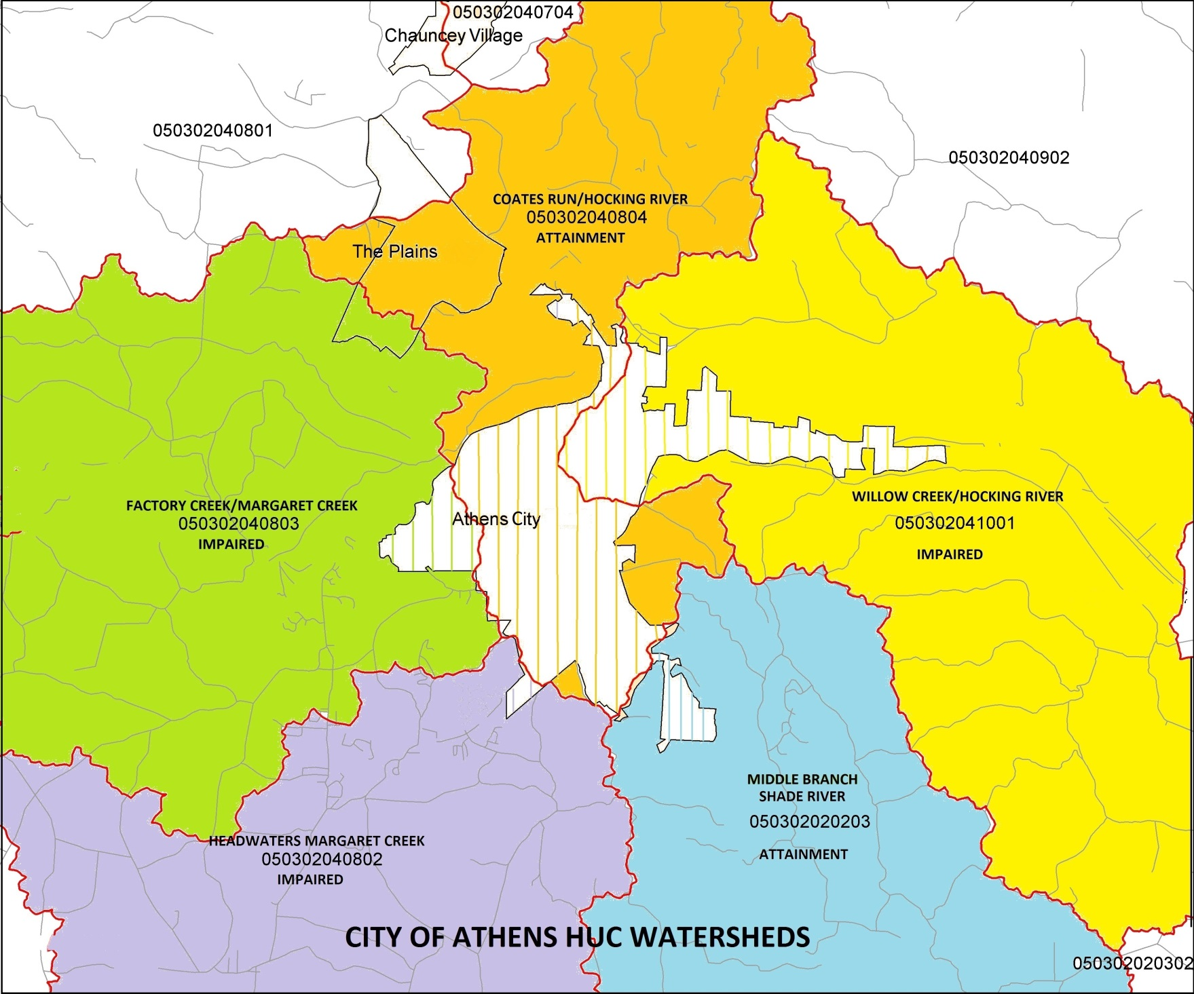

APPENDIX II HYDROGEOLOGIC UNIT CODE (HUC) WATERSHED ASSESSMENT UNITS (WAU)

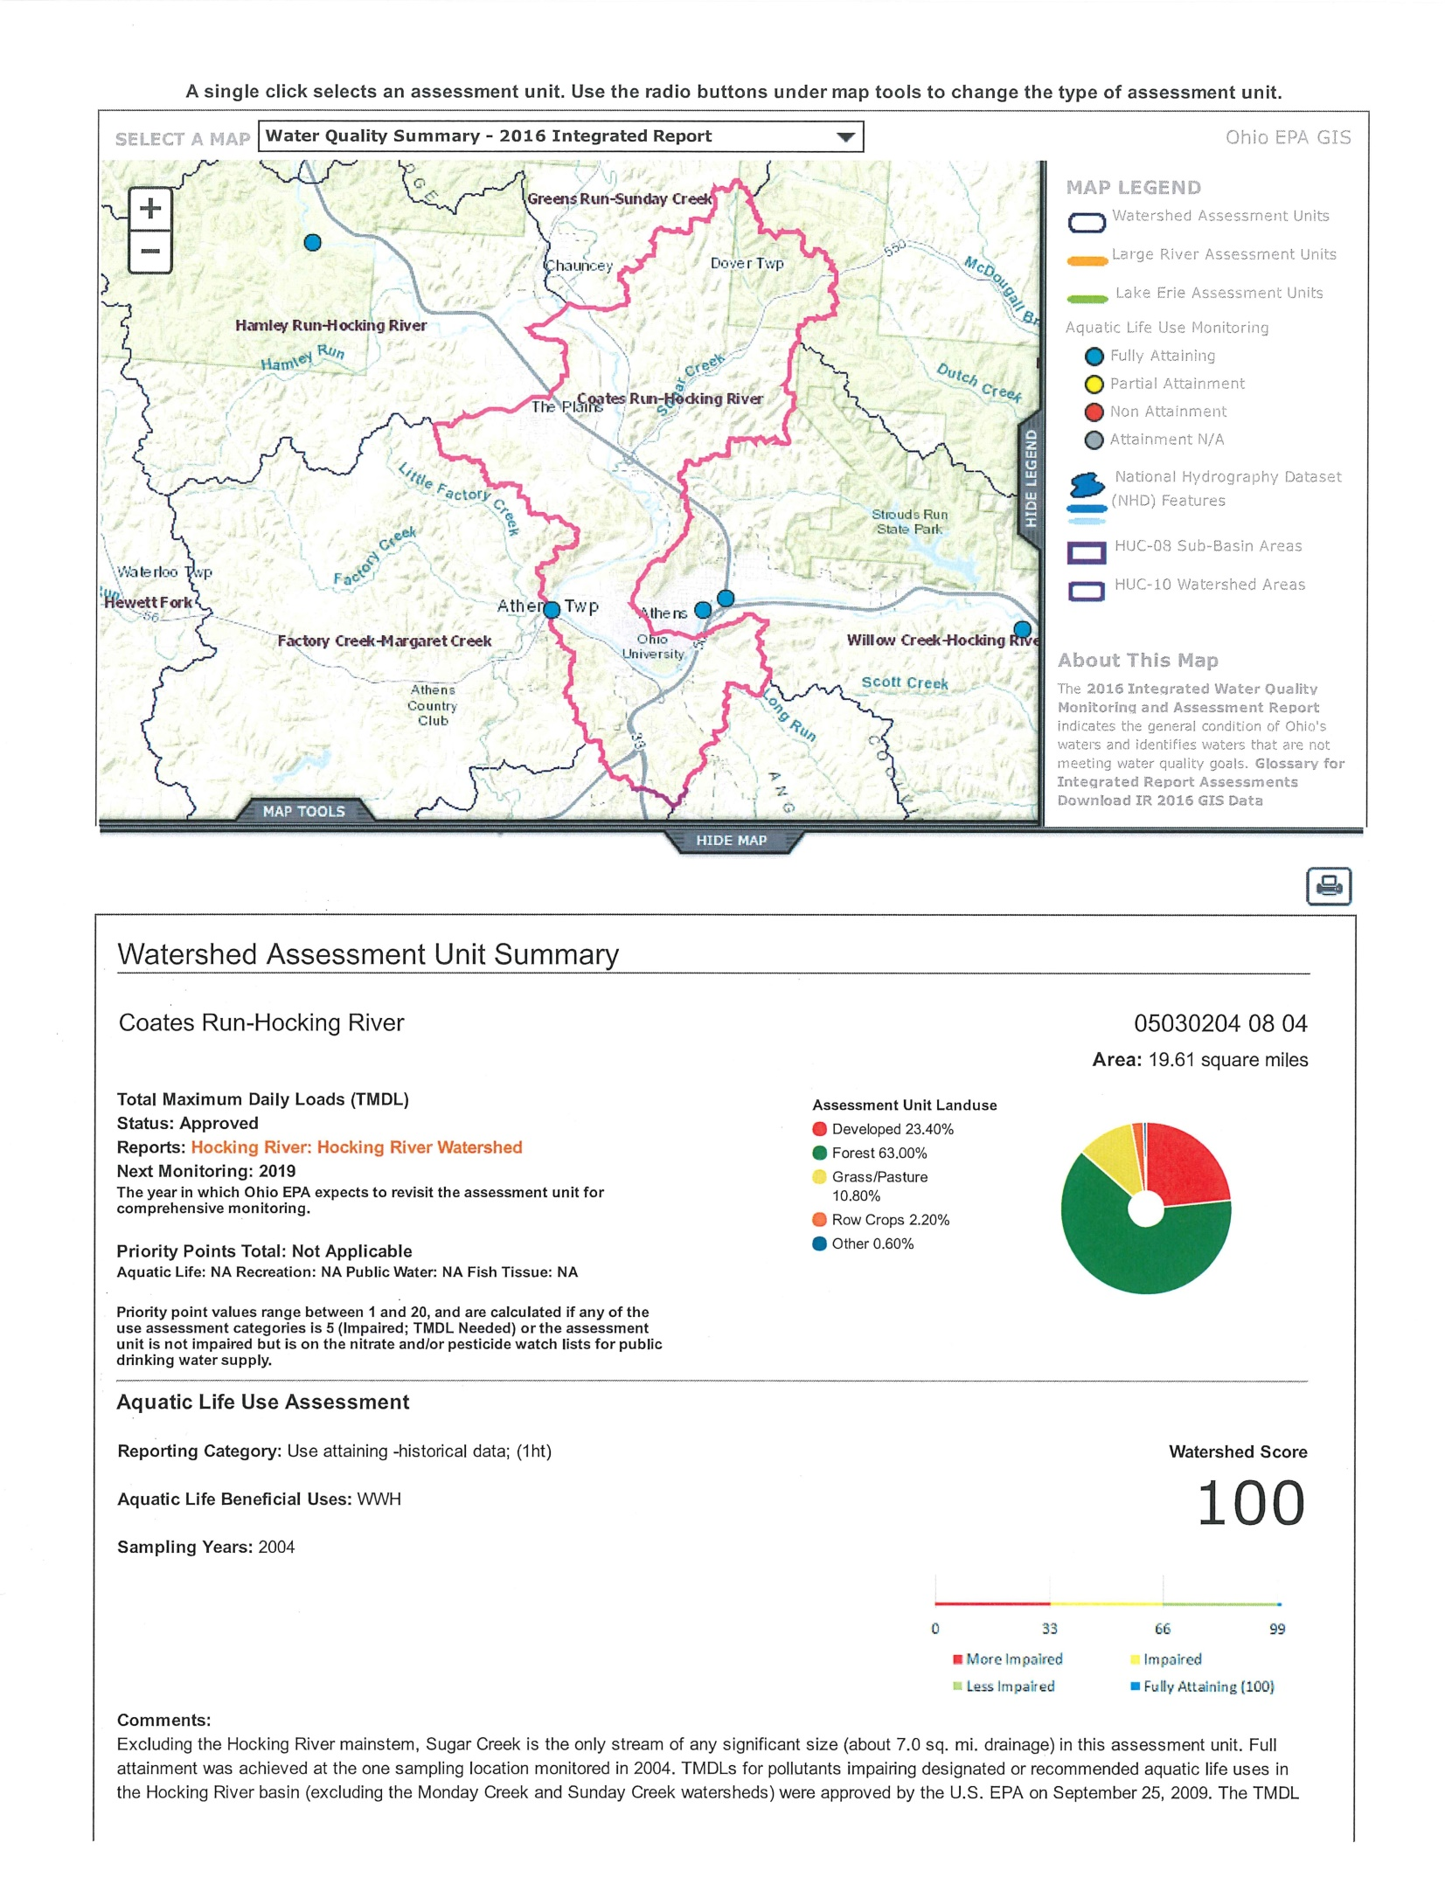
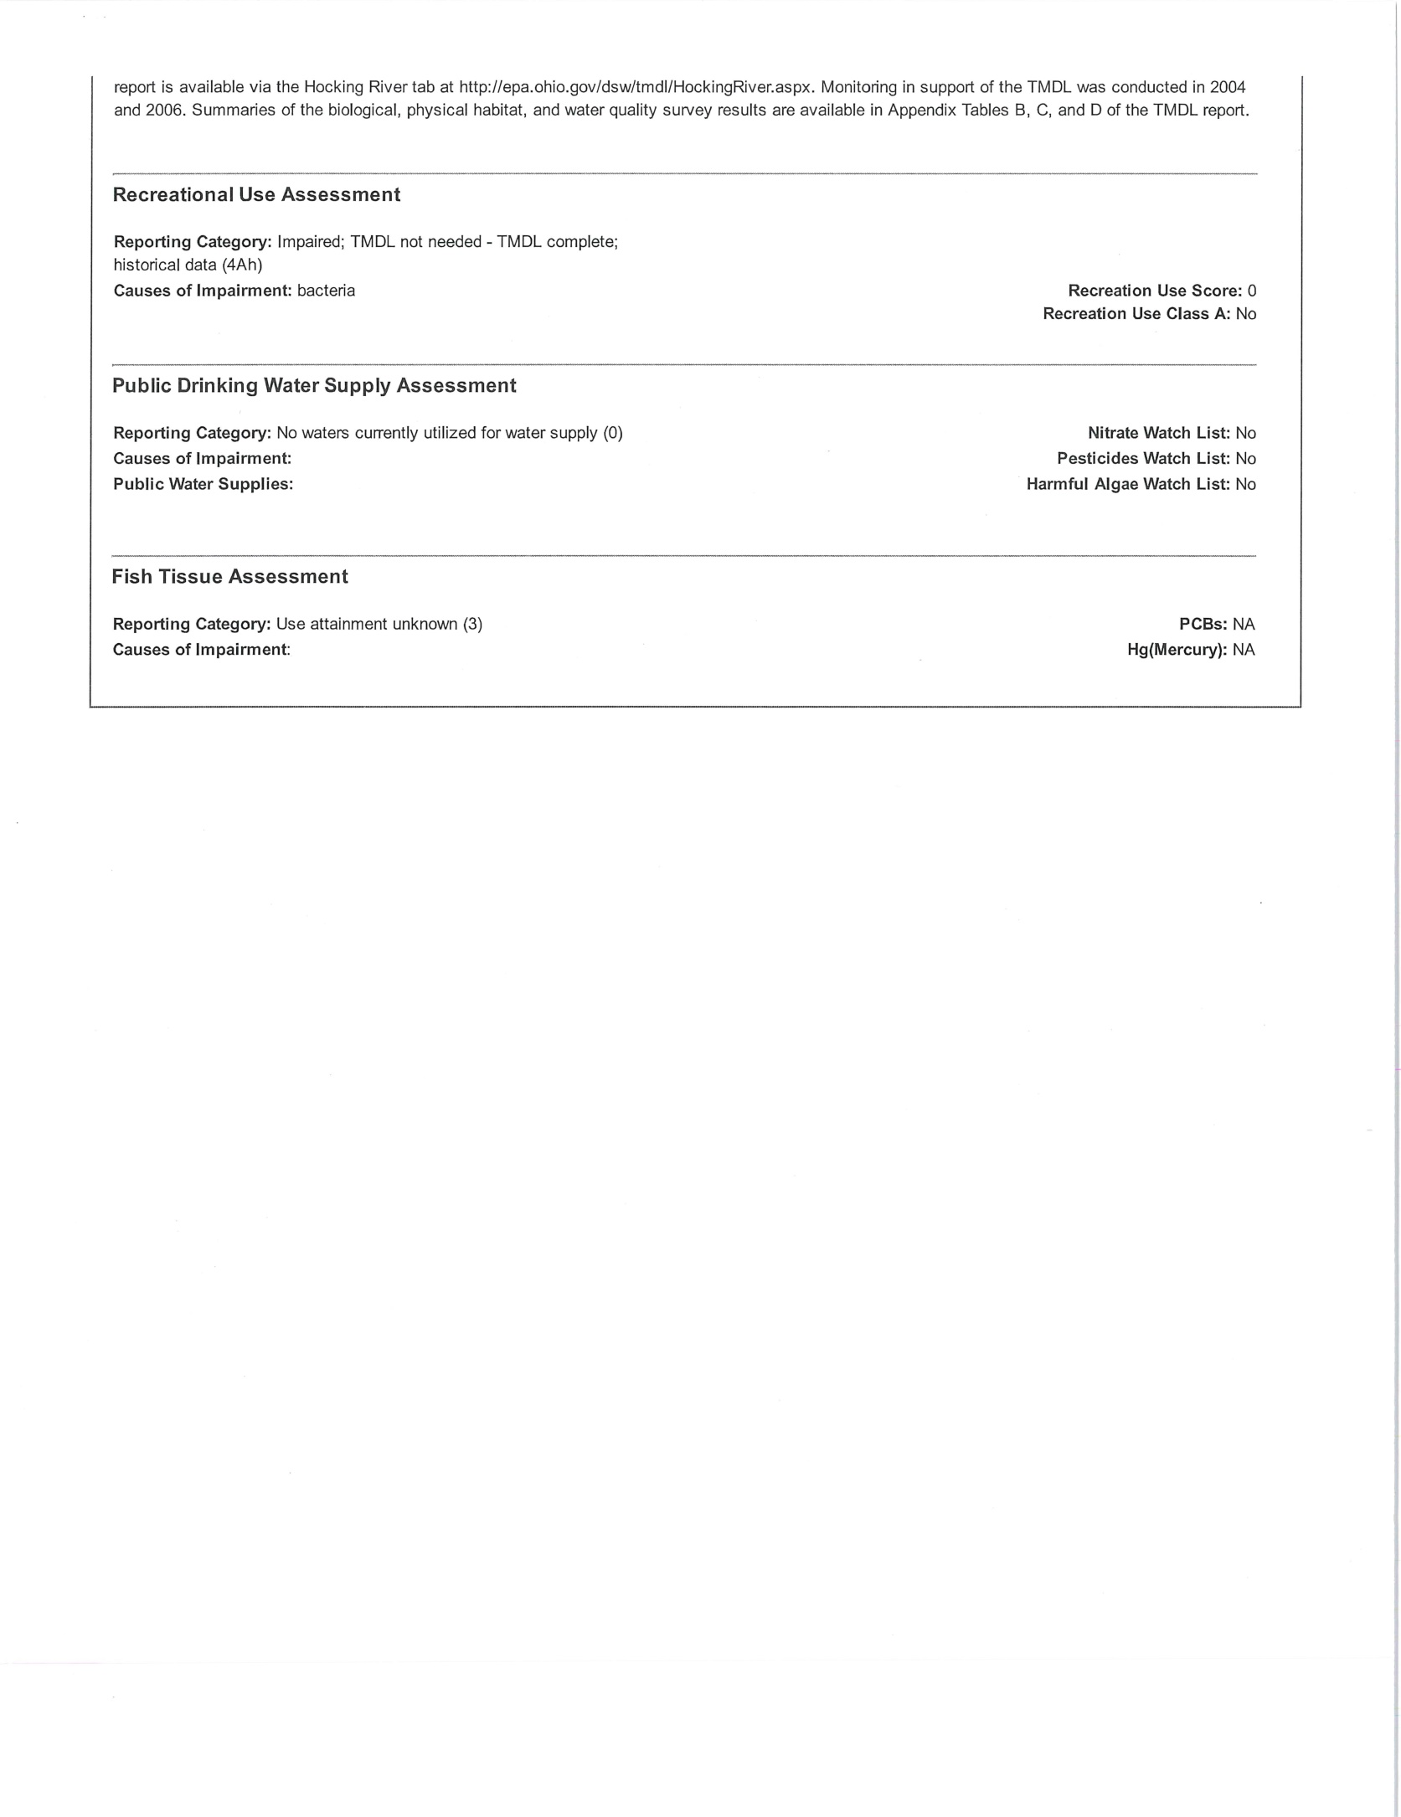
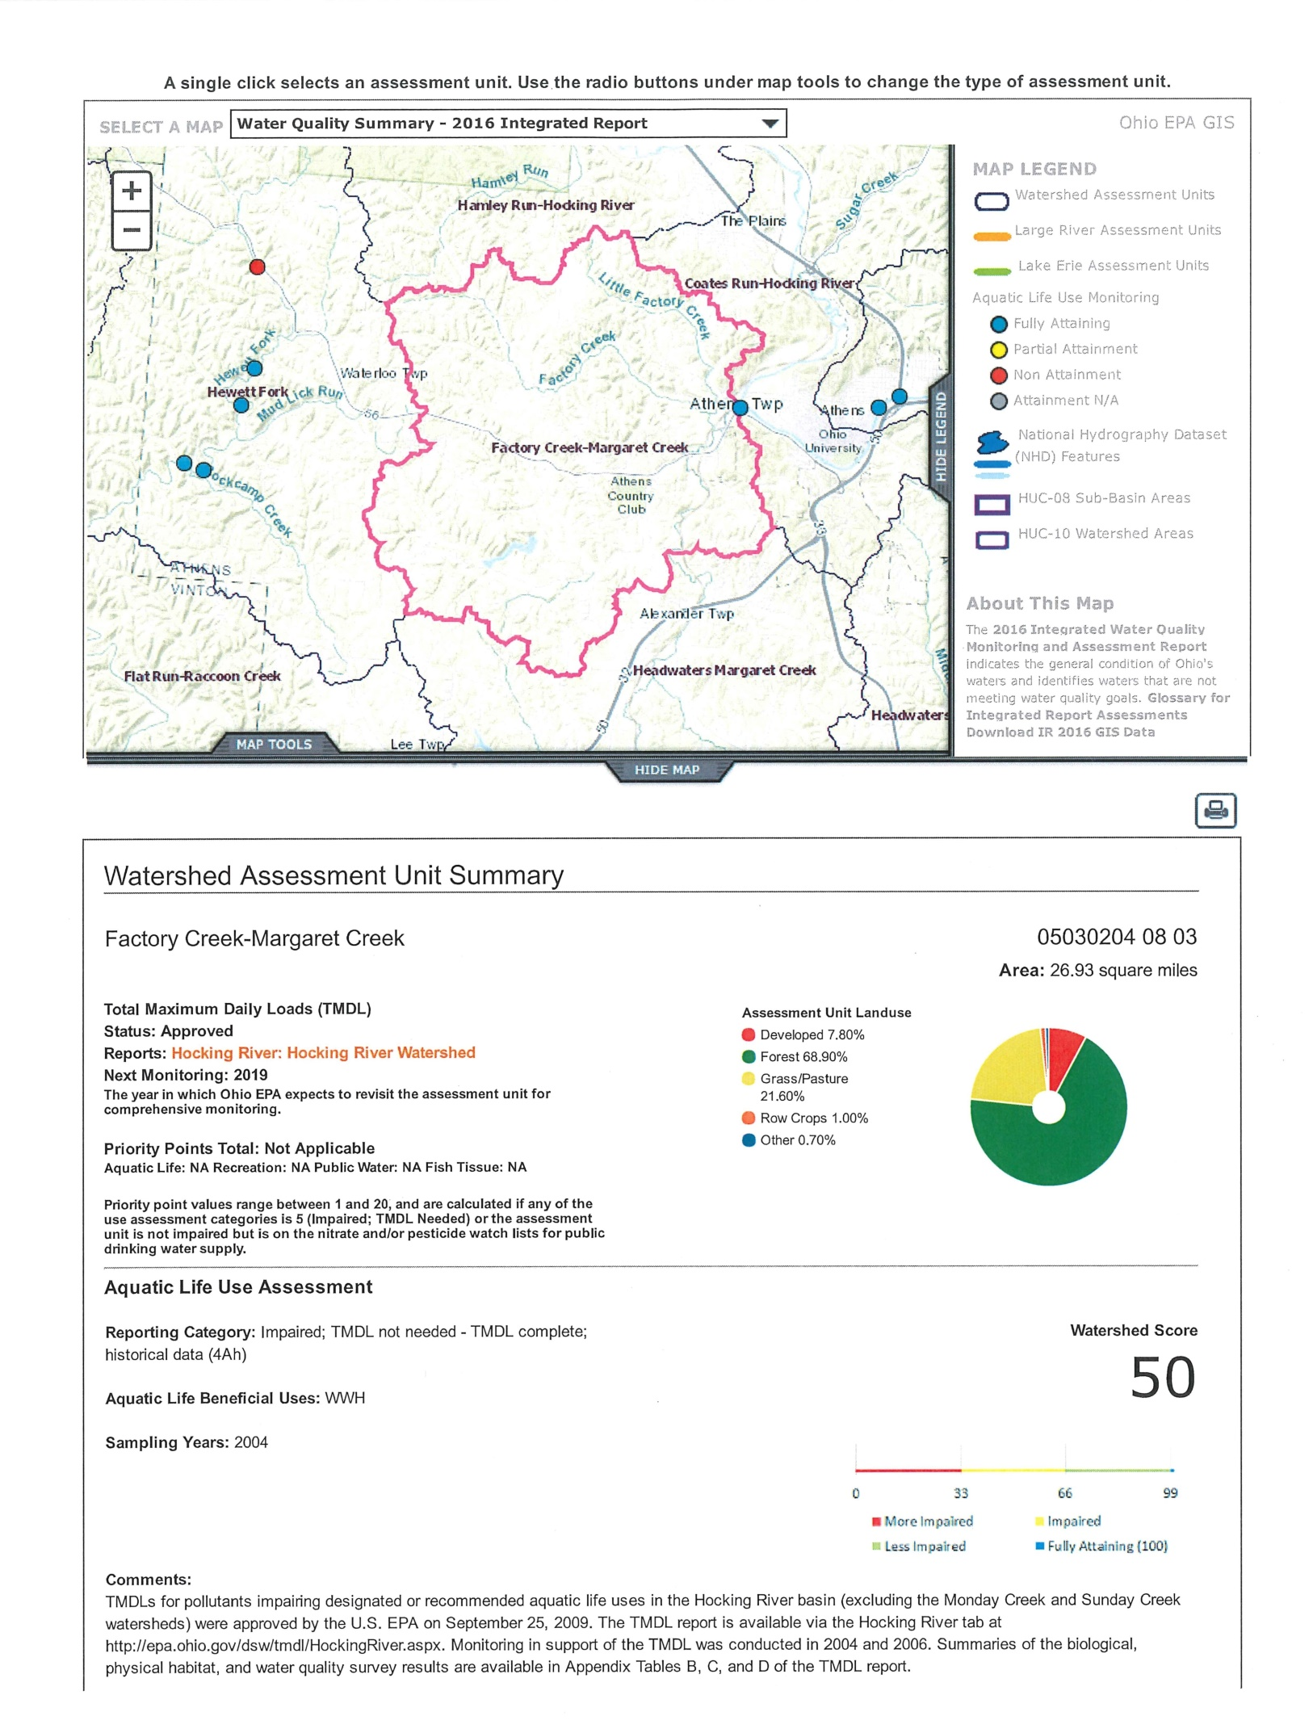
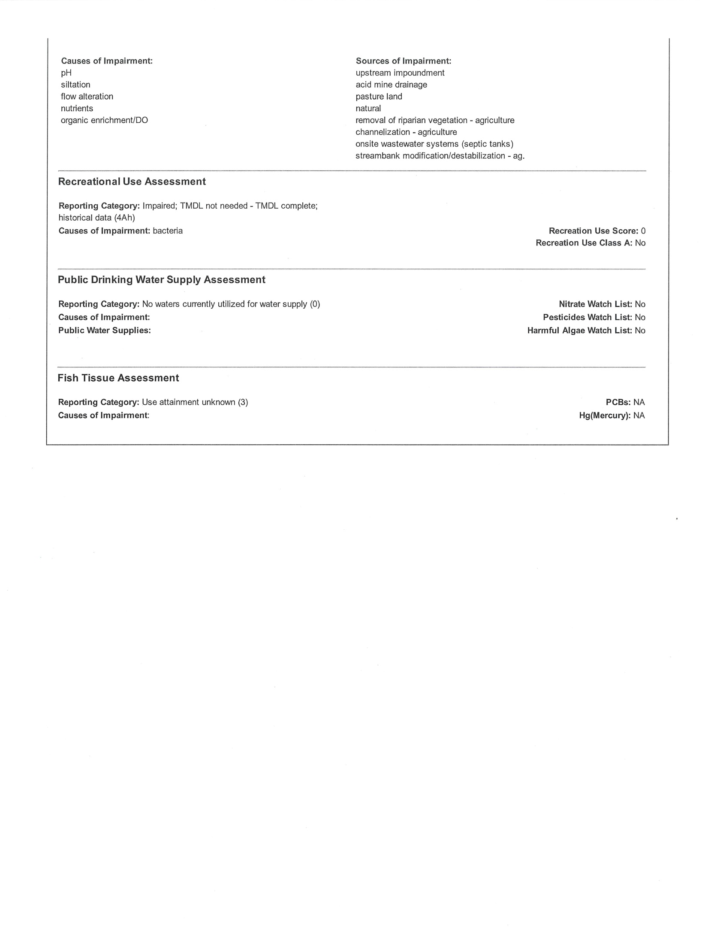
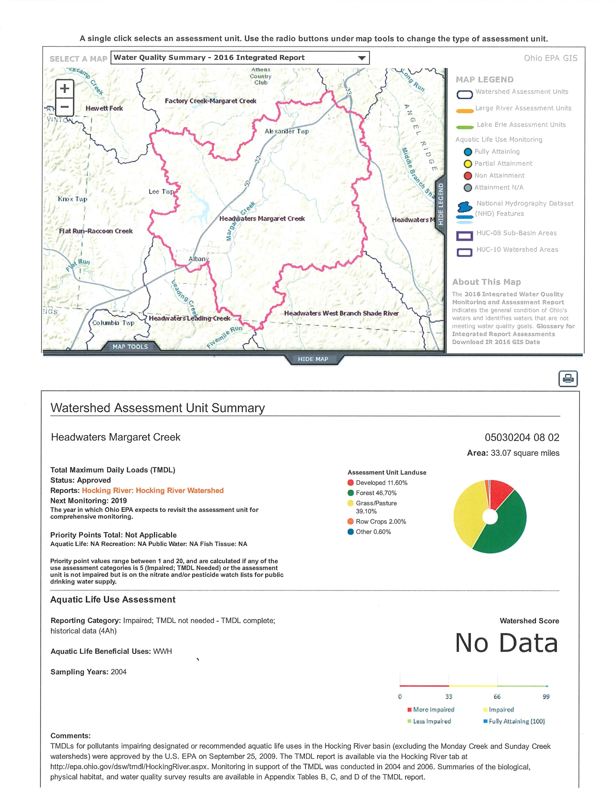
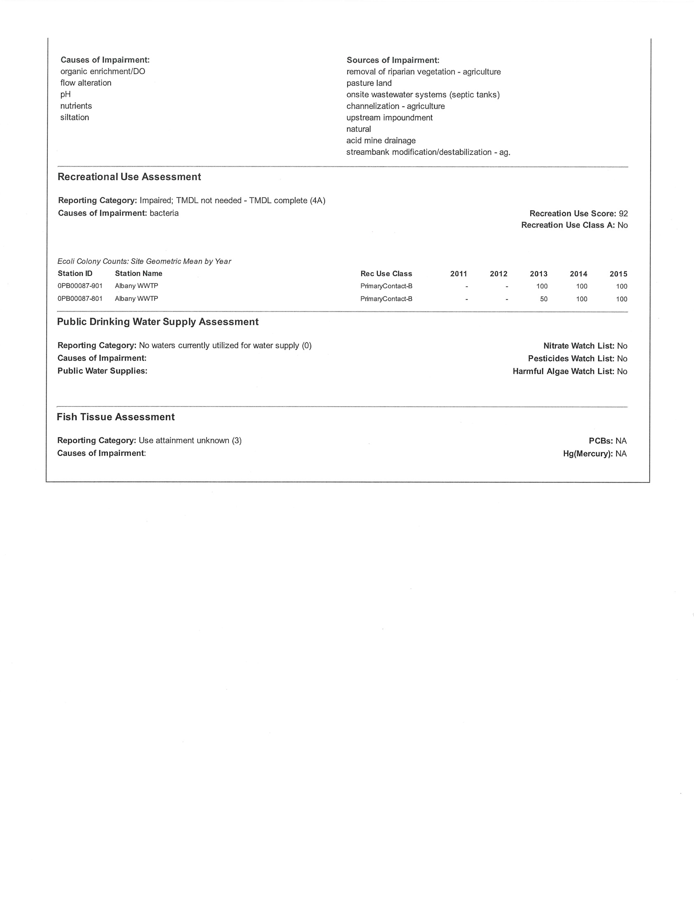
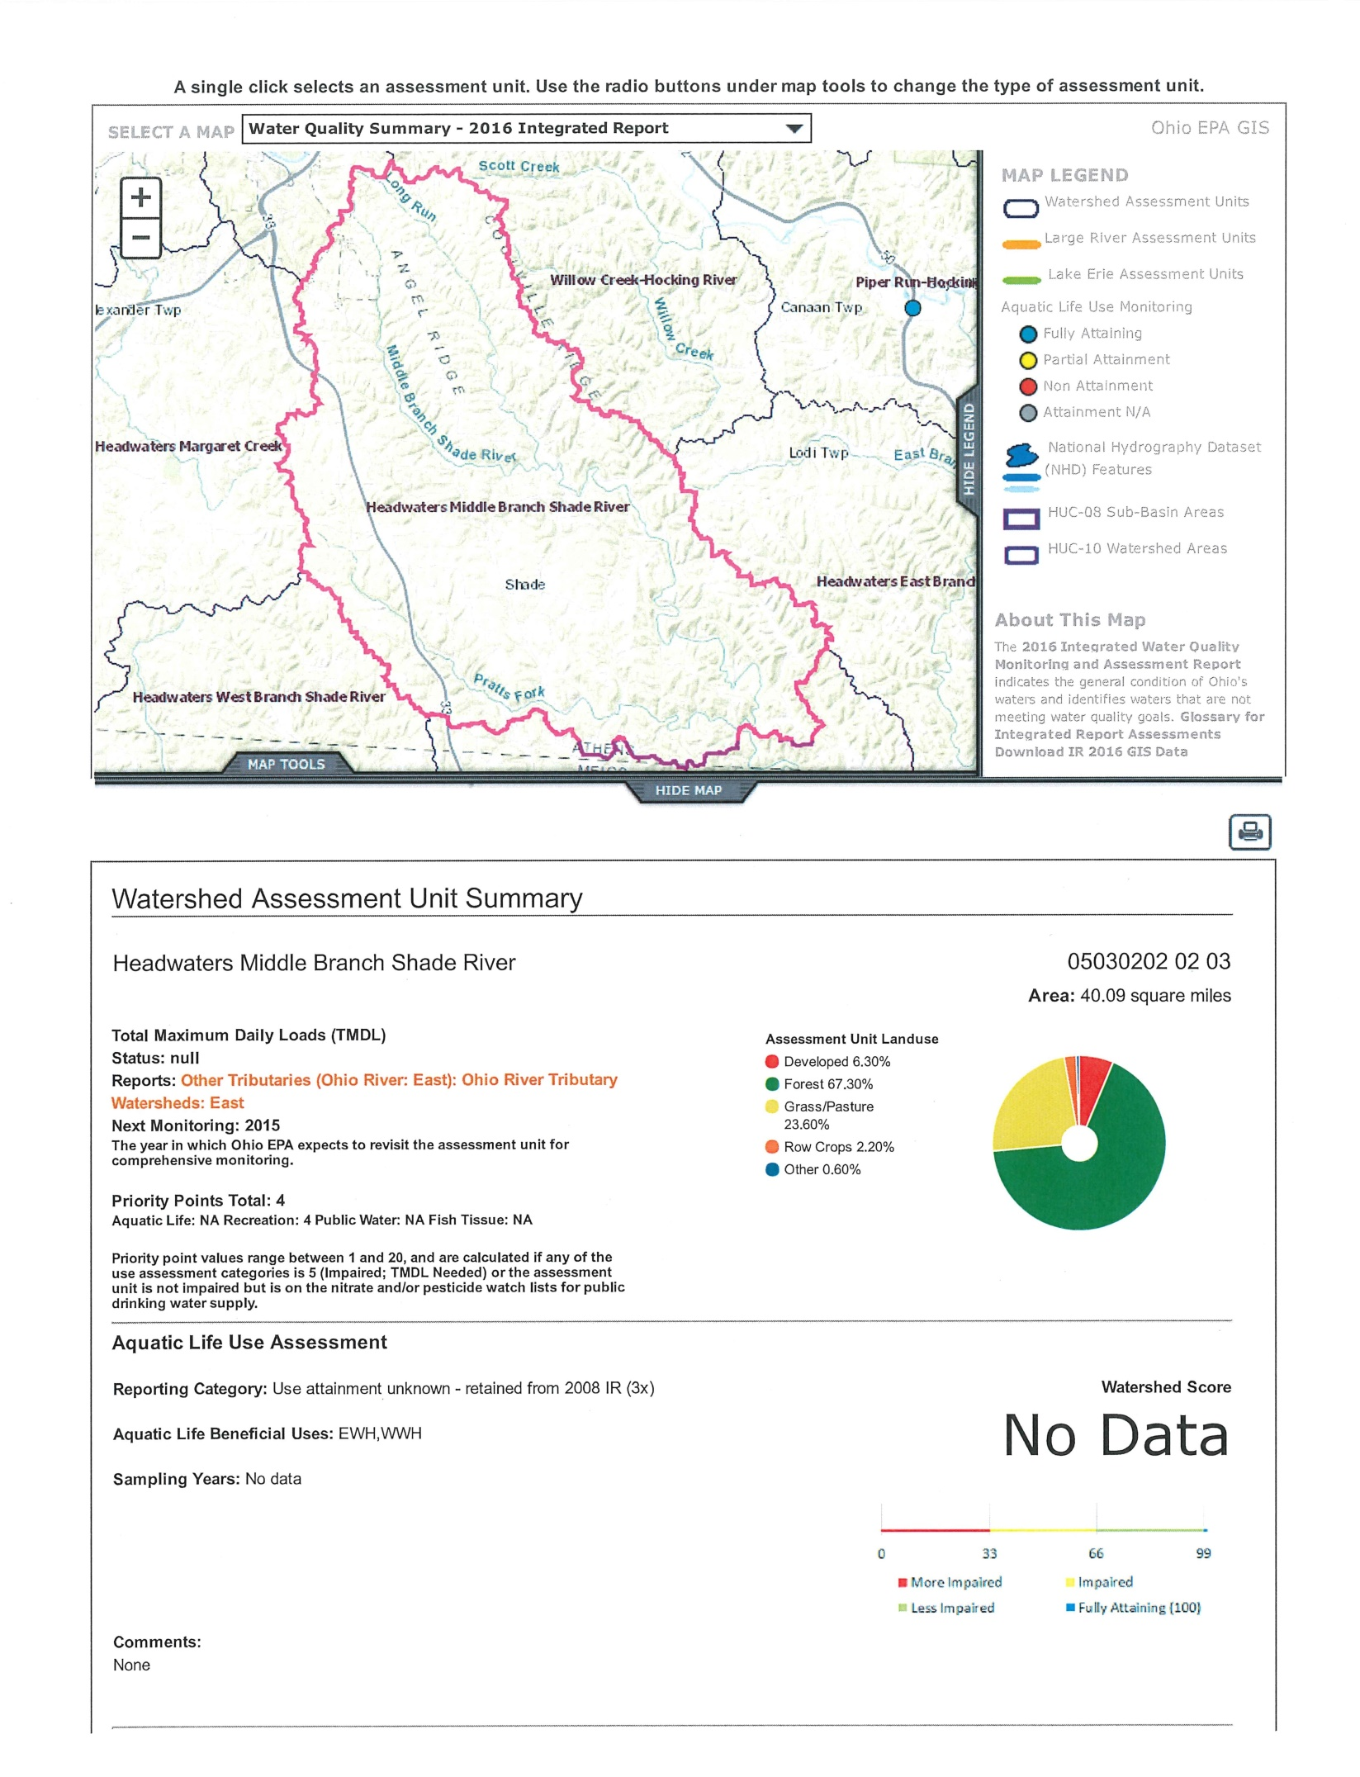
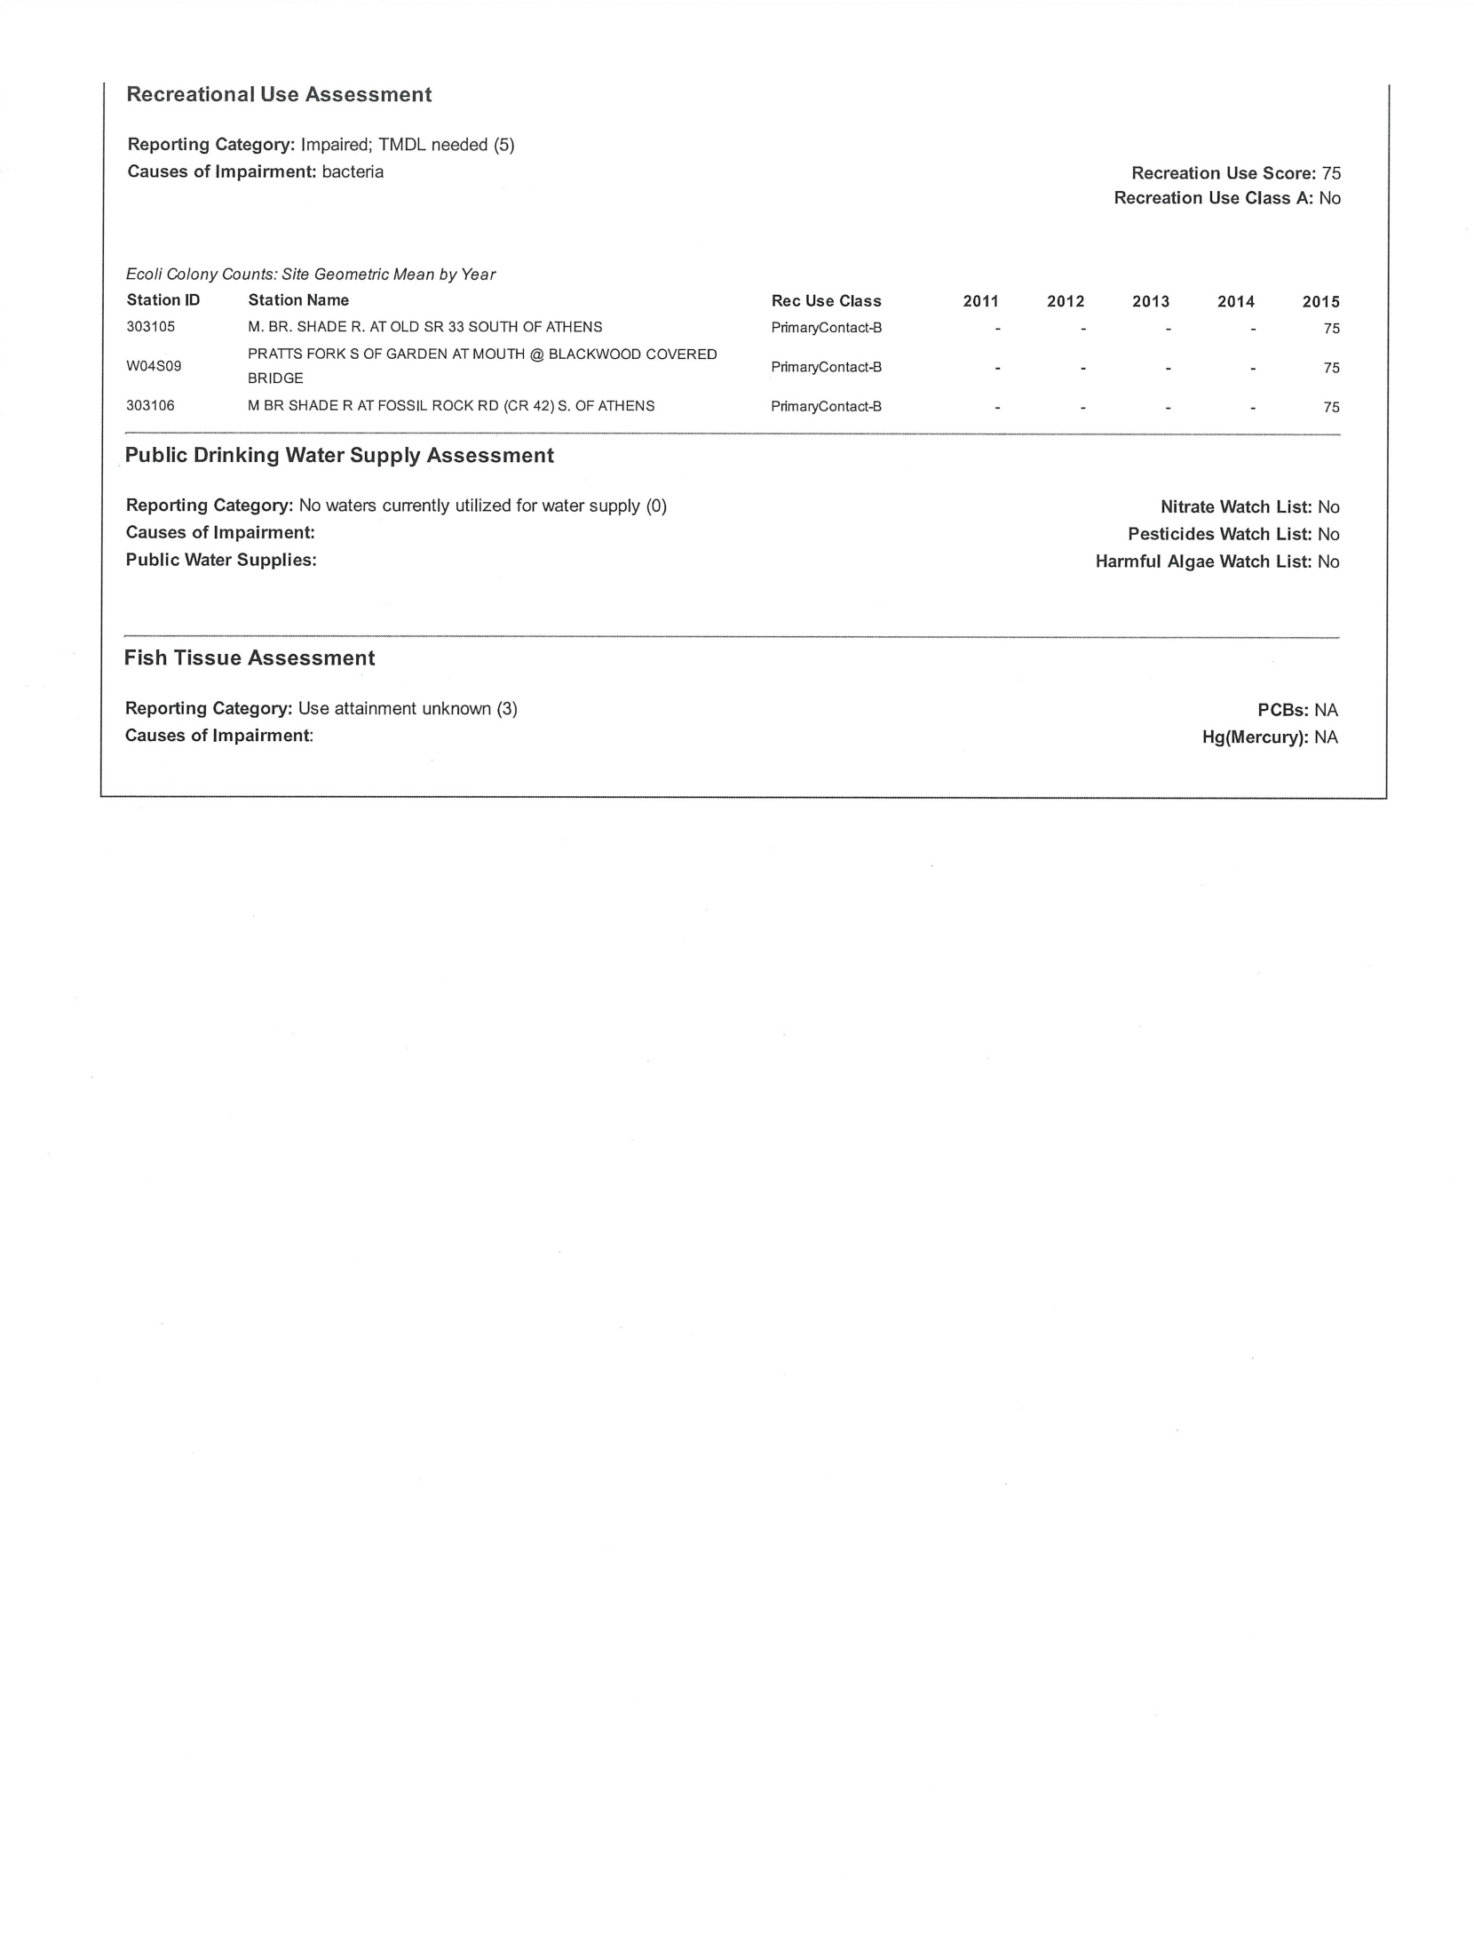
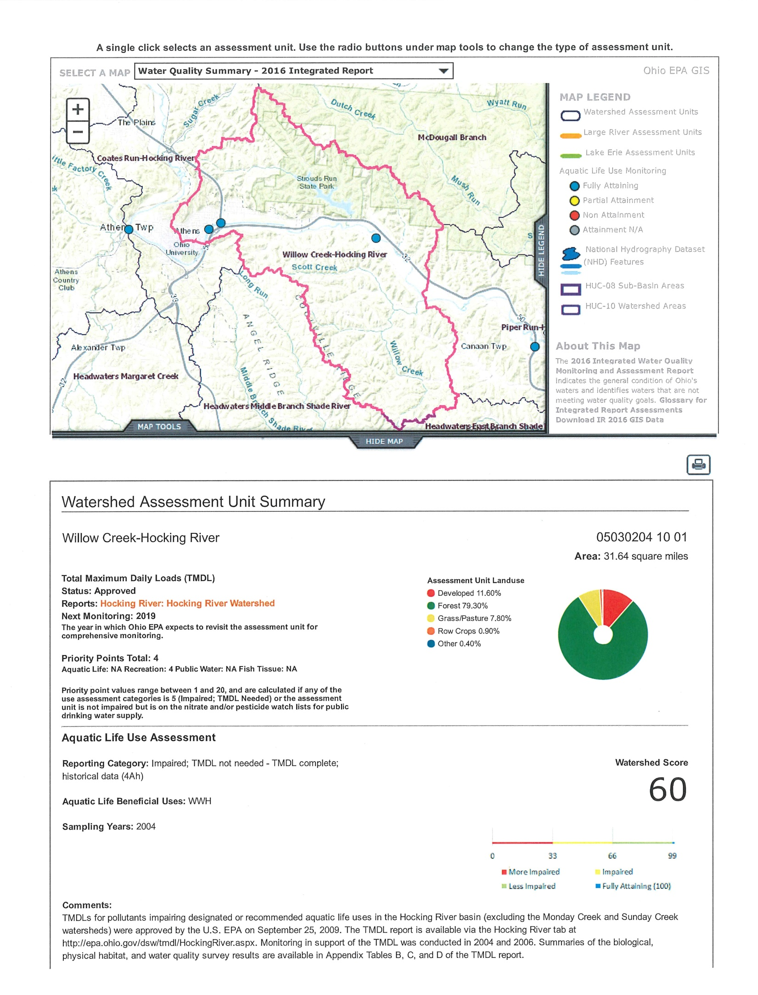
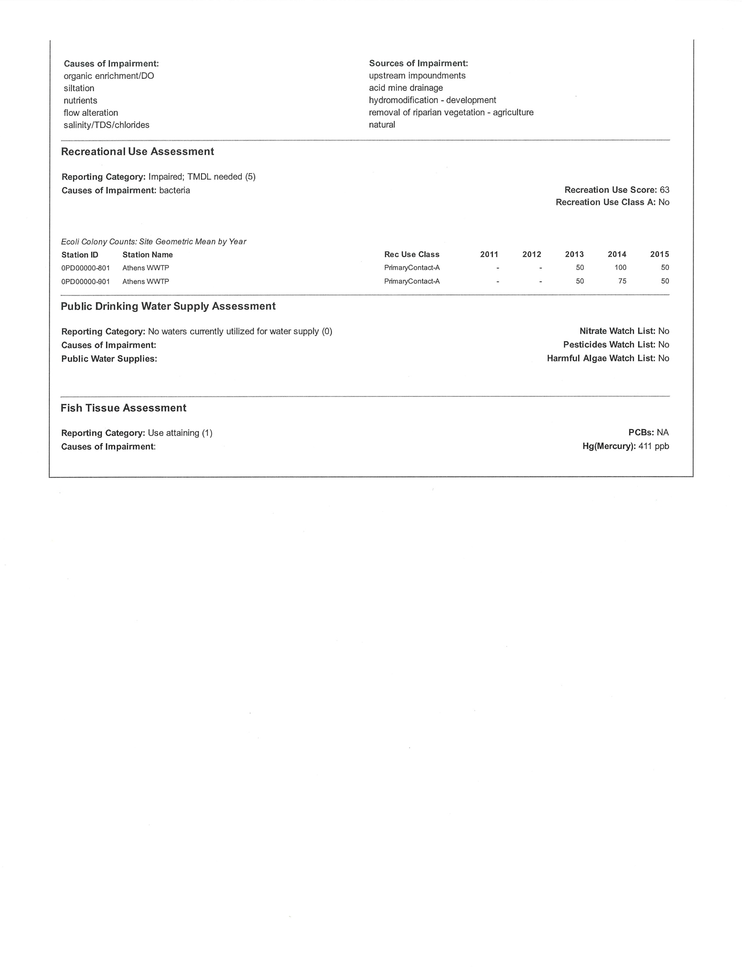

APPENDIX III STORMWATER STRUCTURES WITHIN THE CITY OF ATHENS

STORMWATER BEST MANAGEMENT PRACTICES INSTALLED IN THE CITY OF ATHENS
FACILITY | LOCATION | INFRASTRUCTURE TYPE | OWNER | INSTALLED
City of Athens | Sells Park Avon Place | pond | City | unknown
City of Athens | Union St. | biofiltration boxes | City | 2015
City of Athens | Depot St. | Stream Reconstruction | City | 2015
City of Athens | Union St. | grit vortex device | City | 2015
City of Athens | Richland Ave. at OU Inn | grit vortex device | City | 2015
City of Athens | Richland Ave. round-a-bout | grit vortex device | City | 2015
Ohio University | S. Green Drive | grit vortex device | OU | 2014
City of Athens | Code Enforcement Office | rain garden | City | 2010
City of Athens | Community Center | rain garden | City | 2010
Habitat for Humanity | West Union St. | rain garden | City | 2016
City of Athens | Armitage Rd. | wetland | City | 2015
City of Athens | Richland Ave | Dry basin | City | 2016
City of Athens | US RT 33 West on ramp | Bioretention basin | City | 2019
City of Athens | Richland Ave | Water Quality structure | City | 2020-2021
City of Athens | Stimson Ave | Bioretention cells | City | 2021

