Position Title: Sustainable Infrastructure Hub Coordinator

Funding: Office of Sustainability/Facilities Management & Safety

Position Summary
The Sustainability Hub Coordinators (Sustainable Administration, Sustainable Infrastructure and Sustainable Living Hub Coordinators) will oversee and coordinate core collaborative sustainability efforts at Ohio University. Each of the three leaders will directly manage one sustainability initiative, while fostering connections for other initiatives within and between Sustainability Hubs. Leaders will organize or give one seminar on a sustainability initiative each semester and will report annual progress to the University Sustainability Committee.

Eligibility
All faculty, though preference will be given to faculty members with existing sustainability efforts in research, engagement or teaching.

Action Goals

- Launch/advance core (research, curriculum or engagement) initiatives that support University sustainability goals, in alignment with the Presidential Strategic Pathways and Priorities. Lead subcommittees when appropriate.
- Engage participants in Sustainability Hub activities, including a seminar series, ensuring that faculty, students, staff, and community are appropriately represented within the Hub.
- Report progress toward Hub-related OHIO Sustainability & Climate Action Plan goals and strategies as needed, including through a bi-weekly newsletter to participants.
- Contribute to Sustainability Committee meetings twice per year.
- Collaborate closely with the Office of Sustainability and other Hub Leaders to ensure that administrative and organizational support is provided for OHIO sustainability initiatives.
- Oversee graduate student assistant jointly with the Office of Sustainability.

Compensation

$10,000 in salary will be provided annually for each Hub Coordinator.
A stipend for a graduate student assistant will be provided for each Hub Coordinator.
Coordinator positions are for either 2- or 3-year terms, and are potentially renewable, based on progress toward goals.

Detailed Expectations

Metrics for success for each goal
- Launch or advance initiatives (25 hours/semester)

  - Launch or advance at least one initiative each year that uses the campus as a laboratory for sustainability, and creates an engagement ecosystem composed of faculty, staff, students and community members.
  - Facilitate the launching or advancement of initiatives; where appropriate, encourage submissions to the Sustainable Project Laboratory for each of the 4 Hub themes.

- Engage participants in Hubs (10 hours/semester)
  - Ensure that Hub seminars are well-attended.
  - Maintain or increase active initiative collaborators. Mention/introduce these collaborators in Hub seminars and reports.
  - Forward content for the Office of Sustainability newsletter during Hub theme months. Encourage campus & community members to sign up for the newsletter when opportunities arise.

- Report progress (15 hours/semester)
  - Submit annual progress report on relevant goals and strategies by February 15 of each year.
  - Contribute where appropriate to other sustainability reports. These reports include, but are not limited to, AASHE STARS, Second Nature Carbon Commitment, US EPA Green Power Partnership, APPA Key Facilities Metrics, and annual Board of Trustees reports.
  - Contribute information on existing sustainability initiatives to each Hub theme webpage.
  - Lead a public seminar once each semester about ongoing initiatives. Main speaker may be Coordinator or another Hub participant.

- Contribute to University Sustainability Committee meetings (1.5 hours/semester)
  - Attend and participate at University Sustainability Committee meetings twice per year.
- Collaborate closely with the Office of Sustainability and other Hub Coordinators (9 hours/semester)
  - Attend regular meetings with the Office of Sustainability and Hub Coordinators.
  - Attend all Hub seminars each semester.
- Mentor and oversee graduate student assistant jointly with the Office of Sustainability (15 hours/semester)
  - Meet regularly with graduate student.
  - Align graduate student tasks with their own academic and personal interests as well as Hub goals.

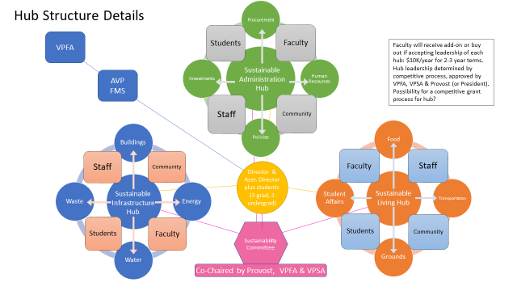

Mission Statement:
The Sustainability Hub Coordinators will facilitate the implementation of Ohio University sustainability initiatives related to their Hubs, with the support of the Hub participants and Office of Sustainability staff and students. Particular attention will be given to the integration of academic and operational sustainability into leading-edge sustainability laboratories and engagement ecosystems that are synergistic with existing University goals, in accordance with the Presidential Strategic Pathways and Priorities. The Hub Leaders will collaborate with the University Sustainability Committee, each other, and the Office of Sustainability.

