Table of Contents

- Introduction..........2

- Organization.......... 3

- Leadership Experience Journal.......... 4

- Outcomes.......... 6

- References.......... 8

- Self-Evaluation.......... 9

- Organization Evaluation.......... 10

- Signatures.......... 11

Environmental Leadership Experience with the Hammock Project

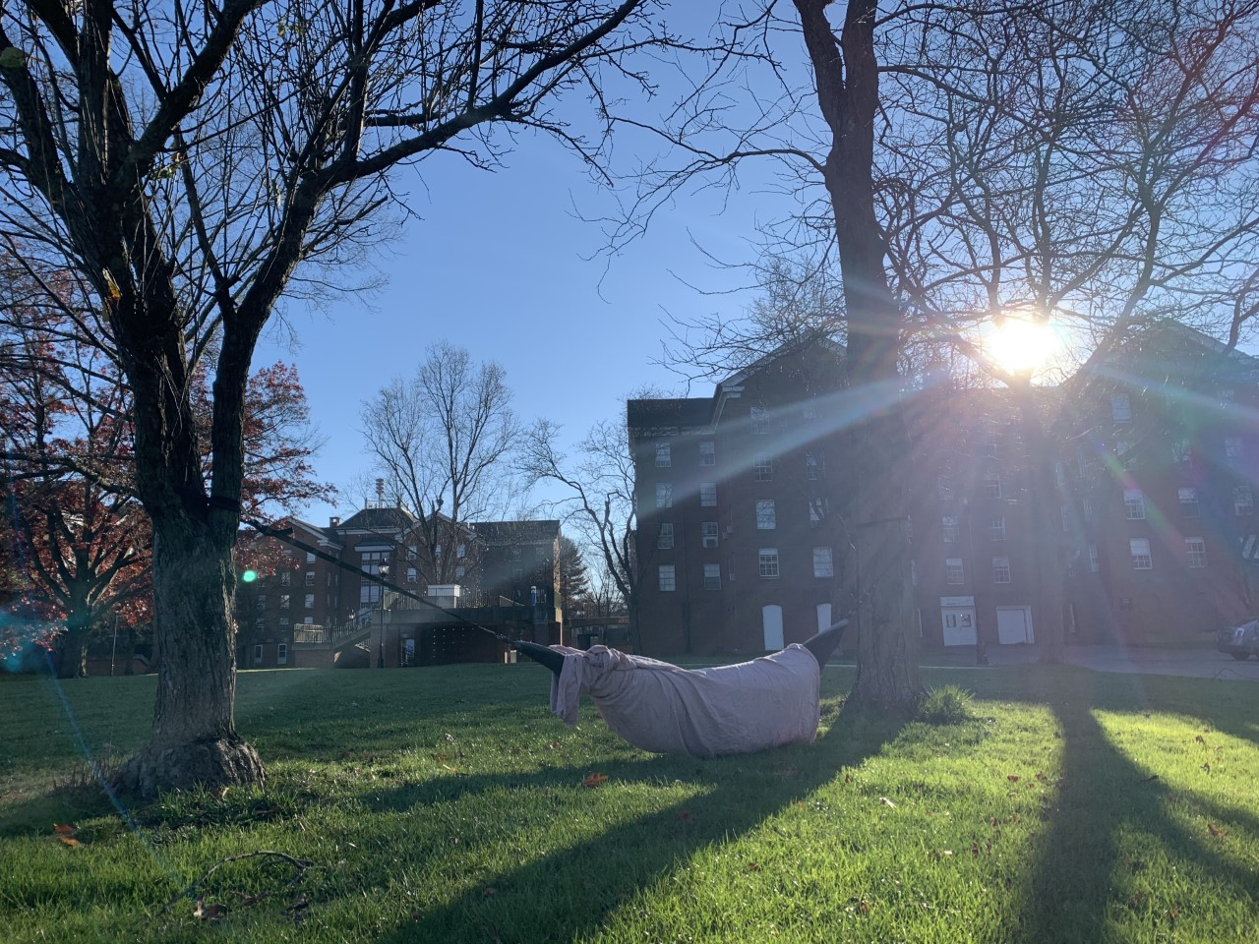

Introduction
Everyone enjoys relaxation, whether it be going kayaking at one's favorite river, riding bikes, or enjoying a delightful read while hammocking in the trees. While all these activities can be enjoyable for humans, hammocking in particular can have a negative impact on the health of trees. Depending on the type of tree, the risk of injury varies. This is because some trees have thick bark that is resistant to injury and others are easily injured because they have thin bark (Duryea & malavasi, 1998).
One of the main problems that cause damage to the trees, are the types of straps used for the hammock. Unless the person utilizing the hammock is using “leave-no-trace straps,” or another alternative to standard straps, then the tree is being harmed. Leave no trace straps are hammock support straps that provide a plurality of hook points that are folded over on each other and sewn into the strap using stitching. When one looped end of the strap is inserted in another looped end of the strap, the strap cinches down on a tree without damaging the tree (conlin, 2017). Also, covering the tree in padding or felt before applying the straps is another alternative, but it is time consuming and is not practiced among most “hammock users.” For example: a pilot survey was conducted in Minneapolis park on hammock and slackline use, and only 16% reported using felt covers before hanging their hammocks (Nelson, 2018).
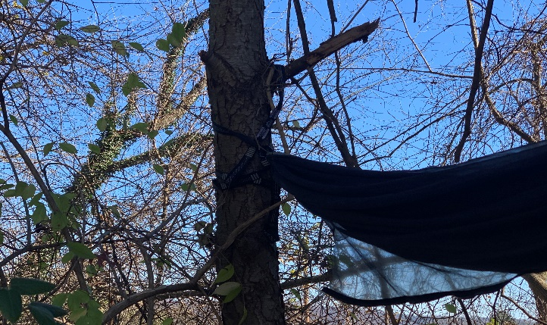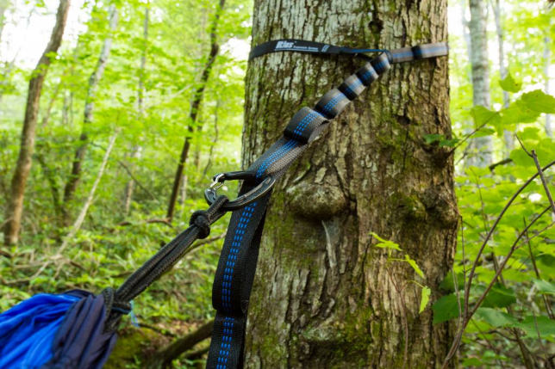
The reason to utilize “leave no trace” straps or felt padding, is because thin straps can cut into their bark or strip it off entirely, which leaves the trees vulnerable to insects, fungus, animals, the drying effects of wind and sun, and can cut into the cambium tissue which disrupts food and water transport systems. Once the tree is infected by an outside bacterium, the infection takes place in three stages: penetration of hyphae into the root system, colonization of the tissues, and degradation of the host’s cell structures (Nandris, Nicole and Geiger, 2020). With all of this in consideration, one hammock is not going to cause severe damage, but when the same trees work to support them over and over, that is when it is problematic (Benzschawel, Carodine, King, Bouchard, & Mohatt, 2020).
The smaller trees on College Green at Ohio University are taking the biggest hit caused by hammocks, as this is a popular area among students. Most of the public population are not going to be tree experts, so it is not fair to put the blame on them causing this unintentional damage. If a tree looks healthy and sturdy, the average person is going to assume that it is strong enough to hang a hammock on. However, a lot of times trees can have root rot or disease or underlying issues you cannot see on the surface, or they are too small to support the structure people are trying to attach (Benzschawel, Carodine, King, Bouchard, & Mohatt, 2020).
I would like to also mention soil compaction in the root zone if a site is used repeatedly by hammocking. A compacted soil has a reduced rate of both water infiltration and drainage, which causes an increase in the likelihood of aeration-related problems. In addition, a compacted soil also means roots must exert greater force to penetrate the compacted layer (DeJong-Hughes, 2018).
Finally, too much stress on the tree can cause harm to the tree growth process as well. Tree growth processes can be ranked by order of importance in foliage growth, root growth, bud growth, storage tissue growth, stem growth, growth of defense compounds and reproductive growth. Under stress photosynthesis is reduced and carbon allocation is altered (Dobbertin, 2005).
A solution to avoiding all of the above tree damage would be to implement a system of “hammock poles” on campus. This has been done at multiple universities and has proven to work amazingly. One university in particular is Iowa State University. Iowa State has placed a dozen poles to their campus over the summer in various locations. Multiple hammocks can be hung on the metal poles and each pole has bands to hold the straps of the hammocks in place, so they do not slide down during use. A total of four bands are on each pole, three toward the top of the pole and a fourth closer to the bottom for slacklines (Smith, 2020).
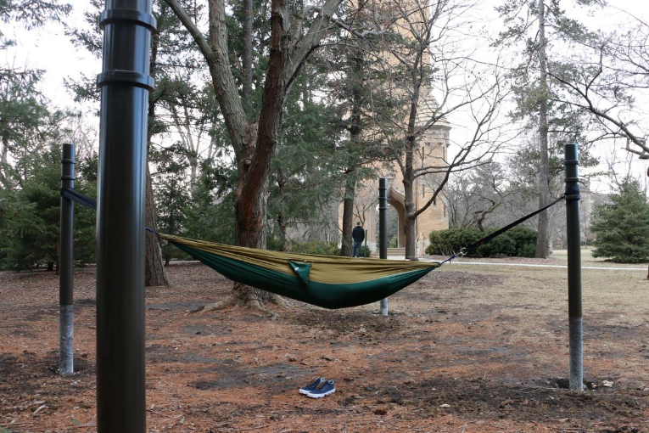

Organization
For this project I was working under Susan Calhoun, who is the director of the grounds and landscape coordinator for Facilities Management & Safety at Ohio university and The Office of Sustainability. The Office of Sustainability at Ohio University’s mission is to facilitate the implementation of the Ohio University Sustainability and Climate Action Plan by providing services and support to the campus community and ensures fulfillment of institutional commitments to environmental, social, and economic well-being. The Facilities Management & Safety encompasses Architecture, Design and Construction services, Facilities Operations, Safety, Sustainability, and Emergency Management.
The office of sustainability offers many projects for students to help with. I was fortunate enough to participate in the hammock stand proposal on campus with Susan. Although the office of sustainability plays a key role in end goal of this project, Susan is the main person in charge of helping this hammock pole design come to life. Susan is incredibly intelligent on the environment surrounding Ohio University and was enjoyable to work under.
Susan Calhoun
calhouns@ohio.edu
740-593-2911
---------------------------
OFFICE OF Sustainability
sustainability@ohio.edu
740.593.0460
Leadership Experience Journal
Before I started my leadership experience with the hammock project, I set out a list of tasks I wanted to accomplish by the end of the semester in my proposal. A quick rundown of the list includes deciding on the appropriate hammock pole design to use, finding a spot to implement the poles once the carpenters were finished with the cost estimate, creating, and placing signs around the trees to educate the public on health hazards, conducting surveys for students on campus regarding the hammock poles, creating a social media page for the hammocks, and installing the first hammock pole for testing.
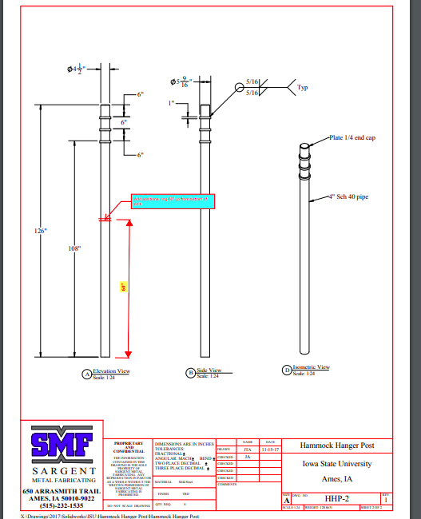
During my journey through this semester, I accomplished almost everything I had set out for myself. I started by researching other universities that had already accomplished installing hammock poles on their campus. I found that Iowa State University in particular, had the best functioning pole system and set-up. I had the chance to call Rhonda Martin, the landscape architect of facilities design and Constuction at Iowa State University. Rhonda gave me the blueprints of the dimensions and cost regarding the poles they used on their campus. I was then able to pass along that information to Susan, who sent it to the carpenters on campus here at Ohio University.
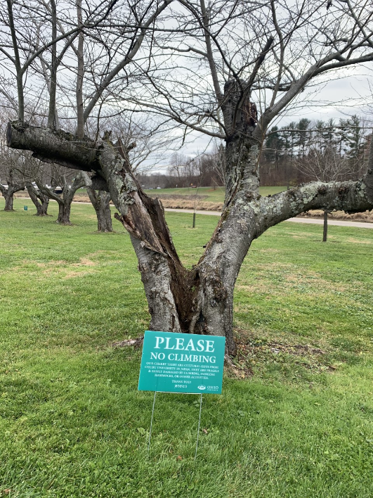
While waiting for the carpenters to give us their exact cost estimate on everything, I contacted Susan regarding the signs that are set up around the cherry blossom trees on Shafer street. I met with Susan at her office and she gave me a sign to set up around the trees because people were taking some of them down.
I decided to conduct a brief survey that I would ask people on college green or people I saw hammocking regarding hammocking and if they would be interested in using hammock poles if Ohio University had them. The survey looked like this:
  - How often do you hammock?
  - When/if you hammock, do you use a standard strap or an alternative?
  - If hammock poles were available would you use them?
  - Would you use them if they were located at Emeriti park or Stocker Picnic Grove?
Total I received 23 responses from repeatedly going out and asking. 9 of those people were actively hammocking when I asked them the survey questions. The results were roughly ¾ of the people asked hammock occasionally and the rest did not hammock that much at all. All but 2 of the people said they use a standard strap instead of an alternative. However, everyone mentioned how unique the idea of hammock poles on campus would be and how they would love to have somewhere to hammock without damaging the trees. Finally, everyone mentioned how they would rather have the location at Emeriti park instead of Stocker picnic grove because they were more familiar with the area. Although this survey was short and not full of depth it still provided valuable information on how the students are feeling and offered them some insight on how hammocks are harming the trees.
Finally, I created a social media page for the hammocks on Instagram. This page has the pictures I have been taking throughout the semester on it and has information regarding tree health and hammocking tips and tricks. It started off slow but now the page officially has almost 30 followers.

The last round of meetings was conducted about this project on Teams video. I spoke with Susan, Sam, who is from the office of sustainability, and Loraine. We all discussed the progress I have made this semester and how we want the pole to look. Thoughts of making one big pole in the center with smaller poles around it was brought up by Susan, to cut down on costs. Sam mentioned that they would love to move forward on this project when the office of sustainability has the correct funds for it. Also, when the right space of land becomes available and does not have any prior obligations to house something else.

Outcomes
The final outcomes for this project were successful. Although we did not physically get a hammock pole into the ground for testing, the steppingstones and the groundwork have been planted. This is a vital part to the end goal. Once the funds are available and the space for the poles are picked out, this project is almost ready-to-go. With the motivation behind Susan and the office of sustainability there is no doubt in my mind that Ohio University will implement hammock poles on campus soon.
I accomplished almost all my set-out tasks in my proposal. I received the design for the poles and received a final cost estimate from our carpenters. Which in the end was:
Labor: approximately 8 hrs. @ $51.00/hr…………. $408.00 Materials: Pipe, concrete & paint: $250.00 Total: Approximately $700.00
This does not include utility marketing charge.
I am proud of the social media page I created for the hammocks because it is shedding more light on the damage hammocks can cause to trees. A lot of people are unaware of this. The Instagram is picking up speed and more people are spreading the word on the account. As mentioned already, the account now has nearly 30 followers.
I would say all-in-all I met my objectives for this project. My goal was not to make these poles officially happen, rather, make the process easier for Susan and the office of sustainability by doing the research that I did. My work aided in their journey to bring this project to life and I am by no means taking the credit for that. Susan was a pleasure to work under and I am profoundly grateful for the experiences I got to make during this process and learning more about how the environment works when it is disturbed. The knowledge I obtained from this experience will stay with me forever and will be the first steppingstone for many more projects to come in my future career path.

References
Benzschawel, C., Carodine, V., King, L., Bouchard, J., & Mohatt, K. (2020, June 16). Why Tree Hammocking Is Not Allowed in Denver's Parks. Retrieved November 30, 2020, from https://www.5280.com/2020/06/why-tree-hammocking-is-not-allowed-in-denvers-parks/

Nelson, A. (2018). Hammocks, Slack Lines and Tension Tents: Protecting Trees and Park Users. Retrieved 2020, from https://www.forestry.umn.edu/sites/forestry.umn.edu/files/2.hammocks.report.12-06-2018.pdf
Duryea, M., & Malavasi, M. (1998). How Trees Grow in the Urban Environment1. Retrieved November 25, 2020, from http://citeseerx.ist.psu.edu/viewdoc/download?doi=10.1.1.537.9364&rep=rep1&type=pdf
Conlin, T. (2017). US9907389B2 - Single piece hammock strap with integral woven eyelets. Retrieved November 27, 2020, from https://patents.google.com/patent/US9907389B2/en
Nandris, D., Nicole, M. and Geiger, J., 2020. Root Rot Diseases. [online] Horizon.documentation.ird.fr. Available at: <https://horizon.documentation.ird.fr/exl-doc/pleins_textes/pleins_textes_7/b_fdi_51-52/010015907.pdf> [Accessed 27 November 2020].
DeJong-Hughes, J., 2018. Soil Compaction. [online] Extension.umn.edu. Available at: <https://extension.umn.edu/soil-management-and-health/soil-compaction#:~:text=Soil%20compaction%20occurs%20when%20soil,both%20water%20infiltration%20and%20drainage.> [Accessed 30 November 2020].
Dobbertin, M., 2005. Tree Growth As Indicator of Tree Vitality And Of Tree Reaction To Environmental Stress: A Review. [online] Tree growth as indicator of tree vitality and of tree reaction to environmental stress: a review. Available at: <https://link.springer.com/article/10.1007/s10342-005-0085-3> [Accessed 30 November 2020].
Smith, S., 2020. Additional Hammock Poles Placed To Relieve Trees. [online] Lib.dr.iastate.edu. Available at: <https://lib.dr.iastate.edu/cgi/viewcontent.cgi?article=1000&context=iowastatedaily_2019-10> [Accessed 30 November 2020].
Self-evaluation

Organization Evaluation

