Detour instructions to EBI parking lot. Using Convo as starting point of reference.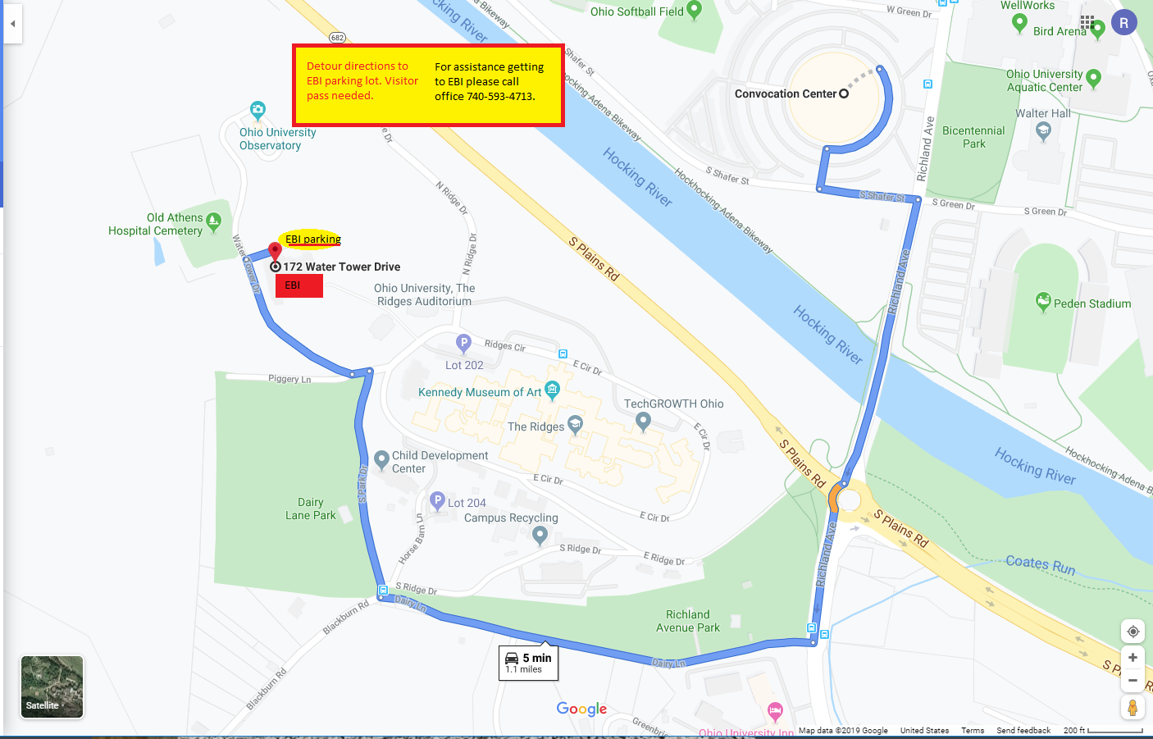

Detour to The Ridges parking lot from 682, S. Plains Rd. Using Convo as starting point of reference.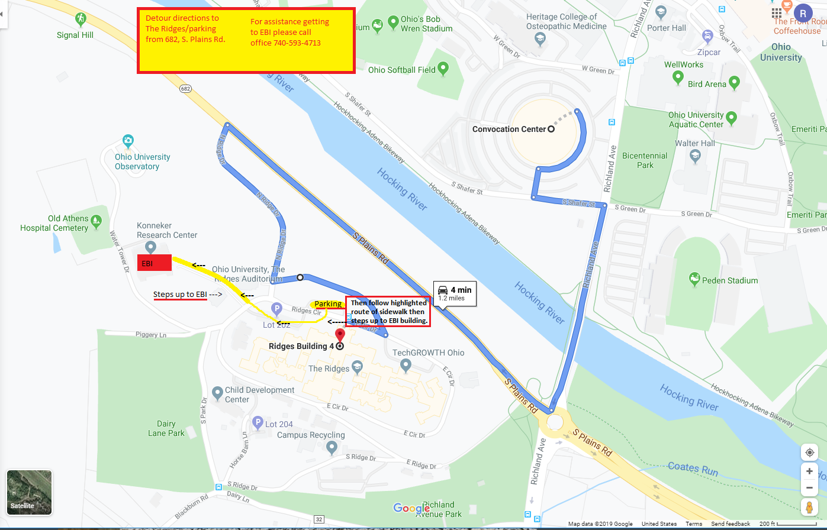
Detour to The Ridges parking lot from Dairy Lane. Using Convo as starting point of reference