- In order to uninstall the Hyland Unity Client you must first stop the Windows Service it is running as. In the bottom right hand corner of your Windows screen select the “up” arrow to view the System Tray.
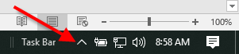
- Right click on the Hyland Unity Client service icon.
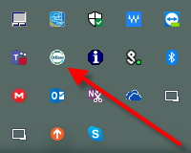
- Select “Exit OnBase”.
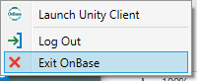
- To uninstall the Hyland Unity Client select the Windows Start Menu in the bottom left hand corner of your Windows screen.
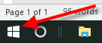
- Start typing the words “Control Panel” and a listing for the Control Panel desktop application will appear in the search hit list. Select “Control Panel” to open the “All Control Panel Items” dialog box.
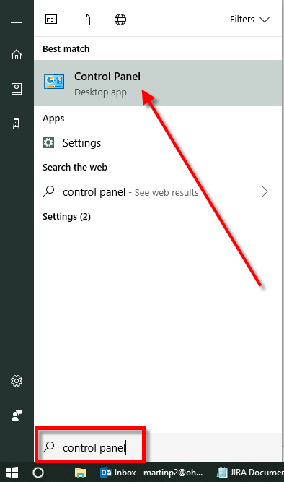
- Select the “Programs and Features” listing in the “All Control Panel Items” dialog box.
- In the “Programs and Features” dialog box select the “Hyland Unity Client [Prod] listing.
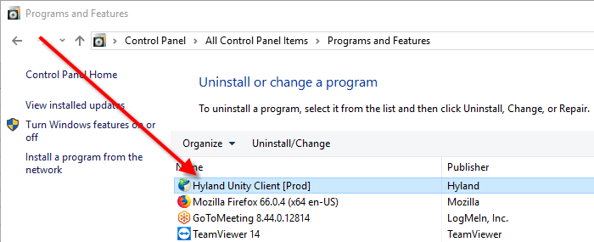
- Select the “Uninstall/Change” button.
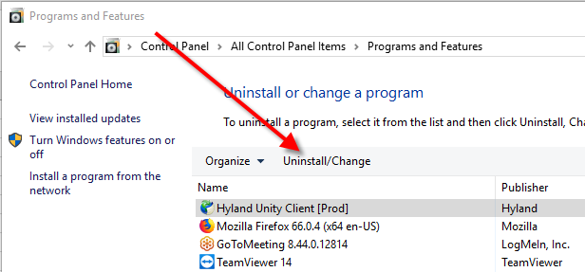
- The “Hyland Unity Client [Prod] Maintenance dialog box will appear. Select the “OK” button.
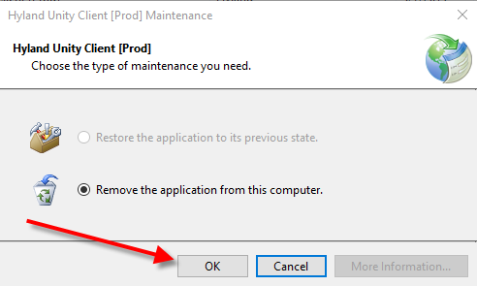
- The “Hyland Unity Client [Prod] Maintenance” dialog box will close when the uninstallation completes and the “Hyland Unity Client [Prod]” listing will no longer be visible in the “Programs and Features” dialog box.
- In order to install the Hyland Unity Client you must open Internet Explorer. Select the Windows Start Menu in the bottom left hand corner of your Windows screen.
- Start typing the words “Internet Explorer” and a listing for the Internet Explorer desktop application will appear in the search hit list. Select “Internet Explorer” to open the browser.
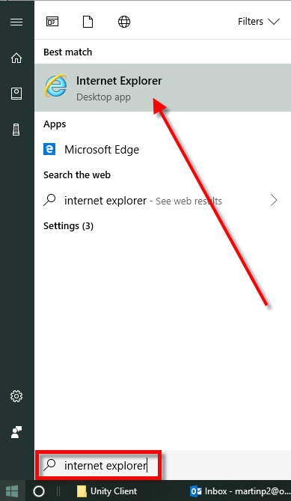
- With Internet Explorer open, navigate to the following URL: http://OIT-APP-WP042.OIT.OHIO.EDU/UnityClientPRD/UnityClientPRD.application
- The “Launching Application” dialog box should appear: 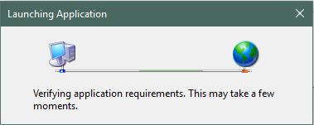
- After a short period of time, the “Application Install – Security Warning” dialog box should appear:
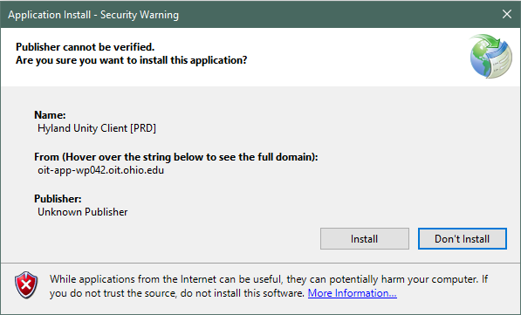
- Select the “Install” button on the “Application Install – Security Warning” dialog box.
- The “Installing Hyland Unity Client [PRD]” dialog box will appear:
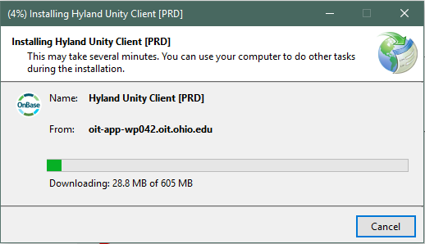
- Once the download and installation completes the “Installing Hyland Unity Client [PRD]” dialog box will disappear and after a short while, the Hyland Unity Client login screen should appear. The Build Version (highlighted by the red square below) should read 18.0.1.39 or greater):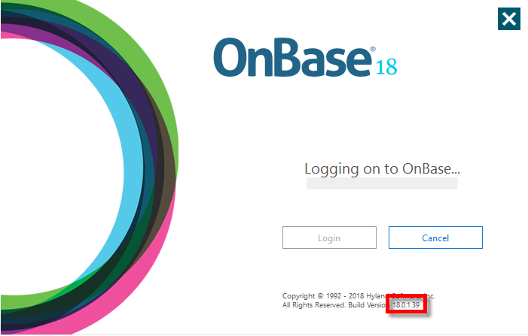
- In addition, the SAML Single Sign-On screen will appear:
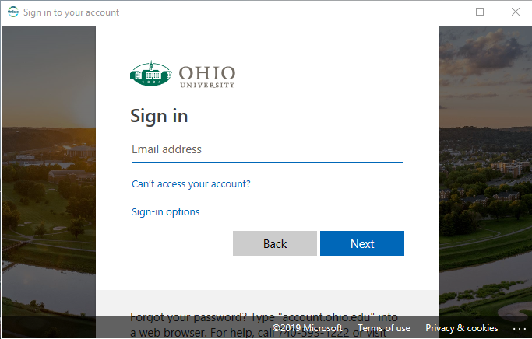
- From this screen you will provide your email address and select the “Next” button and then enter your password and select the “Sign in” button:
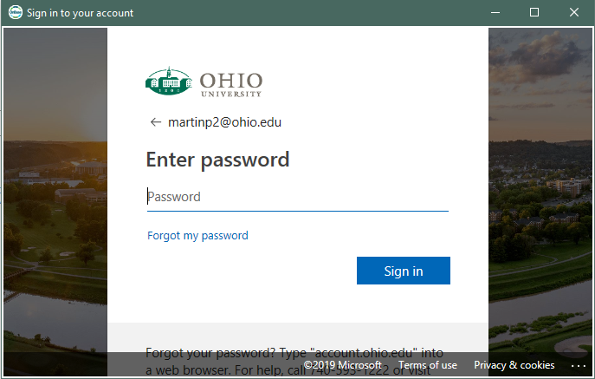
- You may be prompted by the “Duo Security –Azure Active Directory” dialog box to Choose an authentication method:
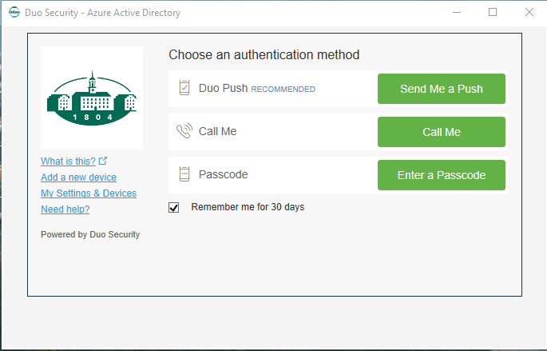
- After approving your method of choice, the Hyland Unity Client should open and you can begin using it.

