Type Title in Title Case [Initial Caps]: Do Not Capitalize Coordinating Conjunctions [and, but, for, nor, or, so, yet], Prepositions, and Articles
Read all instructions first and then perform each step in this order.
- Select File/Save As menu options to save this document (name it: Last, First MM-DD-YY) to your computer disk.
- Open Word and this file. The file opens in Protected Mode. Type title above in the gray box as instructed and tab to next field (see instructions in each gray field and in the status bar). Tab and answer all questions until you return back to the title above.
- Please scroll to and read Chapter 1 to learn how to unprotect this document. Once the document is unprotected the gray fields will continue to display on the screen, but will not print or convert to the PDF file. Fields can then also be modified if needed.
- Once the document is Unprotected, scroll to Chapter 2 to read about the automatic Table of Contents, Heading Styles, Tables, Figures, References, and Appendices.
- To remove this box, click it, point to outer gray hash marks until you see the Move icon, click to select, and press Delete key.

A thesis presented to
the faculty of
the College of Health Sciences and Professions of Ohio University

In partial fulfillment
of the requirements for the degree
Master of Science

Type First M. Last Name

© Type First M. Last Name. All Rights Reserved.

This thesis titled
Type Title in Title Case [Initial Caps]: Do Not Capitalize Coordinating Conjunctions [and, but, for, nor, or, so, yet], Prepositions, and Articles

by
TYPE FIRST M. LAST NAME

has been approved for
the of
and the College of Health Sciences and Professions by

Type Advisor’s First M. Last name only without degree acronym
Type Advisor’s professional title—use Campus Directory

Randy Leite

Dean, College of Health Sciences and Professions

Abstract
TYPE LAST NAME, FIRST M., M.S., , ,
Type Title in Title Case [Initial Caps]: Do Not Capitalize Coordinating Conjunctions [and, but, for, nor, or, so, yet], Prepositions, and Articles
Director of Thesis: Advisor’s First M. Last name only
An abstract is a concise account of the thesis or dissertation and should state the problem, describe the procedure or method used, and summarize the conclusions reached. An abstract is required for all papers. A maximum of 350 words are recommended for dissertations and a maximum of 150 for theses. Format the paragraphs with the same layout used in the document. All lines on this page are double spaced.
Text formatting in the document should be uniform in terms of type size, typeface (font) and line spacing. TAD Services will accept 11 or 12 point text and double spacing for body text in any standard font (Times New Roman, Courier, Arial, etc.)

Preface
Chapter 3 contained within the thesis document serves as a prepublication manuscript. This manuscript has been formatted to meet the guidelines set forth by
Thesis and Dissertation Services at Ohio University.

Dedication

A simple, optional note dedicating the work to a single person or small group of persons.
The dedication is centered, typically in italic and
rarely more than 3-4 lines.

Acknowledgments
The Acknowledgments page is optional. This page includes a brief, professional acknowledgment of the assistance received from individuals, advisor, faculty, and institution.

Table of Contents
Page
Abstract 3
Preface 4
Dedication 5
Acknowledgments 6
List of Tables 9
List of Figures 10
Chapter 1: How to Unprotect this Document 11
Chapter 2: How to Use this Document 13
Special Heading Information for APA Style Run-In Headings 13
What is a run-in heading? 13
Making run-in headings work with the automated table of contents. 14
Chapter 3: Formatting or Modifying Headings in a Manuscript 16
What Formats are Included in this Document? 17
Updating the Table of Contents 17
Correcting capitalization errors in Heading 1 in the table of contents. 18
Removing text from the table of contents that does not belong. 19
Tables and Figures 20
Using a table in your document. 20
Using a figure in your document. 21
References 23
Appendix: How to Format Appendix Pages 24

List of Tables
Page
Table 1: APA 6 Heading Formats by Hierarchy Level 14
Table 2: Electronic Documents Processed in Academic Year 2005-06 21

List of Figures
Page
Figure 1: Steps to unprotect a document 11
Figure 2: Formatting a title to Heading 1 level through the Style menu 13
Figure 3: How to modify a heading level 16
Figure 4: Electronic theses and dissertations filed by degree 2001-06 22

*Note to Student: Please note that the capitalization of titles on List of Tables and List of Figures are both acceptable. For example, Page 7 uses Title Case, while page 8 uses Sentence Case. We only ask that you be consistent with your choice throughout the document.

Chapter 1: How to Unprotect this Document
When you no longer need this document in protected mode, you can remove the protection..
- Click on the Review tab and click on the "Protect Document" icon on the far right.
- From the Protect Document sub-menu, check box Restrict Formatting and Editing. The Restrict Formatting and Editing task pane appears on the right side of the screen.
- In the Restrict Formatting and Editing task pane, click Stop Protection button located at the bottom left corner of the pane. In the Unprotect Document dialogue box, type the password “etd” to unprotect the document and click OK.

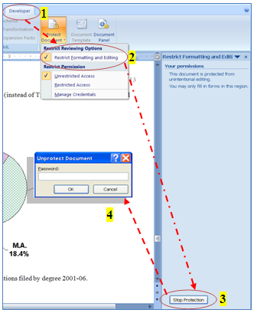
Figure 1. Steps to unprotect a document. (TAD Services suggests Figure captions be single spaced. Captions and body text may not wrap around figures. TAD Services does not recommend text boxes for use with captions.)
The document protection is now removed. You may now edit this document. If you already have a thesis or dissertation document, you may want to copy only parts of this document into your current document. If you choose to paste your text into this document, you may need to reformat your heading levels before regenerating the automated Table of Contents. To re-format headings, see Chapter 2.
A video demonstration of unprotecting the document and other common formatting tips and troubleshooting is available on the TAD web site for both PC and Mac users:
- MS Word Training for PC: http://www.ohio.edu/graduate/etd/wordpc.cfm
- MS Word Training for Mac: http://www.ohio.edu/graduate/etd/wordmac.cfm

Chapter 2: How to Use this Document
The first five heading levels in this document have been modified to meet APA 6th edition styles, however the figures show APA 5th edition examples. To format heading levels, click in each title and select the appropriate heading level (Heading 1 through 5) while on the Home tab in the Styles group. (Note: The Chapter 2 title above has been formatted as a Heading 1 level. See Figure 2.) This document provides tips for those using a PC version of Microsoft Word 2007. For other format tips, also see the Word 2007/PDF Manuals at www.ohio.edu/etd.

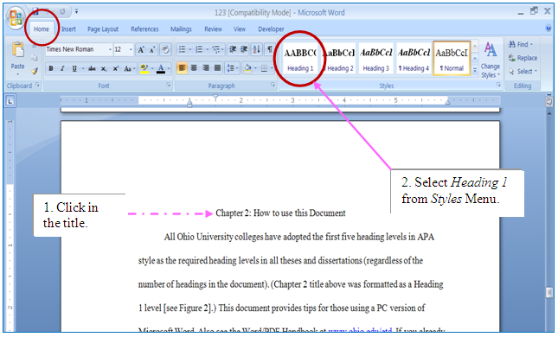
Figure 2. Formatting a title to Heading 1 level through the Style menu.

Special Heading Information for APA Style Run-In Headings

What is a run-in heading?
A run-in heading is when the first sentence of a paragraph is the section subheading. APA 6 uses this in heading levels 3, 4 and 5. This type of heading style cannot be applied to the paragraph and appear in the automated table of contents without a bit of extra work.

Table 1

APA 6 Heading Formats by Hierarchy Level
Level | Format
1 | Centered, Boldface Uppercase and Lowercase Heading
2 | Left-aligned, Boldface, Uppercase and Lowercase Heading
3 | Indented, boldface, lowercase heading with a period. Begin body text after the period.
4 | Indented, boldface, italicized lowercase heading with a period. Begin body text after the period.
5 | Indented, italicized lowercase heading with a period. Begin body text after the period.

Making run-in headings work with the automated table of contents.
First, type your heading and the text that follows it as separate paragraphs. I am using APA 6 Heading 3 style in this example:
Heading formatted using Styles palette.
Sample paragraph text lorum ipsum dolor sit amet, etc.

Format the heading using the styles palette and leave the second paragraph alone.
If you don’t have nonprinting characters displayed, press the Show/Hide button in the Paragraph group on the Home tab of the Ribbon in Word 2007 and 2010 and in the standard toolbar at the top of Word for Mac. You should see your paragraphs like this:

Heading formatted using Styles palette.¶
Sample paragraph text lorum ipsum dolor sit amet, etc. ¶

Highlight just the paragraph mark (¶) at the end of the heading and format it as Hidden (Press and hold Control+Shift then type H). You will not immediately see any change, but when you press the Show/Hide ¶ button again, your paragraphs will join. When you update your table of contents, only the section styled as Heading 3 should appear in the listing.
Heading formatted using Styles palette.

Sample paragraph text lorum ipsum dolor sit amet, etc.

Some caveats:
- If your Body Text style is justified (straight with margins on the left and right), your heading style must also be justified, or else the first line of your paragraph will not be justified. You can modify this using the information in Chapter 3.
- You must hide nonprinting characters (or at least Hidden text) before generating your TOC, or the page numbers will very likely be wrong.
A video demonstration is available: http://www.ohio.edu/graduate/etd/wordpc.cfm (PC) or http://www.ohio.edu/graduate/etd/wordmac.cfm (Mac)

Chapter 3: Formatting or Modifying Headings in a Manuscript
Click in the title above, look at the Style box (while on the Home tab in the Styles group) and note that the block “Heading 1” was selected. To format other heading levels, simply click in each title within your document and select the appropriate heading level (Heading 1 through 5) while on the Home tabin the Styles group. If you are using this Template document, you should not need to modify heading styles. If a heading modification is needed: on the Home tab in the Styles group, open the Styles task pane by clicking on the drop down menu (see Figure 3). Next, in the Styles task pane click on the desired heading, then point to the drop down arrow to the right of the headingand click; select Modify…from the menu that appears as shown in Figure 3. The following page discusses the dialog boxes that follow.

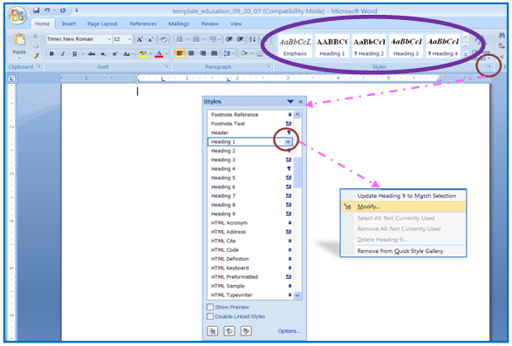
Figure 3. How to modify a heading level.
The dialog box that appears allows you to change the heading level’s font, text size, line spacing, alignment, boldface, and spacing before and after a heading (click Format Button/select Paragraph/set Before and After to zero), and more.

What Formats are Included in this Document?
Click in the title above, look at the Style box (while on the Home tab in the Styles group) and note the block “Heading 2” was selected. This document contains most required formats for an Ohio University thesis or dissertation. The settings include: global margin and header settings; page breaks; page numbers; automatic “total number of pages” field on Abstract page (see below); an automatic Table of Contents; the heading levels adopted by all Ohio University colleges for theses and dissertations; and a sample table and figures.
If you have elected to use this template to format your document, just delete any unwanted text and tables/figures from this document after reviewing all instructions and then copy and paste your chapters in the appropriate place. Remember, you may need to click in each heading within your document, format them to the appropriate heading levels as discussed above, and finish by updating the Table of Contents.

Updating the Table of Contents
While you may hand type your Table of Contents, there is an automated Table of Contents already available in this document. Simply format all heading levels as discussed, right click in any gray area of the current Table of Contents, and select Update Table, select Update entire table from the menu, and click OK. Any time a change is made to a heading or text is modified, the Table of Contents needs to be regenerated (using the steps just mentioned).
The Table of Contents in this document was generated originally by clicking on the References tab. In the Table of Contents group, the Table of Contents drop down menu was clicked and the InsertTable of Contentswas selected. (The Show Page Numbers and Right Align Page Numbers were checked and the Tab Leader “….” options were selected by default.). You should not need to generate a new Table of Contents using the steps just mentioned unless your Table of Contents code becomes corrupt. For example, the dot leaders begin to function incorrectly or the case styles of titles do not appear in the correct format. To recreate the Table of Contents, click in any gray area in the present Table of Contents and click on References tab, in Table of Contents group click on the Table of Contents drop down menu and select InsertTable of Contents. A Table of Contents dialogue box opens, and you may select from any of the available Formats (Classic, Distinctive, Fancy, Modern, Formal and Simple) to replace the current Table of Contents format. TAD Services recommends selecting the Formal style, but any of Microsoft Word’s built-in template styles that include dot leaders are acceptable formats for the Table of Contents (once a new template style is selected, there is no need to modify the text style of the template, unless requested by your Committee).

Correcting capitalization errors in Heading 1 in the table of contents.
In the Table of Contents, your Heading 1 titles will appear in the same case style (Title case or Uppercase) as you originally typed them. Before you format your title to Heading 1 level, this style is called Normal. To see this style (how the text was typed in originally), click in the title in the document, select the Normal style from the Styles box (on the Formatting Toolbar). Change the title to the desired case style (Title case or Uppercase) and then select Heading 1 again from the styles menu. To see this change in your Table of Contents, right click on the gray area in the Table of Contents list and select Update Field/Update Entire Table.

Removing text from the table of contents that does not belong.
Click in the title above, look at the Style box (while on the Home tab in the Styles group) and note the block “Heading 3” was selected. Sometimes when you update your Table of Contents, extra text appears within the Table of Contents that should not be there. This occurs with misplaced paragraph codes (obtained by pressing the Enter key) or heading codes in the document text. Locate and select the text in the document that should not be in the Table of Contents. Next, select the Normal block from the Style box (while on the Home tab in the Styles group) and then regenerate the Table of Contents (right click on any gray area in the Table of Contents and select Update Table). If this does not correct the problem, click your Show/Hide icon located on the Home tab in the Paragraph group. Move to the area of the document where it is not coded correctly and use your arrow keys to step through the document. While on the Home tab in the Styles group, watch for the heading box to be highlighted. Once you see a heading appear that should not be there, scroll to see where the code begins and ends. Select the area that is not formatted correctly and select Normal from the Style menu to reformat this text.
To correct a heading that appears twice in a Table of Contents, simply add a paragraph code in the document before the heading as follows: move to the heading in the document and press the Enter key once before the heading at the top of the page. You can also try to move to the bottom of the page before and pressing the Enter key at the end of the paragraph to correct this error. (Microsoft Word formats headings between paragraph marks [created when you press the Enter key], so if a title appears twice in the Table of Contents, Word is interpreting the title to expand over two pages due to the placement of the paragraph codes).

Tables and Figures

Using a table in your document.
Click in the title above, look at the Style box and note the block “Heading 3” was selected (if needed, please see figure and instructions at the beginning of Chapter 3).The Table 1 sample below is formatted in APA style. The table text is double spaced. The Table # stands alone on a line above the title. The title is italicized and is in Title Case (Initial Caps). The Enter key should be pressed two times while in double space mode before and after the table to separate the table from other text in the document. Tables and figures are always mentioned in text before they appear in a document. APA style requires that all tables and figures be left aligned in a document.

Table 2

Electronic Documents Processed in Academic Year 2005-06

Quarter No. %

Fall ’05 45 21

Winter ’06 44 21

Spring ’06 60 28

Summer ’06 62 29

Total ETDs 211 100
Note: Tables should not have body text wrapped around them. You may hand type tables or use the Table formatting (grid) tools to set up your tables. Using shading on cells should be carefully considered as anything darker than 15% gray can make text hard to read.

Using a figure in your document.
Figures are formatted similarly to tables within a document. Press the Enter key two times in double space mode (leaving one blank double spaced line) before and after the figure. Figures are typically mentioned in the text before they appear in a document. In most APA styles, the caption is placed below the figure in sentence case (instead of Title Case as seen on Tables) and ends with a period (see Figure 3 caption). Note in APA the word “Figure” and the number are both italicized.

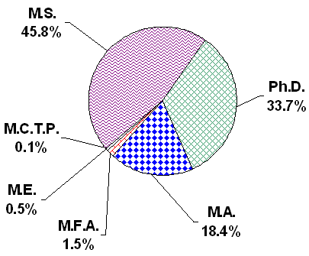
Figure 4. Electronic theses and dissertations filed by degree 2001-06.

References
Use your departmental style requirement to format your references. Thesis and Dissertation Services spot-checks references for completeness and consistency in format.
If hanging indents are required by your style handbook (APA, MLA, etc.), position the cursor in the reference paragraph (or select multiple paragraphs) and on the Ruler Bar (select View/Ruler if needed on the right hand side of the screen), drag the Hanging Indent icon found on the left side of the Ruler Bar to ½ inch (to indent the second line of text ½ inch from the left margin). See sample hanging indent reference below.

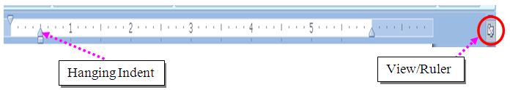

Sample reference with hanging indent:
Denscombe, M. Ground Rules for Good Research. Philadelphia, PA: Open University Press, 2003.

Appendix: How to Format Appendix Pages
The appendix contains pages that do not fit well within the body of your document or that stop the flow of your document. Appendices typically contain data tables, letters, consent forms, programming codes, etc. Any style font and text size can be used in an appendix. The only rules you need to follow are 1) the word “Appendix” and a title should appear at the top of each appendix, and 2) the margins remain the same as in the rest of the document. Use the following labels at the top of the first page of each appendix for multiple appendices: Appendix A: Title, Appendix B: Title, etc. Label each in the order in which they are mentioned in the main text. Each appendix should appear in the Table of Contents. TAD Services recommends that the title of each appendix also appear in the Table of Contents.

