Office of Student Financial Aid and Scholarships

Student Employment Handbook
2023-2024

Table of Contents

- Introduction 3
- Purpose of Employment on Campus 3
- Types of Employment 3
- Student Hourly Employment 3
- PACE 4
- FWS 4
- Student Employee Responsibility 6
- Disciplinary Procedures 7
- Hiring Student Employees 7
- Student Employee Evaluation 7
- Requesting a FWS Position 7
- Work-Study Job Description Examples 8
- Contact Information 9

Introduction
This Student Employment Handbook was created to answer many of the questions student employees and supervisors may have about employment opportunities and procedures at Ohio University. Information contained in this document is currently in effect, with potential for revision in policy and procedures as needed.

Student employees at Ohio University are a very important part of the workforce. Many students will utilize their supervisors as a reference for prospective employers in the future. For this reason, it is advantageous for the student to be a dependable employee.

Student Employees play a significant role in the day-to-day functioning of Ohio University and perform a wide range of duties. These duties vary from that of office assistance to more specialized positions according to departmental needs.

If you have read through the handbook and still have questions, please contact the Office of Student Financial Aid and Scholarships at (740) 593-4141.

Purpose of Employment on Campus
- To provide a means and opportunity for students to supplement their income and assist with educational expenses
- To provide students with work experience

Departments are responsible for determining the duties and responsibilities to be performed. These will be established before a vacancy is advertised and discussed with the student employee upon selection of a position.

Types of Employment
The various types of student employment at Ohio University include Student Hourly Employment, Federal Work-Study (FWS), and the Program to Aid Career Exploration (PACE).

Student Hourly Employment
Students not eligible for Federal Work-Study, but still interested in working on campus should explore the opportunities of Student Hourly Employment. Hourly Employment jobs are positions available to all students enrolled at Ohio University. Employers will work to arrange work hours based on need and the academic schedules of students. Job Postings are online at: https://ohiouniversityjobs.com. Search by position type “Student.”

Human Resources has the responsibility to ensure that hourly employees and employers are in compliance with state statutes, federal provisions and Ohio University policy.

Program to Aid Career Exploration (PACE)
PACE is an on-campus, internship-like work program sponsored by and unique to Ohio University. Approximately 300 students are employed each year in the PACE program. PACE gives students the opportunity to explore their career interests while attending school, and enhances their professional skills while earning a paycheck.
- Must have completed 15 semester hours of coursework at Ohio University
- Maintain at least a 2.3 Cumulative GPA
- Demonstrate a need for earning
- Be enrolled during the semesters of employment
- Undergraduate students only
- Positions available summer, fall and spring semesters

Students in PACE can work up to 10 hours per week and are paid at the current Ohio minimum wage unless otherwise indicated. Students may NOT hold a PACE position and Work-Study position at the same time.

To learn more about PACE and to complete a quick application, visit
https://www.ohio.edu/financial-aid/types/employment/pace

Federal Work-Study
Federal Work-Study (FWS) is a Campus-Based Aid Program that provides University and community service work positions to qualifying Ohio University students. Students must meet the financial aid requirement to qualify for a position. FWS funds are awarded based on student eligibility and availability of funds.

Eligibility for FWS
- Complete the Free Application for Federal Student Aid (FAFSA) for the current academic year at studentaid.gov.
- Answer “yes” that you are interested in FWS when completing your FAFSA.
- The Office of Student Financial Aid and Scholarships will determine financial need and eligibility for the FWS program.
- Eligibility will be shown on your Financial Aid Offer.
- You must complete a new FAFSA by January 15 of each year and continue to demonstrate financial need for continued consideration.

If you are interested in Federal Work-Study and not awarded, please email financial.aid.employment@ohio.edu and request to be put on the waitlist. If additional funding becomes available, eligible students will receive an email around October.

Selecting a position
Students with FWS search for available positions at https://webapps.ohio.edu/faos.
- Select the current aid year.
- Under the Work-Study tab, select “search jobs.”
- Use the filter options to narrow your search, or leave all filters blank and select “search for jobs” to view all available positions.
- When you find a position in which you are interested, select the “job number” to view the contact information and complete job description.
- To choose the job select “Select This Job.” If you want to continue to look at the other options, click on “Return to previous page.”
- Once you selected the position, the job contact will receive an email that you have selected the position. Please reach out to the contact to complete all necessary hiring forms and set up your work schedule.
- To be removed from a position you selected, email the job contact and copy financial.aid.employment@ohio.edu.

Awarded Hours
Student employees, including work-study students, shall work no more than 25 hours per week (combined 25 hours total if also employed hourly) during times of enrollment. During times of non-enrollment, students may work up to a combined total of 36 hours per week.
- Awards are given to allow students to work 10 hours per week for each semester, at the state minimum wage, unless otherwise indicated.
- Typical awards for a semester $1,650.
- Students cannot work more than their awarded amount. Work-Study earnings in excess of the specified award amount will be transferred to the employing department’s account number.
- If a student has not utilized the entire award, they may be eligible to work hours beyond the semester. Supervisors can request additional hours for a student by emailing financial.aid.employment@ohio.edu.
- By visiting the website: https://webapps.ohio.edu/faos students can select “View My Job” under the Work-Study tab. This will showcase the entire award amount, the amount paid, and the remaining balance.

Payment
- The money you earn through employment is paid to you in the form of a bi-weekly paycheck, calculated by multiplying the number of hours you worked during the previous two weeks by your current rate of pay. This money does not credit your student account balance.
- Students are encouraged to utilize direct deposit for earnings. This will allow the student’s net pay to be deposited into the bank account of their choice. For more information and guidelines to enroll in direct deposit, visit https://www.ohio.edu/hr/compensation-pay/hr/payroll-services/direct-deposit

Continuing Eligibility
- Students cannot hold both a PACE and FWS position at the same time.
- During a semester in which the student is enrolled, the student cannot work more than 25 hours per week. During periods of breaks, students cannot work more than 36 hours per week.
- Students are not required to be enrolled during the summer semester to be employed in a Federal Work-Study position. Students must be awarded Work-Study and enrolled in spring semester to work the first part of the summer semester. Students must be awarded Work-Study and enrolled in fall semester to work the second part of the summer semester. To determine a student’s summer employment eligibility, email financial.aid.employment@ohio.edu.
- Federal Work-Study jobs should not replace a university employee. Due to the volume of job requests and the limited number of Work-Study awarded students, there is no guarantee that all positions will be filled.

Student Employee Responsibility

Conduct
Student employees, as representatives of the University, will be expected to conduct themselves in a professional and courteous manner and to perform their jobs to the best of their abilities. Responsible conduct includes reporting to work on time and in proper dress, filling out only their own time sheet and notifying the supervisor of any planned absences at least 24 hours in advance. Students are expected to abide by the Student Code of Conduct available on the Community Standards website at: https://www.ohio.edu/communitystandards/

Inappropriate Behaviors
Behaviors that take away from workplace productivity will not be tolerated, and may warrant progressive disciplinary procedures. Examples include but are not limited to: unapproved cell phone usage during work time or in a work space, doing homework or other non-work related tasks during work hours without permission, utilizing office computers/equipment for personal use rather than work, and any other behavior deemed inappropriate in the selected departmental area.

Drug or Alcohol Abuse
Student employees are governed by the same drug and alcohol policy that pertains to full-time University employees. Ohio University is unequivocally opposed to the misuse of lawful drugs and the possession and use of unlawful drugs. Pursuant to the requirements of the Drug-Free School and Community Act Amendments of 1989 (PL 101-226), Ohio University has adopted and implemented drug and alcohol policies and programs designed to prevent drug and alcohol problems within the university setting. The policies and programs are designed to identify problems at the earliest stage, motivate the affected individuals to seek help, and to direct the individual toward the best assistance available.

Use of University Property
Student employees will be expected to respect University property and to refrain from any unauthorized use thereof. In general, student employees are not permitted to use University equipment or supplies for personal business. The supervisor should inform the student employee about departmental policy concerning this matter.

Confidentiality
Student employees are expected to maintain the confidentiality of any information or records (written or electronic files) to which they have access. Any breach of confidentiality is considered a serious offense and may lead to disciplinary action and/or discharge.

*The complete Student Employment policy and procedures can be viewed at: https://www.ohio.edu/policy/20-110.

Disciplinary Procedures
Students can be terminated from their positions as a progressive act of discipline. A student may also be discharged from a position immediately for any serious violation of departmental or University policy. Levels of Action include:
- Verbal coaching/counseling with a written record of the discussion
- Written notice of unsatisfactory behavior/performance
- Suspension or termination in writing with a copy sent to the Office of Student Financial Aid and Scholarships

Hiring Student Employees
Visit https://www.ohio.edu/hr/hire-manage/student-employment-procedures for instructions for hiring student employees.

Add the student to Workforce. Instructions are found at https://www.ohio.edu/sites/default/files/sites/hr/files/WF_Hiring_a_Student_ORG_2019.pdf.

Student Evaluations
Student employees are subject to performance evaluations. The frequency of these evaluations should be established by the supervisor at the time of hiring and should be discussed with the student. Every student employee will receive an end of term evaluation every semester of employment. Additional department evaluations may also be included as part of the student evaluation process.

Requesting a Federal Work-Study Position
To request a FWS position for your department, visit the website https://webapps.ohio.edu/faos.
- Select the aid year you want to work with and click on “Submit”
- Under the “Work-Study” Tab, select “Create New Job”
- Complete the job request with description of duties and contact information and then “Create New Job”
- Financial Aid will receive an email to review the posting
- Once approved, the position will go live for students to view and select a position
- The job contact and supervisor you listed in the job order will receive an email when a student selects the position
- You will also be able to view earnings and remaining award amounts for each student attached to your position by selecting “My Funded Jobs”

*If updates to positions are necessary, please contact: financial.aid.employment@ohio.edu

Work-Study Job Description Examples

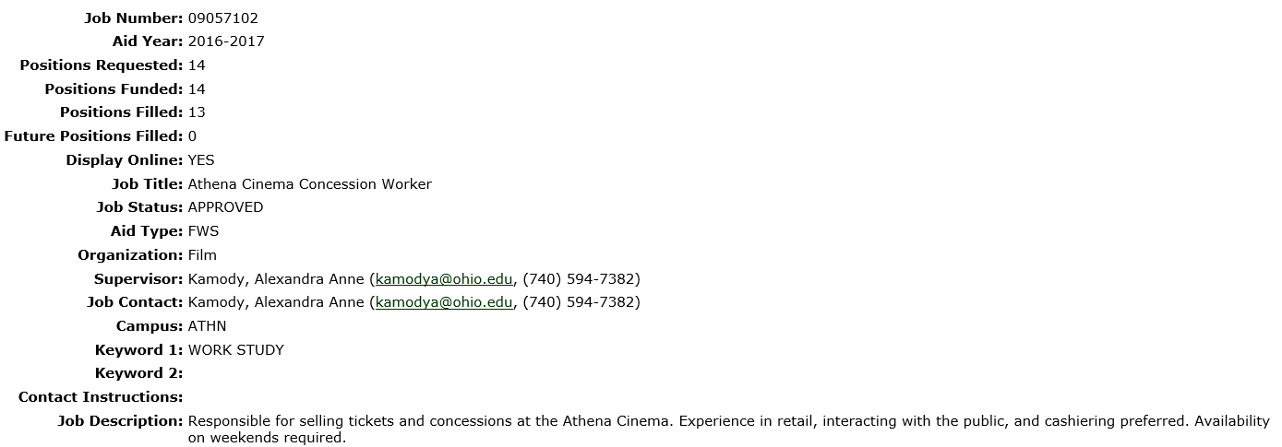

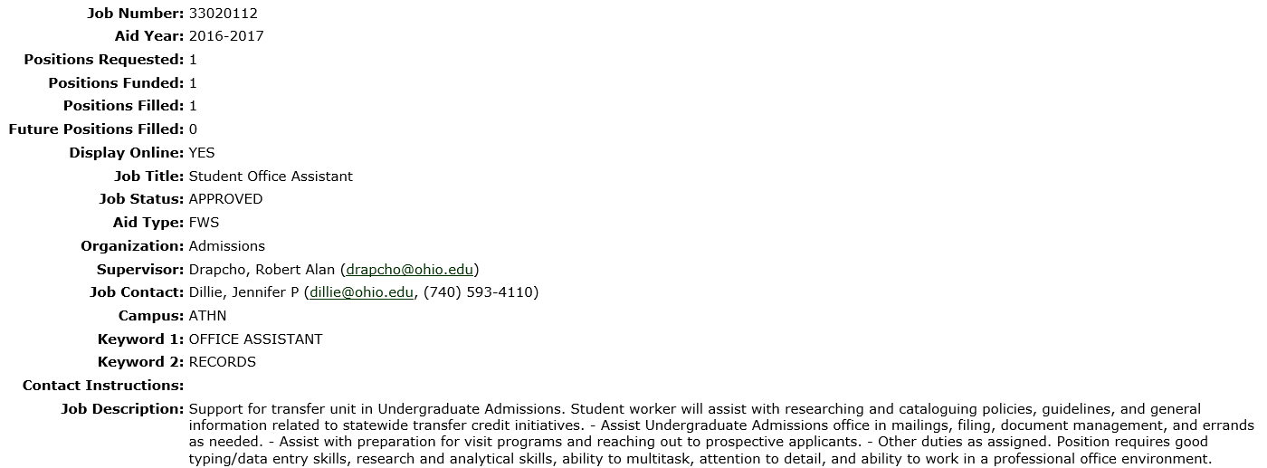

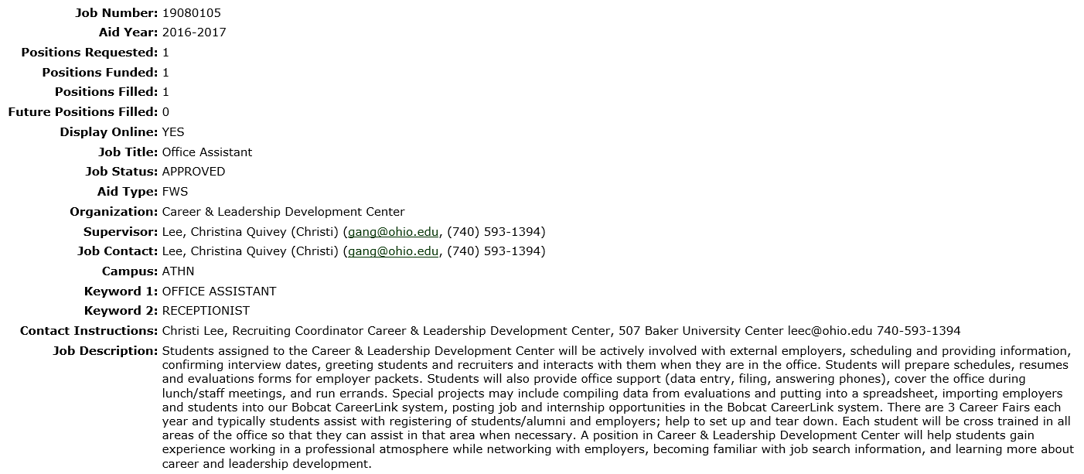

Contact Information
Any additional questions or concerns regarding the Federal Work-Study Program can be directed to the Student Office of Financial Aid and Scholarships at (740) 593-4141 (8:00am-5:00pm, Monday-Friday) or financial.aid.employment@ohio.edu.

