Fly America Act and Open Skies Agreements Guidance

A person traveling on funds provided by the federal government must use a U.S. flag carrier (an airline owned by an American company), regardless of cost or convenience.

When scheduling international travel that is federally funded, you must ensure that all flights, where possible, are scheduled on U.S. flag carriers or on foreign air carriers that code share with a U.S. flag carrier. Code sharing: when two or more airlines “code” the same flight as if it was their own.

A U.S. airline may sell a seat on the plane of a foreign air carrier; this seat is considered the same as one on a plane operated by a U.S. flag carrier. Compliance with the Fly America Act is satisfied when the U.S. flag air carrier's designator code is present in the area next to the flight numbers on the airline ticket, boarding pass, or on the documentation for an electronic ticket (passenger receipt) – see example below, where Delta Airlines (DL) has a code share agreement with Air France (AF) to Paris, France.
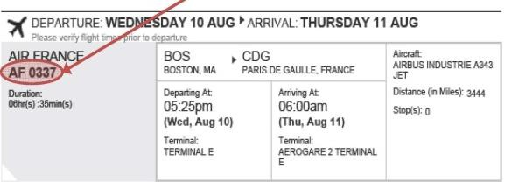

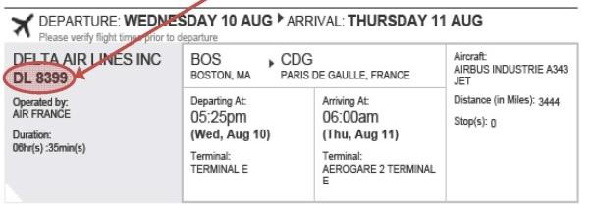

COMPLIANT NOT COMPLIANT
US Flag Air Carriers - U.S. flag carriers and their codes are identified on the link below.

In order for a flight to be in compliance with the Fly America Act, the code of a U.S. flag air carrier must be noted as part of the flight number on the airline ticket, flight coupon (boarding pass*), or passenger receipt. Each airline has a two letter alpha code. From this list, you will be able to compare airline codes on the ticket with those on the list and thereby be able to ascertain whether or not the flight is on a U.S. Flag air carrier.

For Domestic travel and travel to Canada the following is a link to the mainline airlines
along with their code:

https://en.wikipedia.org/wiki/List_of_airlines_of_the_United_States#Mainline

Note: *Air Canada is NOT a U.S. flag air carrier*.
Exceptions to the Fly America Act
To document the exceptions, you must complete the Fly America Act Waiver Checklist on page 3.

The most widely used exception to the Fly America Act is the Open Skies Agreement. On October 6, 2010, the United States and European Union (EU) Open Skies Air Transport Agreement was published by the U.S. General Services Administration. This multilateral agreement is in place so that qualifying travelers, whose travel is supported by federal funds, may travel on EU airlines as well as U.S. Flag Air Carriers. There are also Open Skies agreement with Australia, Switzerland, and Japan. Please see the flow chart on page 4.

There are other exceptions to the Fly America Act which may be appropriate as well. A list of exception criteria may be found in the Federal Travel Regulation Guidelines – FTR sections 301-10.135-138. Please note that lower cost and personal convenience are not acceptable criteria for justifying the non- availability of a U.S. flag air carrier.

Please note: Travelers using Department of Defense (DOD), Air Force, Army or Navy are not permitted to take advantage of Open Skies Agreements. These travelers must use an American carrier, unless they qualify for an exemption as noted in FTR 301-10.135, sections (a), (d), (e), (f), and (g).

FLY AMERICA ACT WAIVER CHECKLIST
Please provide documentation for all checked items to the
Grants Accounting Office

(To assist in determining qualification for a waiver of the restrictions of the Fly America Act under 41 CFR Part 301-10, check the applicable statement(s) below.)
Use of foreign air carrier is a matter of necessity because of. (Must check one below)
U.S. flag air carrier cannot provide the air transportation needed, for example:
Use of foreign air carrier is necessary for medical reasons.
Use of foreign air carrier is required to avoid unreasonable risk to traveler’s safety. (See 41 CFR 301-10.138(b)(2) for supporting evidence needed.)
Seat on U.S. air carrier in authorized class of service is unavailable; seat on foreign air carrier in authorized class of service is available.
Other (Provide detailed justification.)
Code sharing agreement exists. This two letter alpha code of a U.S. flag air carrier is clearly noted as part of the flight number on the airline ticket, flight coupon (boarding pass), or passenger receipt.
Bilateral or multilateral air transportation agreement. U.S. is a party and Dept. of Transportation determines agreement meets requirements of Fly America Act.
No U.S. flag air carrier provides service on a particular leg of your route (Travelers can only use foreign air carrier to or from the nearest interchange point to connect with a U.S. carrier).
A U.S. flag air carrier involuntarily reroutes traveler on a foreign air carrier.
Service on a foreign air carrier is three hours or less, and use of U.S. flag air carrier doubles en route travel time.
Air travel is between the U.S. and another country and use of a U.S. carrier on a nonstop flight extends travel time by 24 hours or more.
Any other air travel (You must check at least one of the following statements to qualify for a waiver of the Fly America Act restrictions in this section)
Use of a U.S. carrier increases the number of aircraft changes outside the U.S. by two or more.
Use of a U.S. carrier extends travel time by six hours or more.
Use of a U.S. carrier requires a connecting time of four hours or more at an overseas interchange point.

Remember, you must use a U.S. flag air carrier on every portion of the route where it provides service unless you qualify for a waiver. If a travel expense is disallowed, the department accepts liability of charges with departmental funds or identifies a suitable non-federal funding source to cover the disallowance.

Name and Dept. of Traveler

Signature of Traveler Date
Information for travelers who have questions about air travel
from the US to a foreign country on Federal funds
Are you traveling to a foreign
country funded by the DOD or
Air Force
,
Army
,
or Navy
?
You are
NOT

permitted to take advantage of
the OPEN SKIES Agreements
.
You
MUST

Fly on a US flag airline unless you
qualify for an exemption as noted in the FLY
AMERICA ACT
.
YES
Are you traveling between
:

US and European Union
(
EU
)
?
NO
You MAY fly on a US flag airline or EU airline
.
List of EU Countries.
.
Are you traveling between the
US and other foreign
countries
?
Are you traveling between any
two points outside of the US
?
Are you traveling between
:
A

)
US and Australia
?
B
)

US and Switzerland
?
C

)
US and Japan
?
Does the government have a published airfare
rate for your travel route
?
City Pair Program
YES
YES
YES
NO
You
MUST

fly a
US Flag airline
.
You
MAY

fly a US flag
airline or
A

)
Australian airline
B

)
Swiss or EU airline
C

)
Japan airline
You
MUST

fly a US Flag airline unless you qualify for
an exemption as noted in the FLY AMERICA ACT
.
You
MAY

fly a US flag
,
Australian
,
Swiss
,
EU
,
Japan
,
Norwegian
,
Icelandic airline
.
Use of a foreign carrier
not listed above is
NOT ALLOWED and MAY NOT

be
reimbursable through a federal award
.
YES
YES
NO
NO
NO

