Ohio University

University Curriculum Council
March 7, 2023

Microsoft Teams

Present: Amrit Bahadur Thapa, Kelly Broughton, Kathleen Brown Pugh, Sherleena Buchman, Shea Burden, James Casebolt, Mario Cinquepalmi, Debra Cox, Catherine Cutcher, Bob DeLong, Susan Dowell, Todd Eisworth, Kristine Ensign, Ann Frymier, Ellen Gordon, Karla Hackenmiller, Katie Hartman, Sara Hartman, Josh Hill, Jess Holliday, Molly Johnson, Jason Jolley, David Juedes, Pramod Kanwar, Jennie Klein, Zaki Kuruppalil, Macario Llamas, Sally (Marinellie) Marion-Fetty, Brenda Miller, Greg Newton, Hannah Nissen, Connie Patterson, Beth Quitslund, Nukhet Sandal, Bärbel Such, Loralyn Taylor, Allison White

Absent: Luke Beccasio, Michele Clouse, Virginia Dickens, Allyson Hallman-Thrasher, Emily McCarty, Beth Novak, Talinn Phillips, Jennifer Smith, Alexis Thomas, Chris Vinyard, Yuqiu You, William Zanotelli

Excused: Mike Hess, Courtney Silver-Peavey, Jatin Srivastava, Jim Strode, Lijing Yang

Guests: Surajya Padiyath Abdulla, Rebecca Bryant, Dylan Demonte, Mary Kate Hurley, Jenny Klein

Call to Order: Todd Eisworth called the meeting to order at 3:00 p.m.

Approval of Minutes: The February 7, 2023 meeting minutes were approved.

Vice Provost of Faculty Development: Katie Hartman

Beth Quitlund:
- Helps we’ve prepared for new program proposals when they go to the state level. There is also a document that lays out all the steps that need to be taken after UCC approval for new programs. New degree program has to go through HLC ODHE and BOT. Certificate programs only go to BOT for notification. They are outlining for timings. Hope to have it ready in April.
- The process for state approval for undergraduate programs and graduate programs is different and goes through different people and uses different forms but the undergraduate side has made fairly significant revisions to their process and to their forms. We have prepared a template to assist for submitting new undergraduate degree programs for ODHE approval post-UCC.
- ODHE reserves the right to change its forms at any time so you can’t pull a form off the website and assume you have the right form.
- Some details about curriculum and faculty, some detailed about the institution. Current undergraduate form. Created boilerplate language in blue you can plug in and that’s the answer. Red notes instructions or resources to answer those questions. Posted Programs Committee page: ODHE New Undergraduate Program Template.
- Carla: Does this form take the place of the UCC form?
- Beth: No. The next stage is to rethink some of the program forms to lead you more smoothly into what you will need for the ODHE.
- Loralyn: Now complicated because the state is now differing to the HLC if HLC determines that we need to go through a substantive change form for HLC the state will accept the HLC stubstantive change form in place of its own form. The problem the changes in HLC none of our new programs will need to go through a substantive change form.
- Katie: Even our own program forms are going to ask information that ODHE doesn’t want but that we need. How do you want to describe that in the catalog.

Program Committee Report: Connie Patterson, Chair

PROGRAM CHANGES
Second Reading
- Russ College of Engineering and Technology (Approved)
Program Code: BS7273
Program Name: Technical Operations Management
Department/School: Engineering Technology and Management
Contact: Yuqiu You (youy@ohio.edu)
Desired Start Date: Fall 23

The changes in this proposal are needed to convert this program to better adapt to the current market need for project managers. No impact on any other departments and staffing requirements.
The following changes are proposed:
a. Program Name Change from Technical Operations Management (BSTOM) to BS in Project Management (BSPM)
b. Course Option Change: five courses have course name/credit hour changes:
ETM 3001 Course Name
ETM 3625 Course Name
ETM 3820 Course Name
ETM 4005 Course Name
ETM 4600 Course Name, Credit Hour
c. New Course Added: ETM 4100 Data Visualization, ETM 4500 Advanced Project Management
d. Program Required Courses Removed: CHEM1210 or 1500, PHYS 2001 or 2051
e. Removed Pre-Major (PM) Requirement
f. Change admission requirement from "Technical associate degree" to "Any associate degree" is also requested

There is no change in credit hours.

First Reading
- Center for International Studies (Approved)
Program Code: CTWARU
Program Name: War and Peace Studies Certificate
Department/School: Center for International Studies
Contact: Cat Cutcher (cutcher@ohio.edu)
Desired Start Date: Fall 23

We are deleting core and elective courses that have not been offered frequently in the last eight years. We are adding new core and elective courses. We are changing the requirements to 6 hours of core courses from two disciplines, and 12 hours of elective courses from three disciplines. This certificate program has not changed significantly since 2015 and these changes will not impact on program learning outcomes or credit hour requirement.

The total requirements will include
CORE: Complete 6 hours from two disciplines of the following courses:
Add to Core Courses: HIST 2200, MGT 4640
Delete from Core Courses: CAS 1425, PHIL 4460, SOC 4680

ELECTIVES: Complete 12 hours from three disciplines from the following courses:
Add electives: CARS 2160, HIST 3162, HIST 3164, HIST 3291, HIST 4770, INST 3700, POLS 4225, POLS 4415, POLS 4465, POLS 4640, POLS 4738
Delete electives: ANTH 4620, HIST 3320, HIST 3371, HIST 3420, HIST 3640, HIST 3868

- Center for International Studies (Held for 2nd Reading)
Program Code: CTLAMS
Program Name: Latin American Studies Certificate
Department/School: Center for International Studies
Contact: Cat Cutcher (cutcher@ohio.edu)
Desired Start Date: Fall 23

We are reducing the total hours requirement from 26 to 20 to align with new certificate guidelines. We are reducing the language requirement from two years to one year (two semesters) of Latin American language courses, to make the program more accessible to students from all colleges and majors. We are deleting electives that have not been offered in the last eight years. We are adding new electives. We are also deleting all language courses beyond the required elementary level and moving intermediate and advanced language courses to electives. This certificate program has not changed significantly since 2015 and these changes will not impact program learning outcomes.

The total requirements will include:
3 hours core course- INST 1600 Interdisciplinary Survey of Latin American
9 hours of electives from 2 departments. Must take at least one course from Group A. Group B is optional.
8 hours of elementary language courses.

Delete electives: AH 3310, ANTH 3660, ANTH 3830, ILML 2901, POLS 4360, PORT 3110, PORT 3120, PORT 4900
Add electives: ILML 2907, SPAN 2110, SPAN 2120, SPAN 3110, SPAN 3120
Delete language courses: PORT 3180, PORT 3190, SPAN 2110, SPAN 2120

- Center for International Studies (Held for 2nd Reading)
Program Code: CTAFRI
Program Name: African Studies Certificate
Department/School: Center for International Studies
Contact: Cat Cutcher (cutcher@ohio.edu)
Desired Start Date: Fall 23

We are reducing the total hours required from 26 to 20 to align with new certificate guidelines. We are reducing the language requirement from two years to one year (two semesters) of African language courses, to make the program more accessible to students from all colleges and majors. We are adding AAS 1060 as a core course. We are deleting electives that have not been offered in the last eight years. We are adding a French elective related to Africa and the African diaspora. We are adding to electives two INST special topics courses focused on African languages and literatures. We are also adding intermediate and advanced African language courses to electives. We are deleting French and Portuguese to prioritize indigenous African languages for students to learn. We are also deleting all language courses beyond the required elementary level. This certificate program has not changed significantly since 2015 and these changes will not impact on program learning outcomes.

The total requirements will include:
6 hours core courses: AAS 1060 OR INST 1100
6 hours electives from two departments. Must take at least one course from Group A. Group B is optional.
8 hours of elementary language courses (or equivalent).

Add core: AAS 1060
Delete electives: AH 4331, CARS 4710, ECON 4550, HIST 3360, HIST 3420, and HIST 4906.
Add electives: AKAN 2110, AKAN 2120, ARAB 2110, ARAB 2120, ARAB 3990, FR 4511, INST 3904, INST 3905, KIKU 2110, KIKU 2120, SOMA 2110, SOMA 2120, SUDN 2110, SUDN 2120, SWAH 2110, SWAH 2120, SWAH 3990, WOL 2110, WOL 2120, ZULU 2110, ZULU 2120.
Delete French and Portuguese from list of African languages.
Delete language courses: ARAB 2110, ARAB 2120, ARAB 3990, FR 1110, FR 1120, FR 2110, FR 2120, FR 3110, FR 3120, INST 3904, INST 3905, KIKU 2110, KIKU 2120, PORT 3110, PORT 3120, PORT 3180, PORT 3190, PORT 4110, PORT 4120,

- Center for International Studies (Held for 2nd Reading)
Program Code: CTASIA
Program Name: Asian Studies Certificate
Department/School: Center for International Studies
Contact: Cat Cutcher (cutcher@ohio.edu)
Desired Start Date: Fall 23

We are reducing the total hours required from 26 to 20 to align with new certificate guidelines. We are reducing the language requirement from two years to one year (two semesters) of Asian language courses, to make the program more accessible to students from all colleges and majors. We are deleting electives that have not been offered in the last eight years. We are adding new electives and adding Arabic to the list of Asian Languages. We are also deleting all language courses beyond the required elementary level and moving intermediate and advanced language courses to electives. This certificate program has not changed significantly since 2015 and these changes will not impact program learning outcomes.
The total requirements will include:
3 hours core course- HIST 2460
9 hours of electives from 2 departments. Must take at least one course from Group A. Group B is optional.
8 hours of elementary language courses.

Delete electives: AH 3400, AH 3420, AH 4171, ANTH 3800, CARS 4350, ECON 4730, ENG 3310, ENG 3320, HIST 3450, HIST 4904, HIST 4907, ILL 3400, ILL 3450, JPN 3390, POLS 4450.
Add electives: CHIN 2110, CHIN 2120, CHIN 3110, CHIN 3120, COMM 3800, HIND 2110, HIND 2120, HIST 3465, HIST 3866, HIST 4115, INDO 2110, INDO 2120, INDO 3110, INDO 3120, INST 3909, INST 3911, JPC 2900, JPN 2110, JPN 2120, JPN 3110, JPN 3120, KHMR 2110, KHMR 2120, MALA 2110, MALA 2120, MALA 3110, MALA 3120, MDIA 4160, THAI 2110, THAI 2120, THAI 3110, THAI 3120, VIET 2110, VIET 2120.
Delete language courses: CHIN 2110, CHIN 2120, CHIN 3110, CHIN 3120, HIND 2110, HIND 2120, INDO 2110, INDO 2120, INDO 3110, INDO 3120, INST 3909, INST 3911, JPN 2110, JPN 2120, JPN 3110, JPN 3120, KHMR 2110, KHMR 2120, MALA 2110, MALA 2120, MALA 3110, MALA 3120, THAI 2110, THAI 2120, THAI 3110, THAI 3120, VIET 2110, VIET 2120.
Add language courses: ARAB 1110, ARAB 1120, MALA 1110, MALA 1120.

- Center for International Studies (Held for 2nd Reading)
Program Code: CTSEAS
Program Name: Southeast Asian Studies Certificate
Department/School: Center for International Studies
Contact: Cat Cutcher (cutcher@ohio.edu)
Desired Start Date: Fall 23

We are reducing the total hours required from 26 to 20 to align with new certificate guidelines. We are reducing the language requirement from two years to one year (two semesters) of Southeast Asian language courses, to make the program more accessible to students from all colleges and majors. We are deleting electives that have not been offered in the last eight years. We are adding new electives. We are also deleting all language courses beyond the required elementary level and moving intermediate and advanced language courses to electives. This certificate program has not changed significantly since 2015 and these changes will not impact program learning outcomes.

The total requirements will include:
3 hours core course- INST 1114 OR HIST 2460
9 hours of electives from 2 departments. Must take at least one course from Group A. Group B is optional.
8 hours of elementary language courses.

Add and delete electives. Create two sets of electives in Group A (Arts, Humanities, Natural Sciences, Social Sciences) and Group B (Intermediate and Advanced Language courses). Require students to take at least one course from Group A. Delete language courses beyond elementary level. Add Malaysian to language course offerings.

Delete electives: CLWR (CARS) 4350, ECON 4730, HIST 3450, HIST 4904, ILL 3400, ILL 3450.
Add electives: INDO 2110, INDO 2120, INDO 2900, INDO 3110, INDO 3120, INDO 4900, INST 3909, INST 3911, KHMR 2110, KHMR 2120, MALA 2110, MALA 2120, MALA 3110, MALA 3120, MALA 3930, THAI 2110, THAI 2120, THAI 2900, THAI 3110, THAI 3120, THAI 4900, VIET 2110, VIET 2120
Delete language courses: INDO 2110, INDO 2120, INDO 3110, INDO 3120, INST 3909, INST 3911, KHMR 2110, KHMR 2120, MALA 2110, MALA 2120, MALA 3110, MALA 3120, THAI 2110, THAI 2120, THAI 3110, THAI 3120, VIET 2110, VIET 2120
Add language courses: MALA 1110, MALA 1120

- Center for International Studies (Held for 2nd Reading)
Program Code: CTEAST
Program Name: East Asian Studies Certificate
Department/School: Center for International Studies
Contact: Cat Cutcher (cutcher@ohio.edu)
Desired Start Date: Fall 23

We are reducing the total hours required from 26 to 20 to align with new certificate guidelines. We are reducing the language requirement from two years to one year (two semesters) of East Asian language courses, to make the program more accessible to students from all colleges and majors. We are deleting electives that have not been offered in the last eight years. We are adding new electives. We are also deleting all language courses beyond the required elementary level and moving intermediate and advanced language courses to electives. This certificate program has not changed significantly since 2015 and these changes will not impact program learning outcomes.

The total requirements will include:
3 hours core course- HIST 2460
9 hours of electives from 2 departments. Must take at least one course from Group A. Group B is optional.
8 hours of elementary language courses.

Delete electives: AH 3420, AH 4171, HIST 4907, JPN 3390, POLS 4450.
Add electives: CHIN 2110, CHIN 2120, CHIN 3110, CHIN 3120, COMM 3800, HIST 4115, JPC 2900, JPN 2110, JPN 2120, JPN 3110, JPN 3120, MDIA 4160.
Delete language courses: CHIN 2110, CHIN 2120, CHIN 3110, CHIN 3120, JPN 2110, JPN 2120, JPN 3110, JPN 3120.

- Center for International Studies (Held for 2nd Reading)
Program Code: CTEURO
Program Name: European Studies Certificate
Department/School: Center for International Studies
Contact: Cat Cutcher (cutcher@ohio.edu)
Desired Start Date: Fall 23

We are reducing the total hours required from 26 to 20 to align with new certificate guidelines. We are reducing the language requirement from two years to one year (two semesters) of European language courses, to make the program more accessible to students from all colleges and majors. We are deleting electives that have not been offered in the last eight years. We are adding new electives. We are also deleting all language courses beyond the required elementary level and moving intermediate and advanced language courses to electives. This certificate program has not changed significantly since 2015 and these changes will not impact program learning outcomes.

The total requirements will include:
3 hours core course- INST 1400
9 hours of electives from 2 departments. Must take at least one course from Group A. Group B is optional.
8 hours of elementary language courses.

Delete electives: GER 2350, GER 3349, GER 3910, HIST 3600, HIST 3640, HIST 3868, HIST 4903, ILML 2901, ILML 2903, RUS 3910, RUS 4930, SPAN 3460, SPAN 3910, SPAN 4437, SPAN 4439, SPAN 4441.
Add electives: AH 3200, AH 3210, AH 3220, AH 3230, AH 3260, AH 3520, AH 3530, AH 4221, AH 4241, AH 4250, CARS 2010, CARS 2020, CARS 2100, CARS 2110, CLAS 3430, CLAS 4520, FR 2110, FR 2120, FR 3110, FR 3120, FR 4502, FR 4503, FR 4505, FR 4506, FR 4514, FR 4515, FR 4516, FR 4517, FR 4518, FR 4519, FR 4520, FR 4521, FR 4930, GER 2110, GER 2120, GER 3110, GER 3120, HIST 2220, HIST 3291, HIST 3292, HIST 3293, HIST 3531, HIST 3542, HIST 3560, HIST 3683, HIST 3715, HIST 3831, HIST 4536, HIST 4770, ITAL 2110, ITAL 2120, ITAL 3110, ITAL 3120, ML 2300, PHIL 4280, PHIL 4590, POLS 3700, POLS 4390, PORT 3180, PORT 3190, RUS 2110, RUS 2120, RUS 3110, RUS 3120, SPAN 2110, SPAN 2120, SPAN 3110, SPAN 3120, SPAN 4555, SPAN 4558, SPAN 4565, SPAN 4570.
Delete language courses: FR 2110, FR 2120, FR 3110, FR 3120, GER 2110, GER 2120, GER 3110, GER 3120, ITAL 2110, ITAL 2120, ITAL 3110, ITAL 3120, PORT 3180, PORT 3190, RUS 2110, RUS 2120, RUS 3110, RUS 3120, SPAN 2110, SPAN 2120, SPAN 3110, SPAN 3120.

- College of Health Sciences and Professions (Approved)
Program Code: BS6340/BS6357
Program Name: Bachelor of Science in Integrated Healthcare Studies
Department/School: Interdisciplinary Health Studies
Contact: Tobe Gillogly (gilloglt@ohio.edu)
Desired Start Date: Summer 23

IHS is proposing two program changes in this document. (1) We propose to change the admissions GPA from a 2.67 to a 2.0 keeping all other admissions criteria the same as this is a completion degree. (2) Due to the growth in enrollment in the Bachelor of Science in Integrated Healthcare Studies (BSIHS), along with the changes in general education requirements, it is necessary to include course offerings to offer students optimal opportunities to select the courses that best meet their educational journey. By adding the courses below, the courses will automatically appear on the student’s DARS thus making the transition from their previous degree more seamless. This proposal increases the number of course options both on campus and online, facilitates a smooth transition for students changing their degree, and addresses general education requirements. There is no impact on program learning outcomes and no change in credit hours.

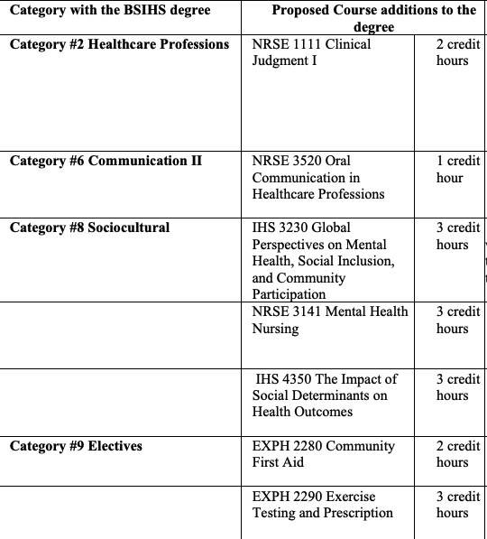

- College of Health Sciences and Professions (Approved)
Program Code: MS1224
Program Name: Family Nurse Practitioner
Department/School: School of Nursing
Contact: Sherleena Buchman (buchmans@ohio.edu), Margie Vogt (vogtm@ohio.edu)
Desired Start Date: Fall 23

The American Association of Colleges of Nursing (AACN) and the National Organization of Nurse Practitioner Faculties (NONPF) have established new accreditation standards for nursing education with a move to competency-based education and an increase in clinical practice hours from 500 to a minimum of 750 at the Graduate level. The proposed program change reflects the new accreditation standards including the new required clinical hours. Although some of the courses have revised titles, course descriptions and learning outcomes based on the new accreditation standards, the content, assessments and evaluations have remained consistent (see Table I: Comparison of Current Programs of Study versus Proposed Programs of Study). The courses have been reorganized and content redistributed in a revised scope and sequence based off our accrediting bodies’ requirements. The overall Program Outcomes have also been revised to reflect these changes. The Programs of Study for the AG-ACNP certificate have also been revised.
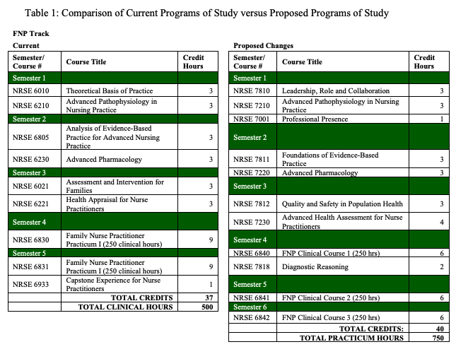
- College of Health Sciences and Professions (Approved)
Program Code: DN1235
Program Name: Doctor of Nursing Practice (BSN-DNP)
Department/School: School of Nursing
Contact: Margie Vogt (vogtm@ohio.edu)
Desired Start Date: Fall 23

The American Association of Colleges of Nursing (AACN) and the National Organization of Nurse Practitioner Faculties (NONPF) have established new accreditation standards for nursing education with a move to competency-based education and an increase in clinical practice hours from 500-750 at the master's level while continuing to require 1000 clinical hours at the Doctor of Nursing Practice (DNP) level. National professional organizations have also recommended the DNP be entry to practice for Advanced Practice Registered Nurses (APRNs) and Nurse Leaders. In the BSN-to-DNP program, students take an APRN clinical specialty focus track such as the Family Nurse Practitioner (FNP), Adult-Gerontology Acute Care Nurse Practitioner (AGACNP), Psychiatric Mental Health Nurse Practitioner (PMHNP), or an indirect specialty focus track such as the Nurse Leader (NL), and Nurse Leader/Nurse Educator (NL/NE). This has required changes in program codes leading to some inconsistencies and confusion when meeting graduation requirements. Ohio University Registrar has requested new program codes that reflect the DNP Program with the clinical specialty focus of Family Nurse Practitioner (FNP), Adult-Gerontology Acute Care Nurse Practitioner (AGACNP), Psychiatric Mental Health Nurse Practitioner (PMHNP), Nurse Leader (NL), and Nurse Leader/Nurse Educator (NL/NE). Ohio University has also decreased the required credit hours for a clinical doctorate to 70 credit hours. The proposed program change reflects the new accreditation standards, the new program codes, and the new required credit hours. Although some of the courses have revised titles, course descriptions, and learning outcomes based on the new accreditation standards, the content, assessments, and evaluations have remained consistent overall. The Programs of Study for all the BSN-to-DNP specialty focus tracks have also been revised (see Table II: Comparison of Current Programs of Study versus Proposed Programs of Study).

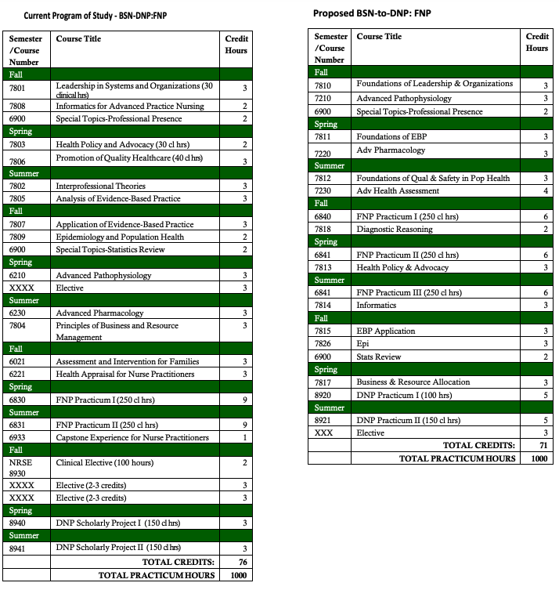
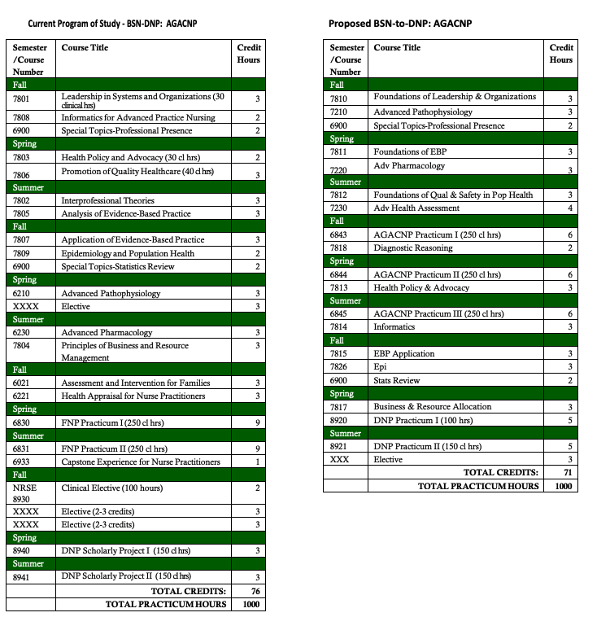
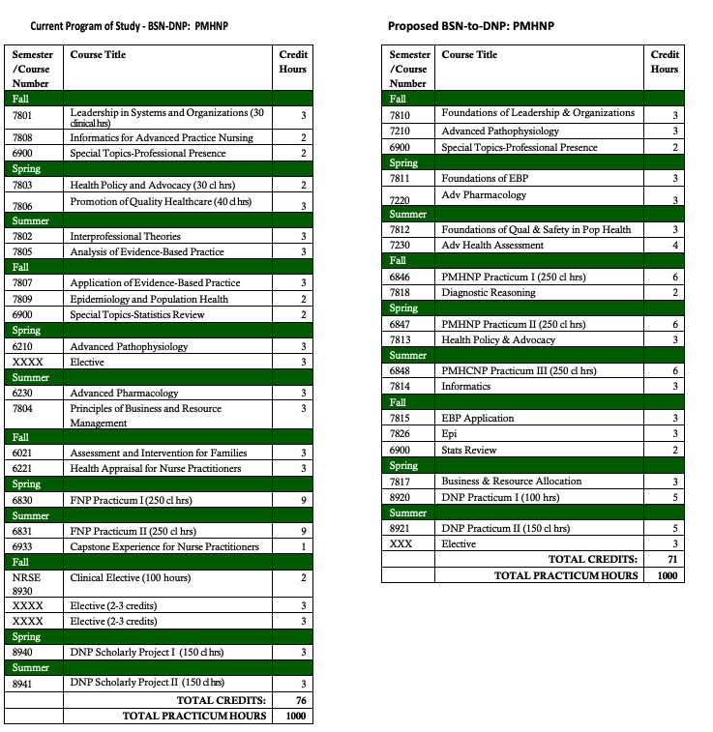
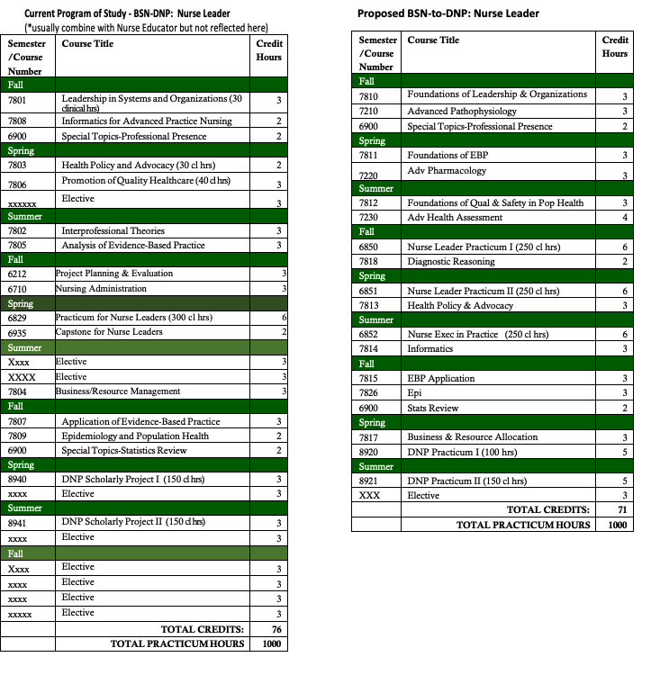
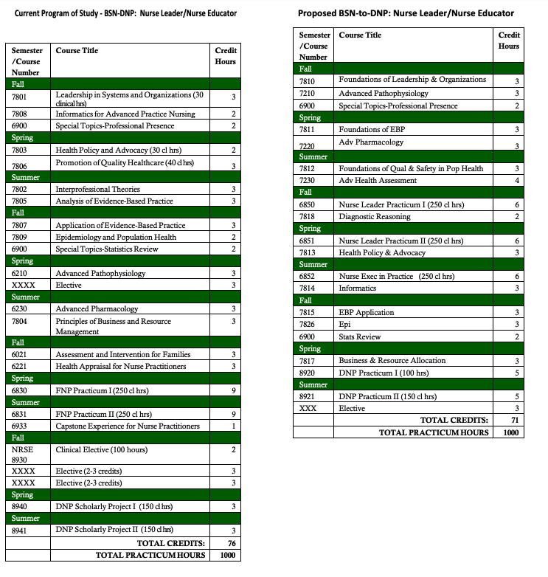
- College of Health Sciences and Professions (Approved)
Program Code: DN1234
Program Name: Doctor of Nursing Practice (MSN-DNP)
Department/School: School of Nursing
Contact: Margie Vogt (vogtm@ohio.edu)
Desired Start Date: Fall 23

The American Association of Colleges of Nursing (AACN) and the National Organization of Nurse Practitioner Faculties (NONPF) have established new accreditation standards for nursing education with a move to competency-based education and an increase in clinical practice hours from 500-750 at the master's level while continuing to require 1000 clinical hours at the Doctor of Nursing Practice (DNP) level. National professional organizations have also recommended the DNP be entry to practice for Advanced Practice Registered Nurses (APRNs) and Nurse Leaders. In the MSN-to-DNP program, students are admitted with a Master of Science and an APRN clinical specialty focus track such as the Family Nurse Practitioner (FNP), Adult-Gerontology Acute Care Nurse Practitioner, Psychiatric Mental Health Nurse Practitioner, or indirect specialty focus track such as the Nurse Leader, Nurse Educator or a combination of these specialty focused tracks. A gap analysis is done, according to the national accreditation standards on each individual student to determine the additional required clinical hours needed to meet the 1000 hours at the DNP level. Most students come with a minimum of 500 clinical hours from their previous master's program. The proposed program change reflects the new accreditation standards, the new program outcomes, and the revised courses. Although some of the courses have revised titles, course descriptions, and learning outcomes based on the new accreditation standards, the content, assessments, and evaluations have remained consistent overall. This resulted in a credit reduction from 37 to 36 credit hours. The Programs of Study for all the MSN-to-DNP have also been revised (see Table II: Comparison of Current Programs of Study versus Proposed Programs of Study).
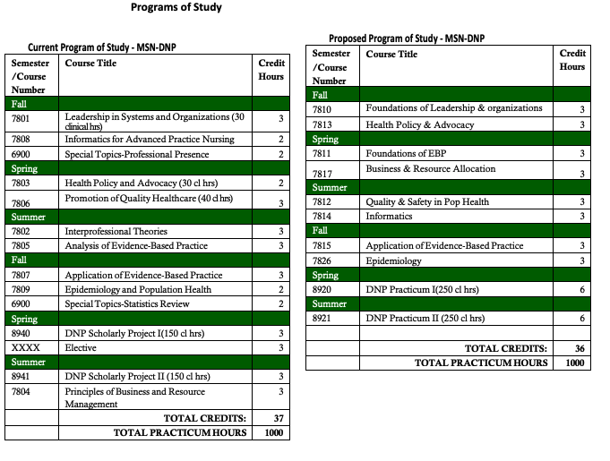
- College of Health Sciences and Professions (Approved)
Program Code: CTPMHN
Program Name: Post-Graduate Psychiatric Mental Health Nurse Practitioner
Department/School: School of Nursing
Contact: Sherleena Buchman (buchmans@ohio.edu) Margie Vogt (vogtm@ohio.edu)
Desired Start Date: Fall 23

The American Association of Colleges of Nursing (AACN) and the National Organization of Nurse Practitioner Faculties (NONPF) have established new accreditation standards for nursing education with a move to competency-based education and an increase in clinical practice hours from 500 to a minimum of 750 at the Graduate level. The proposed program change reflects the new accreditation standards including the new required clinical hours. Although some of the courses have revised titles, course descriptions, and learning outcomes based on the new accreditation standards, the content, assessments, and evaluations have remained consistent (see Table I: Comparison of Current Programs of Study versus Proposed Programs of Study). The courses have been reorganized and content redistributed in a revised scope and sequence based on our accrediting bodies’ requirements. The overall Program Outcomes have also been revised to reflect these changes. The Programs of Study for the AG-ACNP certificate have also been revised.
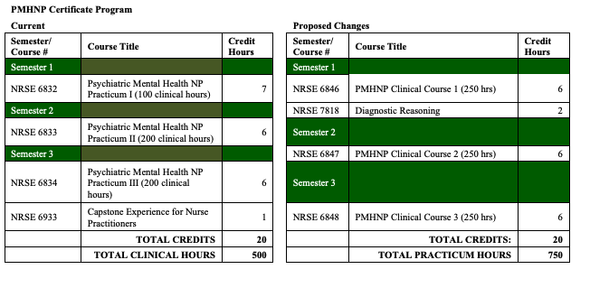
- College of Health Sciences and Professions (Approved)
Program Code: CTFNPG
Program Name: Post-Graduate Family Nurse Practitioner
Department/School: School of Nursing
Contact: Sherleena Buchman (buchmans@ohio.edu) Margie Vogt (vogtm@ohio.edu)
Desired Start Date: Fall 23

The American Association of Colleges of Nursing (AACN) and the National Organization of Nurse Practitioner Faculties (NONPF) have established new accreditation standards for nursing education with a move to competency-based education and an increase in clinical practice hours from 500 to a minimum of 750 at the Graduate level. The proposed program change reflects the new accreditation standards including the new required clinical hours. Although some of the courses have revised titles, course descriptions, and learning outcomes based on the new accreditation standards, the content, assessments, and evaluations have remained consistent (see Table I: Comparison of Current Programs of Study versus Proposed Programs of Study). The courses have been reorganized and content redistributed in a revised scope and sequence based on our accrediting bodies’ requirements. The overall Program Outcomes have also been revised to reflect these changes. The Programs of Study for the AG-ACNP certificate have also been revised. The Programs of Study for the FNP track have also been revised.

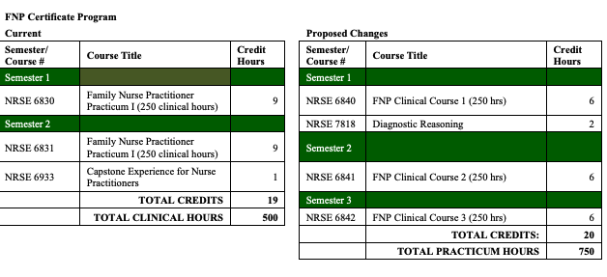
- College of Health Sciences and Professions (Approved)
Program Code: CTNEDG
Program Name: Nurse Educator Certificate
Department/School: School of Nursing
Contact: Sherleena Buchman (buchmans@ohio.edu)
Desired Start Date: Fall 23

The American Association of Colleges of Nursing (AACN) and the National Organization of Nurse Practitioner Faculties (NONPF) have established new accreditation standards for nursing education with a move to competency-based education and an increase in clinical practice hours to 500 at the master's level. In the BSN-to-MSN program, students take an indirect specialty focus track such as the Nurse Leader, and Nurse Educator. The proposed program change reflects the new accreditation standards including the new required clinical hours. Although some of the courses have revised titles, course descriptions, and learning outcomes based on the new accreditation standards, the content, assessments, and evaluations have remained consistent (see Table I: Comparison of Current Programs of Study versus Proposed Programs of Study). The overall Program Outcomes have also been revised to reflect these changes. The Programs of Study for all the BSN-to-MSN Nurse Educator track has also been revised.
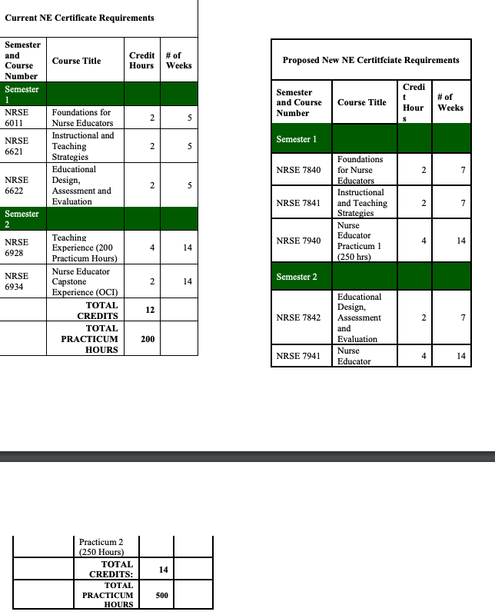

- College of Health Sciences and Professions (Approved)
Program Code: MS1213
Program Name: Nurse Educator
Department/School: School of Nursing
Contact: Sherleena Buchman (buchmans@ohio.edu)
Desired Start Date: Fall 23

The American Association of Colleges of Nursing (AACN) and the National Organization of Nurse Practitioner Faculties (NONPF) have established new accreditation standards for nursing education with a move to competency-based education and an increase in clinical practice hours to 500 at the master's level. In the BSN-to-MSN program, students take an indirect specialty focus track such as the Nurse Leader, and Nurse Educator. The proposed program change reflects the new accreditation standards including the new required clinical hours. Although some of the courses have revised titles, course descriptions, and learning outcomes based on the new accreditation standards, the content, assessments, and evaluations have remained consistent (see Table I: Comparison of Current Programs of Study versus Proposed Programs of Study). The overall Program Outcomes have also been revised to reflect these changes. The Programs of Study for all the BSN-to-MSN Nurse Educator track has also been revised.
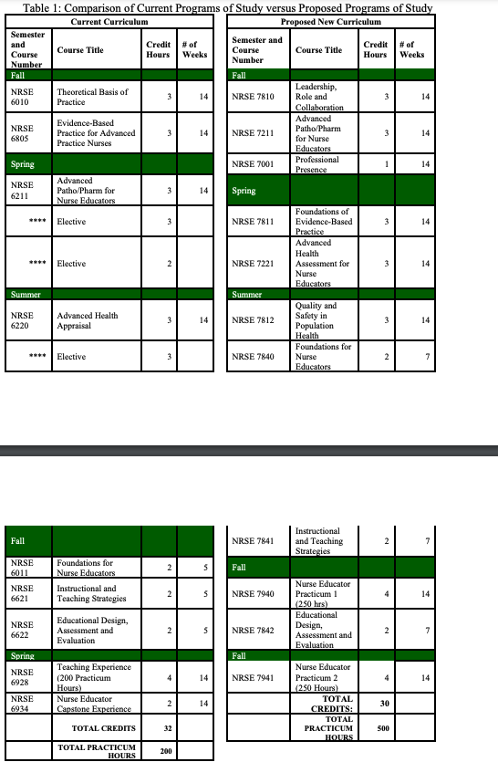
- College of Health Sciences and Professions (Approved)
Program Code: MS1240
Program Name: Nurse Leader
Department/School: School of Nursing
Contact: Margie Vogt (vogtm@ohio.edu)
Desired Start Date: Fall 23

The American Association of Colleges of Nursing (AACN) and the National Organization of Nurse Practitioner Faculties (NONPF) have established new accreditation standards for nursing education with a move to competency-based education and an increase in clinical practice hours to a minimum of 500 at the master's level. In the BSN-to-MSN program, students take an indirect specialty focus track such as the Nurse Leader, and Nurse Educator. The proposed program change reflects the new accreditation standards including the new required clinical hours. Although some of the courses have revised titles, course descriptions, and learning outcomes based on the new accreditation standards, the content, assessments, and evaluations have remained consistent overall (see Table I: Comparison of Current Course Offerings versus Proposed Course Offerings). The overall Program Outcomes have also been revised to reflect these changes. The Programs of Study for all the BSN-to-MSN Nurse Leader track have also been revised (see Table II: Comparison of Current Programs of Study versus Proposed Programs of Study).
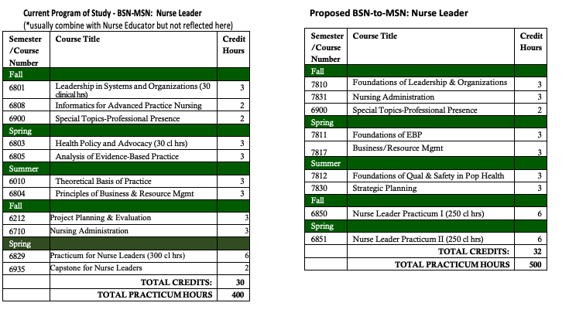
- College of Health Sciences and Professions (Approved)
Program Code: MS1238
Program Name: Psychiatric Mental Health Nurse Practitioner
Department/School: School of Nursing
Contact: Margie Vogt (vogtm@ohio.edu)
Desired Start Date: Fall 23

The American Association of Colleges of Nursing (AACN) and the National Organization of Nurse Practitioner Faculties (NONPF) have established new accreditation standards for nursing education with a move to competency-based education and an increase in clinical practice hours from 500 to a minimum of 750 at the Graduate level. In the BSN-to-MSN program, students take an indirect specialty focus track such as the FNP, and AG-ACNP. The proposed program change reflects the new accreditation standards including the new required clinical hours. Although some of the courses have revised titles, course descriptions and learning outcomes based on the new accreditation standards, the content, assessments and evaluations have remained consistent (see Table I: Comparison of Current Programs of Study versus Proposed Programs of Study). The courses have been reorganized and content redistributed in a revised scope and sequence based off our accrediting bodies’ requirements. The overall Program Outcomes have also been revised to reflect these changes. The Programs of Study for the PMHNP certificate have also been revised.
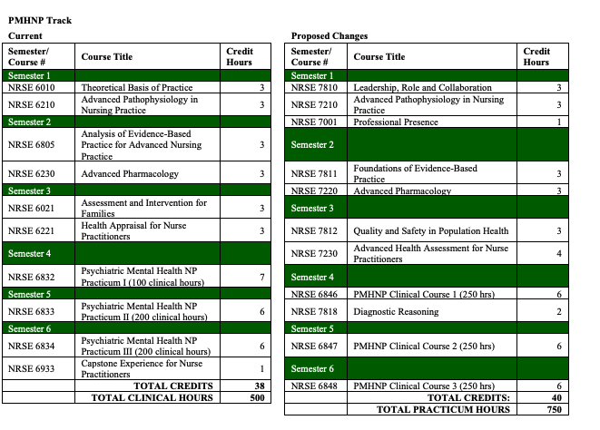
- College of Health Sciences and Professions (Approved)
Program Code: MS1236
Program Name: Adult Gerontology-Acute Nurse Practitioner
Department/School: School of Nursing
Contact: Sherleena Buchman (bucmans@ohio.edu) & Margie Vogt (vogtm@ohio.edu)
Desired Start Date: Fall 23

The American Association of Colleges of Nursing (AACN) and the National Organization of Nurse Practitioner Faculties (NONPF) have established new accreditation standards for nursing education with a move to competency-based education and an increase in clinical practice hours to a minimum of 500 at the master's level. In the BSN-to-MSN program, students take an indirect specialty focus track such as the Nurse Leader, and AG-ACNP. The proposed program change reflects the new accreditation standards including the new required clinical hours. Although some of the courses have revised titles, course descriptions, and learning outcomes based on the new accreditation standards, the content, assessments and evaluations have remained consistent (see Table I: Comparison of Current Programs of Study versus Proposed Programs of Study). The overall Program Outcomes have also been revised to reflect these changes. The Programs of Study for the AG-ACNP track have also been revised.
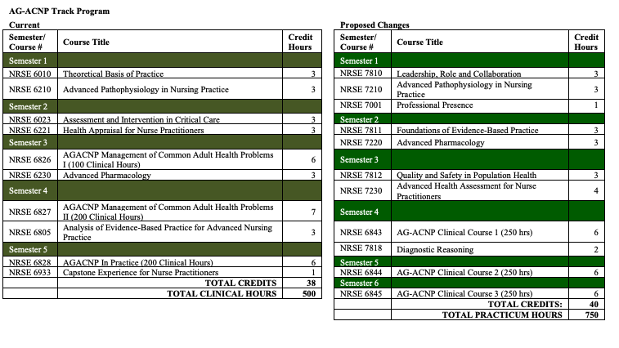
- College of Health Sciences and Professions (Approved)
Program Code: BS1221
Program Name: Bachelor of Science in Nursing (BSN)
Department/School: School of Nursing
Contact: Char Miller (millerc3@ohio.edu), Molly Johnson (johnsom4@ohio.edu), Sherleena Buchman (bucmans@ohio.edu) & Lindsey Shotts (shottsl@ohio.edu)
Desired Start Date: Fall 23

The Bachelor of Science in Nursing curriculum changes are based on new professional guidelines and standards which have been set forth by the American Association of Colleges of Nursing (AACN), an accrediting body. Names, descriptions, and outcomes for every nursing course in the program have been updated to reflect “The Essentials: Core Competencies for Professional Nursing Education”, which outlines the educational framework required to prepare professional nurses. Additionally, program outcomes have been updated and changes have been made to our required general education courses. Many of the changes were simply a clean-up of the terminology and language with some minor shifting of content in the biggest courses. The overall credit hours increased by one and we amended our general education required courses.
Overall credit hours for the BS1221 program increased by one credit hour, now total of 121 credits (previously 120 credits).

Starting with the current curriculum- 120 credit hours- Due to updated general education guidelines, two student elective courses were removed from the curriculum. This decreased the total by four credit hours, resulting in a total of 116.

One of the remaining student elective courses on the current curriculum was listed as two credit hours. Elective courses needed by students in the program under specific general education components are currently offered as three credit hours or more. One credit hour was added to that elective requirement, resulting in total credit hours of 117.

Nursing has elected to require IHS 2215 and IHS 2220, each three credit hours in place of two elective courses. This change is credit neutral. Nursing Excellence was decreased by one credit hour. This resulted in a total of 116. The School of Nursing removed NUTR: 1000 as a required course (3 credit hours). This resulted in a total of 113 credit hours.

The School of Nursing faculty identified the need for students to receive specific dosage calculation instruction in the BSN program to support safe medication administration. One credit hour was added to the Foundations nursing course. This resulted in a total of 114 credit hours.

Due to general education guidelines through OHIO, one credit hour was added to the Community / Populations course to ensure coverage of “Bridge Diversity and Practice”. This resulted in a total of 115 credit hours.

The School of Nursing added a Health Promotion Across the Lifespan course (2 credit hours). This course will be taught by nursing faculty. This resulted in a total of 117 credit hours.

The School of Nursing realigned topics being covered in several current courses to create more succinct content delivery. The “Professional Essentials and Applications of Clinical Judgment” series was created to support this content realignment as well as add any additional topics required to meet new professional standards in the updated BSN Essentials. One credit was added to each of the year three Professional Essentials courses that are replacing the Clinical Judgment courses. An additional Professional Essentials course was added to year four of the program. The increase for the course series was four (4) credits. This resulted in a total of 121 credit hours.

- College of Health Sciences and Professions (Approved)
Program Code: CTANPG
Program Name: Post-Graduate Adult Gerontology-Acute Care Nurse Practitioner Certificate
Department/School: School of Nursing
Contact: Sherleena Buchman (bucmans@ohio.edu) & Margie Vogt (vogtm@ohio.edu)
Desired Start Date: Fall 23

The American Association of Colleges of Nursing (AACN) and the National Organization of Nurse Practitioner Faculties (NONPF) have established new accreditation standards for nursing education with a move to competency-based education and an increase in clinical practice hours from 500 to a minimum of 750 at the Graduate level. The proposed program change reflects the new accreditation standards including the new required clinical hours. Although some of the courses have revised titles, course descriptions and learning outcomes based on the new accreditation standards, the content, assessments and evaluations have remained consistent (see Table I: Comparison of Current Programs of Study versus Proposed Programs of Study). The courses have been reorganized and content redistributed in a revised scope and sequence based off our accrediting bodies’ requirements. The overall Program Outcomes have also been revised to reflect these changes. The Programs of Study for the AG-ACNP certificate have also been revised.
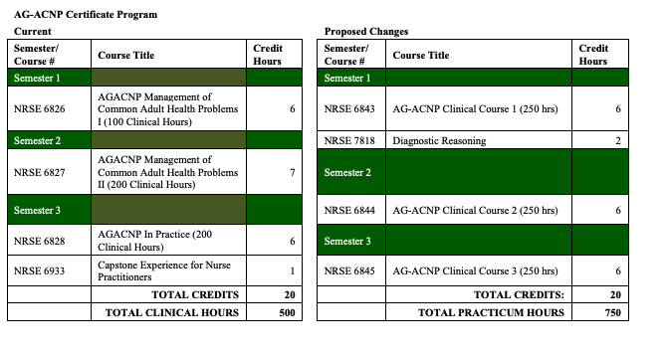
- College of Health Sciences and Professions (Approved)
Program Code: CTEPCG
Program Name: Epidemiology Graduate Certificate
Department/School: School of Social and Public Health
Contact: Alexander Sergeev (sergeev@ohio.edu)
Desired Start Date: Fall 23

The change is for a modality addition only. We would like to open the certificate to e-campus students. All the certificate courses have been offered in the past as Athens online.

- College of Health Sciences and Professions (Approved)
Program Code: CTATRG
Program Name: Athletic Training Residency in Pediatrics
Department/School: School of Applied Health Sciences and Wellness
Contact: Laura Harris (harrisl2@ohio.edu)
Desired Start Date: Fall 23

This change will have no impact on program learning outcomes or the assessment plan. However, it will change how students are determined eligible for graduation. Currently, the minimum requirement is a “B” in all courses. The proposed change would amend the minimum requirement to allow at least a “C” in program courses. Our program data from the past two cohorts indicates that we typically have 1-2 residents earn a “C” in one course, while maintaining a 3.00 GPA throughout the program. Based upon this data, I believe a minimum of a “C” allows students more flexibility. Mathematically this would allow residents to earn no more than two “Cs” in the program. This change seems reasonable, especially considering the academic rigor of the program.

- College of Arts and Sciences (Approved)
Program Code: BS4232
Program Name: Geography-Environmental Geography
Department/School: Geography
Contact: Gaurav Sinha (sinhag@ohio.edu)
Desired Start Date: Fall 23

We are proposing five types of changes in response to changing course offerings both within Geography and other units, and to streamline the major for students. The changes include:
1) TRACK NAME CHANGE: Since our curriculum prioritizes analysis of human environment interactions affecting our climate and physical environments, we will change the track name from Environmental Geography to Climate, Environment and Society to clearly inform students about the scope of the major. The program will be Geography- Climate, Environment and Society.
2) CHANGE COURSE GROUPINGS TO HIGHLIGHT THEMATIC CONTRIBUTIONS: We will reorganize the required and elective courses under thematic categories to improve students’ understanding of which courses are related and how they collectively address different pedagogical components of the major’s curriculum.
3) CORE COURSES: GEOG 2060 The Physical and Global Dimensions of Climate Change will be added as a required core course.
4) CORE ELECTIVES: GEOG 3260 Urban Geography will be added to the list of core electives. 5) EXTRA-DEPARTMENTAL SUPPORTING COURSES: We want to simplify our curriculum by replacing extra-departmental requirements with a curated list of extra-departmental courses for fulfilling BRICKS and CAS distribution requirements.

REQUIRED CREDIT HOURS: The total number of required hours will be reduced from the current total of 65 credit hours (44 in Geography + 21 extra-departmental courses) to only 48 to 52 required credit hours (all in Geography). This proposal does not represent a greater than 50% change in the program requirements. Most students will continue to enroll in similar extra-departmental courses as before, the proposed changes will not substantially affect enrollment in a particular course or department.

EXPEDITED REVIEW- NA
NOTIFICATIONS
Program Suspension/Closure
- College of Health Sciences & Professions
Program Code: AA5019
Program Name: Medical Assisting Technology (MAT)
Contact: Tobe Gillogly (gillogt@ohio.edu)

The Medical Assisting Technology (MAT) program has been identified as low-enrolled on regional campuses. Applications to the MAT program were closed after Fall 2022 admission cycle which means no new applications or admissions will occur for this program. The purpose of this proposal is to submit the teach-out plan for the program, which will close at the end of the Spring semester, 2023-24. Currently, the MAT program has 6 students enrolled in cohort one (admitted fall 2021) who will graduate spring 2023 and 9 students in cohort 2 (admitted fall 2022) who will graduate in spring 2024.

New Course Prefix

- University College
To: Connie Patterson, UCC Programs Committee Chair
From: David Nguyen, Dean, University College
Re: Data Prefix
Date: February 16, 2023

A new undergraduate program in Data Analytics (BDA) within University College is undergoing the approval process by the University.
We plan to get the process moving forward with OCEAN submissions and updates of the proposed courses. We already have a temporary program code, BDXX02. We’d like to request the “DATA” prefix for this major (short for BDA), based on which the new courses will be named and input into the OCEAN system.

Exemption Approval

The formal exemption request for two standalone, financially-aid eligible, undergraduate certificates, CTX46U Mechatronics Technician and CTX47U Automation Technician, was approved by Provost Sayrs on February 6, 2023.

Program Review Committee – Bärbel Such, Chair

On-Going Reviews AY 2022-23

- Second Reading
  - HCOM
  - History
  - Psychology

- First Reading
  - Social and Public Health
  - English

- Review report at Graduate Council
  - Physics & Astronomy, forwarded 2/7
  - Dance, forwarded 2/27

- Review report received and forwarded to program director and dean
  - Environmental and Plant Biology, forwarded 2/6
  - Chemistry and Biochemistry, forwarded 2/28

- Site visit scheduled; internal reviewers assigned
  - Social Work, 3/24 and 27

- Site visit to be rescheduled
  - Biological Sciences

Other Business

- Updates to Program Review Process – First Reading

- Updates to Self-Study Requirements – First Reading

- 13 programs notified of their upcoming review (AY 2024)

- orientation meeting scheduled for Mar. 24

Individual Course Committee Report: Beth Quitslund, Co-Chair and Allyson Hallman-Thrasher, Co-Chair

*Were there any conditional BRICKS approvals this month, they would be in red italic.

NEW COURSES
College | Course | BRICKS
Arts & Sciences | MATH 2120: Number and Algebra for Middle School Teachers
Business | SAM 3920: Business Application Simulation | BLD
Health Sciences & Professions | NRSE 2222: Pharmacology for Nursing Practice
 | NRSE 3112: Scholarship for Nursing Practice
 | NRSE 3122: Person-Centered Nursing Care of Adults I
 | NRSE 3212: Psychiatric/Mental Health Nursing Care
 | NRSE 3222: Person-Centered Nursing Care of Adults II
 | NRSE 4202: Professional Essentials and Application
Russ College | ETM 4100: Executive Data Visualization
 | ETM 4500: Advanced Project Management
Scripps College | ECT 6925: Graduate Seminar for the MFA in Communication Media Arts
 | MDIA 4132: Visual Analytics
University College | DATA 4510: Data Programs Capstone | Cap

COURSE CHANGES
College | Course | BRICKS | Changes
Arts & Sciences | CARS 2440: Paganism, Judaism, and Christianity in the Roman Empire | [PHTC/T2HL] | Prefix and number (from CLAS 2550), name (from Pagan to Christian in Late Antiquity), desc, LOs, Topics, Summ exp
 | CARS 3020: Introduction to Islam | BDP/BER [T2CP] | Desc, LOs, Topics; add Texts, KGFs, BRICKS component
 | CHEM 1205: Survey of Chemistry for Health Sciences | [ANW] | Prereqs
 | ENG 1100: Crossing Cultures with Texts | [FIE/PHTC] | Name (from … Text…), LOs
 | ENG 3650: Introduction to Literary Editing and Publishing | BLD | LOs, Course Topics info; add BRICKS component
 | ENG 4510/5510: Teaching Language and Composition |  | LOs, prereqs; add Texts, KGFs
 | ENG 5950: Introduction to English Studies |  | Desc, LOs, Course Topics info
 | HIST 2755: Nature, Science and Religion in premodern Europe to 1750 | ACNW->ACSW [T2SS] | Desc, LOs, BRICKS component
 | HIST 3682/5682: Nazi Germany | BER | Desc, LOs; add Course Topics info, BRICKS component
 | MATH 3050: Applied Discrete Mathematics |  | Name (from Discrete Mathematics), desc, LOs, prereqs, Course Topics info
 | MATH 3060: Discrete Mathematics |  | Name (from Introduction to Mathematical Reasoning, Problem Solving, and Proof), desc, LOs, prereq, Course Topics info
 | MATH 3240: Abstract Algebra |  | Desc, LOs, prereqs, Course Topic; add Texts, KGFs
 | MATH 4100/5100: Mathematics Teaching in Secondary School |  | Name (from Teaching of Mathematics in Secondary School), desc, LOs, prereqs, Topics; add Texts, KGFs
 | MATH 4100L/5100L: Mathematics Teaching in Secondary School |  | Name (from Teaching of Mathematics in Secondary School Field Experience), desc, LOs, prereqs, Course Topics info
 | MATH 4501/5501: Mathematical Statistics I |  | Number (from 4500/5500)
Fine Arts | FILM 2050: Introduction to Film Production |  | Name (Technical Toolbox I), prereq (majors only)
 | FILM 2060: Film Set Production |  | Name (from Technical Toolbox II), prereq (majors only)
Health Sciences & Professions | AT 6310: Neuromechanics of Sports Injury Rehabilitation |  | Desc, GEC, LOs, prereqs, course components (removed lab); added Texts, KGFs
 | EH 4010: Climate Change and Public Health | T3->T3E | Prefix (from T3), desc, LOs, prereq, Course Topics info
 | IHS 2930: Interprofessionalism in Healthcare |  | Credit hours (1-3 variable -> 1 fixed), GEC, prereq
Heritage College | OCOM 7902: Introduction to Clinical Education |  | Desc, LOs, Coure Topics info
 | OCOM 8202: Elective - Continuity in Primary Care: Longitudinal Integrated Clerkship |  | LOs, KGFs
Patton College | EDRE 7610: Computer Science Applications in Educational Research |  | LO, prereq
 | PCOE 5915: Student Development and Learning |  | Name (from … Learning & Curriculum Development), desc, Texts, KGFs
Russ College | AVN 4750: Internship in Aviation Operations |  | Min credit hrs (2->3), LOs
 | ENGT 2210: Programmable Logic Controllers 1 and Motor Controls |  | Name (from Programmable Controllers, Instrumentation, and Processes), desc, prereqs
 | ME 4701: Mechanical Engineering Capstone Design I | BSL | LOs; add Course Topics info, BRICKS component
 | SEC 4963 / EE 4963: Electrical and Computer Engineering Capstone Design II | [Cap/BSL/ BLD] | Desc; add cross-list, prereqs
Scripps College | COMM 6960: Master's Capstone |  | LO; add prereq
 | MDIA 2500: Animation I |  | Desc, LOs, prereqs; add Course Topics info
 | MDIA 3306: The Music Industry: Understanding the Revenue Streams and Systems of the Music Business |  | Name (from Business of Selling Music: Record Labels, Distribution, and Marketing), desc, LOs, prereqs, Course Topics info
 | MDIA 3705/5705: Podcasting Production Essentials |  | Name (from Writing and Producing the Non-Fiction Podcast Series), desc
 | MDIA 4310: Music Production/Recording Capstone | [Cap/T3E] | LOs, prereqs
 | MDIA 4706: Podcasting Production II: Series Development |  | Name (from Writing and Recording Episodic Content for the Podcasting Marketplace)
 | MDIA 7000: Professional Seminar for Mass Communication PhD |  | Name (from Professional Seminar in Media Arts & Studies), prereqs
 | VICO 1414: Introduction to Visual Communication Skills: Design |  | Prereqs
 | VICO 1421: Introduction to Visual Communication Skills: Photography |  | Prereqs, LOs, KGFs
 | VICO 2390: Photojournalism I: Single Images |  | Prereqs
 | VICO 2392: Photojournalism II: Picture Story | [BLD] | Desc, prereqs
 | VICO 3310: Multimedia Production for Visual Communication |  | Prereqs

COURSE DEACTIVATIONS
PAW 1205: Cycling
PAW 1207: Fundamentals of Handball
PAW 1224: Canoeing
PAW 2204: Intermediate Indoor Rock Climbing

General Education Committee Report: Nukhet Sandal, Chair
- HLC Evidence gathering committees, general education assessment updates:

AY 2021-22

Data gathered to assess the outcomes Quantitative Reasoning, Written

Communication, and Oral Communication

Assessment teams were led by Cat Penrod, Paul Abraham, and Jerry Miller

Teams consisted of 4 faculty members teaching larger sections of general

education courses.

• Assessment was done by instructors using our standard rubrics.

• Recommendations from first round are process oriented, and these outcomes

will be assessed again in AY 2023-24 taking recommendations into account.

AY 2022-23

• Outcomes are Humanities, Arts, Ethical Reasoning, and Intercultural

Competence.

• Leads are James Petrik, Cassidy Brauner, Yeong Kim, and Angela Hosek.

The Humanities and Arts teams also needed to desian and calibrate a rubric

for their work.

• Teamwork was also on the schedule, but we do not have enough courses

available. We will need to work out how to improve this as part of the

assurance of learning cycle.

• Reports from teams should be done by May.

AY 2023-24

• Quantitative Reasoning, Written Communication, and Oral Communication are

to be assessed again, incorporating recommendations by the initial teams.

• Integrative Learning, Critical Thinking, Social/Behavioral Science, and Natural

Science are to be assessed for the first time.

• Recruiting should occur over the next month for team leads, and possibly

assessors as well

This is an opportunity to help shape the process and make it useful for faculty

as BRICKS continues to evolve.

There is compensation for those who

participate.

• CTLA is hirina an associate director of assessment who will help us run this

process,

