Ohio University

University Curriculum Council
Tuesday, December 3, 2019

Alden Library, Friends of the Library, Room 319

Present: Khurrum Bhutta, Gordon Brooks, Sherleena Buchman, John Cotton, Catherine Cutcher, Edwin Darty, Jim Dyer, Kristine Ensign, Katherine Hartman, Sara Helfrich, Pramod Kanwar, Zaki Kuruppalil, Jody Lamb, Sally Marinellie, Ruth Palmer, Connie Patterson, Sarah Poggione, Andrew Pueschel, Beth Quitslund, Sherri Saines, Elizabeth Sayrs, Barbel Such, Loralyn Taylor, Lijing Yang

Absent: Courtney Archibald, Benjamin Carman Timothy Goheen, Sara Hartman, David Koonce, Yang Li, April Loudner-Maffin, Deborah McAvoy, Jim McKean, Luke Pittaway, Nukhet Sandal, Jim Smith, Scott Smith, Allison White
Excused: Bayyinah Jeffries

Guests: Deb Benton, Nick Bochenek, Bob Delong, Howard Dewald, Kathy Spicer, Nicki Willamson

Call to Order: Sara Helfrich called the meeting to order at 3:05 p.m.

Approval of Minutes: The November 5, 2019 meeting minutes were approved by voice vote.

Associate Provost for Faculty & Academic Planning: Howard Dewald
- Impacts on faculty and scheduling will happen during the alignment of regional campuses and the Athens campus. As budget discussions continue, there are potential implications to curriculum.
- There are numerous approval processes that take place after items are approved by the University Curriculum Council (UCC). The Board of Trustees needs to be notified in many cases, also the state of Ohio, and the Ohio Department of Higher Education. As we consider realignments of programs, notifications have to come to UCC and the Higher Learning Commission.
- There is a program approval manual on the Ohio Department of Higher Education’s (ODHE) website. All new programs have to go to Columbus. We frequently notify them of new certificates, name changes, program changes, and substantive changes, anything over 50 percent. Contact the ODHE with details when creating a new program or making changes. They will either give you a form or tell you the process involved.
- There are guidelines and learning outcomes on the Ohio Department of Higher Education’s website for Ohio Transfer Modules (OTM). There is information specific to Ohio University and information specific to the processes. If you are concerned with your courses, how they align with the OTM, and how they will fit into the general education discussion, contact Bob Callahan or Jessica Holliday in the admissions office. They handle transfer module questions and can guide the decisions you need to make in adding courses.
- The General Education Steering Committee met and Katie Hartman and Elizabeth Sayrs were officially appointed to that committee.
- The Guaranteed Transfer Pathways steering committee met last week and saw the first exceptions to the transfer pathways. Those were presented by the University of Cincinnati and were exclusive to their program of Fine Arts; specifically their bachelors programs in music, architecture, and theater. The committee was inclined to recommend approval of those exceptions.

Program Review Committee Report: John Cotton, Chair
- Cotton presented the agenda.
AY16
- Aviation – Self-study received. Externals approved. Site visit spring.
AY18
- Department of Interdisciplinary Healthcare Studies – Review delayed until Fall 2021.
- Honor's Tutorial College – Review delayed until Fall 2020.
AY19
- Technical and Applied Studies – Site visit complete. Report received. Sent to Director and Dean for response 12/2.
- Applied Management – Site visit Nov 7. Awaiting report.
- Voinovich School MPA – Sent to graduate council for comment on Oct 15.
- Educational Studies – Review received. Sent to chair and dean for comment Oct 15.
- School of Rehabilitation and Communication Studies - Negotiating a review date for three separate programs aligned with accreditation (Howard agreed to 3-separate reviews.)
AY20
- Applied Health Sciences and Wellness – Received self-study. Site visit spring.
- Chemical and Biomolecular Engineering – Awaiting self-study.
- Civil Engineering –Received self-study. Site visit spring.
- Computer Science/Electrical Engineering – Received self-study. Site visit spring.
- Industrial and Systems Engineering –Site visit Nov 21-22. Report Received. Sent to chair and dean for response 12/3.
- Mechanical Engineering – Awaiting self-study.
- School of Nursing – Externals waived. Review received. Director comment received, awaiting dean response.

Program Committee Report: Connie Patterson, Chair
- Patterson presented the agenda.

PROGRAM CHANGES
- College of Health Sciences and Professions
Program Code: CTGLHG
Program Name: Global Health
Department: Health Sciences and Professions
Contact: Sally Marinellie

The proposed change is to remove the Global Health Capstone I (IHS 5931) and Global Health Capstone II (IHS 5932) courses from the program requirements, resulting in a 5-credit reduction in the total certificate. The experiential “capstone” portion is duplicative of the student’s thesis and/or practicums as well as the curriculum required in the certificate program. Students gain the skills of project proposals in other certificate core courses.

- College of Health Sciences and Professions
Program Code: CTGLHL
Program Name: Global Health
Department: Health Sciences and Professions
Contact: Sally Marinellie

1. Remove the IHS 3930 Global Health Capstone Preparation Course (2-credit) from the Certificate program; the course is duplicative of the IHS 3521 Global Health Research and Service (3 credit).

2. Replace the IHS 4910 Global Health Capstone Experience (2-credit) with a special section of the IHS 3934 Global Health Capstone: Interprofessional Experiential Learning (IPE credit, 3-credit) course. This section of the IHS 3934 was developed and approved by the department in summer 2019 to blend the learning objectives of the original capstone with the IPE learning objectives.

The removal of the IHS 3930 reduces the certificate program by 1-credits from 19 to 18credits required in the program.

- College of Fine Arts
Program Code: BF5051
Program Name: Studio Art
Department: School of Art
Contact: Karla Hackenmiller

1. For our current studio concentrations in Ceramics, Photography, Sculpture, Printmaking, Painting + Drawing; we propose changing the number of 2000-level studio courses from 4 to 5; and the number of 3000-level studio courses from 6 to 5. The motivation for this one-course shift is to make it easier for students to meet the pre-requisites for advanced level courses. There is no change in the total number of courses taken nor in program hours.

2. The School of Art + Design would like to propose an additional track under the Studio Art BFA degree program, called “Art Therapy”. Currently, our concentration areas consist of: Ceramics, Printmaking, Photography + Integrated Media, Sculpture + Expanded Practice, and Painting + Drawing. (Appendix A: Comparison of tracks.) This new concentration would serve to prepare students for a graduate degree program in Art Therapy; and for professional work in the blossoming field of Arts & Health.

The American Art Therapy Association (AATA) recommends that undergrads have a minimum of 18 hours of studio art credits and 12 hours of psychology courses (that include developmental and abnormal psych coursework) prior to applying for a graduate program in Art Therapy. There are no other outlined requirements for an undergraduate art therapy. Undergraduate programs in art therapy are common, but none are accredited. The total number of credits for this track is slightly higher than the other tracks (other studio art tracks require 85 whereas this new proposed track would be 91); however, 9 of the additional required credits are Tier I and Tier II courses.

- Russ College of Engineering and Technology
Program Code: CTPMCU
Program Name: Project Management Certificate
Department: Engineering Technology and Management
Contact: Zaki Kuruppalil

- Change the current requirement from [ETM 3830 or ISE 4190 or ISE 4490] to [ETM 3830 or (ISE 4192 and ISE 4490)]
- Student must secure a B- or above in the section that satisfy Project Management requirement (section 4 of the DARS). Student take at least one course to satisfy this requirement, ETM 3830 or (ISE 4490 and ISE 4192) Total program hours increase by 1 credit hour.

- Regional Higher Education
Program Code: AA5019
Program Name: Medical Assisting Technology
Department: OHIO-Lancaster
Contact: Cynthia Boles

The program proposes to add an option to gain knowledge in human structure and function content.

Complete one of the following:
BIOS 1030 Human Biology Credit Hours: 3 and
BIOS 1300 Anatomy & Physiology I Credit Hours: 4 and
BIOS 1310 Anatomy and Physiology II Credit Hours: 4

Or
BIOS 1200 Human Structure and Function for Allied Health Credit Hours: 4 and
NUTR 1000 Introduction to Nutrition Credit Hours: 3

Medical Assisting Technology (MAT) students currently take the BIOS 1030, 1300, and 1310 courses to obtain human structure and function content and meet accrediting body requirements. This program change will incorporate an additional option for students to gain human structure and function content knowledge.

If students elect for the BIOS 1200 and NUTR 1000 option, the total semester required hours for graduation will decrease from 63 to 60 with the potential need for a free elective. If students choose the BIOS 1030, 1300, 1310 track, the total credit hours will remain at 63. The BIOS 1030, 1300, and 1310 series will remain as an option for MAT students. This will ease the transition of students switching between the MAT and pre-nursing majors.

- Arts & Sciences
Program Code: MS3324
Program Name: Geological Sciences
Department: Geological Sciences
Contact: Xizhen Schenk

We propose a program change in the non-thesis M.S. degree in Geological Sciences (MS3324) to better recruit and retain non-traditional students. Our existing program requires too many courses and credits relative to the thesis option and that the required courses do not meet the needs of students. We are proposing a reduction in total program hour requirement from a minimum 34 to 30 semester hours to better reflect norms in the field. Please note that this credit hour change is accomplished in part by dropping from 8 to 7 letter graded courses and dropping the GEOL 5050 and GEOL 6902 as required courses, that the non-traditional students may find irrelevant to their career plans.

FIRST READING- NEW PROGRAM/ CERTIFICATE
- Scripps College of Communication
Program Code: CTZZ3G
Program Name: Interacting with Media for STEM Professionals and Researchers
Department: Scripps College of Communication
Contact: Beth Novak

This certificate is a combination of teaching media literacy and media competency to early to mid-career STEM professionals. The courses are designed to give media skills to STEM professionals so that they can better convey the importance of their research to lay audiences both through the news media and directly through social media and other media forms. The certificate also will enhance STEM professionals’ skills at direct communication through social media and other media devices to advance a personal or professional brand. Although obvious overlap with the proposed Media for Non-Journalists certificate exists, this certificate and its associated courses are developed specifically for this audience. The certificate totals 12 credit hours.

COMM 5013 Media for STEM Professionals Seminar (1 credit)
This seminar prepares STEM professionals to interact with media to promote a finding, idea, or grant-funded research. It provides an overview of media, media messaging, translating research and research findings, message delivery and some best practices on how to give an effective interview.

COMM 5401: Media Today and Tomorrow for STEM (3 credits)
This historical retrospective of media introduces students to the changing landscape of media and how it is being redefined and traversed by STEM professionals. Students learn how to be good sources for positive public information and how to create their own understandable media messages. Message development and delivery for areas related to Science, Technology, Engineering and Math are emphasized.

COMM 5411: STEM Media Messaging (4 credits)
Students learn how to take complex concepts, research findings and data and synthesize the information into cogent media messages for public consumption. Media interviewing techniques are analyzed and strategies explained. Students learn how to shape, promote and deliver policy messages that resonate with the public.

COMM 5421: Mastering the Media Interview for STEM Professionals (4 credits)
This course emphasizes best practices for how to be interviewed and avoid pitfalls. Topics includes creating sound bites from scientific research, interview preparation and interview delivery techniques. Through mock interviews student hones their own techniques both verbally and non-verbally and maximize scientific messaging through the interview process

- Scripps College of Communication
Program Code: CTZZ1G
Program Name: Crisis Communication
Department: Scripps College of Communication
Contact: Beth Novak

The certificate consists of three courses totaling 12 credit hours. Two experiences comprise the first “course:” a 1 credit hour seminar (COMM 5011 Crisis Communication Seminar) and a 3-credit hour online course (COMM 5300 Crisis Communication and Planning). The seminar and the course can be taken concurrently, and the seminar will be offered both in-person and online. The seminar provides a general overview for professionals who cannot commit to a semester-long course and also acts as a recruitment tool for the certificate. The second and third courses are COMM 5310 Crisis Communication Strategy and COMM 5320 Social Analytics. The courses do not need to be taken in sequence but will all be delivered online, in person (including a seminar), or as a hybrid.

The target population is primarily professionals in private sector, public sector, and nongovernmental leadership and communication positions who are likely to be directly impacted by a crisis affecting their organization. There is a significant national gap in formal and relevant education to prepare communication professionals and leaders when a crisis impacts an organization. Resources include existing University technologies such as Blackboard; seminar space on/off main campus; potential use or remote use of WOUB studios, personnel, or technology (remote interviews or course practical assignments).

- Scripps College of Communication
Program Code: CTZZ2G
Program Name: Interacting with Media for Non-Journalists
Department: Scripps College of Communication
Contact: Beth Novak

This certificate is a combination of teaching media literacy and media competency to nonjournalist professionals. The certificate consists of three courses totaling 12 credit hours. Two experiences comprise the first “course:” a 1 credit hour seminar (COMM 5012 Media for Non-Journalists Seminar) and a 3-credit hour online course (COMM 5400 Media Today and Tomorrow). The seminar and the course can be taken concurrently, and the seminar will be offered both in-person and online. The seminar provides a general overview for professionals who cannot commit to a semester-long course and also acts as a recruitment tool for the certificate. The second and third courses are COMM 5410 Media Messaging and COMM 5420 Mastering the Media Interview. The courses do not need to be taken in sequence but will all be delivered online, in person (including a seminar), or as a hybrid.

The target population is early to mid-career professionals who need media training to improve their on-the-job media interactions and messaging skills. The certificate will enable professionals the opportunity to improve their skills and have better success by understanding the media and being more successful at communicating through reporters. The certificate also will teach professionals how to use media, on their own, without going through reporters. This will enhance their skills at direct communication through social media and other media devices to advance a personal or professional brand.

- Scripps College of Communication
Program Code: CTX88G
Program Name: Digital Media Transformation & Innovation
Department: Scripps College of Communication
Contact: Greg Newton

The certificate consists of three new courses totaling 12 credit hours:
MDIA 5610/COMM 5610, Assessing Digital Media Transformation & Innovation;
MDIA 5611/COMM 5611, Leading Digital Media Transformation & Innovation in Organizations; JOUR 5812/COMM 5812, Promoting Digital Media Transformation & Innovation.

The courses are intended to be taken in sequence, and will be delivered online or in hybrid mode. The target population is primarily early to mid-career professionals in media businesses as well as mangers in other types of organizations who are tasked with responsibilities that involve digital media for organizational and strategic communication. The certificate may also be appropriate as a part of the program of study for graduate students enrolled in an Ohio University degree program, Students completing the certificate will be prepared to develop, analyze, and lead digital media transformation projects and innovations in entertainment, journalism, and advertising; and capable of providing analysis, insight, and leadership to a wide range of organizationsfaced with strategic opportunities and operational challenges posed by the rapidly evolving digital media environment.

- Russ College of Engineering & Technology
Program Code: CTX93G
Program Name: Engineering Analytics
Department: Industrial and Systems Engineering
Contact: Dean Bruckner

In response to market changes, the Industrial and Systems Engineering Department—the MEM’s parent program—introduced a series of three or four-course, 9 to 11 credit hour graduate specialized stackable certificates drawn from the 13 existing courses offered in the 34-credit-hour masters degree (Program Code ME7266). The three certificates, approved on April 25, 2018 by the UCC, are these: • Certified Lean-Six Sigma (CTLSSG) • Engineering Leadership (CTELCG) • Engineering Management (CTEMCG)

This newly proposed certificate consists of completing the following four courses, with credit hours shown:
• EMGT 6100 (4) Statistics for Engineering Management
• EMGT 6200 (3) Information Systems Engineering
• EMGT 6210 (3) Database Information Systems
• EMGT 6220 (3) Data Acquisition and Predictive Analytics

These four courses total 13 semester credit hours. If a student has completed the EMGT 6100 course already, only three courses totaling nine credit hours remain to be completed for this certificate.

- The Patton College of Education
Program Code: BSXX04
Program Name: Early Childhood and Elementary Education
Department: Teacher Education
Contact: Sara Hartman

The program is being developed in order to comply with Senate Bill 216, which stipulates a licensure change for the existing Early Childhood Education program. As such, a new program is being developed. The Early Childhood and Elementary Education (ECEE) program prepares teacher candidates to work with children ages 3 to grade 5. The program aligns to the Council for the Accreditation of Educator Preparation’s K-6 standards and is also guided by recommendations from the National Association for the Education of Young Children. Via successful completion of the EdTPA and Ohio Assessments for Educators (OAE) exams, the program grants initial licensure for preschool-grade 5. The program provides intensive and sustained clinical experiences that are paired with integrative coursework with emphasis on developmentally appropriate practices, inclusive environments, and critical pedagogy.

The ECEE program will be replacing the Early Childhood Education program (EDEC), which is no longer permitted to offer licensure (per SB 216) starting in the 2020-21 academic year.

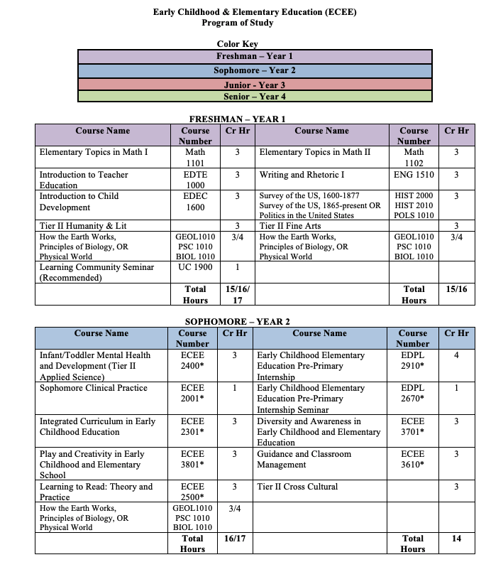
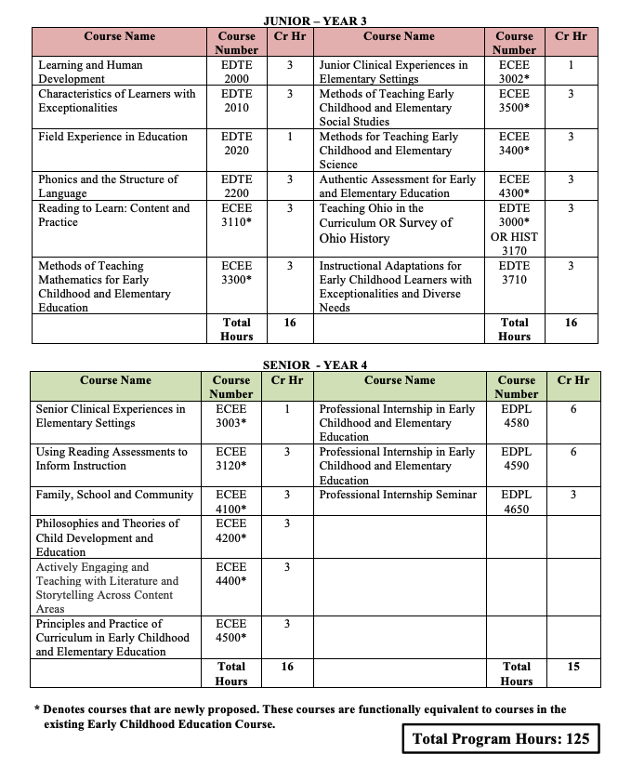

- The Patton College of Education
Program Code: NDXX08
Program Name: Early Childhood and Elementary Education
Department: Teacher Education
Contact: Sara Hartman

This pre-major code is being created to allow students to indicate their intention to pursue a degree in the Early Childhood and Elementary Education (ECEE) bachelor’s degree program. The pre-major code creates a curriculum plan for students’ first year in a four year bachelor’s degree program and is critical for planning field experiences with school partners.

- The Patton College of Education
Program Code: BSXX28
Program Name: Hospitality Management
Department: Human and Consumer Sciences
Contact: Rebecca Choi

Online bachelor’s degree completion programs are designed to help people return to school and complete their bachelor’s of applied degree. This degree is designed specifically for any student who has completed an associate’s degree or for those who have completed a minimum of 60 semester credit hours. Students interested in expanding their career options in hospitality and tourism, and/or looking to advance in their current jobs and desiring to secure better opportunities in the field would consider this flexible, online program. This program will be included in the American Association of Family and Consumer Sciences (AAFCS) accreditation. The program will be able to: Address the growing need for and demand for baccalaureate prepared employees to work within and lead hospitality professions. Also, it will provide opportunities for students to obtain a bachelor’s degree relevant to their work experiences in hospitality and related areas, enabling career progression.

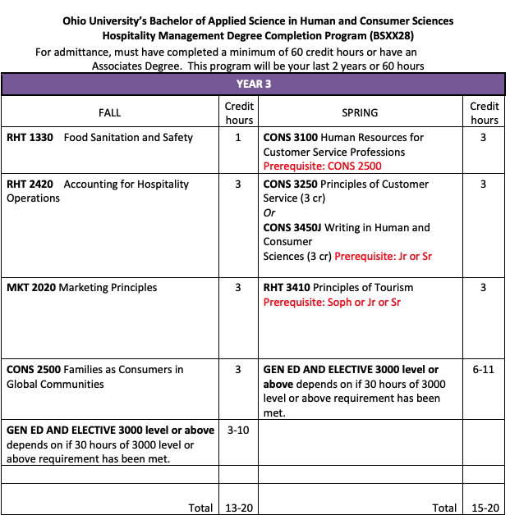
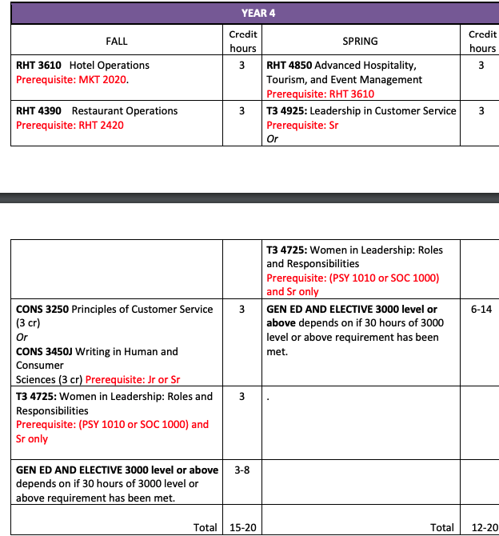

EXPEDITED REVIEW
- Arts & Sciences
Program Code: BA5222
Program Name: German
Department: Modern Languages
Contact: Christopher Coski

This proposal seeks UCC approval to change current course requirements for the German major by altering the requirement for three specific courses (GER 3550, 3560 and either 3348 or 3349) and replacing it by requiring that students complete any three 3000-level courses above GER 3120. The proposed change will increase student options and better allow the section to attract students with diverse interests and will expand the section’s curricular profile to a broader focus on German Studies.

- Russ College of Engineering & Technology
Program Code: CTLSSC
Program Name: Lean Six Sigma Certificate
Department: Engineering Technology & Management
Contact: Zaki Kuruppalil

In order for student to obtain the certificate, the additional criteria stated below must be met:
1. Student must secure a B- or above in the course that satisfy Six Sigma methods requirement (section 3 of the DARS). Student take one course to satisfy this requirement, ETM 3630 or ISE 4160.
2. Student must secure a B- or above in the course that satisfy Lean Systems requirement (section 4 of the DARS). Student take one course to satisfy this requirement, ETM 4320 or ISE 4170.

NOTIFICATIONS
- College of Fine Arts
Program Code: BF5198
Program Name: Interior Architecture BFA
Contact: Karla Hackenmiller

This memo is to notify all concerned that the Interior Architecture Major (BFA BF5198) will now be offered in two, separate delivery formats – face to face and online.

- Announcement of RHE Program Alignment

Individual Course Committee Report: Sally Marinellie, Chair and Beth Quitslund, Co-Chair
- Marinellie presented the agenda.

NEW COURSES
Course Prefix and Number | Course Name | Gen Ed | Credit Hours
ANTH 4750/5750 | Lithic Analysis: Stone Tools and Human Behavior |  | 3, 4
ART 2950 | Introduction to Art Therapy | T2 SS | 3
AT 6400 | Evidence-based Care in Athletic Training |  | 3
COMS 5220 | Facilitating Difficult Conversations |  | 4
CTCH 2300 | Human and Computer Interaction |  | 3
CTCH 2670 | Introduction to Cloud Computing |  | 3
EM 1020 | Writing for Media |  | 3
EM 2921 | Video Practicum I |  | 1-3
EM 2922 | Video Practicum II |  | 1-3
EM 2923 | Audio Practicum I |  | 1-3
EM 2924 | Audio Practicum II |  | 1-3
EM 2925 | Media Design Practicum I |  | 1-3
EM 2926 | Media Design Practicum II |  | 1-3
ISE 6145 | Design for Reliability |  | 3
ISE 7265 | Artificial Neural Networks in ISE |  | 3
ISE 7275 | Intelligent Decision Making in ISE |  | 3
ISE 7325 | Design and Control of Global Supply Chains |  | 3
ISE 7385 | Systems Safety |  | 3
L J C 6930 | Independent Study in Law, Justice, and Culture |  | 1-4
MATH 3560 | Theory of Interest |  | 3
MDIA 4706 | Writing and Recording Episodic Content for the Podcasting Marketplace |  | 3
MGT 3580 | Foundations of Festivals, Events, and Entertainment Management |  | 3
OCOM 8005 | Family Medicine |  | 8
OCOM 8015 | General Internal Medicine |  | 8
OCOM 8025 | Pediatric Medicine |  | 8
OCOM 8035 | Obstetrics and Gynecology |  | 8
OCOM 8045 | Emergency Medicine |  | 8
OCOM 8055 | Psychiatric Medicine |  | 8
OCOM 8065 | General Surgical medicine |  | 8
SLS 2900 | Special Topics in Sport and Lifestyle Studies |  | 1
THAR 2150 | Performing Patient Care: Immersive Healthcare Theater | T2 FA | 3
VICO 1113 | Visual Communication Design I |  | 3

COURSE CHANGES
Course Prefix and Number | Course Name | Change Type
EDTE 3710 | Instructional Adaptations for Early Childhood Learners with Exceptionalities and Diverse Needs | Description and topics
ES 4620/5620 to ES 3620/5620 | Environmental Science and Public Policy | Course number for UG section
FIN 3200 | Financial Statement Analysis and Financial Modeling | Prerequisite
HC 4900 | Special Topics in Honors College | Variable credit, grade code, max repeat, prerequisite, sample texts, key grade factors
MUS 3752/5752 | German for Singers | Name, description, learning outcomes, requisite, topics, key grade factors
MUS 3753/5753 | French for Singers | Name, description, learning outcomes, requisite, topics, key grade factors
*MUS 4830 | Music Therapy Principles and Techniques III | Make T3 equivalent, prerequisite, hours
OCOM 6900 | Special Topics in OCOM | Grade eligibility
OCOM 7008 | Longitudinal Integrated Clerkship 5 | Learning outcomes and description
QBA 1720 | Intro to Information Analysis and Descriptive Analytics | Content updates, description, learning outcomes
SASM 4400 | Sport Ticket Sales and Systems | Prerequisite

*approved by general education committee, but was returned for minor changes. Course will reappear on the next ICC agenda.

Expedited Course changes (for information only)

EDPL 4580

EDPL 4590

ME 4770/5770
PT 7011
PT 7012
PT 7042

RFPD 2010 to RFPD 1010

RFPD 3910 to RFPD 2910

RFPD 4230 to RFPD 3230

SASM 4140

SASM 4200

SASM 4500

General Education Committee’s Report: Katie Hartman, Chair

- Hartman presented attendees with a handout and gave a PowerPoint presentation on the updated, recommended general education model that was chosen last month. Both can be found at: https://www.ohio.edu/faculty-senate/committees/ucc/general-education
- The recommended model has changed slightly due to continued feedback. The number of credit hours were decreased from 40 to 38, and the UC 1900: Learning Community course was removed as a requirement. Even though the university has 98 percent of students on the Athens campus participate in the course, one principle states that we provide general education that is appropriate for all of our students. While we still encourage the course, it’s not a requirement. The number of required hours for the capstone was decreased from 3 to 2, based on feedback stating that if we reduced the capstone to 2 hours, the additional hour could be paired with any of the bridges. The names of the pillars and arches were changed to make them clearer.
- The next window to submit documentation for the Ohio Transfer Module is March 2 and the one after is October 1, two windows per year. Jessica Holliday is the OTM approval person at Ohio University. Contact her with any questions. The OTM involves a committee approval process with the state.
- Hartman gave the first reading for the resolution to reimagine general education. https://www.ohio.edu/faculty-senate/committees/ucc/general-education
- She is finishing three faculty learning communities that have spent the last three semesters developing processes and procedures for how to teach, incorporate, and assess the four common goals. They will develop a rotating schedule for assessment, every three years a group of faculty would collect syllabi and assessment data to see if students are achieving learning outcomes. If the students aren’t achieving the learning outcomes, the group of faculty would write recommendations for how to improve curriculum.
- Resources for assistance across campus with assessment implementation include the Assessment Liaison Committee, the Assessment Clearinghouse Assessment, and the Teaching Assessment Committee.
- A second reading and vote on the resolution to reimagine general education will take place in January. The committee will pass a general education model in January. This spring they will work on the policy and structures involved with the chosen model. The chosen model will launch fall 2021.
NEW BUSINESS:

- The next UCC meeting will take place January 21.

Adjournment:
- The meeting adjourned at 4:27 p.m.

Submitted by: Angie Brock, University Curriculum Council, Administrative Assistant

