Resolution to Reimagine General Education
Faculty Senate Executive Committee
Second Reading & Vote: February 3, 2020

Whereas the "Interim Report of the General Education Assessment Working Group" (2010) found that General Education at Ohio University is strong overall but identified areas of improvement; and

Whereas the 1804 General Education Task Force (2012) recommended that Ohio University move forward with a revision of the general education program and proposed a set of principles and learning outcomes based on best practices such as the LEAP Essential Learning Outcomes; and

Whereas the General Education Committee (2012-13) developed baccalaureate common goals from the proposed learning outcomes based on consultation with undergraduate colleges and schools concerning their shared values; and

Whereas in May 2014, the University Curriculum Council (UCC) approved the common goals and Faculty Senate formally endorsed them in the “Resolution for the endorsement of the General Education common goals”; and

Whereas the “Resolution for the endorsement of the General Education common goals” (2014) directed a General Education Task Force to develop learning outcomes for these goals, propose possible changes to general education in order to meet the learning outcomes, and incorporate learning outcomes and assessment into any proposed changes to general education; and

Whereas the 2017-18 UCC General Education Committee developed definitions and learning outcomes for the General Education common goals which were approved by both UCC and Faculty Senate; and

Whereas the Ohio Department of Higher Education (ODHE) has requirements for general education curriculum at all public institutions in the state of Ohio; and

Whereas the Higher Learning Commission (HLC) has expectations for general education curriculum and assessment; and

Whereas the 2019-20 Reimagining General Education Task Force proposed possible changes to general education in order to meet the learning outcomes and external requirements, presented different models to Faculty Senate and UCC, and sought feedback at each stage of development from faculty constituents on reimagining general education; and

Whereas the 2019-20 Reimagining General Education Task Force presented to and sought feedback from other constituents such as Student Senate, President’s Cabinet, Deans’ Council, University Academic Advising Council, and the Board of Trustees on reimagining general education; and

Whereas the 2019-20 Reimagining General Education Task Force used constituent suggestions and balanced constituent responses to propose a recommended reimagined curriculum for general education at Ohio University;

Therefore, be it resolved that Faculty Senate endorse the recommended statements of intent for general education at Ohio University; and

Be it resolved that Faculty Senate endorse the recommended reimagined curriculum for general education at Ohio University; and

Be it further resolved that the Reimagining General Education Task Force and UCC replace the 2007 “learning objectives and learning outcomes” (from the UCC’s Learning Objectives and Outcomes for General Education, 2007) to align with the approved learning outcomes for the common goals, discipline-specific state requirements, HLC expectations, and the endorsed general education statements of intent; and

Be it further resolved that the Reimagining General Education Task Force and UCC develop and/or modify curricular policies and processes to implement the reimagined general education curriculum at Ohio University; and

Be it further resolved that the Reimagining General Education Task Force and UCC incorporate assessment practices into the implementation to ensure compliance with accreditation criteria and use of institutional assessments, where appropriate.

Appendix: Reimagined General Education

Statement(s) of Intent
The Reimagining General Education Task Force recommends six statements of intent for OHIO’s Reimagined General Education. The six statements are referred to as OHIO BRICKS.

B | Students will build connections between themselves and others through teamwork and intercultural knowledge.
R | Students will reason quantitatively, critically, and ethically.
I | Students will integrate learning between knowledge and experience.
C | Students will communicate effectively in writing and speech.
K | Students will know the materials and methods of inquiry in arts, humanities, social sciences, and natural sciences.
S | Students will synthesize skills and knowledge across the curriculum.

Recommended Model
The Reimagining General Education Leadership Team recommends a blended model where elements of a distribution model and integrative model are combined to create a meaningful, cohesive general education program. The recommended model (Figure) includes six high-impact educational practices: common intellectual experience, writing-intensive courses, collaborative assignments / projects, diversity learning, experiential learning, and capstone courses / projects.
Figure: OHIO BRICKS General Education Model
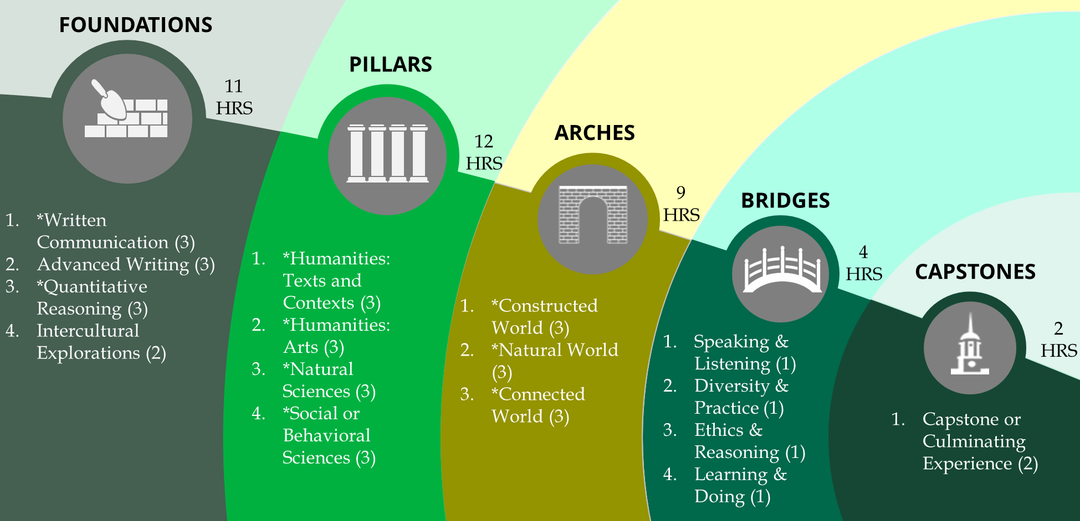

The recommended model includes a minimum of 38 credit hours across five general education categories: foundations, pillars, arches, bridges, and capstones. For each category, components limited to only courses that have Ohio Transfer Module (OTM) approval to meet state general education requirements are noted with an asterisk (*). Minimum credit hours are noted for each category and each component.

Category 1: Foundations (minimum = 11 credit hours)
Foundations ground general education.
Foundations should provide coursework to develop students’ abilities to communicate effectively through writing, to use quantitative reasoning, and to develop global and domestic intercultural knowledge and competence. For each requirement, the majority of the course content and experiences should focus on the common goal.
Requirement(s) | Min. Hrs. | Common Goal(s)
*Written Communication | 3 | Written Communication
Advanced Writing | 3 | Written Communication
*Quantitative Reasoning | 3 | Quantitative Reasoning
Intercultural Explorations | 2 | Intercultural Knowledge and Competence

Category 2: Pillars (minimum = 12 credit hours)
Pillars support breadth of knowledge.
Pillars provide an understanding of knowledge and methods associated with the humanities, natural sciences, and social sciences. Through breadth of knowledge, pillars allow students to explore multiple viewpoints, ideas, and disciplines important for any career. Courses must be accessible for all learners to explore and develop an understanding of broad disciplines important for a liberal arts education.
GE Component | Min. Hrs. | Common Goal(s)
*Humanities: Texts and Contexts | 3 | Arts and Humanities Knowledge & Methods
*Humanities: Arts | 3 | Arts and Humanities Knowledge & Methods
*Natural Sciences | 3 | Natural Science Knowledge & Methods
*Social or Behavioral Sciences | 3 | Social or Behavioral Science Knowledge & Methods

Category 3: Arches (minimum = 9 credit hours)
Arches span disciplinary perspectives.
Arches should enable students to explore a single topic from different disciplinary perspectives. Arches include nine credit hours (minimum) and are multi-disciplinary. Example topics (subject to faculty development) include Sustainability, Global Connections, and Heath & Wellness.
GE Component | Min Hrs. | Common Goal(s)
*Constructed World | 3 | Critical Thinking and Teamwork  - as a set of courses or individual courses
*Natural World | 3
*Connected World | 3

Category 4: Bridges (minimum = 4 credit hours)
Bridges connect disciplines to common goals.
Bridges should focus explicitly on specific common goal learning outcomes. Course options should encourage students to build competencies through experiences in a liberal arts discipline and/or their major or minor field.
GE Component | Min Hrs. | Common Goal(s)
Speaking & Listening | 1 | Oral Communication
Ethics & Reasoning | 1 | Ethical Reasoning
Diversity & Practice | 1 | Intercultural Knowledge and Competence
Learning & Doing | 1 | Integrative Learning

Category 5: Capstones (minimum = 2 credit hours)
Capstones complete general education.
Capstones should be a capstone course or culminating experience that requires students to integrate and apply what they have learned. Typically offered at the end of a student’s educational journey, capstones may be specific to the major, an arch requirement, or combined with a bridges course.
GE Component | Min Hrs. | Common Goal(s)
Capstone or Culminating Experience | 2 | Critical Thinking  Integrative Learning

NOTES

Course option fulfilling the Advanced Writing requirement may be at any level and may be specific to major requirements. At least one option must be OTM-approved as Second Writing.
Course option fulfilling the Intercultural Explorations requirement must be at the 1000 or 2000 level. At least one option must be OTM-approved for any of the five state-defined areas of distribution. Courses fulfilling the Intercultural Explorations requirement may also fulfill (“double-count”) as a Pillar or Arches requirement.
Course options fulfilling Pillar requirements must be OTM-approved for the corresponding OTM area of distribution.
Course option fulfilling Arch requirements must be distinct from course options fulfilling Pillar requirements. Double-counting courses as fulfilling both Pillar and Arch requirements is not permitted.
Most students will be required to complete one Arch; exceptions will be made for select populations (e.g., transfer students who complete the OTM) or select programs (e.g., degree completion).
Students may complete Arch requirements by completing individual courses not included in an Arch topic (i.e., Breadth of Knowledge). Individual course options not included in an Arch topic must include course content and experiences to achieve both Critical Thinking and Teamwork common goal learning outcomes.
Course options fulfilling Bridge requirements may be (1) standalone courses (1+ credit hours), (2) courses taken concurrently with other courses, or (3) courses with a significant portion of content and experiences is focused on common goal learning outcomes.

