Programs Committee Agenda
4.19.22

PROGRAM CHANGES
- Russ College of Engineering and Technology
Program Code: AA5023
Program Name: Engineering Technology
Department/School: Engineering Technology and Management
Contact: Gina Orr orrg@ohio.edu
Desired Start Date: Fall 22/23

Manufacturing is moving forward at a fast pace with new technologies in the area of robotics and automation. In order to keep up with industry demands and its immediate need for qualified employees, changes within the program are deemed necessary.
- ENGT 2330 Automation & Robotics II (3-new course) is replacing ENGT 2870 Safety Management (3).
- Remove the Technical Elective option and reinstate ENGT 1500 Machine Repair (3) as a REQUIRED course

- Russ College of Engineering and Technology
Program Code: BS7270
Program Name: Aviation Management
Department/School: Aviation
Contact: Deak Arch arch@ohio.edu
Desired Start Date: Fall 22/23

a. The communication requirements of the degree will be changed to mirror the Communication Studies Minor (ORCOMS) requirements to provide a more tailored degree for the graduates of the program. Changing the degree to allow the student to be able to select the COMS classes that align more with career goals will strengthen the degree.
b. Remove AVN 3800 (General Aviation Operations and Management) as a degree requirement; the course is not currently offered by the department and there are no plans to offer the course in the foreseeable future.

- Honors Tutorial College
Program Code: BS1902
Program Name: Biological Sciences HTC
Department/School: Biological Sciences
Contact: Soichi Tanda tanda@ohio.edu
Desired Start Date: Fall 22/23

We are moving to merge future HTC Neuroscience students into the HTC Biological Sciences program (current Neuro students will complete the program as it currently stands). We are proposing to update HTC BIOS requirements to allow flexibility for students focusing on neuroscience or other areas of biological sciences.
a. The proposal splits the BIOS course requirements into two requirements – Biological Sciences Core courses and Biological Sciences (or equivalent) Elective courses to create flexibility and choice.
b. The proposal removes courses from the PHYS requirement to focus on courses that are required for professional and graduate schools.
This results in a reduction of 4-6 credit hours depending on what courses students select to take.

- Honors Tutorial College
Program Code: BS1941
Program Name: Hearing, Speech, and Language Sciences HTC
Department/School: Hearing, Speech, and Language Sciences
Contact: Chao-Yang Lee leec1@ohio.edu
Desired Start Date: Fall 22/23

We are altering two requirements based on course availability and curricular need. Our HTC curriculum has always mirrored the traditional HSL (formerly CSD) major because we want to make sure HTC students complete courses expected by the American Speech-Language-Hearing Association, just as traditional students do. These two changes (to the traditional major) took place back in 2019 and 2020 and therefore we need to update the HTC major.
a. Replace both CSD 3410 and 4410 with CSD 4420. CSD 3410 and 4410 are no longer offered and 4420 meets the same learning outcomes.
b. MATH 1300 will be removed from the outside requirements as additional Math isn’t necessary for our students beyond our Statistics requirement.
c. The name change request for the school has already been sent to UCC for the non-HTC major and minor. We will move back to Hearing, Speech and Language Sciences.

- College of Business
Program Code: BS6108
Program Name: Business Studies
Department/School: Department of Management
Contact: Brian Hoyt (hoyt@ohio.edu) & Ana Rosado Feger (resadof@ohio.edu)
Desired Start Date: Fall 22/23

The Bachelor of Science in Business, led from the College of Business, is designed to comply with AACSB accreditation requirements and maximize the potential of the asynchronous online program. The CoB is proposing the following changes:
• Adding an existing certificate delivered asynchronous online – Festivals, Events, and Entertainment Management (FEEM), 15
• Add TAG compliant MATH 1500 Introductory Statistics (3) to the Pre-Major core options to facilitate transfers. Math 1500 meets the prerequisite requirement for ECON 1030 Principles of Microeconomics (3) for transfers who have TAG 1500 but not MATH 1200 College Algebra (4). MATH 1500 also meets the Brick Quantitative Reasoning requirement.
• Add BA 1100 Introduction to Business and Ethical Reasoning (3) to the program’s Business Skills requirement and meets the BRICKS Ethics and Reasoning requirement. This addition provides additional flexibility for students in meeting this requirement.

These changes constitute less than 50% change to the program. Proposed changes have been assessed for TAG compliance and prepared with the new Ohio University general education curriculum in mind. Other units or programs outside of the College of Business are impacted by these changes. All courses added in this proposal are existing courses.

- College of Arts & Sciences
Program Code: CTWLTH
Program Name: Wealth and Poverty Certificate
Department/School: Geography
Contact: Yeong Kim (kimy1@ohio.edu)
Desired Start Date: Fall 22/23

It is proposed to:
1) add POLS 2300 Democracies & Dictatorships Around the World (3) to the list of Introduction courses.
2) add SOC 3090C Sociology of Appalachia to the Service Learning courses; and
3) add 10 courses to the electives, as they are either newly proposed or taught by new instructors.
ANTH 3510 - Political Anthropology (3)
ANTH 4250 - Ethnographies of Global Capitalism (3) – new course
ECON 2510 - Global and Local Food Economies (3) – new course
ECON 2600 - Economics of Health Disparities (3) – new course
GEOG 4560 - The Just and Sustainable City (3)
HLTH 2230 - Introduction to Appalachian Studies (3)
INST 1010 - Understanding the World (3) – new course;
INST 2700 - Social Media and Global Change (3)
POLS 3200 - Urban Politics (3)
POLS 4640 - Global Humanitarianism (3)
4) remove 3 courses from the Certificate’s electives, as they have not been offered in the past five years.
ANTH 3770 - Peasant Communities (3)
GEOG 4280 - Community Geography (3)
SW 3203 - International Social Work and Social Welfare (3)

- College of Arts & Sciences
Program Code: PH4215
Program Name: History
Department/School: History
Contact: Assan Sarr (sarr@ohio.edu) & Brian Schoen (schoen@ohio.edu)
Desired Start Date: Fall 22/23

We are proposing modest alterations to our program requirements to enable our graduate students to complete the program more quickly without sacrificing quality. The changes we are proposing include
a. Eliminating the requirement of third and cognate fields. The existing program requires that students take 3 courses in the third field and 2 courses in the cognate (i.e. outside) field. With the changes, these requirements will be eliminated.
b. Increasing the number of courses taken in the primary field. Instead of taking 4 courses in this field, students will now take 6 courses.
c. Requiring one of the primary field courses to be an independent study (HIST 6930 Directed Study in History in our existing catalogue) in the 4th semester with the student’s advisor. This course will be dedicated to completing the student’s dissertation prospectus, which will be defended at the end of that same semester. This change is intended to ensure timely progress.
d. Identifying and requiring both a dissertation advisor and a second reader in the primary field. e. Adding one new course (HIST 6908 Colloquium in World History) that was recently created and approved and including existing fields and courses in Asia, Africa, and Middle East that have not been included since fields were last updated.
These changes will only reduce the total number of credit hours students take to fulfill their course requirements by 8 credit hours (from 54 to 48 hours).

- College of Arts & Sciences
Program Code: BS3105
Program Name: Actuarial Science Major
Department/School: Department of Mathematics
Contact: Yaqin Feng (fengy@ohio.edu)
Desired Start Date: Fall 22/23

We are dropping the required courses FIN 4360 Life Insurance because the Finance Department wants to stop offering the course.
We are dropping ET 2100 Engineering Programming as one of the optional computing courses and making MATH 4530 Statistical Computing the required course. ET 2100 has marginal relevance to the actuarial profession whereas MATH 4530 will better prepare our actuarial students for the profession.
This change decreases total program hours by 3 credits.

- College of Fine Arts
Program Code: BF5057
Program Name: Studio Art- Art Therapy
Department/School: School of Art + Design
Contact: Karla Hackenmiller (hackenmi@ohio.edu) & Angela Sprunger (sprunger@ohio.edu)
Desired Start Date: Fall 22/23

This proposal seeks to eliminate one sub-requirement and streamline the course elective listings. Neither of these changes affects the number of courses or total credits required. Due to a recent loss of ability to offer as many different studio options as intended, we would like to change a set of “required” elective options under the category of “Studio Art 3000/4000-Level Courses” into “suggested” courses and instruct the student to consult with their Advisor to select the most appropriate course based on what is offered that year.
The second change is reformatting a catalog entry by altering the way that Art History elective options are listed. This was motivated by a recommendation from the Registrar to simplify things by listing only the excluded elective options. This helps to keep the program current and alleviate repeated Program Update submissions that would be needed simply due to a new course being added as an elective option.
The third request is to add six new courses as options under the 2000-level and 3/4000-level Studio headings, two and four respectively. These courses (ART 2110, 2120, 3110, 3120, 3330 and 3730) were all approved in March 2022.
There is no change in credit hours.

- College of Fine Arts
Program Code: BF5154
Program Name: Dance Performance and Choreography
Department/School: School of Dance
Contact: Tresa Randall (randall@ohio.edu)
Desired Start Date: Fall 22/23

These proposed changes will allow us to achieve several goals:
• reflect current course offerings
• allow greater flexibility and more course options in certain curricular areas
• reduce the Eurocentrism of the studio curriculum by eliminating two courses and moving a course in African technique to the foundational core
• formalize the Colloquium requirement, which has long been an expectation of students without being credit-bearing
• adjust overall credit hours to provide better balance between requirements and electives

- Move DANC 1250: African Dance Technique I from “Studio Dance Techniques” to “Foundational Dance Requirements”.
- Add DANC 3600: Dance Colloquium (1 cr) to “Foundational Dance Requirements”
- Remove DANC 4220 and DANC 4221 from “Studio Dance Techniques” requirements.
- Include MUS 1210: Introduction to World Music and MUS 1250: Introduction to Music History and Literature as acceptable course options to satisfy the Music requirement
- Remove DANC 3130: Dance Notation I from the “Dance Notation and Music” requirements.
- Remove DANC 3303: Bartenieff Fundamentals from the “Dance Kinesiology and Somatic Study” requirement.
- Include AT2690: Health and Injury in Performing Arts, EXPH1490: Introduction to Exercise Science, AT3693: Musculoskeletal Movement in Performing Arts, and EXPH2200: Applied Kinesiology as acceptable course options for the “Dance Kinesiology and Somatic Study” requirement.
- Change “Dance Electives” requirement to “Dance and Fine Arts Electives,” and allow any course in Fine Arts (Dance, Music, Art, Theater, Film) to satisfy the elective requirement.

These changes result in a reduction of 2 credit hours.

- College of Fine Arts
Program Code: BF1906
Program Name: Dance Tutorial
Department/School: School of Dance
Contact: Tresa Randall (randall@ohio.edu)
Desired Start Date: Fall 22/23

These proposed changes will allow us to achieve several goals:
• reflect current course offerings
• allow greater flexibility and more course options in certain curricular areas
• reduce the Eurocentrism of the studio curriculum by eliminating two courses and moving a course in African technique to the foundational core
• formalize the Colloquium requirement, which has long been an expectation of students without being credit-bearing
• adjust overall credit hours to provide better balance between requirements and electives

- Move DANC 1250: African Dance Technique I from “Studio Dance Techniques” to “Foundational Dance Requirements”.
- Add DANC 3600: Dance Colloquium (1 cr) to “Foundational Dance Requirements”
- Remove DANC 4220 and DANC 4221 from “Studio Dance Techniques” requirements.

No change in credit hours.

- College of Fine Arts
Program Code: BA5150
Program Name: Dance
Department/School: School of Dance
Contact: Tresa Randall (randall@ohio.edu)
Desired Start Date: Fall 22/23

These proposed changes will allow us to achieve several goals:
• reflect current course offerings
• allow greater flexibility and more course options in certain curricular areas
• reduce the Eurocentrism of the studio curriculum by eliminating two courses and moving a course in African technique to the foundational core
• formalize the Colloquium requirement, which has long been an expectation of students without being credit-bearing
• adjust overall credit hours to provide better balance between requirements and electives

- Move DANC 1250: African Dance Technique I from “Studio Dance Techniques” to “Foundational Dance Requirements”.
- Add DANC 3600: Dance Colloquium (1 cr) to “Foundational Dance Requirements”
- Remove DANC 3303: Bartenieff Fundamentals from the “Dance Kinesiology and Somatic Study” requirement.
- Include AT2690: Health and Injury in Performing Arts and EXPH1490: Introduction to Exercise Science as acceptable course options for the “Dance Kinesiology and Somatic Study” requirement.
- Reduce the number of Dance Electives from 10 to 8 credit hours for BA5150.

These changes reflect an increase in 0.5 credit hours.

- College of Health Sciences & Professions
Program Code: BS1221 (ND1220)
Program Name: Traditional BSN
Department/School: School of Nursing
Contact: Sherleena Buchman
Desired Start Date: Fall 22/23

The requested changes are
1) To change the capstone course from NRSE 4600 Nursing Excellence to NRSE 4401 Professional Practice in Nursing;
2) We use the NRSE 4600 course for our RN to BSN program as well, and need to keep it as the capstone for the RN to BSN Program, so we need to create a duplicate course with a new name, the course name will be NRSE 4601, for this program;
3) NRSE 3141 Mental Health and NRSE 4151 Nursing Care of Populations: Family and Community will both have 0.1 clinical hours converted to lab hours, and
4) We will add Math 1500 as a viable options for our students to meet the Bricks: Foundation: Quantitative Reasoning requirement, and
5) We are dropping the BIOS 2225 lab as we currently have 13 requirements under the Bricks: Pillars: Natural Sciences and by decreasing the lab, we will remain at 11 credits and 6) now that CHEM 1205 and 1205L are approved as an Arch: Natural World, we are adding this as a requirement instead of offering a student choice.
Our program consists of 49 non-nursing credits; 71 nursing credits, and 120 total credits. The general education requirement credit hours will reduce from 51 to 49.

- College of Health Sciences & Professions
Program Code: CTPAHW
Program Name: Performing Arts Health and Wellness
Department/School: School of Applied Health Sciences and Wellness
Contact: Jeff Russell (russelj4@ohio.edu)
Desired Start Date: Fall 22/23

EXPH 1001 is being taught sporadically secondary to insufficient faculty. EXPH 1490 is a suitable replacement. The course has more scientific content, but still should be attainable for CTPAHW students. The specific change being requested is that the requirement specify taking either EXPH 1001 or EXPH 1490, with EXPH 4140 as an approved alternative. This will increase the minimum credit hour count from 16 to 16–17 because EXPH 1001 is 2 credit hours, while EXPH 1490 is 3 credit hours.

- College of Health Sciences & Professions
Program Code: BS8119
Program Name: Health Services Administration
Department/School: School of Social and Public Health
Contact: Cory Cronin (croninc@ohio.edu) & Cristina Popescu (cristinap@ohio.edu)
Desired Start Date: Fall 22/23

One of the proposed changes would occur in the Professional Course Requirements section of the major. It would add PSY 1110 as an alternative to PSY 2110, such that students could take either course to meet the statistics requirement. The second change would revise current Learning Outcome #5 to reflect program competencies more accurately.

- Patton College of Education
Program Code: BS6228
Program Name: Early Childhood and Elementary Education
Department/School: Department of Teacher Education
Contact: Sara Hartman (hartmans@ohio.edu)
Desired Start Date: Fall 22/23

The program is adding ECEE 3001 (Combined Junior Clinical Experiences in Elementary Settings) to the official program of study. This change increases the required credit hours by 1 to equal 126.

- Patton College of Education
Program Code: BS6309, BS6314, BS6315, BS6395, BS6396, BS6397
Program Name: Integrated Science, Life Science, Earth/Space Science,
Physical Science- Physics & Chemistry, Physical Science- Physics,
Physical Science- Chemistry,
Department/School: Department of Teacher Education
Contact: Danielle Dani (dani@ohio.edu)
Desired Start Date: Fall 22/23

As part of a broader program reorganization, we are removing the course EDSE 3510: Secondary School Teaching and Monitoring of Learning (3 credits) and replacing it with EDTE 3540 Introduction to Inquiry and the Nature of Science (3 credits).

- Patton College of Education
Program Code: BS5012, BS5024
Program Name: French Education & Spanish Education
Department/School: Department of Teacher Education
Contact: Matt Felton Koestler (felton@ohio.edu) & Anne Scott (scotta2@ohio.edu)
Desired Start Date: Fall 22/23

We are removing the course EDSE 3510: Secondary School Teaching and Monitoring of Learning (3 credits) as we will no longer be offering the course. This was a general methods course, and the students are already better served by the existing Modern Language-specific and French-specific or Spanish-specific coursework.

- Patton College of Education
Program Code: BS6306
Program Name: Integrated Language Arts
Department/School: Department of Teacher Education
Contact: Matt Felton Koestler (felton@ohio.edu) & Linda Rice (ricel2@ohio.edu)
Desired Start Date: Fall 22/23

The English department will no longer be offering ENG 3560 Young Adult Literature (3 credits). In addition, the Department of Teacher Education is discontinuing EDSE 3510: Secondary School Teaching and Monitoring of Learning (3 credits) as part of a broader reorganization of its programs. These two courses will be replaced by EDSE 3520: Introduction to Secondary Language Arts Methods (3 credits) and an ENG elective of 2000 or higher. excluding ENG 4510, ENG 4520, ENG 2800, ENG 3***J, ENG 4911, and ENG 4912.

- Patton College of Education
Program Code: BS6307
Program Name: Integrated Mathematics
Department/School: Department of Teacher Education
Contact: Matt Felton Koestler (felton@ohio.edu) & Allyson Hallman-Thrasher (hallman@ohio.edu)
Desired Start Date: Fall 22/23

As part of a broader program reorganization, we are removing the course EDSE 3510: Secondary School Teaching and Monitoring of Learning (3 credits) and replacing it with EDSE 3530 Introduction to Secondary Mathematics Teaching (3 credits).

- Patton College of Education
Program Code: BS6308
Program Name: Integrated Social Studies
Department/School: Department of Teacher Education
Contact: Matt Felton Koestler (felton@ohio.edu) & Mike Kopish (kopish@ohio.edu)
Desired Start Date: Fall 22/23

As part of a broader program reorganization, we are removing the course EDSE 3510: Secondary School Teaching and Monitoring of Learning (3 credits) and replacing it with EDSE 3550 Intro to Secondary Social Studies Methods (3 credits).

NEW PROGRAM/CERTIFICATE
- College of Fine Arts
Program Code: MAXX03
Program Name: Master of Applied Arts in Health
Department/School: School of Interdisciplinary Arts
Contact: Kamile Geist (geistk@ohio.edu)

The Master of Applied Arts in Health (MAAH) will be a 30-credit hour, hybrid, 1-year program (Fall, Spring, Summer) designed for students with an undergraduate degree in fine arts who want to expand their practice to safely and effectively engage within the arts in healthcare and community environments post-graduation. The MAAH foundational curriculum core includes 3 Arts in Health courses, 1 elective in Fine Arts, and 2 electives in a health sciences related discipline. Synthesis courses include an end-of-program Arts in Health graduate topics course and an immersive supervised internship at a pre-approved site where Arts in Health programming is established, and on-site supervisors are available.

Admitted students must have an undergraduate degree in a fine arts discipline (e.g., Bachelor of Music, Bachelor of Fine Art, Bachelor of Dance, etc.) in the United States or its equivalent from a university outside of the United States.

Category | Fall | Spring | Summer
Foundations (Breadth) | IART 5801 (3) Introduction to Arts in Health | IART 5802 (3) Arts in Health Community Project (new)
Foundations (Breadth) | Health Sciences or Related Topic Elective (3) | Fine Arts Elective (3)
Foundations (Depth) | FAR 5403 (3) The Artist in Healthcare (new) | Health Sciences or Related Topic Elective (3)
Synthesis |  |  | FAR 5901 Special Topics in Arts in Health (3) (new)
Synthesis |  |  | FAR 5911 Arts in Health Professional Internship (9) (new)

- College of Business
Program Code: NDAXX6
Program Name: Accelerated Graduate Pathway Strategic Leadership
Department/School: Department of Management
Contact: Ana Rosado Feger (rosadof@ohio.edu)

Exceptionally qualified and prepared students who are seeking to expand their management knowledge and leadership skills beyond the undergraduate coursework required for completion of the CTLEAD or Select Leaders (SL) or Emerging Leaders (EL) will be afforded the opportunity to complete CTMLCG with their bachelor’s degree.

CTMLCG is a nine-hour graduate certificate currently offered as part of the Master of Science in Management graduate degree program or standalone. Courses include MGT 5001, 5002, and 5003 and are offered online as 7- week courses and only require that MGT 5001 be taken prior to either of the other two courses. Students will be eligible to apply when they have earned or are in process of completing 75 credit hours; students will be eligible to enroll in courses when they have earned or are in process of completing 90 credit hours.

- College of Business
Program Code: NDAXX7
Program Name: Accelerated Graduate Pathway Human Resources
Department/School: Department of Management
Contact: Ana Rosado Feger (rosadof@ohio.edu)

Exceptionally qualified and prepared students who are seeking to expand their human resources knowledge and skills beyond the undergraduate coursework required for completion of the CTHRMU will be afforded the opportunity to complete CTHRMG with their bachelor’s degree.

CTHRMG is a nine-hour graduate certificate currently offered as part of the Master of Science in Management graduate degree program or standalone certificate. Courses include MGT 5030, 5031, and 5032 and are offered online as 7- week courses. Students will be eligible to apply when they have earned or are in-process of completing 75 credit hours; students will be eligible to enroll in courses when they have earned or are in-process of completing 90 credit hours.

- College of Business
Program Code: CTX48U
Program Name: Business Cybersecurity Management Certificate
Department/School: Analytics & Information Systems
Contact: Gabe Giordano (giordano@ohio.edu)

This certificate is focused on building skills in cybersecurity for business information systems. The Management Information Systems (MIS) business courses for this certificate will include topics such as business database security, security in the systems analysis and process, and business risk management & security policies. The Information and Telecommunication Systems (ITS) electives are focused on computing-network cybersecurity, and they cover topics such as data communication, compliance, network security, and data encryption. This blend of two areas will give students a mix of business analysis and hands-on networking focused skills. This will allow them to help manage the growing cybersecurity needs in any business area.

For the Certificate curriculum, students will be required to take three business courses and two ITS courses (15 credits total). All of these courses are already offered.
MIS core courses:
MIS 2200 – Systems analysis and Design
MIS 2800 – Database Management
MIS 3800 – Business Cybersecurity

Students will take two of the following elective courses in ITS:
ITS 2300 - Data Communication
ITS 4310 - Privacy
ITS 4330 - IT Compliance and Planning
ITS 4510 - Telecommunication Network Security
ITS 4530 - Encrypted Communications

The intended audience includes any business major, and students from elsewhere that want a business-focused cybersecurity skillset.

- College of Health Sciences & Professions
Program Code: BSXX31
Program Name: Nutrition and Food Studies
Department/School: School of Applied Health Sciences & Wellness
Contact: Rob Brannan (brannan@ohio.edu)

The Bachelor of Science in Nutrition and Food Studies connects what we eat to how we live. The 120-credit hour program features the following thematic elements:
-Nutrition Foundations (13%, 15 cr): Solid nutrition foundations are established in nutrition across the lifespan, in the community, and for active individuals, and is capped with a course that connects whole and fresh foods to general health and well-being.

-Contemporary Food Awareness (13%, 15 cr): A unique pathway from the student farm to the McCracken Hall kitchen to Culinary Services informs and transforms the student perspective of our food system into real world terms.

-Cultural, Social, and Political Aspects of Food Systems (20%, 24 cr total): Students weave a path through the American food system using the lens of Politics and Policy (5%, 6 cr), Social Sciences and Humanities (10%, 12 cr), and Food in Culture or the Arts (5%, 6 cr)

-Environment and Sustainability (8%, 9 cr) Allows the student to complete the Environmental Studies, Resiliency, and Sustainability certificate.

-Remaining Gen Ed, CHSP Requirement, and Capstone (28%, 33 cr)

-Electives: 20% (24 cr) The degree will be a hands-on, transformative educational experience and highly sought after that takes advantage of our thriving regional food system and organizations focused on increasing access to healthy, local food.

Category | Number of Credits | Percent of Total
Existing or repackaged curricula: Courses from existing inventory of courses at OHIO | 64 | 93%
Revised or redesigned curricula: Courses for which content has been revised for the new program | 3 | 4%
New curricula: Courses developed for the new program that haven't been offered at OHIO | 2 | 3%
Total: Must match the total number of credit hours required for the program | 69 | 100%

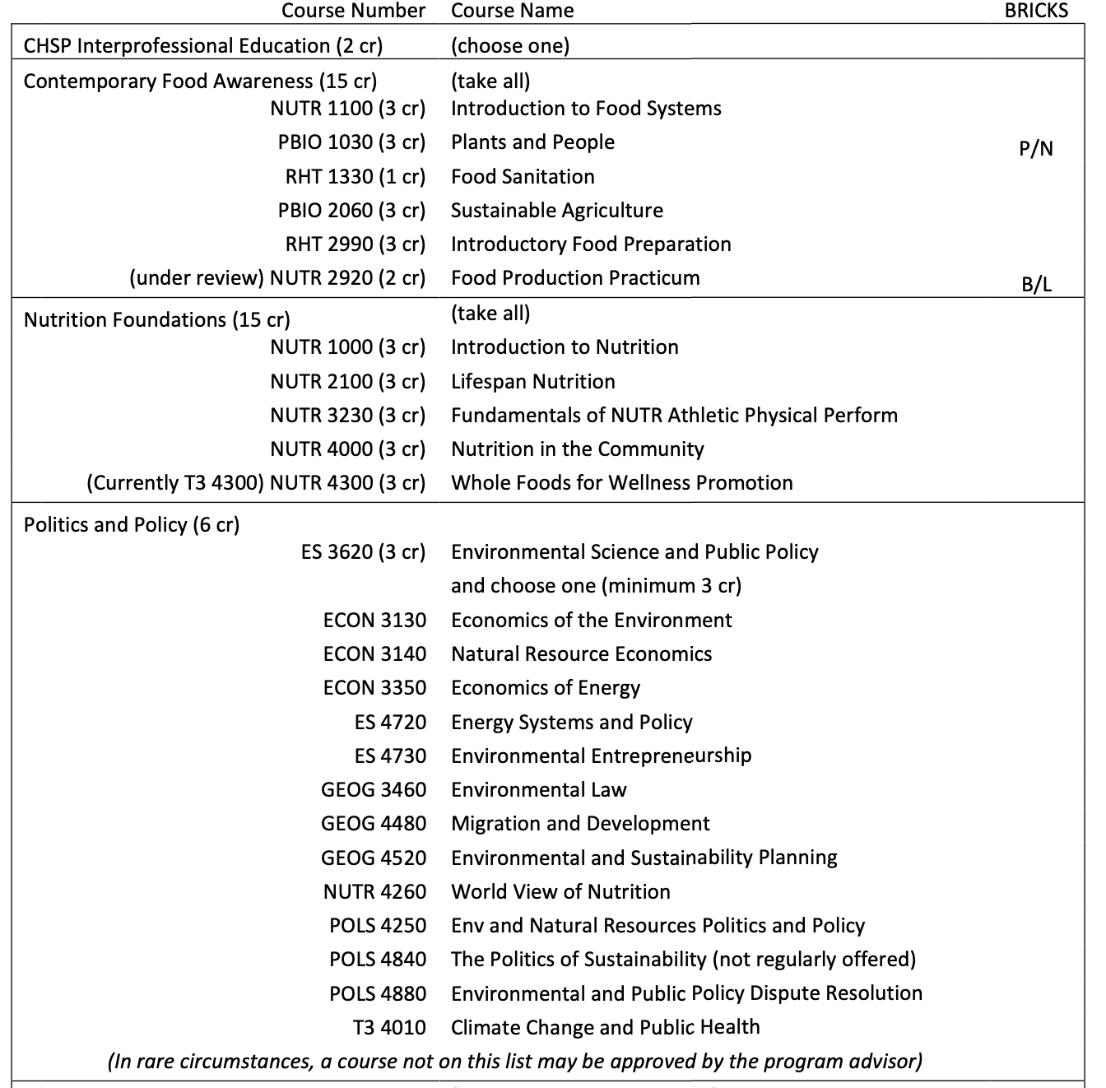
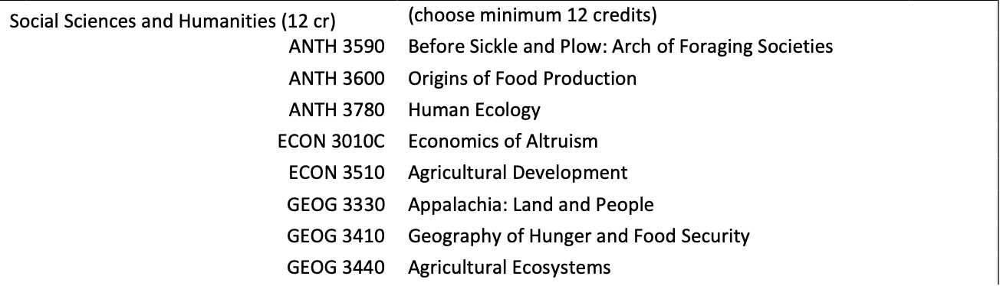
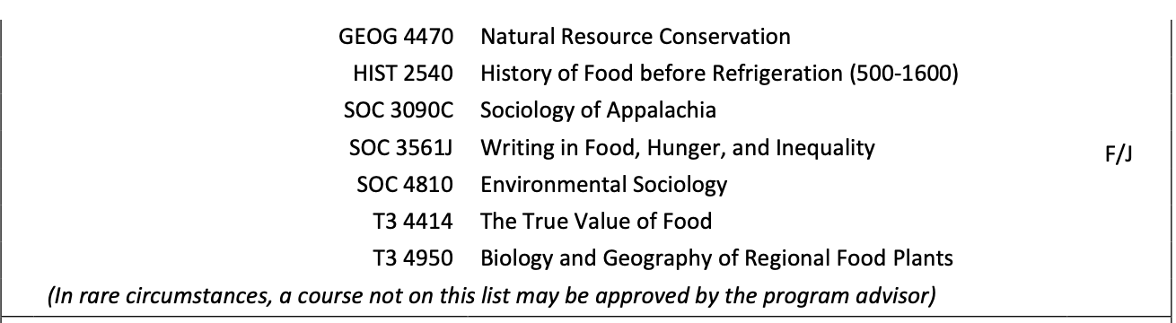

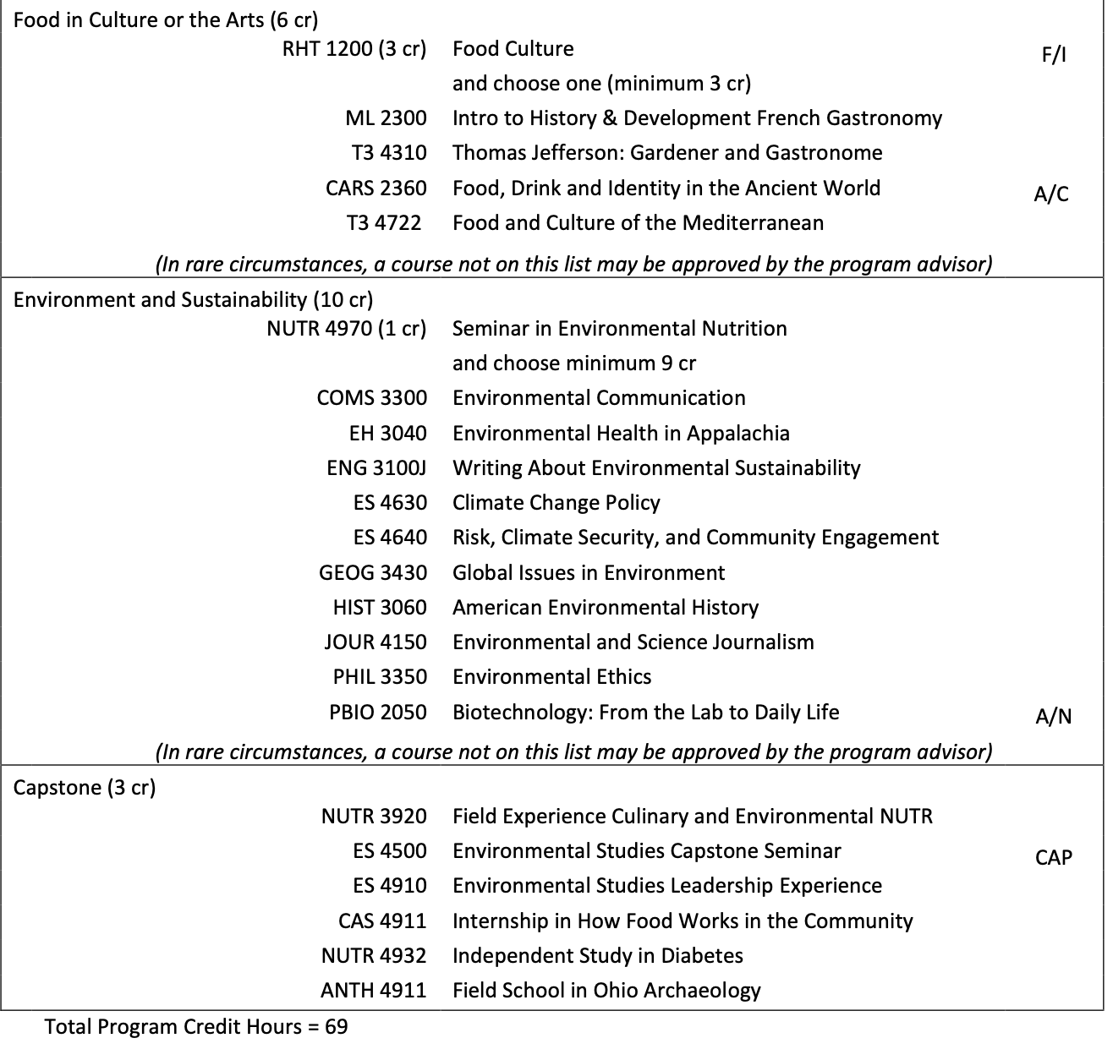

EXPEDITED
- College of Business
Program Code: ORBSAD
Program Name: Business Minor
Department/School: College of Business
Contact: Jim Strode (strode@ohio.edu)
Desired Start Date: Fall 22/23

The minor is being updated to allow students the option to take an analytics course (QBA 1721) in lieu of a business information systems course (MIS 2021). No change in credit hours.

- College of Arts & Sciences
Program Code: BA4252
Program Name: Anthropology
Department/School: Department of Sociology and Anthropology
Contact: Haley Duschinski (duschins@ohio.edu)
Desired Start Date: Fall 22/23

Request to relocate two new 2000-level courses, ANTH 2400 and ANTH 2700, from Section (2) of the DARS (majors) to the section titled “Additional Anthropology Courses Taken to Meet the 33 Hour Requirement Are Listed Below” Request to relocate a relatively new 4000-level course, ANTH 4750, from “Additional Anthropology Courses Taken to Meet the 33 Hour Requirement” to Section (4) of the DARS (majors).

- College of Arts & Sciences
Program Code: CTLJCU
Program Name: Law, Justice & Culture Certificate
Department/School: History/ CLJC
Contact: Kevin Uhalde (uhalde@ohio.edu)
Desired Start Date: Fall 22/23

Adding thirteen courses to the list of electives and deleting two. The additional courses have been approved by the CLJC undergraduate committee. The deleted courses were T3 courses and not converted for the new BRICKS system. No other changes are being made and no departments or schools are affected.

- College of Health Sciences & Professions
Program Code: MS8174
Program Name: Master of Science in Athletic Training- Professional
Department/School: School of Applied Health Science and Wellness
Contact: Kristine Ensign (ensign@ohio.edu)
Desired Start Date: Fall 22/23

Based on student feedback and recommendations from the recent Commission on Accreditation for Athletic Training Education (CAATE) peer review of our program we are making a change to AT 5340. Currently, AT 5340, a three-credit-hour course, occurs online during the Spring semester of the second year of the program. To lessen the student workload during the Spring semester of the second year of the program (while the students are engaged in their full-time clinical immersive experiences), we are creating AT 5341, a one-credit-hour course, and AT 5342, a two-credit hour course. AT 5341 and AT 5342 will cover the same content as AT 5340 currently does, but it will be spread over the full second year instead of during just the Spring semester. This will increase the Fall year 2 credit hours from 15 to 16 and decrease Spring year 2 credit hours from 18 to 17. Total credit hours for the program will remain unchanged at 61.

- College of Fine Arts
Program Code: MM5182 & MM5190 (Graduate Catalog Cleanup)
Program Name: Music Education
Department/School: School of Music
Contact: Margaret Kennedy-Dygas (kennedm1@ohio.edu)
Desired Start Date: Fall 22/23

Complete the following courses for a minimum of 10-12 hours:
MUS 6200 Seminar in Theory, Music History and Literature (2 cr) OR
MUS 6750 Introduction to Graduate Studies in Music Education (3 cr)

MUS 6700 Contemporary Trends in Music Education (3 cr)
MUS 6710 Advanced Topics in Music Education I (3 cr)

MUS 6770 Organization and Administration of School Music (2 cr) OR
MUS 6771 Organization and Administration of School Music Programs (3 cr)

Track Requirements (DELETE this entire section. Tracks are being discontinued.)

Music Theory and Music History (DELETE Composition in this title)

Complete a minimum of 6 hours: at least 3 hours in graduate-level MUS theory and 3 hours in graduate-level MUS history. Course selections must be made in consultation with the Major Advisor.

Electives (DELETE this section)

Supportive Studies in Music
Complete a minimum of 9 hours in additional graduate level MUS courses. Course selections must be made in consultation with the Major Advisor.

One of the following literature courses must be chosen:
MUS 5210 Literature of Choral Music (2 cr)
MUS 5213 Literature of Orchestral Music (2 cr)
MUS 5216 Literature of Band Music (2 cr) OR
MUS 5217 Literature of Band Music (3 cr)

Culminating Experience Students will complete a recital, thesis or professional/clinical project. Students must complete at least 2 credits of the appropriate capstone course, depending on the culminating experience chosen.

