Programs Committee Agenda
(Updated)
4.18.23

PROGRAM CHANGES
- College of Health Sciences & Professions
Program Code: BS8119
Program Name: Health Services Administration
Department/School: Social and Public Health
Contact: Cory Cronin (croninc@ohio.edu), Cristina Popescu (cristinap@ohio.edu)
Desired Start Date: Fall 2023

This proposal reorganizes the Health Services Administration major, with some requirements adjusted (e.g., ECON 2650/3150 moving from elective to required) to meet the expectations for program certification through the Association of University Programs in Health Administration (AUPHA). Overall, the proposed change would eliminate tracks within the program and require all students to complete the same set of core requirements (supplemented by two electives that allow for the pursuit of individual interests). The changes being proposed will ensure that students are being provided content from both prior tracks and include some consolidation where there was overlap in content previously, while also allowing for consistency in course offerings and clear expectations that align with AUPHA certification. There is no change in learning outcomes.
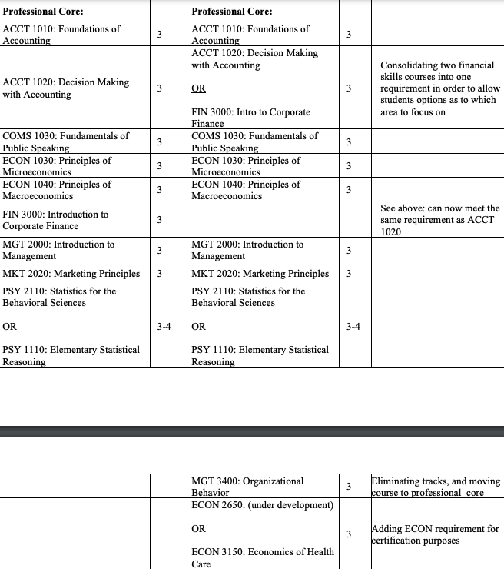
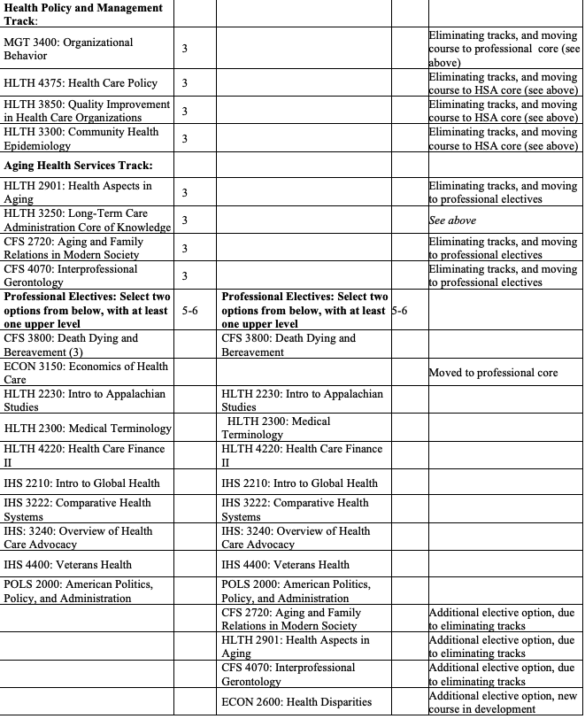
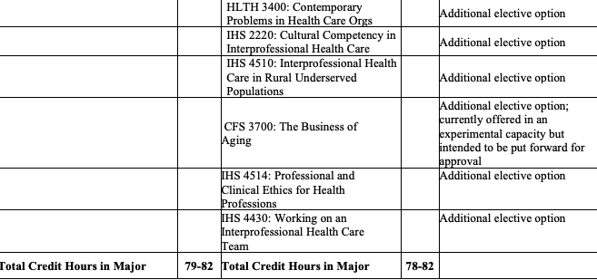
- College of Health Sciences & Professions
Program Code: OR5380
Program Name: Health Services Administration Minor
Department/School: Social and Public Health
Contact: Cory Cronin (croninc@ohio.edu), Cristina Popescu (cristinap@ohio.edu)
Desired Start Date: Fall 2023

The current HSA minor requires HLTH 2170, HLTH 3350, and HLTH 3400, plus two additional HLTH classes selected from listed options. Due to reorganizing the content of HLTH 3350 and HLTH 3400, the new minor will shift to only two required courses – HLTH 2170 and HLTH 3350 – and three additional classes selected from listed options. This is in conjunction with course changes made to the HSA major.
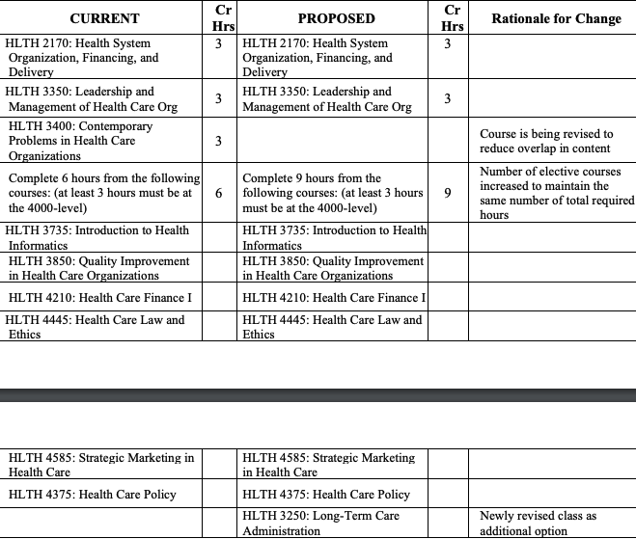

- College of Health Sciences & Professions
Program Code: AU5317
Program Name: Audiology
Department/School: Hearing, Speech and Language Sciences
Contact: Joann Benigno (benigno@ohio.edu)
Desired Start Date: Fall 2023

The faculty members in Hearing, Speech and Language Sciences are proposing to add the following four courses to the Audiology Curriculum: HSLS 6320, HSLS 8400, HSLS 8500, and HSLS 8850. These courses are being added to satisfy requirements for accreditation and certification in audiology. The proposed changes will increase the minimum number of credit hours to earn the degree from 100 to 105, a total of 5 credit hours. These proposed changes in credit hours will not require any new resources.

- College of Health Sciences & Professions
Program Code: MS8174
Program Name: Master of Science in Athletic Training
Department/School: Applied Health Sciences and Wellness
Contact: Kristine Ensign (ensign@ohio.edu)
Desired Start Date: Fall 2023

Based on continued program quality improvement and feedback from stakeholders we are requesting two changes to the program. The first change is to the credit hours and name of AT 5910, Clinical Immersion from 6 credit hours to 4 credit hours. Because AT 5910 is taken twice in the program, this would result in the program credit hours decreasing from 61 credit hours to 57 credit hours. This change will make AT 5910 credit hours better align with the course expectations. Additionally, it will make the program credit hours more like other MSAT/MAT programs in the region. We are also requesting to change the course name to Clinical Immersion in Athletic Training to better align the name with other course names in the program. The second change is to swap PT 7400 with AT 5300. We have identified the content in PT 7400 is redundant with other courses taught in the program. Additionally, students have been requesting more content on manual therapy. The swapping of PT 7400 with AT 5300 is equivalent in terms of credit hours.

- College of Health Sciences & Professions
Program Code: CTNLCG
Program Name: Post-Graduate Nurse Leader Certificate
Department/School: Nursing
Contact: Margie Vogt (vogtm@ohio.edu), Sherleena Buchman (buchmans@ohio.edu)
Desired Start Date: Fall 2023

The American Association of Colleges of Nursing (AACN) and the National Organization of Nurse Practitioner Faculties (NONPF) have established new accreditation standards for nursing education with a move to competency-based education and an increase in clinical practice hours to 500 hours. The proposed program change reflects the new accreditation standards including the new required clinical hours. Although some of the courses have revised titles, course descriptions and learning outcomes based on the new accreditation standards, the content, assessments and evaluations have remained consistent.
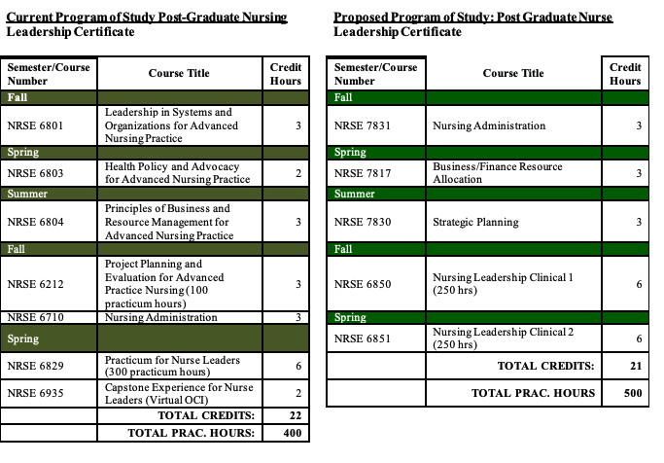
- College of Health Sciences & Professions
Program Code: ND1220
Program Name: Pre-Nursing
Department/School: Nursing
Contact: Sherleena Buchman (buchmans@ohio.edu)
Desired Start Date: Fall 2023

This non-degree pre-licensure program (ND1220) was never submitted to OCEAN historically as this is a pathway for entry into nursing. It outlines the first year of the Traditional BSN (BS1221) program that has already been approved. The School of Nursing has been asked to upload this non-degree pathway to entry into OCEAN. The original change to the Bachelor of Science in Nursing curriculum were based on new professional guidelines and standards which have been set forth by the American Association of Colleges of Nursing (AACN), an accrediting body.

- Patton College of Education
Program Code: ME6229 (Athens)/ME5027 (RHE)
Program Name: Educational Leadership
Department/School: Educational Studies
Contact: Dwan Robinson (robinsd3@ohio.edu), Mike Hess (hessm@ohio.edu), Leonard Allen (allenl@ohio.edu)
Desired Start Date: Fall 2023

The Educational Leadership program is being updated to reflect current trends in Educational Leadership, to reduce credit hours to enhance recruitment and retention efforts, and to be closer to OHIO/ODHE maximums for graduate programs. The Educational Leadership program that included courses leading to a principal license is being reduced from 48 credits to 40. Embedded in the program is a Principal Certificate (green highlights) being submitted for approval concurrent to this program change.

Existing Master's in Educational Leadership with licensure (as published in the graduate catalog) | Credit Hours |  | Proposed Educational Leadership | Credit Hours | Rationale/ Changes
Foundations: |  |  | Required Coursework
EDCS 5040 Sociology, Politics, and Change in Education (or equivalent course with permission of advisor) | 4 |  | EDCS 5090 Education & Democratic Community | 4 | This course is more relevant to students seeking the Educational Leadership master's degree.
Introductory Courses
EDLE 6010 Introduction to Leadership & Organizational Behavior | 4 |  | EDLE 6015 Introduction to Leadership and Organizational Management | 4 | New Course combines EDLE 6010 and EDLE 6020
EDLE 6020 Structure and Behavior in Educational Organizations | 4
Capstone Course
EDLE 6980 Educational Administration Portfolio I: Data Gathering | 4 |  | EDLE 6980 Educational Leadership Data Gathering Portfolio | 3 | Credit hours reduced to 3
Electives (To reach the minimum 34 credit hours, students will complete elective courses appropriate to their concentration in consultation with their advisor. Requirements for Principal Licensure will additionally complete the following courses.
EDLE 5910 Educational Administration Internship 1 | 4 |  | EDLE 5910 Educational Administration Internship 1 | 4
EDLE 6610 School-Community Relations | 4 |  | EDLE 6610 School-Community Relations | 4
EDLE 5911 Educational Administration Internship II | 4 |  | EDLE 5911 Educational Administration Internship II | 4
EDLE 6110 Educational Law for School Leaders | 4 |  | EDLE 6110 Educational Law for School Leaders | 3 | Credit hours reduced to 3
EDLE 6310 Personnel Administration in Education | 4 |  |  |  | Course removed
EDLE 6400 The Principalship | 4 |  | EDLE 6400 The Principalship | 3
EDLE 6425 The Role of the Principal in Instruction | 4 |  | EDLE 6425 The Role of the Principal in Instruction | 3
EDLE 7820 Politics/Policy in Education | 4 |  |  |  | Course combined into 6610
Total Hours | 48 |  | EDRE 5010 Introduction to Research | 3 | Course added
 |  |  | EDLE 5110 Colloquium in Educational Leadership | 2 | Course added
 |  |  | EDLE 7071 Comparative Cultures and Education | 3 | Course added
 |  |  | Total Hours | 40

- Patton College of Education
Program Code: ME5028
Program Name: Educational Leadership
Department/School: Educational Studies
Contact: Dwan Robinson (robinsd3@ohio.edu), Mike Hess (hessm@ohio.edu), Leonard Allen (allenl@ohio.edu)
Desired Start Date: Fall 2023

The Educational Leadership program is being updated to reflect current trends in Educational Leadership and reduce credit hours to enhance recruitment and retention efforts and be closer to OHIO/ODHE maximums for graduate programs. Course credit hours have been reduced in several courses resulting in an overall reduction from 34 credits to 31. Also, to reduce confusion between this non-licensure track and the track that includes principal licensure, we are requesting a name change to Educational Leadership, non-licensure.

Existing Master's in Educational Leadership (as published in the graduate catalog) | Credit Hours |  | Proposed Educational Leadership, non-licensure | Credit Hours | Rationale/ Changes
Foundations: |  |  | Required Coursework
EDCS 5040 Sociology, Politics, and Change in Education (or equivalent course with permission of advisor) | 4 |  | EDCS 5090 Education & Democratic Community | 4 | This course is more relevant to students seeking the Educational Leadership master's degree.
Introductory Courses
EDLE 6010 Introduction to Leadership & Organizational Behavior | 4 |  | EDLE 6015 Introduction to Leadership and Organizational Management | 4 | New Course combines EDLE 6010 and EDLE 6020
EDLE 6020 Structure and Behavior in Educational Organizations | 4
Capstone Course
EDLE 6980 Educational Administration Portfolio I: Data Gathering | 4 |  | EDLE 6980 Educational Leadership Data Gathering Portfolio | 3 | Credit hours reduced to 3
Electives (To reach the minimum 34 credit hours, students will complete elective courses appropriate to their concentration in consultation with their advisor |  |  | Required courses
Selected electives | 18 |  | EDLE 5910 Educational Administration Internship 1 | 4
Total Hours | 34 |  | EDLE 5911 Educational Administration Internship II | 4
 |  |  | EDLE 6610 School-Community Relations and Policy | 4
 |  |  | EDRE 5010 Introduction to Research | 3 | Course added
 |  |  | EDLE 5110 Colloquium in Educational Leadership | 2 | Course added
 |  |  | EDLE 7071 Comparative Cultures and Education | 3 | Course added
 |  |  | Total Hours | 31

- Patton College of Education
Program Code: BS6307
Program Name: Integrated Mathematics
Department/School: Teacher Education
Contact: Matt Felton-Koestler (felton@ohio.edu), Allyson Hallman-Thrasher (hallman@ohio.edu)
Desired Start Date: Fall 2023

The major currently allows for three elective courses (9 credits) with few limitations. We are going to replace this with a more limited set of options (1 required course and some choice from more targeted options). This change is to better meet accreditation requirements, and better prepare graduates for Ohio’s new mathematics pathways which include options in data science, computer science, and discrete mathematics.
CURRENT PROGRAM REQUIREMENTS | PROPOSED PROGRAM REQUIREMENTS
 |  | New course?
Complete 9 hours of math electives from the following options:  - MATH 3000 History of Mathematics (3cr)  - MATH 3060 Introduction to Mathematical Reasoning, Problem Solving, and Proof (3cr)  - Any courses above MATH 3300 | MATH 3060 Introduction to Mathematical Reasoning, Problem Solving, and Proof (3cr) | No
 | Choose one of the following courses:  - MATH 2530 Introductory Data Science (4cr)  - MATH 1060 Quantitative Reasoning (3cr)  - MATH 2530 Introductory Data Science (4cr)  - CS 1400 Fundamentals of Computing (3cr)  - CS 1400 Fundamentals of Computing (3cr) | No
 | Choose one of the following courses:  - MATH 1101 Elementary Topics in Mathematics I (4cr)  - MATH 1102 Elementary Topics in Mathematics II (4cr)  - MATH 2110 Introductory Geometry for Middle School Teachers (3cr)  - MATH 2120X Number and Algebra for Middle School Teachers (3cr) | No

- Patton College of Education
Program Code: MS8163
Program Name: Coaching Education- Soccer
Department/School: Recreation, Sport Pedagogy, and Consumer Sciences
Contact: Ashley Allanson (allanson@ohio.edu)
Desired Start Date: Fall 2023

The Coaching Education program currently requires two in-person residencies with COED 6100 Coaching Workshop I (1) and COED 6101 Coaching Workshop II (2) respectively. The program wishes to reduce the number of in-person residences to one (resulting in the removal of COED 6101) and increase the variable credit hour for COED 6100 from 1 to 3. There is no change in credit hours.

- Patton College of Education
Program Code: BS6326
Program Name: Human Services
Department/School: Counseling and Higher Education
Contact: Bilal Urkmez (urkmezbi@ohio.edu)
Desired Start Date: Fall 2023

The Bachelor’s of Applied Human Services (AHS) is an online program. Currently, students in the AHS must take 34 credits of major courses and 18 credits hours in two areas of emphasis including Leadership and Organization and (b) Diversity and Communication, a total of 52 credit hours of required courses. To better align with similar online undergraduate programs and reduce redundancy, two courses will be eliminated. EDCS 1011 Introduction to Diversity Studies (3 credit hours) and EDCE 4100 Human Relations (2 credit hours). In addition, EDCE 4910 - Internship in Human Services was reduced from 4 to 2 credit hours. This represents an overall reduction of 7 required credits and moves those credits towards elective opportunities. The program still requires 120 total credit hours.
- Patton College of Education
Program Code: AA5017
Program Name: Equine Study
Department/School: Recreation, Sport Pedagogy, and Consumer Sciences
Contact: Kelly Hall (hallk@ohio.edu)
Desired Start Date: Fall 2023

The Equine Studies Program is an online program that has grown each semester since moving to an online format. In the spring of 2019, fewer than twelve students were in the Equine Studies program. Entering the spring 2022-2023 semester, the Equine Studies program has eighty-two students enrolled in courses. The Program Review Team reviewed the program and at their suggestion, courses were merged to allow students to learn about a broader range of topics.

In the spring of 2019, a decision was made to close the Ohio Horse Park. Equine Studies had one online track (CEBM) for online learning. and the remaining courses needed to transfer over to a format better suited to the online format. With the creation of the Commercial Equine Business Management Track, Equine Studies was one of the first in the nation to offer a fully online degree option. This online option brought higher enrollments than the traditional program and expanded recruiting opportunities nationwide in the United States and Europe.

- University College
Program Code: BT5510
Program Name: Bachelor of Technical and Applied Studies
Department/School: Applied Sciences and Professions
Contact: Donna Burgraff (burgrafd@ohio.edu), Jim Smith (smithj27@ohio.edu), Allison White (whitea3@ohio.edu)
Desired Start Date: Fall 2023

A new program core will be comprised of 15 credits of existing program courses (TAS 3010, 3110, 4110, 4440, and 4510) focusing on workplace effectiveness and providing opportunity for application. Three courses cover main content areas on the role and approaches to leadership (TAS 4110), the importance of and methods to achieve effectiveness using work groups and teams (TAS 4440), and the value of diversity to the organization in achieving its goals (TAS 3110). TAS 3010 and 4510 provide the introductory and capstone courses, respectively.

• Removed from the core requirements are 15 TAS credits including TAS 3210, 4040, 4140, 4240, and 4340 however, these remain in the course inventory for possible use in a certificate or as a free elective.

• 15 additional credits are required replacing specific TAS credits selected from the following options:
o selected courses (See section 3 for specifics) o “technical courses” (9 credits maximum) with program advisor approval related to the concentration from an associate degree (or equivalent).
o TAS elective(s)
o completion of an undergraduate certificate program (If 12 credits comprise the certificate then an additional course is to be selected from the above choices.)
• This program proposal does not change the total number of credits students need to graduate with the BTAS (120 credits).
• Program learning outcomes are revised accordingly
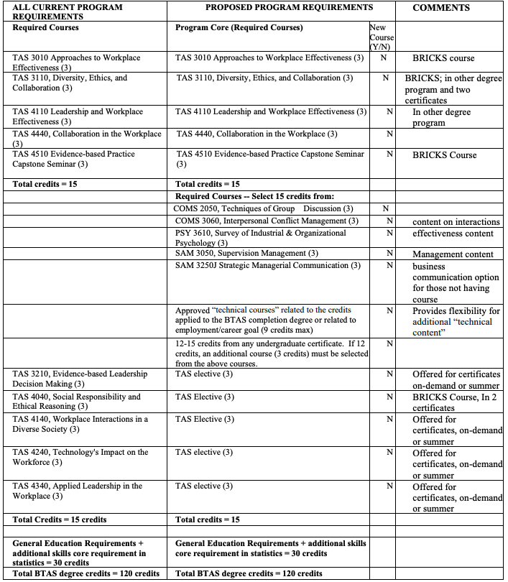

- Russ College of Engineering and Technology
Program Code: ME7266
Program Name: Master of Engineering Management
Department/School: Industrial and Systems Engineering
Contact: Tao Yuan (yuan@ohio.edu)
Desired Start Date: Fall 2023

The Industrial and Systems Engineering Department is submitting in parallel an Accelerated Graduate Pathway (AGP) proposal that involves the BS7255 (Bachelor of Science in Industrial and Systems Engineering) and ME7266 programs. The AGP program will allow students in the BS7255 program to take three on-campus graduate courses (ISE 5151, ISE 5160, ISE 5300) during their undergraduate career that will also count toward the online MEM degree. Hence, we propose to change the coursework requirements for the MEM program to allow ISE 5151, ISE 5160, and ISE 5300 to be counted toward the MEM degree.

Current | Proposed
EMGT 6200 Information Systems Engineering (3) | EMGT 6200 Information Systems Engineering (3) OR  ISE 5151 Information Systems Engineering (4)
EMGT 6110 Principles of Six Sigma (4) | EMGT 6110 Principles of Six Sigma (4) OR  ISE 5160 Principles of Six Sigma (3)
EMGT 6100 Statistics of Engineering Management (4) | EMGT 6100 Statistics of Engineering Management (4) OR ISE 5300 Intro to Designed Experiments (2)
All other degree requirements of the MEM program remain unchanged. The total number of credit hours remains 34.

- College of Business
Program Code: MY6163
Program Name: Master of Accountancy
Department/School: Accounting
Contact: David Stott (dstott@ohio.edu)
Desired Start Date: Fall 2023

1. Change the program name from Master of Accountancy to Master of Accountancy and Analytics to make the degree name consistent with the underlying curriculum.

2. Update the curriculum for the Non-Business Graduate Track students (MY6105, MY6106, MY6107) to get to a minimum of nine required credit hours in analytics and streamline the curriculum between the three entry tracks (Accounting Track, Business/Non-Accounting Track, Non-Business Track). This change will also increase the credit hours for this track from 45 to 48, which will allow students to end with a full term (as opposed to partial), easing financial aid problems.

Currently, Non-Business Graduate Track students take the seven core accounting courses, and four general business courses, of which one is data analytics. We would like to add two data analytics courses - for a total of three - and drop one of the general business requirements, so that all three Tracks now have nine required credit hours in data analytics. We still plan to require two of the General Business Courses (MBA 6335 “Managerial Finance” - 3 credit hours) and MBA 6370 “Operations Management” – 3 credit hours) most relevant to accounting. The core requirements (seven core accounting plus three data analytics courses) between the three tracks (Accountancy, Business and Non-Business) will now be consistent. In addition, the Non-Business Track students will now take a full final term (both A and B terms), as opposed to ending in term A. The proposed changes increase total credit hours for these students from 45 to 48.

3. Update the curriculum to allow choices of analytics courses while holding the nine required analytics credit hours constant.

This change provides more flexibility for the students in selecting three data analytics courses from the following:
• ACCT 6700: Analytics for Accounting Decision Making (3 credit hours – new)
• MBA 6320: Descriptive Analytics (3 credit hours – existing)
• MBA 6325: Prescriptive Analytics (3 credit hours – existing)
• MBA 6360: Strategic Use of Information Systems (3 credit hours – existing)
• MBA 6390: Predictive Analytics (3 credit hours – existing)
• MBA 6395: Business Intelligence (3 credit hours – existing)
• MBA 6420: Programming for Analytics (3 credit hours – existing)
• MBA 6460: Strategic Use of Analytics (3 credit hours – existing)
• MBN 6490: Predictive Analytics II (3 credit hours – existing)
• MBA 6495: Business Intelligence II (3 credit hours – existing)
• MBA 6560: Analytics for Executives (3 credit hours – existing)

- College of Business
Program Code: (Track Codes MB6152/MB6162) Parent Codes MB6146 and MB6155
Program Name: Master of Business Administration with Health Care concentration & Professional Master of Business Administration with Health Care concentration
Department/School: Management
Contact: William Young (youngw1@ohio.edu), Cristina Popescu (cristinap@ohio.edu)
Desired Start Date: Fall 2023

Students in our Online and Professional MBA programs take a total of 12 courses to earn their graduate degree. From this total, nine are core courses and three are courses contained within a single concentration that students select. Presently, we offer nine concentrations in our MBA program. These concentrations are as follows:
1. Accounting
2. Business Analytics
3. Business Venturing
4. Executive Management
5. Finance
6. Health Care
7. Operations and Supply Chain Management
8. Project Management
9. Strategic Selling and Sales

The College of Business (CoB) is proposing a revision to our Health Care Concentration. The CoB has had a longstanding partnership with the College of Health Sciences and Professions (CHSP). Based on feedback from the CHSP, our alumni, and the latest trends in the healthcare space, we would like to propose three new courses to replace the original three courses within this concentration.

Current Health Care Concentration | Proposed Health Care Concentration
HLTH 6010 Introduction to the U.S. Health Care Delivery System (3) | IHS 5200 Foundations of Leadership in Healthcare (3)
HLTH 6210 Health Care Finance (3) | IHS 5201 Quality, Safety and Service in Healthcare Leadership (3)
HLTH 6280 Health Law (3) | IHS 5202 Financial Innovation and Growth Strategies in Healthcare Leadership (3)

- College of Arts & Sciences
Program Code: BS2120
Program Name: Environmental and Plant Biology
Department/School: Environmental and Plant Biology
Contact: Sarah Wyatt (wyatts@ohio.edu)
Desired Start Date: Fall 2023

We are seeking the following changes to respond to course changes and new course developed for BRICKS. We propose to substitute PHYS 2001 for PHYS 2051 (renumbered to PHYS 2054/2055) which has been modified and is now more appropriate for engineers and less so for biologists. We also seek to change the PBIO 4180J course to a newly developed advanced writing course PBIO 2180 Introduction to Research and Writing.

There is no change in credit hours.

- College of Arts & Sciences
Program Code: BS2110
Program Name: Applied Plant Biology
Department/School: Environmental and Plant Biology
Contact: Sarah Wyatt (wyatts@ohio.edu)
Desired Start Date: Fall 2023

We seek to change the PBIO 4180J course requirement to a newly revised advanced writing course PBIO 2180 Introduction to Research and Writing and add PBIO 2480 Dendrology to the major elective list to add more choice and diversity. There is no change in credit hours.

- College of Arts & Sciences
Program Code: BA2119
Program Name: Field Ecology
Department/School: Environmental and Plant Biology
Contact: Sarah Wyatt (wyatts@ohio.edu)
Desired Start Date: Fall 2023

We seek to change the PBIO 4180J course requirement to a newly revised advanced writing course PBIO 2180 Introduction to Research and Writing. There is no change in credit hours.

- College of Arts & Sciences
Program Code: BA5234
Program Name: English Pre-Law
Department/School: English
Contact: Carey Snyder (snyderc3@ohio.edu)
Desired Start Date: Fall 2023

We seek to recreate a Pre-Law Concentration for the English major to make the major more visible to law-school-bound students and their parents. With its emphasis on analysis, close reading, and persuasive writing, the English major has always been and continues to be an excellent pathway for law-school bound students and many of our students go on to law school.
In a program change that went into effect this year (2022-2023), we reorganized and revised our major, reducing our concentrations and eliminating Pre-Law. However, we immediately realized that from a recruiting perspective, that was a mistake. Thus, we seek a program code with the Pre-law name rather than a truly differentiated curriculum, to make visible the way that the English major already aligns with the analysis and communication skills that enable our students to succeed in law school.
The renewed Pre-Law concentration (BA5234) will mirror the current English—Literature, Culture, and Writing concentration (BA 5223), with a single change: substituting ENG 3570: Law and Literature for one 3000+ level English elective. It will have no impact on program learning outcomes and assessment plans.
- College of Fine Arts
Program Code: BF5198 (in-person)/ BF5202 (online)
Program Name: Interior Architecture
Department/School: School of Art + Design
Contact: Nic Campbell (ncampbell@ohio.edu), Karla Hackenmiller (hackenmi@ohio.edu)
Desired Start Date: Fall 2023

This proposal seeks to improve the interior architecture program through a number of adjustments to the current curriculum. These include:
1) requiring a new introductory studio course (ART 1620 which will replace ART 2650),
2) shifting 3, required studio courses (12 credits) to electives under the “Related Courses” category,
3) eliminating a required, introductory lecture course (ART 1240) because interior architecture students are already required to take an introductory lecture course (ART 1600) that has some overlap, and
4) adding course electives, the “Related Courses” category to reflect the broadening needs of the majors.

The overall effect of these changes will reduce the number of total credits required for the major. Currently, interior architecture students must complete 143 credits, which is 23 over the University minimum expectation of 120, and 15 more than the other ART BFA programs at 128. These students need more flexibility and the opportunity to pursue outside coursework, which will make them more marketable in this highly interdisciplinary field.
The full table of changes (13 pages) is located on the proposal in OCEAN.

- Honors Tutorial College
Department/School: Honors Tutorial College
Contact: Mary Kate Hurley (hurleym1@ohio.edu), Beth Novak (novakb@ohio.edu)
Desired Start Date: Fall 2023
Program Codes:
Advanced Computing (CS) BS1949
Anthropology BA1934
Art History BA1935
Astrophysics BS1931
Biological Sciences BS1902
Business Administration BB1926
Chemistry BS1904
Classics BA1932
Communication Studies BC1918
Communication Sciences and Disorders/HSLS BS1941
Dance BF1906
Economics BS1910
Engineering Physics BS1925
English BA1916
Environmental & Plant Biology BS1901
Environmental Studies BA1942
Film BF1924
Geography BA1944
Geological Sciences BS1948
History BA1909
Journalism BJ1923
Mathematics BS1903
Media Arts & Studies BC1920
Music BA1938
Neuroscience BS1937
Philosophy BA1917
Physics BS1905
Political Science BA1908
Social Work BA1930
Sociology BA1912
Spanish BA1915
Studio Art BA1939 and BF1940
Theater BA1913
BF1913 Translational Health–Applied Nutrition
BS1946 Translational Health–Exercise Physiology BS1947
Women's, Gender & Sexuality Studies BA1945

Based on compliance with HLC and ODHE requirements for assessment of general education outcomes, HTC will require all of our students to meet the quantitative skills requirement for a bachelor’s degree going forward. This is not a retroactive change but for students entering the 23-24 catalog onward.
NEW PROGRAMS/CERTIFICATES
- Patton College of Education
Program Code: CTX83G
Program Name: Principal Leadership & Licensure Certificate
Department/School: Educational Studies
Contact: Dwan Robinson (robinsd3@ohio.edu), Mike Hess (hessm@ohio.edu), Leonard Allen (allenl@ohio.edu)
Desired Start Date: Fall 2023

The Principal Leadership and Licensure Certificate is a 17-credit hour graduate certificate that prepares students for an Ohio Department of Education principal license. Students admitted to this certificate must already possess a master’s degree in education or a related field and a current teaching license. Prior to the development of this certificate, students utilized an ND code to take licensure courses. This certificate will allow these students to earn an OHIO credential. These courses are already being taught so no new resources are needed.

The certificate includes the following courses:
EDLE 6980 Seminar: Data Gathering and Analysis (3)
EDLE 5911 Internship II: Action Research Project (4)
EDLE 6015 Introduction to Leadership and Organizational Management (4) (new)
EDLE 6425 The Role of Principal in Instruction (3)
EDLE 6400 The Principalship (3)

Students completing the certificate should obtain a minimum GPA of a 3.0 in all classes as well as for the overall certificate.

- College of Arts & Sciences
Program Code: CTX21U
Program Name: Social Justice
Department/School: Sociology and Anthropology
Contact: Bruce Hoffman (hoffman@ohio.edu)
Desired Start Date: Fall 2023

The Social Justice certificate provides liberal arts training in the theory and practice of social justice, providing critical thinking and social consciousness skills that can be applied in a number of fields. With courses from a wide array of social science and humanities disciplines, the certificate curriculum emphasizes a social constructivist approach that enables students to understand and respond to social disparities and structural inequalities associated with race, class, ethnicity, gender, sexuality, nationality, and other identities. Students may study social justice issues in local, national, and international arenas to become more informed citizens and community leaders.

The certificate requires 18 credits, comprising 6 hours of 2000-level interdisciplinary coursework, 9 hours of 3000/4000-level Social Justice Analysis courses, and 3 hours of 3000/4000-level Social Justice Skills courses. The Social Justice Analysis courses equip students with the analytical and conceptual tools required to tackle social inequality, disparities, and injustices. Meanwhile, Social Justice Skills courses emphasize skill-based training in areas that prioritize a context-driven, meaning-centered, and culturally sensitive approach, such as qualitative methods, ethical application, or international education and study-abroad experiences.
The certificate requires one course, ANTH/SOC 2700: Social Justice, as well as one additional 2000-level course and four 3000/4000 level courses. ANTH/SOC 2700 is a cross-listed course offered every semester in the Department of Sociology & Anthropology. The Department is responsible for staffing ANTH/SOC 2700 with existing resources.

Complete the following required course (3 credit hours):
● ANTH/SOC 2700: Social Justice (3 credit hours) (Foundations IE and Arch)

Complete one of the following courses (3 credit hours):
● AAS 2200: Introduction to Black Political Economy (3 credit hours)
● AAS 2540: History of Injustice in the United States (3 credit hours)
● ANTH/SOC 2400: Breaking the Law (3 credit hours)
● CAS 2410: Principles and Practice of Food Justice (3 credit hours)
● ENG 2320: Literature and Social Justice (3 credit hours)
● SOC 2300: Social Inequalities and Social Change (3 credit hours)
● WGSS 2200: Introduction to LGBTQ Studies (3 credit hours)
● WGSS 2300: Women, Gender, and Sexuality in a Global Context (3 credit hours)

Social Justice Analysis: Complete 3 courses in the following competency areas for 9 credits total with classes in at least two areas:

Racial Justice Competencies
● AAS 3650: The Protracted Struggle for Civil Rights (3 credit hours)
● AAS 3680: African American Political Thought (3 credit hours)
● AAS 4693: Legal Policy and Disparities in the American Health Care System (3 credit hours) ● POLS 4739: Politics of Race (3 credit hours)
● POLS 4751: Critical Race Theory (3 credit hours)
● POLS 4753: American Whiteness (3 credit hours)
● POLS 4754: Black Political Thought (3 credit hours)
● POLS 4757: Race, Violence and Human Security (3 credit hours)
● SOC 3290: Race and Ethnic Relations (3 credit hours)

Economic Justice Competencies
● ANTH 3500: Economic Anthropology (3 credit hours)
● ANTH 4250: Ethnographies of Global Capitalism (3 credit hours)
● GEOG 3410: Geography of Hunger and Food Security (3 credit hours)
● SOC 3300: Sociology of Poverty (3 credit hours)
● SOC 3310: Class and Inequality (3 credit hours)
● SOC 3325: Access to Justice (3 credit hours)
● T3 4400: Seminar in Wealth and Poverty (3 credit hours)

Gender and Sexuality Justice Competencies
● AAS 3450: The Black Woman (3 credit hours)
● AAS 3460: Black Men and Masculinities (3 credit hours)
● GEOG 4450: Gender, Environment, and Development (3 credit hours)
● POLS 4190: LGBTQ Politics (3 credit hours)
● POLS 4210: Politics of Law & Sexuality (3 credit hours)
● POLS 4780: Feminist Political Theories and Movements (3 credit hours)
● SOC 4670: Violence Against Women (3 credit hours)
● SOC 4700: Sociology of Gender (3 credit hours)
● SOC 4710: Gender and Justice (3 credit hours)
● WGSS 3200: Sexual Revolutions (3 credit hours)
● WGSS 3500: Feminist Theory (3 credit hours)
● WGSS 4610: Queer Theory (3 credit hours)

Environmental Justice Competencies
● GEOG 3450: Access to Water in a Changing World (3 credit hours)
● GEOG 4470: Natural Resource Conservation (3 credit hours)
● GEOG 4560: The Just and Sustainable City (3 credit hours)
● PHIL 3350: Environmental Ethics (3 credit hours)
● POLS 4250: Environmental and Climate Change Politics and Policy (3 credit hours)
● POLS 4260: Politics of the Contemporary Environmental Movement (3 credit hours)
● POLS 4840: The Politics of Sustainability (3 credit hours)
● SOC 4810: Environmental Sociology (3 credit hours)
● T3 4080: Environmentalism in America (3 credit hours)

International Justice Competencies
● ANTH 3510: Political Anthropology (3 credit hours)
● ANTH 3530: Anthropology of Violence and Peace (3 credit hours)
● ANTH 4590: Legal Anthropology (3 credit hours)
● ANTH 4620: Human Rights, Law and Justice (3 credit hours)
● POLS 4465: International Human Rights (3 credit hours)
● POLS 4640: Global Humanitarianism (3 credit hours)
● POLS 4765: Postcolonial Politics (3 credit hours)
● SOC 3685: Human Trafficking (3 credit hours)
● SOC 4680: Crimes Against Humanity (3 credit hours)
● WGSS 4100: Global Feminisms (3 credit hours)
● WGSS 4110: Women and Globalization (3 credit hours)

Social Justice Skills: Complete any course in one of the following competency areas (3 credit hours total):
Social Justice Practice Competencies
● ANTH 3010: Visual Anthropology (3 credit hours)
● ANTH 3490: Life History (3 credit hours)
● ANTH/SOC 3568J: Writing for Social Justice (3 credit hours)
● ANTH 4560: Ethnographic Methods (3 credit hours)
● GEOG 3270: Geographies of Social Justice (3 credit hours)
● GEOG 4520: Environmental and Sustainability Planning (3 credit hours)
● PHIL 3300: Ethics (3 credit hours)
● PHIL 4921: Applied Ethics (3 credit hours)
● POLS 4465: Gandhi and King: Nonviolence as Philosophy and Strategy (3 credit hours)
● SOC 3090C: Sociology of Appalachia (3 credit hours)
● SOC 3620: Ethics in Law, Crime, and Justice (3 credit hours)

Cross-Cultural Competencies: Study Abroad / Study Away
Students seeking to satisfy coursework in this competency area must complete 3 credit hours of international education programs dealing with social justice themes, subject to approval by the Certificate Director. Students are encouraged to develop plans for a study abroad and study away in consultation with the Certificate Director.

- Russ College of Engineering & Technology
Program Code: NDAXY2
Program Name: Accelerated Graduate Pathway Industrial and Systems Engineering
Department/School: Industrial and Systems Engineering
Contact: Tao Yuan (yuan@ohio.edu)
Desired Start Date: Fall 2023

Students in the BS-ISE program who wish to also earn an MEM degree will take three courses (2 required, 1 elective) during their undergraduate career that will also count toward the MEM degree. After completing the BSISE degree, students will need to take 8 courses over 2 or 3 semesters to complete the remaining MEM requirements. There is a program change for the ME7266 program submitted in parallel with this to allow those three courses to be counted for the MEM degree.

Students will be eligible to apply for conditional admission when they have completed 60 credit-hours and have completed the following classes:
• ET 2450 (Engineering Statistics)
• ET 3300 (Engineering Economy)
• ISE 1200 (Software Tools for ISE)
• ISE 3210 (Engineering Probability)

Students with a composite ACT of 30 or higher and a math ACT of 30 or higher will be eligible for EAP.

Students will be eligible to take graduate courses once they have completed 75 credit-hours. Students must have a GPA of 3.2 overall or 3.0 overall with 3.5 in the most recent 30 hours and 3.0 in all ISE classes completed.
Undergraduate students may take the following graduate courses.

• ISE 5151 Information Systems Engineering (4 credits)
• ISE 5160 Principles of Six Sigma (3 credits)
• ISE 5300 Intro to Designed Experiments (2 credits)

- University College
Program Code: CTX81U
Program Name: Technical and Applied Studies Certificate
Department/School: Applied Sciences & Professions
Contact: Donna Burgraff (burgrafd@ohio.edu), Allison White (whitea3@ohio.edu), Jim Smith (smithj27@ohio.edu), David Nguyen (nguyend4@ohio.edu)
Desired Start Date: Fall 2023

The proposed Technical and Applied Studies Certificate (12 credits) offers OHIO students the opportunity to study theory and practices leading to organizational effectiveness. The courses in the certificate program provide an overview of leadership concepts and basic skills of being a formal or informal leader. This is complemented by the recognition of the importance of work groups and teams and how leaders can optimize their work. A course on diversity creates awareness of the value of attracting and retaining a diverse workforce for the benefit of having a variety of input, developing creative solutions, and positively influencing the bottom line. As a supplement to any existing major, the certificate provides the graduate with the tools to be a successful formal or informal leader in the workplace. Three TAS courses and one SAM class are required.

Choose 3 TAS Courses (9 Credits):
1. TAS 3010 – Approaches to Workplace Effectiveness (3)
2. TAS 3110 – Diversity, Ethics, and Collaboration (3)
3. TAS 4110 – Leadership and Workplace Effectiveness (3)
4. TAS 4440 – Collaboration in the Workplace (3)

Complete one SAM course (3 credits)
a. SAM 3050 – Supervision Management (3)
b. SAM 3250J –Strategic Managerial Communication (3)

EXPEDITED
- College of Arts & Sciences
Program Code: BS5025
Program Name: Environmental Water Resources
Department/School: Geological Sciences
Contact: Greg Springer (springeg@ohio.edu)
Desired Start Date: Fall 2023

We propose to change the name of BS5025 Environmental Water Resources to Environmental Geoscience. This would be consistent with the equivalent minor: OR3326 Environmental Geoscience. There would be no changes to the program’s curriculum or structure, which was proposed and approved roughly three years ago.
- College of Arts & Sciences
Program Code: BS3321
Program Name: Geological Sciences
Department/School: Geological Sciences
Contact: Greg Springer (springeg@ohio.edu)
Desired Start Date: Fall 2023

We propose to change the extradepartmental math requirement to make it more flexible. We propose to change the requirement for MATH 2301 Calculus (see item 3 below) to two options: MATH 1300 Precalculus or MATH 2301 Calculus. This will not change the credit hours required but will liberalize choices. The change reflects the fact that our major curriculum does not require the use of calculus and alumni in the private sector tell us they do not use calculus as part of their jobs. However, we will encourage students to consider taking MATH 2301 Calculus if they plan on going to graduate school.

- College of Business
Program Code: CTBACG
Program Name: Business Analytics Certificate
Department/School: Analytics and Information Systems
Contact: William Young (youngw1@ohio.edu)
Desired Start Date: Fall 2023

The College of Business (CoB) is proposing a revision to the elective options in the Business Analytics certificate program. We believe the proposed changes will better serve our students’ professional and academic goals by resolving a prerequisite issue in the current structure of the Business Analytics and Advanced Business Analytics Certificate programs.

MBA 6490 Predictive Analytics II (3) is replacing MBA 6395 Business Intelligence (3).

- College of Business
Program Code: CTABAG
Program Name: Advanced Business Analytics Certificate
Department/School: Analytics and Information Systems
Contact: William Young (youngw1@ohio.edu)
Desired Start Date: Fall 2023

The College of Business (CoB) is proposing a revision to the required courses in the Advanced Business Analytics certificate program. We believe the proposed changes will better serve our students’ professional and academic goals by resolving a prerequisite issue in the current structure of the Business Analytics and Advanced Business Analytics Certificate programs.
MBA 6395 Business Intelligence (3) is replacing MBA 6490 Predictive Analytics II (3).
- College of Business
Program Code: CTBALG
Program Name: Business Analytics Leadership
Department/School: Analytics and Information Systems
Contact: William Young (youngw1@ohio.edu)
Desired Start Date: Fall 2023

The College of Business (CoB) and the Analytics and Information Systems (AIS) Department would like to propose one change to the Business Analytics Leadership Certificate program. The change relates to the certificate’s learning outcomes. In preparing for our accreditation, the CoB and the AIS Department would like to propose learning outcomes for the Business Analytics Leadership Certificate program. It should be noted that the learning outcomes for this certificate program are not stated in Ohio University’s graduate catalog. Therefore, to become transparent about the learning outcomes of this program, we would like to submit this change request.

At the conclusion of this certificate, students will be able to:
1) Support decision-making through visual communication of analytics
2) Synthesize executive-level strategies to promote and develop an effective progression to analytics maturity

- College of Business
Program Code: MB6173
Program Name: Master of Business Analytics
Department/School: Analytics and Information Systems
Contact: William Young (youngw1@ohio.edu)
Desired Start Date: Fall 2023

The College of Business (CoB) and the Analytics and Information Systems (AIS) Department would like to propose one change to the Master of Business Analytics (MBAn) program. The change relates to the program’s learning outcomes. In preparing for our accreditation, the CoB and the AIS Department would like to propose revised learning outcomes for the Master of Business Analytics (MBAn) program. It should be noted that the learning outcomes for this certificate program are stated in Ohio University’s graduate catalog. Therefore, to become transparent about the learning outcomes of this program, we would like to submit this change request as we prepare to update the Ohio University Graduate Catalog.

At the conclusion of this program, students will be able to:
1) Design descriptive analytical solutions for business problems
2) Design predictive analytical solutions for business problems
3) Design prescriptive analytical solutions for business problems
4) Design analytic application solutions to support decision-making through programming
5) Support decision-making through written communication of analytics
6) Support decision-making through visual communication of analytics

- College of Business
Program Code: BS6108/BS6109 (RHE)
Program Name: Business Studies
Department/School: Management
Contact: Ana Rosado Feger (rosadof@ohio.edu), Brian Hoyt (hoyt@ohio.edu)
Desired Start Date: Fall 2023

This proposal includes two changes.
First, it adds BA1000 Introduction to the College of Business (1) as a substitute for SAM 3030 Introduction to BSB and Career Development (1) and BA 2000 Career Management Strategies (1) as a substitute for SAM 3905 Internship and Career Preparation (1). This change aligns the Regional and eCampus programs with the Athens campus.
Second, it adds SAM 3920 Business Simulation (3) (approved through UCC in Feb) as an alternative to SAM 3910 Internship (3).
- College of Fine Arts
Program Code: CTVAMG
Program Name: Visual Arts Management Certificate
Department/School: Art + Design
Contact: Karla Hackenmiller (hackenmi@ohio.edu)
Desired Start Date: Fall 2023

We are requesting a simple addition of elective options under the “Elective Courses” category. There are no new courses and no change in total credit hours. Under the “Elective Courses” category, please add the following 3-credit courses: AH 5210 Roman Art; AH 5220 Medieval Art; AH 5230 Italian Renaissance Art; AH 5430 History of Japanese Art; AH 5711 – Art History Methods; and Delete AH 5180 - Contemporary East Asian Art, 3-credits.

- College of Fine Arts
Program Code: CTMSTG
Program Name: Musuem Studies Certificate
Department/School: Art + Design
Contact: Karla Hackenmiller (hackenmi@ohio.edu)
Desired Start Date: Fall 2023

We are requesting a change to the “Elective Courses” category to a “Directed Electives” title, which would open the category to any advisor-approved course instead of a specific set of options. There are no new courses and no change in total credit hours.

Currently, the “Elective Courses” category contains a list of around 100 course options from across the University. As this certificate becomes more and more popular, as well as interdisciplinary, this list will continue to grow. Museums and collections exist in all disciplines and the expansive list of options reflects the need to acknowledge that. Four additional courses have been proposed this year in Art History and Geology, a trend that has continued since the certificate was approved. At this time, we feel it is necessary to change this heading to “Directed Electives” and remove the specific courses. This is a strategy that the Registrar has suggested in the past. This will reduce the number of “Program Update Proposals” and related consultations with other programs, reduce the number of DARS substitutions, and allow the student and advisor to select the most appropriate coursework for the individual student. The current list of options will be converted into an advising document that will be shared with students/potential students in the certificate. It will be maintained by the Program Director who also serves as the students’ advisor. As new courses are approved by the Program Director, they can be added to this list.

- College of Fine Arts
Program Code: MA5146
Program Name: Art History
Department/School: Art + Design
Contact: Sam Dodd (dodds1@ohio.edu), Karla Hackenmiller (hackenmi@ohio.edu)
Desired Start Date: Fall 2023

We are requesting a simple addition of elective options, instructional catalog text edits, and one course restriction to prevent it from counting as required credits.

The following courses are being added as elective options in the following sub-categories: Theory, AH 5616 Art Spaces (3); World, AH 5191 Visual Culture in China (3); Modern, AH 5540 Modern Architecture and Design (3) and AH 5616 Art Spaces (3).
Because some courses are now listed in more than one sub-category, we are adding language to ensure that a single course may not be used to fill more than one subcategory.
Under the “Art History Electives” category, AH 5922 Seminar in Art History: Teaching, Research, Publication, has been included among the courses that will not fulfill these electives. The Art History department prefers that students enroll in other discussion and lecture-based courses to complete these credits.
No new courses are involved in this proposal. Total credit hours remain the same.
- College of Fine Arts
Program Code: MA5174
Program Name: Printmaking
Department/School: Art + Design
Contact: Karla Hackenmiller (hackenmi@ohio.edu)
Desired Start Date: Fall 2023

Program Code: MF5052
Program Name: Painting + Drawing

Program Code: MF5171
Program Name: Photography

Program Code: MF5172
Program Name: Ceramics

Program Code: MF5175
Program Name: Sculpture

Program Code: MF5176
Program Name: Graphic Design

This proposal adjusts the academic course requirements such that, 1) a broader menu of contemporary art history courses is available to fulfill the “Art History” category, 2) the total number of required art history courses is increased from 2 to 3, 3) the open academic electives is then reduced from 2 to 1. We are also adding elective course options to the “Seminar Requirement” category.

Currently, all students are required to complete two specific contemporary art history courses. However, in order to better acknowledge diversity and other approaches to discussions surrounding contemporary art, 3 courses have been added to the menu. Students will now be required to complete 1 contemporary-specific course and any 2 other art history courses to fulfill the “Art History” category.

This increase of 1 course in “Art History” comes from a reduction to the “Academic Coursework” category, which is now only 1 course instead of 2. Most students already choose to take art history courses to fulfill the “Academic Coursework” category, and we believe that is in their best interests. However, we still want to provide the option for students to take 1 course outside of the School of Art + Design.

The only other change is adding 2 electives to the “Seminar Requirement” category to provide more options for students based on their interests and research.

- Patton College of Education
Program Code: BS6228
Program Name: Early Childhood and Elementary Education
Department/School: Teacher Education
Contact: Jeesun Jung (jungj@ohio.edu)
Desired Start Date: Fall 2023

The ECEE program faculty decided to eliminate the Essay Statement from the Admission Requirements.

NOTIFICATIONS
Program Suspensions
- College of Health Sciences & Professions
Program Code: AA5018
Program Name: Environmental Engineering Technology (EVT)
Department/School: Social & Public Health
Contact: Sally Marion-Fetty (marinels@ohio.edu)

The Environmental Engineering Technology (EVT) program has been identified as low-enrolled on regional campuses. No new applications or admissions will occur for this program. The purpose of this proposal is to submit the teach-out plan for the program, which will close at the end of Spring semester, 2023-24. Currently, the EVT program has three (3) students. One student has applied for graduation this spring semester. The other two students have several EVT courses yet to take, as they just started in the program AY 22-23. With this schedule of offerings (see below), it is projected that all students can complete the program by Spring or Summer 2023-24.

- College of Health Sciences & Professions
Program Code: MS8184
Program Name: Cardiovascular Perfusion
Department/School: Interdisciplinary Health Studies
Contact: Sally Marion-Fetty (marinels@ohio.edu)

The MS in Cardiovascular Perfusion is suspending admissions. There are currently 6 students in the program at the Cleveland Clinic. The last date the last student will be awarded the degree is in Spring 2024. The required courses to complete the program will be offered as follows:

Summer (Semester 3)
IHS 6305 Clinical Implementation II (2.0 cr hrs) (prereq IHS 6303)
IHS 6306 Perfusion Theory III (2.0 cr hrs.) (prereq IHS 6304)
IHS 6923 Perfusion Practicum III (4.0 cr hrs) (prereq IHS 6922)
IHS 6941 Research Seminar II (1.0 cr hrs) (prereq IHS 6940)

Fall (Semester 4)
IHS 6307 Mechanical Support (3.0 cr hrs)
IHS 6942 Research Seminar III (1.0 cr hr) (prereq IHS 6941)
IHS 6900 Perfusion Special Topics (1.0 cr hrs)
IHS 6924 Perfusion Practicum IV (4.0 cr hrs) (prereq IHS 6923)

Spring (Semester 5)
IHS 5513 Health Informatics (3.0 cr hrs)
IHS 6925 Perfusion Practicum V (5.0 cr hrs) (prereq IHS 6924)
HLTH 5850 Quality Improvement in Healthcare (3.0 cr hrs)

- College of Business
Program Code: AA5002
Program Name: Accounting Technology
Department/School: Accounting
Contact: David Stott (dstott@ohio.edu)

This program is now in the process of being closed due to low demand/enrollment. Currently there are 27 students officially listed as students in the program. There is a teach-out plan in place for these students over the next two academic years. No new enrollments are being accepted at this time.
- Patton College of Education
Program Code: BS5012 & BS6232
Program Names: French Education & French
Department/School: Teacher Education
Contact: Matt Felton Koestler (felton@ohio.edu)

We are requesting to suspend admissions to the French Education major (BS5012). This also affects French (BA6232), which was replaced by BS5012, as we still have two students enrolled in that major.
The program is being suspended because we have been informed by Modern Languages that they can no longer offer the number of French courses required to complete this major. The effective date is as soon as possible.
Two Athens-based students who are on track to graduate in spring 2024 and spring 2026 will continue to have available coursework and study abroad opportunities. One Lancaster-based student who has not enrolled in courses since fall 2021 has been contacted and informed that if they choose to continue, appropriate independent studies will be available to them.
If new faculty are hired in French who can offer the needed coursework for this program, we would be happy to explore reopening it.
- College of Health Sciences & Professions
Contact: Sally Marion-Fetty (marinels@ohio.edu)

Change ND0210 Undecided Health Sciences and Professions to Undecided-Discovering Health Sciences and Professions
- Center Relocation
Center for International Studies within the College of Arts and Sciences & Scripps College of Communication
EVPP Elizabeth Sayrs convened a working group in 2021-2022 Spring Semester to report on how the Center for International Studies (CIS) would operate in an embedded structure in the College of Arts and Sciences (CAS) and Scripps College of Communication (Scripps). The working group was composed of all the Program Directors at the Center for International Studies and a previous Program Director and CIS advisor who is currently an Associate Dean at the College of Arts and Sciences. The working group prepared a report, and EVPP endorsed the report as is. This process was followed by an Implementation Committee in 2022-2023 that involved the members of the working group, two new Center program directors, Interim Executive Director of CIS, and the Dean of Scripps College of Communication.

Many thanks to the 2022-2023 UCC Programs Committee members.

Kelly Broughton Jason Jolley
Chad Boeninger Molly Johnson
Cat Cutcher Pramod Kanwar
Ann Frymier Macario Llamas
Chris Hayes Greg Newton
Karla Hackenmiller Hannah Nissen
Beth Novak Allison White
Mary Kate Hurley Mario Cinquepalmi
Bob DeLong Connie Patterson, Chair

