SECOND READINGS – PROGRAM CHANGES
NA
SECOND READINGS – NEW PROGRAMS
NA

PROGRAM CHANGES
- Patton College of Education
Program Code: BS6228
Program Name: Early Childhood and Elementary Education
Department Name: Teacher Education
Contact: Sara Hartman

The program is being updated to outline alignment to BRICKS components. Additional changes include a change in course number in Diversity and Awareness in Early Childhood and Elementary Education (ECEE 3701 to ECEE 2701) and a course revision in EDPL 2910 (Pre-Primary Internship). As part of the revision for the Pre-Primary Internship (EDPL 2910), ECEE 2670 is being removed from the program of study.

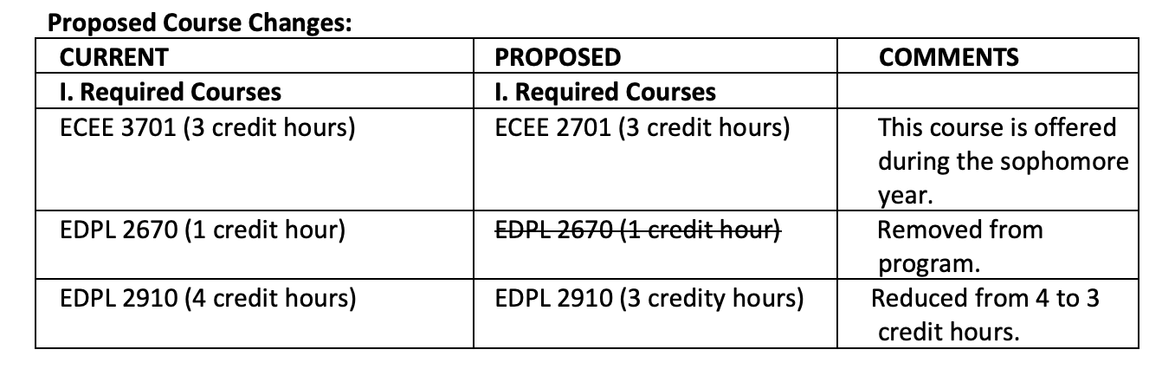

- Patton College of Education
Program Code: AA1106
Program Name: Child Development
Department Name: Teacher Education
Contact: Sara Hartman

This program is being revised to be responsive to the needs of graduates from the program. The program has long needed to be re-envisioned in order to better prepare graduates to work with children in birth-age 5 settings. The proposed changes are specifically designed to do this. As part of these changes, 6 courses are being removed, 3 content-specific courses are being added, and a full alignment to BRICKS is occurring.
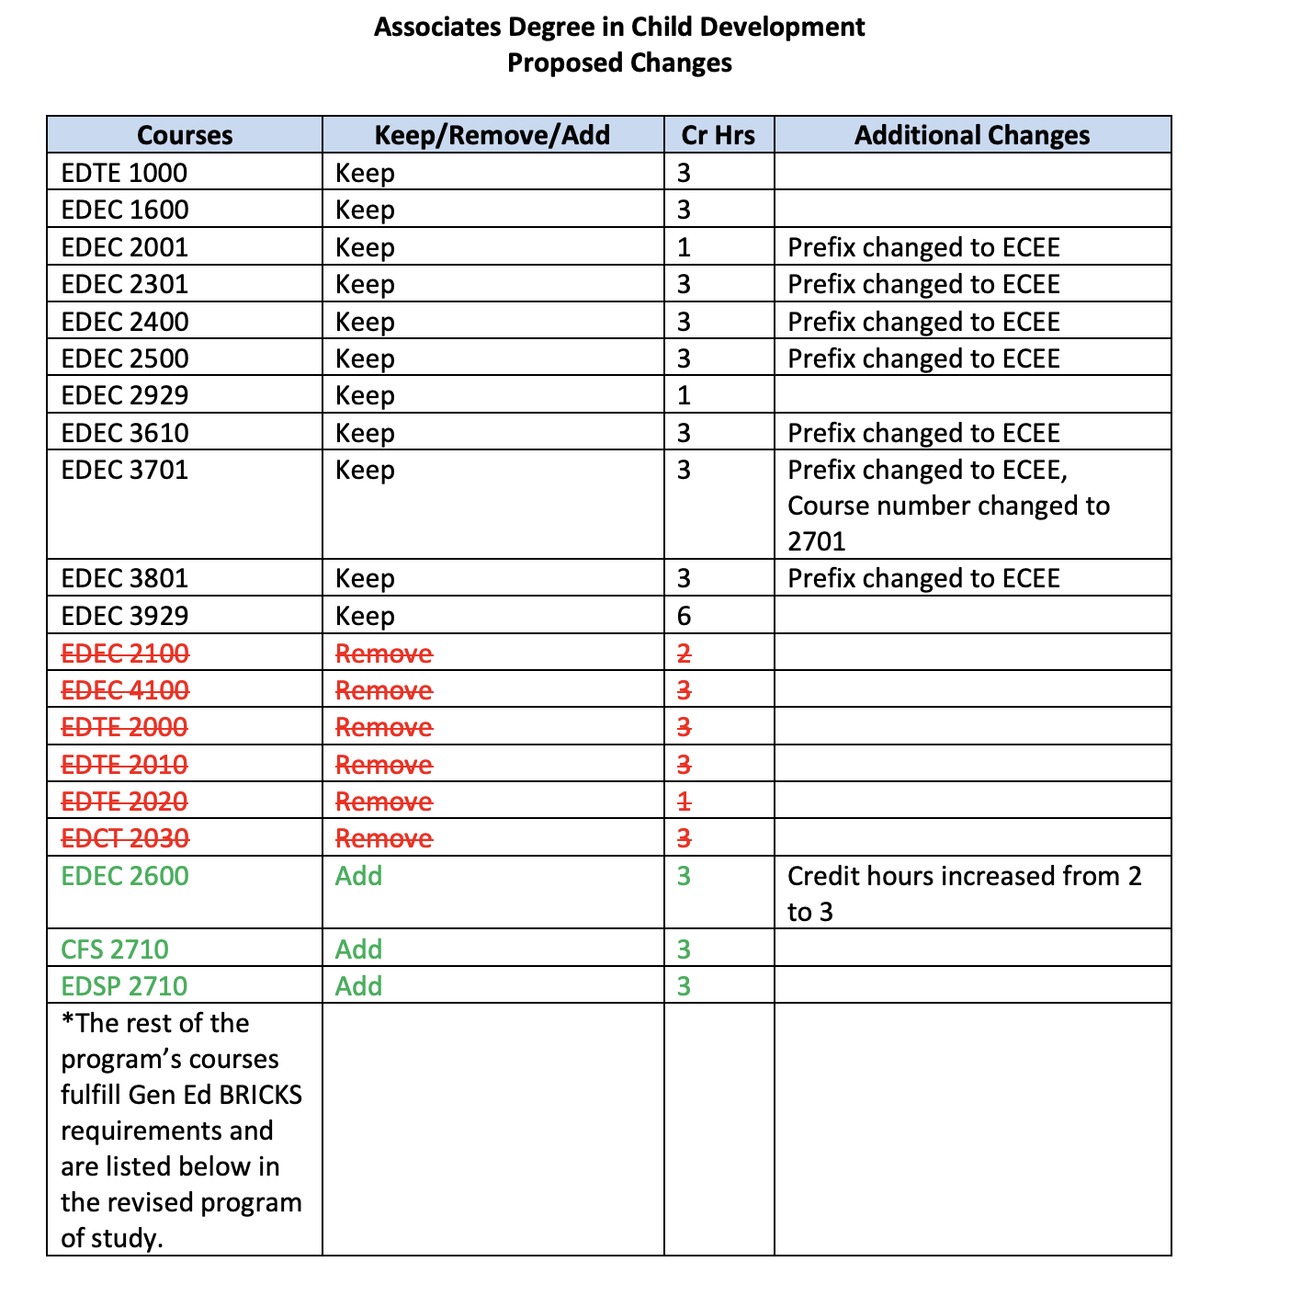
- Patton College of Education
Program Code: BS6308
Program Name: Integrated Social Studies
Department Name: Teacher Education
Contact: Matt Felton-Koestler

These revisions are designed to both respond to changes in general education requirements (BRICKS) and to bring content course requirements (those outside of the College of Education) in alignment with licensure testing requirements— specifically the content on the Ohio Assessment for Educators for secondary social studies teachers.

Current |  | Proposed
Requirement | Cr | Requirement | Cr
Fine Arts  Complete ONE: AH 2110 From Caves to Calligraphy… (4)  AH 2120 History of Art II (4)  FILM 2010 Intro to Film: History of World (3) FILM 2020 Intro to Film: Film Analysis (3) | 3-4 | No requirement | 0
Geography  Complete ONE:  GEOG 2400 Environmental Geography (3) GEOG 2150 Envronmental Geology (3)  Complete ONE:  GEOG 1100 Physical Geography (4)  GEOL 1010 How the Earth Works (4)  GEOL 1200 The Mobile Earth (3)  GEOL 2210 Earth and Life History (3)  Complete:  GEOG 1200 Human Geogoraphy (4) | 9-10 | Geography  GEOG 1100 Physical Geography (4)  GEOL 1200 The Mobile Earth (3) | 7
History Specialization  Select one of many possible specializations, all requiring three, 3-credit courses. | 9 | No requirement, but see Electives below. (Note: there are still required history courses, just no additional specialization.) | 0
Political Science  POLS 1010 Politics in the United States (3) POLS 1500 Themes in Global Politics (3) POLS 2500 International Relations (3)  Complete ONE:  POLS 3540 Different Approaches to… (3) POLS 4150 The American Presidency (3) POLS 4160 Legislative Processes (3)  POLS 4600 Intl. Political Economy (3) | 12 | Political Science  POLS 1010 Politics in the U.S. (3)  POLS 2000 Amer. Politics… (3)  POLS 2500 International Relat… (3)  Also see Electives below. | 9
Sociology  SOC 1000 Intro to Sociology (3) | 3 | No requirement | 0
No requirement | 0 | Electives  6 credits of electives 3000 or higher in HIST and/or POLS | 6
Total | 36-38 |  | 22

- Patton College of Education
Program Code: BS6232
Program Name: French Major
Department Name: Teacher Education
Contact: Matt Felton-Koestler

We are removing FR 4640 – Theory of Teaching French (3cr) due to an inability to offer the course. We are also changing the name of the major to “French Education” for better clarity. Finally, we are noting that EDCS 3010 has been renumbered as EDCS 2010 following a course change to align with BRICKS. Total credit hours are decreased by 3.

- Patton College of Education
Program Code: BS6235
Program Name: Spanish Major
Department Name: Teacher Education
Contact: Matt Felton-Koestler

We are removing SPAN 4640 - Teaching Spanish: Theory and Methodology (3cr) due to an inability to offer the course. We are also changing the name of the major to “Spanish Education” for better clarity. We are noting that EDCS 3010 has been renumbered as EDCS 2010 following a course change to align with BRICKS. Finally, we are also adding a thid advanced writing option for the students to select from (ML3280J Translation as Writing: Spanish to English). Total credit hours are decreased by 3.

- Patton College of Education
Program Code: BS6315
Program Name: Earth/Space Science
Department Name: Teacher Education
Contact: Danielle Dani

Program Code: BS6309
Program Name: Integrated Science

Program Code: BS6314
Program Name: Life Science

An elective is added to the program to accommodate BRICKS Arches: Constructed World or Arches: Connected World. Three credits are added to the total number of required credits for the program. The course number of EDCS 3010 is changed to EDCS 2010.

- Scripps College of Communication
Program Code: BJ6906
Program Name: Journalism News and Information
Department Name: Scripps School of Journalism
Contact: Mary Rogus

Program Code: BJ6907
Program Name: Journalism Strategic Communications

Program Code: BJ6910
Program Name: Journalism Carr Van Anda Program

The proposed changes to the program’s General Requirements will eliminate unnecessary duplication on the DARS of BRICKS requirements and allow us to maintain our breadth of knowledge goals, but also adapt to the changing political and social environment journalists now face.

Requirements for ENG II, Natural Sciences, Applied Science, IART/Fine Arts, and 2CP will be dropped from our General Requirements because they are repetitious of BRICKS requirements and it is no longer necessary to ensure that students not use these courses to meet both General Requirements and Specialization requirements in their Journalism Program. The A&S Elective requirement will also be dropped because the additional non-professional hours are no longer required for our accreditation.

Changes will be made to the HIST, ECON, ENG I, PHIL/CLWR, and AAS/WGSS requirements to direct students to the most valuable course topic areas as preparation for being journalists in the current environment.

The required 21-hour Specialization area(s) will be replaced with a requirement that students declare a Minor or Certificate Program, or create an advisor approved, minimum 15-hour, group of related courses.

Delete from College (Journalism) General Requirements:
ENG II requirement (any ENG course)
Natural Science (Tier 2 Natural Science courses)
Applied Science (Tier 2 Applied Science courses)
IART/Fine Arts (Tier 2 Applied Science courses)
Cross Cultural Perspective (Tier 2 2CP courses)
Arts & Sciences Elective (Any College of Arts and Sciences course + Public Speaking COMS 1030, 3 credit hours)

Changes to College (Journalism) General Requirements:
HIST: Take 2 HIST courses changes to Take 2 2000 level or above HIST courses (Any HIST 2000 level or above course)
ECON/Business: Take 2 ECON courses (Any ECON course) OR 1 ECON and 1 Business course from the list below (MKT 2020, ACCT BUSL, MGT) changes to Take 1 ECON course (Any ECON course)
ENG I: Change the name of this requirement from ENG I to Literature—no changes in the required course choices)
PHIL/CLWR: Take 1 PHIL or CLWR course (Any PHIL course except PHIL 1200 or CLWR course) changes to Take 1 CLWR course (Any CLWR course)
AAS/WGSS: Take 1 AAS or WGSS course (Any AAS or WGSS course) changes to Take 1 AAS course AND Take 1 WGSS course (Any AAS and WGSS course)

Changes to Specialization Area Requirement:
Delete 21-hour Specialization Area requirement (21 hours in one department OR 12 hours in one department—not MDIA, JOUR, or VISCOM--and 9 hours of related courses)
Add requirement that students declare a Minor or Certificate program, or create an advisor approved, minimum 15-hour, group of related courses.

Impact on program credit hours: These proposed changes should reduce the number of credit hours required for most students because we are deleting 2 general course requirements, but only adding 1, and depending on students’ choice of Minor or Certificate program, 1-2 more courses will be dropped from required hours.

*Note CARS Courses to Replace “PHIL or CLWR” General Requirement document in OCEAN.

- Scripps College of Communication
Program Code: CTSOME
Program Name: Social Media Certificate
Department Name: Scripps College of Communication
Contact: Karen Riggs

Summary of Changes:
1. Freshman/First-Year Admission section changes from “Students are eligible for entry with a 2.5 GPA, must maintain a 2.5 GPA overall, and must complete an 18 credit-hour minimum” to “Students are eligible for entry with a 3.0 GPA, must maintain a 3.0 GPA overall, and must complete an 18 credit-hour minimum. Students are required to earn a C or above in MDIA 2113 and MDIA 4120.”

2. Change of Program Policy section changes from changes from “Students are eligible for entry with a 2.5 GPA, must maintain a 2.5 GPA overall, and must complete an 18 credithour minimum” to “Students are eligible for entry with a 3.0 GPA, must maintain a 3.0 GPA overall, and must complete an 18 credit-hour minimum. Students are required to earn a C or above in MDIA 2113: Social Media Introduction and MDIA 4120: Social Media Capstone.”

3. External Transfer Admission section changes from “Students are eligible for entry with a 2.5 GPA, must maintain a 2.5 GPA overall, and must complete an 18 credit-hour minimum” to “Students are eligible for entry with a 3.0 GPA, must maintain a 3.0 GPA overall, and must complete an 18 credit-hour minimum. Students are required to earn a C or above in MDIA 2113: Social Media Introduction and MDIA 4120: Social Media Capstone.”

4. These program electives are added:
• COMS3250:Communication Technology and Organizing
• ITS 4310: Privacy in the Internet Age
• MDIA3912: Social Media Practicum
• MDIA 3705: Writing and Producing the Non-fiction Podcast Series
• MDIA 4122: Social Media Industries
• MDIA 4130: Social Media Analytics
• MDIA 4176: Technology, Communication, and Culture Scripps College

5. One elective is deleted from the program: MDIA 3175: Gossip, Rumors, and Outlaw Memes. (This class is not currently taught.)

- College of Health Sciences and Professions
Program Code: CTEXPE
Program Name: Experimental Study of Language Certificate
Department Name: Rehabilitation and Communication Sciences
Contact: Sally Marinellie

We are proposing to remove the thesis requirement (3 credits) and reduce the research experiences from 3 to 2. The effect of these changes is an overall reduction from 26 to 22 hours for certificate completion.

- College of Health Sciences and Professions
Program Code: ND6603
Program Name: Pre-Social Work
Department Name: Social and Public Health
Contact: Sally Marinellie

There are two changes being proposed:
a. Establishing the statistics requirement as being either PSY 2110 or 1110. Giving students the option of taking either PSY 2110 or 1110 is consistent with similar professional programs (nursing). Students planning to go on to Master’s Degree in Social Work will be encouraged to PSY 2110.

b. Elimination of Anthropology as a coursework option. This was originally listed to become aware of cultural differences. There are now more relevant cross- cultural courses for this requirement (for the practice of social work) that also meet accreditation standards.

- College of Health Sciences and Professions
Program Code: BA6601
Program Name: Bachelor of Arts in Social Work
Department Name: Social and Public Health
Contact: Sally Marinellie

Program Code: BS6605
Program Name: Bachelor of Social Work
Department Name: Social and Public Health
Contact: Sally Marinellie

There are two changes being proposed to this curriculum:
• Reducing the A&S 2000 and above requirement from 60 to 50 credit hours. The change in the A&S coursework does not change the minimum number of hours for this degree; ten of the 60 hours will now be electives. The change in the ANTH requirement reflects a reduction of three credit hours.
• Elimination of Anthropology as a requirement (included in pre-major and major requirements)

Current | Proposed | Rationale
Under College Requirements A&S 2000-Level or higher- at least 60 hours must be earned from A&S coursework at or the 2000 level. This includes courses that apply to the A&S foreign language, humanities, social sciences and natural sciences requirement ; courses from the department of your major; all LPA, & POCO courses; and Tier III courses offered by A&S departments | A&S 2000-Level or higher- at least 50 hours must be earned from A&S coursework at or the 2000 level. This includes courses that apply to the A&S  foreign language, humanities, social sciences and natural sciences requirement ; courses from the department of your major; all LPA, & POCO courses; and Tier III courses offered by A&S departments | These changes reflect the program’s move from the College of Arts and Sciences to the College of Health Science and Professions (CHSP). This gives the student the opportunity to take more global health classes (for example) that align with the mission of the college (10 credit hours).
Premajor: Complete one course in any two of these areas: ANTH, ECON, POLS, SOC Major: Complete one course from two of the following areas NOT used to fulfill premajor requirements. ANTH, ECON, POLS, SOC (These two requirements together mean that a student must take one course in each of the areas.) | Premajor: Complete one course in two of these areas: ECON, POLS, SOC Major: Complete one course from one of the following areas NOT used to fulfill the premajor requirement: ECON, POLS, SOC | ANTH was originally included as a requirement to become aware of cultural differences. There are now many relevant cross- cultural courses for students to take as an elective (for the practice of social work) that also meet accreditation standards.

- College of Health Sciences and Professions
Program Code: BS6468
Program Name: Child and Family Studies
Department Name: Social and Public Health
Contact: Sally Marinellie

We are making revisions to the CFS major core curriculum and three concentrations (Child Life, Child, Adult and Family, and Gerontology).
The faculty members in the Child and Family Studies (CFS) program have reviewed the undergraduate curriculum. The changes proposed here reflect an update of the curriculum and the addition of flexibility for students with respect to course options. Additionally, adjustments were needed in the child life and pediatric health care concentration to reflect the updated 4+1 graduate program that launched last year. Also, an update on the family gerontology concentration was needed, as courses in that concentration are no longer being offered.

These changes are less than 25%. The comparison charts are listed in OCEAN 1.9.

- University College
Program Code: BT5510
Program Name: Technical & Applied Studies
Department Name: University College
Contact: Donna Burgraff

To improve the assessment process and to better align with BRICKS, the program level learning outcomes are being slightly edited for grammar and language. Additionally, the faculty, in an effort to better assess student learning and to bring the major in compliance with BRICKS, will require students to obtain 30 credits in Technical and Applied Studies (TAS) courses. This does not change the total number of credits for the major but does eliminate optional category choices. To enhance student comprehension of the program’s purpose and focus on application and skill development in the major, some of the catalog language is being updated so that it is consistent throughout and reflects the inclusiveness of the program.

Summarizing, the changes are (1) language editing to the program level learning outcomes, (2) moving courses from optional to required without changing the number of credit hours for the major, (3) adding a new course to the options available under professional skills core additional requirements and (4) some language editing to the catalog.

Current | Proposed | Comments
Required Coures Option | Required Course | No more option. TAS course now required with grade of C or better. Other option courses remain electives.
Collaboration: COMS 3060, EDCE 4400, TAS 4440 | TAS 4440
Diversity: COMS 3300, EDCE 4100, HIST 3060, TAS 4140 | TAS 4140
Ethics: COMS 4604, SW 3213, TAS 4040 | TAS 4040
Leadership: SAM 3000, 3050, TAS 4340 | TAS 4340
Research and Technology: COMS 3200, LET 3550, SAM 3020, TAS 4240 | TAS 4240

- Honors Tutorial College
Program Code: BF1940
Program Name: Studio Art
Department Name: School of Art
Contact: Beth Novak

During the Q2S transition, it seems only the DARS for the BF1940 program got updated and not the catalog. In 2018, the Registrar’s office discovered the discrepancy and asked HTC to bring them into alignment by changing the DARS to reflect the catalog. This was approved without needed scrutiny and the requirements now reflect our quarter system. These requirements are not feasible for current students. As an example, students can only take a maximum of 10 studio courses in the semester system in the sophomore through senior year. The current requirements demand 15. For the benefit and ultimate success of our HTC BFA Studio Art students, it is imperative that the current requirements are updated to match the current reality. These changes, drastically reducing the number of classes required, align with the requirements from our post-Q2S DARS (2017) with a few tweaks because of course changes, etc.

Current | Proposed | Comments
Required | Required
Practicum: Complete one of the following:  Studio Art Option (ART 4950 and 4952)  Graphic Design Option (ART 4954 and ART 4956) | No change | No change
Foundation Courses: Complete the following: ART 1200, A | No change | No change
Studio Courses: Complete 15 studio art courses | Delete | Courses listed as Studio Courses are covered in the eight tutorials HTC students are required to take.
Art History: Complete one: AH 2110,  AH 2120  Theory:  Complete two of the following:  AH 3600, AH 4111, AH 4190, AH 4621, AH 4902  Contemporary Western Art: Complete AH 4101  Contemporary World Art: Complete one: AH 3320, AH 3420, AH 3540, AH 3610, AH 4101, AH 4180, AH 4331, AH 4611 | Art History: Complete two 3000/4000-level Art History courses in consultation with advisor | The majority of the original requirements will also be covered in the eight tutorials HTC students are required to take. This is a better balance of AH requirements for our students.
Collateral Courses Complete 24 hours approved by the director of studies | Delete | The spirit of this requirement is met via liberal arts courses and courses within COFA that HTC students take in their flexible curriculum
 | Complete one of the following: 2 sections of ART 4000: Critique Community in the student’s area of concentration OR  ART 4510: Graphic Design Studio III and ART 4520: Graphic Design Studio IV | The new options are essential to build the student’s professional critique and making skills.

- Honors Tutorial College
Program Code: BC1920
Program Name: Media Arts & Studies HTC
Department Name: Media Arts & Studies
Contact: Beth Novak

Changes to the non–HTC Media Arts and Studies undergraduate programs necessitate changes to the HTC major. Additionally, these changes add flexibility and offer students choice, a hallmark of our HTC programs. These are only changes to the major requirements; college requirements, including tutorials and thesis, remain the same. All courses referenced here are already approved and in the catalog. No change to credit hours and no impact to other units

Current | Required | Comments
Required courses | Required courses
Media Arts and Studies Core: MDIA 1020, MDIA 2011, 3 CH of Production Basics (MDIA 1250, MDIA 1300, MDIA 1450) 9 CH | Media Arts and Studies Core: Take MDIA 1010 Choose one: MDIA 1020, MDIA 2011, MDIA 2305, MDIA 2701 6 CH | Allows students more flexibility, production basics courses (3 CH) are no longer being offered so a new introductory requirement is added to the “Specialization”
Specialization: Complete a minimum of 15 hours from one of five predetermined emphases or selfdetermined by the student with advisor approval. | Media Arts and Studies Specialization:  Complete at least one introductory course in your area of interest: MDIA 1250, MDIA 1350, MDIA 1450, MDIA 2201, MDIA 2401, MDIA 2500, MDIA 2700 (3 CH)  Complete a minimum of 15 hours of intermediate and advanced courses (2000-level and above) from one of four predetermined emphases or self-determined by the student with advisor approval. | Adds an introductory level requirement to replace the production basics requirement from the previous core, again giving students more flexibility. Specifies that the previous specialization must now be mid- to upper-level coursework.
Complete a minor or certificate approved by your advisor | Complete a minor or certificate approved by your advisor | No change
Total: 24 credit hours + minor / cert | Total: 24 credit hours + minor / cert

- Honors Tutorial College
Program Code: BB1926
Program Name: Business Administration
Department Name: Management
Contact: Katie Hartman

We are proposing to add two courses to the HTC Business Administration major requirements. These courses, BA 1000 and BA 2000, will offer students a better foundation in the COB, giving our HTC students a common language and chance for cohort-building with non-HTC students. Students will also have the opportunity to complete milestones as a part of Guarantee+ in these courses. These are only changes to the major requirements; college requirements, including tutorials and thesis, remain the same. All courses referenced here are already approved and in the catalog. This will require students to complete 2 additional hours total and no impact to other units.

Current | Required | Comments
Required courses | Required courses
Business Courses: Complete the following: ACCT 1010, FIN 3000, MATH 1350 or MATH 2301; MGT 2800J, QBA 1720, QBA 2720 | Business Courses: Complete the following: BA 1000, BA 2000, ACCT 1010, FIN 3000, MATH 1350 or MATH 2301; MGT 2800J, QBA 1720, QBA 2720 | Adds BA 1000 and BA 2000 to the requirement list for an additional 2 CH hours total added to the major. Provides students with stronger foundation.
Cluster Courses: Complete the following courses in the same semester: BA 2500; MGT 2100; MIS 2020; MKT 2400 | No change | No change
Economics Courses: Complete the following: ECON 1030, ECON 1040 | No change | No change

- College of Arts & Sciences
Program Code: BS3323
Program Name: Geological Sciences- Environmental Geology
Department Name: Geological Sciences
Contact: Greg Springer

Change name of major from Geological Sciences-Environmental Geology to Geological Sciences- Environmental Water Resources to reflect change in required upper-level GEOL courses to emphasize water-related topics because retirements mean we cannot sustain the program as currently configured. Change required upper-level courses by removing classes taught by retired faculty and replace with courses we can teach, including newly developed courses. Expand list of electives to give students greater choice. No substantive changes to extra-departmental coursework, except for substitution of MATH 1300 for MATH 2301. The total credit hours decreases from 44 to 43 unless students take statistics outside of the department (46 hours).
Remove GEOL 1700 & 2710 as elective options due to faculty retirements.
Reduce number of required courses to increast curicular flexibility and accommodate upcoming faculty retirements in Geology Core Courses from 44 to 43 hours. Courses removed were moved to the advanced electives. GEOL 4060, 3700, and 4750 are newly developed water resources focused courses that will provide practical training to majors.
Revised advanced electives from 4000-level courses to the ability to complete courses from 3000- or 4000-level courses for at least 12 hours.

A full side-by-side comparison chart is in OCEAN 1.9.
FIRST READING- NEW PROGRAM/ CERTIFICATE
- Scripps College of Communication
Program Code: MSXX07
Program Name: Master of Communication
Department Name: Scripps College of Communication
Contact: Greg Newton

The Scripps College of Communication proposes development of an innovative Master of Communication (M.C.) degree that is designed to offer flexible and modular solutions for students who need to obtain additional training and expertise in emerging areas within the communication field. The M.C. requires the completion of 30 semester hours of graduate coursework. Students are required to complete 6 credit hours of core communication curriculum courses (i.e., an introductory course in graduate communication research and an applied capstone project course), to which they will supplement approved graduate-level electives. The degree will provide an adaptable set of electives that can be shaped into specific areas of demand that are relevant to career professionals in a rapidly changing workplace environment including but not limited to: media relations, strategic communication, crisis communication, emerging communication technology, health communication, inclusive workplaces, and others.

All courses will be offered through Ohio University’s eCampus. Some courses may also be offered in person, through Athens Campus Online, or via blended modes if sufficient demand exists.

Core courses = 6 credit hours
New OHIO Courses
These courses have never been offered at OHIO before. Courses listed below are not yet in the graduate catalog. These courses have been approved by UCC. Depending on their elective certificates selected, 20--50% of total hours includes NEW courses listed under forthcoming electives as well.
COMM 6000 | Introduction to Graduate Research in Communication
COMM 6960 | Master’s Capstone
Total electives required= 24 credit hours
Forthcoming electives
*Courses listed below are not yet in the graduate catalog. These courses have been approved by UCC and when published would be part of the proposed M.C. elective options.
COMM 5018 (1 cr) | Strategic Communication Seminar
COMM 5800 (4 cr) | Strategic Communication Fundamentals
COMM 5830 (4 cr) | Media Planning Fundamentals
Existing OHIO course electives
*Courses below are already in the graduate catalog. These would be elective options for the Master’s. Total number of credit hours listed below (65 credit hours). Students will only be required to take 24 credit hours from these options (and the three pending courses above). 50-80 % of total hours.
Course number | Course name | Course number | Course name
COMM 5011 | Crisis Communication Seminar (1cr) | MDIA 5610/COMM 5610 | Assessing Digital Media Transformation & Innovation (4cr)
COMM 5300 | Crisis Communication and Planning (3cr) | MDIA 5611/COMM 5611 | Leading Digital Media Transformation and Innovation in Organizations (4cr)
COMM 5310 | Crisis Communication Strategy (4cr) | JOUR 5812/COMM 6812 | Promoting Digital Media Transformation & Innovation (4cr)
COMM 5320 | Social Analytics in Crisis Communication (4cr) | VICO 5010 | Communicating with Data Visualization (4cr)
COMM 5012 | Media for Non-Journalists Seminar (1cr) | COMM 5013 | Media for STEM Professionals Seminar (1cr)
COMM 5400 | Media Today and Tomorrow (3cr) | COMM 5401 | Introduction to Media for STEM (3cr)
COMM 5410 | Crafting a Positive Media Message (4cr) | COMM 5411 | Crafting a Positive Media Message for STEM (4cr)
COMM 5420 | Mastering the Media Interview (4cr) | COMM 5421 | Mastering the STEM Media Interview (4cr)
JOUR 5130 | Gender, Race, and Class in Journalism and Mass Media (3cr) | COMS 5220 | Facilitating Difficult Conversations (4cr)
JOUR 5820 | Strategic Communication Management for Advertising and PR Professionals (3cr) | JOUR 7200 | Ethics, Mass Media, and Society (3cr)

- College of Business
Program Code: CTX16U
Program Name: Business Ethics and Social Responsibility Certificate
Department Name: Finance
Contact: Travis Davidson

Curriculum: The Business Ethics and Social Responsibility Certificate program will consist of two required courses (3 hours each) and 9 hours of elective courses for a total of 15 credit hours. Interested students in the College of Business (CoB) can broaden their education to add an emphasis on ethics in preparation for a career in the business world, while non-CoB students can gain knowledge of the importance of ethics in a business setting to complement their discipline-specific skills and understanding of ethics. The program will incorporate two required courses to give an introduction to the business environment and the associated values and responsibilities necessary to be a successful corporate citizen. The elective courses allow students to customize the certificate to align with their particular areas of interest.

- College of Business
Program Code: BAXX13
Program Name: Sport Management
Department Name: Sport Administration
Contact: James Strode

Complete a total of 15 credit hours from the following:
Required Courses:
Complete both of the following courses:
1. BA 1100 Introduction to Business and Ethical Reasoning (Requisites: None). 3 credit hours 2. MGT 3100 Values, Business Ethics, and Corporate Responsibility (Requisites: None). 3 credit hours

Business-Related Electives:
Complete at least six credit hours from the following:
1. COMS 4082 Communication Ethics and Leadership (Requisites: COMS 2500 or COMS major and Jr or Sr) 3 credit hours
2. LPA 4710 Social Entrepreneurship (Requisites: None). 3 credit hours
3. MGT 3270 Sustainable Supply Chain Management (Requisites: None). 3 credit hours
4. MGT 4420 Gender Issues in Management (Requisites: Jr or Sr). 3 credit hours
5. MKT 4100 Sustainability Marketing (Requisites: None). 3 credit hours
6. PHIL 2350 Business Ethics (Requisites: None). 3 credit hours
7. POLS 4840 The Politics of Sustainability (Requisites: Jr or Sr). 3 credit hours
8. BA 3900 Topics in Business Ethics (Requisites: None). 1 credit hour
9. SASM 3120 Sports Governance and Ethics (Requisites: SASM 1001 or SASM 1010). 3 credit 10. TAS 4040 Ethics and Organizational Social Responsibility (Requisites: None). 3 credit hours

General Education Electives
Complete any three credit hours of BRICKS Ethics & Reasoning coursework

- College of Arts & Sciences
Program Code: CTX79U
Program Name: Certficiate in Craft Brewing
Department Name: Chemistry & Biochemistry
Contact: Michael Held

This certificate aims to provide students with fundamental principles and concepts of biochemistry, microbiology, and engineering, as well as entrepreneurial aspects and small business ownership, all through the lens of craft brewing. Successful and consistent brewing is largely dependent on a firm understanding of the science behind the process. But craft brewing is far more than brewing science. Craft breweries are small businesses that require specific skillsets for management, planning, marketing, social media presence, and operation. Craft breweries often fail because they do not fully understand and/or appreciate the business skills necessary for small business ownership. Therefore, this program aims to help bring together students with science backgrounds with business-minded students to provide a translational, peer-led learning environment. Bringing these diverse groups of students together will facilitate the exchange of knowledge across disciplines that is lacking in many industries (not only in craft brewing).

This certificate will provide a multidisciplinary educational experience attractive to a wide variety of students across numerous colleges. Students will have the option of completing the certificate program in one of two tracks: a “science” track or a “business” track. The core coursework for both tracks will prepare students to take in their senior year a hands-on brewing science course (CHEM 4500) and a brewing case study course (CAS 4413). All students will gain valuable practical experience through internship courses (BIOS4910; CHEM4911; MGMT3730). Currently, Jackie O’s of Athens Ohio has agreed to host students for a wide variety of internship opportunities

Category I: Science Track
1. Microbiology (select one from the following)
BIOS2210/2225 – Microbes and Humans (5cr.)
BIOS3220/3225 – General Microbiology (5cr.)
2. Biochemistry (select one from the following)
CHEM4890 – Basic Biochemistry (3cr.)
CHEM4901 – General Biochemistry I (3cr.)
BIOS4630 – Biological Chemistry (3cr.)
3. Core Brewing Courses (required)
CAS4413 – Art of Craft Brewing: Athens case study (3cr.)
CHEM4500 – Brewing Science (3cr.)
- Internship (select one from the following)
CHEM4911 – Chemistry Internship (3cr.)
BIOS4910 – Biological Sciences Internship (1-3cr.)

Category II: Business/Entrepreneur track
- Entrepreneurial studies
MGT3700 – Introduction to Entrepreneurship (3cr.)
- Business plan design (select one of the following)
MGT3710 – Business Plan Design (3cr.)
MGT3740 – Ideation and Business Models (3cr.)
- Core Brewing Courses (required)
CAS4413 – Art of Craft Brewing: Athens case study (3cr.)
CHEM4500 – Brewing Science (3cr.)
- Internship (select one from the following)
CHEM4911 – Chemistry Internship (3cr.)
BIOS4910 – Biological Sciences Internship (3cr.)
MGT3730 – Entrepreneurial Business Consulting (3cr.)
MGT3735 – Entrepreneurship in Practice (3cr.)

EXPEDITED REVIEW

- College of Business
Program Code: MB6146, MB6141, MB6155
Program Name: OMBA with Executive Management Concentration; PMBA with Executive Management Concentration
Department Name: Management
Contact: William Young

We would like to make the following change to our MBA with Executive Management concentration because we feel that the change will result in a better learning experience for our MBA students that have selected Executive Management as a concentration due to the emerging role that analytics plays within modern business. Our proposal calls for MBA 6560 Analytics for Executive to replace MBA 6325 Prescriptive Analytics as a required course for the MBA with Executive Management concentration.

- College of Business
Program Code: BB6127
Program Name: Marketing
Department Name: Marketing
Contact: Mick Andzulis

Program Code: OR6127
Program Name: Marketing Minor

The change in the marketing major program will allow students interested in working for the public or social good to expand their studies to include a Non Profit Marketing course. Add course option to marketing major electives: • MKT 3400 Non Profit Marketing (3)

- College of Arts & Sciences
Program Code: OR4221
Program Name: Economics Minor
Department Name: Economics
Contact: Shamila Jayasuriya

The Economics department faculty recently met and discussed the need to re-word the elective requirements for both majors and the minor. The current wording for the electives for our minor is the following: “Complete 9 hours” We are proposing that the new wording should be: “Complete 3 courses for at least 9 hours. At least 2 courses must be at the 3000 level or higher” Note: All economics electives are 3 credit-hour courses.

The reason for the proposed change is that we now have a longer list of 2000-level courses and we think it is a good idea to limit the number of 2000-level courses that get counted as electives. Most of our 2000-level courses generally have no/fewer prerequisites and tend to be less quantitative in nature than the 3000-level or higher courses. By limiting the number of 2000-level courses that get counted as electives, students can experience a higher level of rigor that can result in a more challenging and culminating academic experience as an Economics minor.

- College of Arts & Sciences
Program Code: BA4221
Program Name: Economics
Department Name: Economics
Contact: Shamila Jayasuriya

The Economics department faculty recently met and discussed the need to re-word the elective requirements for both majors and the minor. The current wording for electives for our B.A. major is the following: “Complete 4 courses for at least 12 hours” We are proposing that the new wording should be: “Complete 4 courses for at least 12 hours. At least 3 courses must be at the 3000-level or higher” Note: All economics electives are 3 credit-hour courses.

- College of Arts & Sciences
Program Code: BS4225
Program Name: Economics
Department Name: Economics
Contact: Shamila Jayasuriya

The Economics department faculty recently met and discussed the need to re-word the elective requirements for both majors and the minor. The current wording for electives for our B.S. major is the following: “Complete 6 courses” We are proposing that the new wording should be: “Complete 6 courses for at least 18 hours. At least 5 courses must be at the 3000-level or higher” Note: All economics electives are 3 credit-hour courses.

- Patton College of Education
Program Code: BS6395
Program Name: Physical Science- Physics & Chemistry
Department Name: Teacher Education
Contact: Danielle Dani

Program Code: BS6396
Program Name: Physical Science- Physics

Program Code: BS6397
Program Name: Physical Science- Chemistry

The course number of EDCS 3010 is changed to EDCS 2010. The course has been renumbered to align with BRICKS General Education Requirements.

- Patton College of Education
Program Code: BS6418
Program Name: Customer Service Leadership
Department Name: Human and Consumer Sciences
Contact: Robin Ambrozy

- An adjustment to course offerings is requested. Course hour requirement remains the same; however the course options have changed to better complement the curriculum from interdisciplinary departments across campus.
- Replace the requirement for “a grade of C or better in each major course” with “an overall GPA requirement of 2.0 in the major core classes.”

Graduate Catalog Cleanup
- Patton College of Education
Program Code: ME6276
Program Name: Higher Education
Department Name: Counseling & Higher Education
Contact: Dave Nguyen

This program change is being submitted to comply with the Graduate College Curriculum Cleanup process as well as ensure our program requirements reflect current trends in the field of higher education.
We are proposing eight (8) changes that account for:
o Credit hour changes (e.g., EDRE5010),
o Course eliminations for content not necessary for prospective and current students (e.g., EDHE7810, EDHE7790),
o Course number updates (e.g., EDHE6910 to EDHE6940), and
o Course content alignment with program learning outcomes (e.g., EDHE7210, EDHE7850)
No other units are affected by this program change.

This reduces the total required credit hours from 36 to 30.

Current | Cr | Proposed | Cr | Comments
EDHE 6880 - Higher Education and Student Affairs in the United States | 3 | EDHE 6880 - Higher Education and Student Affairs in the United States | 3 | No change
EDHE 7860 - Leadership and Change Management in Higher Education | 3 | EDHE 7860 - Leadership and Change Management in Higher Education | 3 | No change
EDHE 7790 - Finance and Budgeting in Higher Education | 3 | EDHE 7790 - Finance and Budgeting in Higher Education | 3 | No change
EDHE 6910 - Capstone Project in Higher Education and Student Affairs | 3 | EDHE 6940 - Capstone Project in Higher Education and Student Affairs | 3 | EDHE6910 was a legacy course during the quarters to semesters transition and no longer exists in OCEAN 2.0.  EDHE6940 is the course number for the current iteration of the course.
EDHE 6890 - Legal Issues in American Higher Education | 3 | EDHE 6890 - Legal Issues in American Higher Education | 3 | No change
EDCP 6200 - Introduction to Student Affairs Organization and Administration | 4 | EDHE7850 – Organization and Governance in Higher Education | 3 | EDCP6200 is a four-credit course that is designed to introduce student affairs professionals to how student affairs are organized and administered.  EDHE7850 focuses on how students affairs are organized, as well as how student affairs fit within higher education, how higher education is governed, and how the different governance functions (e.g., Board of Trustees, University Presidents) operate.
EDRE 5010 - Introduction to Research Methods | 4 | EDRE 5010 - Introduction to Research Methods | 3 | This course changed from 4 to 3 credits.
EDHE 7810 - Practicum in College Teaching and Curriculum Development OR  EDHE 7920 - Practicum in Higher Education Administration and Leadership | 3 | NA | 0 | Practicum requirements have been eliminated from the program. The Masters in Higher Education program is aimed at working professionals so having to complete a practicum for practical experience is not necessary.
EDCP 5210 - College Student Development: Theory with Practice | 4 | EDCP 5220 - Campus Environments | 3 | EDCP 5220 addresses content that is more relevant to students.
EDHE 7780 - Assessment and Evaluation in Higher Education and Student Affairs | 3 | NA | 0 | Many students enter this program with Assessment and Evaluation experience so this course is not necessary.
EDHE 7830 - Institutional Research and Planning in Higher Education | 3 | EDHE5885 - Historical and Contemporary Issues in Higher Education | 3 | EDHE7830 was a specialized course that none of our current faculty can teach. EDHE5885 is a contemporary issues in higher education course.
NA | 0 | EDHE7210 - Diversity in American Higher Education | 3 | This course reflects the changing demography of students in Higher Education and is the only course in the Masters in Higher Education curriculum focused on college students.
Total Credits | 36 | Total Credits | 30

- Patton College of Education
Program Code: ME6275
Program Name: College Student Personnel
Department Name: Counseling & Higher Education
Contact: Dave Nguyen

We are proposing five (5) changes that account for:
o Updating courses with credit hour changes (e.g., EDRE5010),
o Reducing the number of required practicum courses from 3 to 1 (e.g., EDCP6920), while adding two professional development courses (e.g., EDCP6400, EDCP6500) that address practical issues in higher education.
o Adding a EDHE8930 Readings and Research requirement during the student’s first semester to ease with transition to graduate work and to develop career planning with the student’s advisor, and o Adding a Legal Issues in Higher Education course to address the changing legal environment for today’s student affairs professionals.
• No other units are affected by this program change.

- Patton College of Education
Program Code: PH6276
Program Name: Higher Education
Department Name: Counseling & Higher Education
Contact: Dave Nguyen

Summary of Changes:
1. Reducing the Number of courses from 11 to 9 and adding in spaces for students to take two elective courses.
2. Explicitly outlining the minimum scholarly tools courses needed to be taken by students

- College of Business
Program Code: MS8112 & MS8149
Program Name: Master of Sport Administration/ MSA MBA Program
Department Name: Sport Administration
Contact: James Strode

Our current request is that we make the corrections below to accurately reflect and complete the UCC/OCEAN Catalog Matching Project so it synchs with the UCC approved 2016 Changes.
• Remove SASM 6501 in Required Courses and Replace with SASM 6550
• Remove SASM 6550 from Electives

- College of Fine Arts
Program Code: MM5182
Program Name: Thesis/ Recial Track
Department: School of Music
Contact: Matthew Talbert
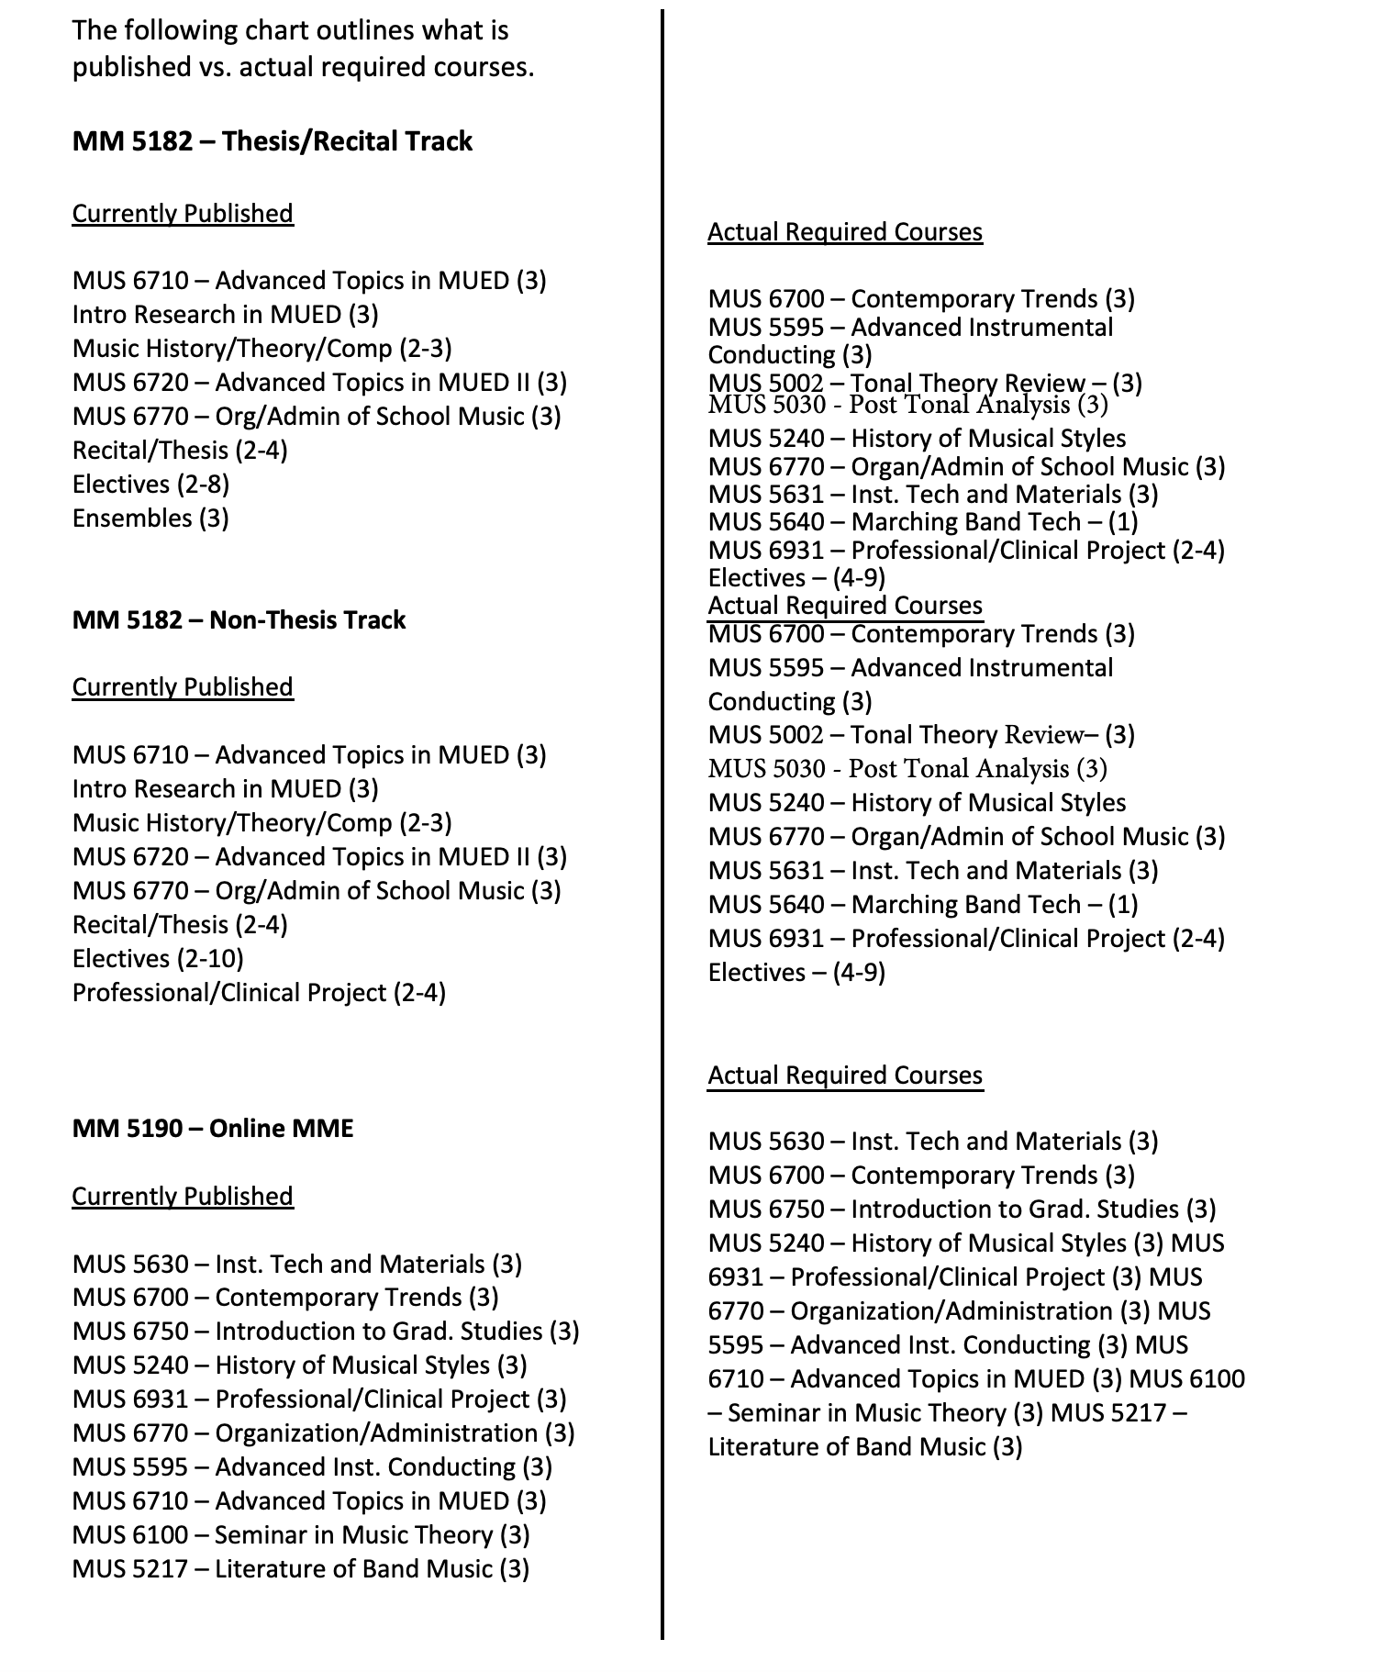

NOTIFICATIONS
MERGED DEPARTMENT PROPOSALS- Will follow the program relocation process and have 2 readings.

SECOND READING:
Patton College of Education- see full memo on Programs Committee website
The Patton College’s intent to merge the Department of Recreation and Sport Pedagogy (RSP) and the Department of Human and Consumer Sciences (HCS) into a single department. The decision to merge these two departments was made at the end of AY2019-2020 by Dean Renee Middleton in consultation with the chairs of these two departments: Dr. Beth VanDerveer (HCS) and Dr. Bruce Martin (RSP). The purpose of this departmental merger is twofold: 1) to realize greater operational efficiencies within the college and 2) to create greater opportunities for interdisciplinary collaboration and curricular innovation among the programs in these departments. Faculty members in both departments have been working throughout the current academic year to facilitate the merger. These efforts have included the development of a new departmental committee structure, the development of new policies and procedures under which faculty will engage in shared governance in the department, the development of new promotion and tenure policies, among other tasks.

The faculty members from both departments held a joint faculty retreat conducted by a neutral facilitator on Friday, February 26, 2021 to develop a new department name, along with a new mission statement, vision statement, and statement of shared values for the department. The new department name that emerged from the faculty retreat is the Department of Recreation, Sport Pedagogy, and Consumer Sciences.

FIRST READING:
University College- see two memos on Programs Committee website
This memo outlines the intent to form a new department in University College, the Department of Applied Sciences and Professions, effective July 1, 2021. The decision to form a department was made by interim dean Carey Busch after several discussions with the RHE faculty who were realigned to UNC in August 2020. The primary purpose of creating this department is to create the structure currently lacking to address the needs of the faculty and programs recently realigned as part of One Ohio.

Several meetings were held during the fall semester which included the faculty, the dean, assistant dean for advising and student services and the director of degree programs. The purpose of these meetings was for UNC dean and staff to develop a better understanding of the new programs and subjects as well as the faculty developing a better understanding of UNC with the goal of providing a foundation for determining opportunities and making informed, strategic decisions. While discussions have been productive the lack of a formal department and ability to name a department chair has become a hindreance our ability to develop appropriate governance and support to the new programs and subjects.
The new department will include the following degrees:
- Bachelor of Applied and Technical Studies
- Associate of Science in Law Enforcement Technology,
- Associate of Technical Studies
In addition to the above amed degrees, the department will include two subject areas:
- Real Estate
- Office Administration Technology
PROGRAMS COMMITTEE GUIDELINES & TEMPLATE-
PROPOSED REVISIONS FOR 21-22

