SECOND READINGS – PROGRAM CHANGES
- Scripps College of Communication
Program Code: BC5329
Program Name: Information Telecommunication Systems
Department: Emerging Communication Technologies
Contact: Trevor Roycroft

Advanced network applications like live video, audio, or gaming frequently demand specific services from the network infrastructure. Advanced applications like live video and gaming are a function of not only the type of data that is being transferred but of the transmission requirements of the information and the location of the information being exchanged. Augmented and virtual reality are two examples of applications that may demand specific services from networks and also need to know from where the required information can be delivered by the network to the end user. To address this technology transformation, the J. Warren McClure School of Emerging Technologies proposes to evolve the ITS degree into two tracks: the traditional track (ITS) will remain dedicated to information telecommunication systems networking; the new track (ECT) will be dedicated to emerging communication technologies production, e.g., virtual and augmented reality (VR/AR). According to our school advisory board, students possessing both networking and content production skills have a competitive advantage in the marketplace. Adding a second track to our major will allow our students to develop this competitive edge by combining courses that build competency in both networking and content production.

The current ITS major requires that students complete at least 78 semester credit hours. Completion of the ECT track requires students to complete at least 82 credit hours. Current ECT/ITS resources are sufficient to meet expected demand, which is anticipated to grow during the first three years from an initial five to a steady state of 12 total ECT track students.

The new track would be the Emerging Communications Technologies Track. Below is the comparison between the two
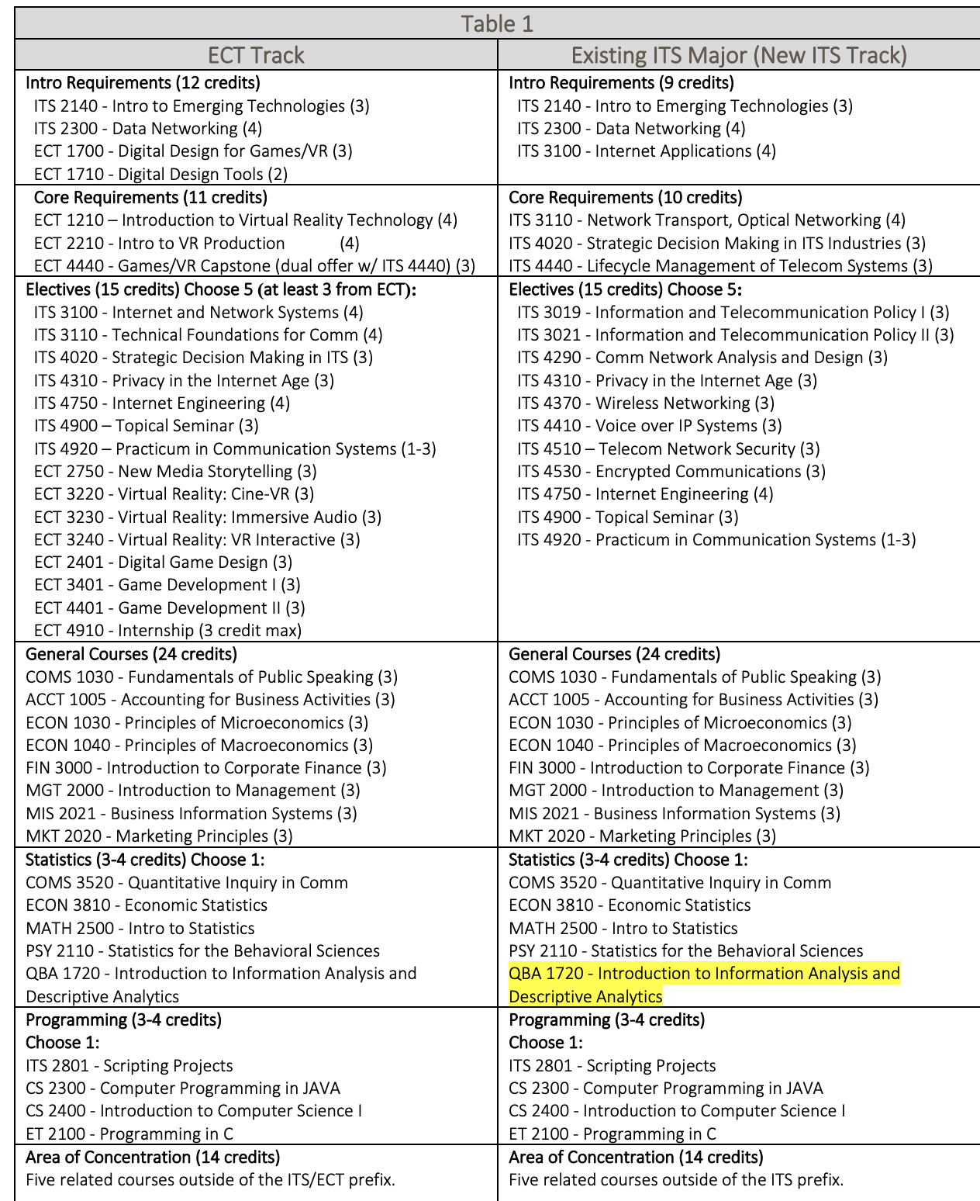

SECOND READINGS – NEW PROGRAMS
- Scripps College of Communication
Program Code: BSXX09
Program Name: Virtual Reality and Game Development
Department: Emerging Communication Technologies
Contact: Julio Arauz

The Virtual Reality and Game Development major (VRG) is housed in the McClure School of Emerging Communication Technologies (McClure). In addition to a core set of Virtual Reality and game design classes, VRG electives within the McClure School introduce our students to the information networking systems and coding required to solve problems and implement VR and game systems within a larger context. Within the 120 total credit hours needed to complete their undergraduate degree, the students’ business or communication courses (two minors from which they must choose) prepare our students to become effective leaders, entrepreneurs and/or creative problem solvers in a wide variety of industries.

The total credit hours required for completion of the major:
59 credit hours for major
+ 15 credit hours for minor
The total credit hours required for completion of the degree: 120 credit hours

Major Requirements within ECT (37 credits)
ECT 1210 Understanding VR Technologies (4 credits)
ECT 1700 Foundations of VR & Game Development (3 credits)
ECT 1710 Digital Tools for VR and Games (2 credits)
ECT 2210 Intro to VR Production (4 credits)
ECT 2401 Game Design (3 credits)
ECT 2750 New Media Storytelling (3 credits)
ECT 3260J VR: Critical Analysis and Evaluation (3 credits)
ECT 3401 Game Dev I (3 credits)

Choose 3:
ECT 3220 VR Production: cine-VR (3 credits)
ECT 3230 VR Production: Interactive (3 credits)
ECT 3210 VR Production: Immersive Audio (3 credits)
ECT 4401 Game Dev II (3 credits)

Choose 1:
ECT 4440 VR and Game Design Capstone (3 credits)
COMM 4023 Theme Park Capstone (3 credits)
Major Requirements outside of ECT (13 credits)
COMS 1030 Public Speaking (3 credits)
ITS 2140 Intro to Info and Telecom Systems (3 credits)
ITS 2801 Scripting Projects (3 credits)

Choose 1:
PSY 1110 Elementary Statistical Reasoning (3 credits)
PSY 2110 Statistics for the Behavioral Sciences (3 credits)
PHIL 1200 Principles of Reasoning (3 credits)
Electives for the major (9 credits)
ECT 2411 Game Design: World Creation (3 credits)
ECT 2900 Special Topics (3 credits)
ECT 4110 Augmented Reality Development (3 credits)
ECT 4910 Internship (1-8 credits)
ECT 4920 Practicum (1-4 credits)
ECT 4900 Special Topics (3 credits)
ITS 2010 Understanding Internet Tech (3 credits)
ITS 2300 Data Networking (4 credits)
ITS 3100 Internet Applications / Systems (4 credits)
ITS 3110 Technical Foundations for Communication (4 credits)
ITS 4020 Strategic Decision Making in ITS (3 credits)
ITS 4310 Privacy in the Internet Age (3 credits)
MDIA 1350 Animation Foundation (3 credits)
MDIA 2500 Animation I (3 credits)
MDIA 3500 Animation II (3 credits)
COMS 3200 Comm & New Technologies (3 credits)
COMS 4110 Comm w/ People w/ Disabilities (3 credits)
COMS 4510 Instructional Training (3 credits)
ENG 3860 Composing in New Media (3 credits)
ECT 4250 Transmedia Storytelling (3 credits)

OPTIONS IF NOT PREVIOUSLY CHOSEN AS REQUIREMENTS:
ECT 3220 VR Production: cine-VR (3 credits)
ECT 3230 VR Production: Interactive (3 credits)
ECT 3240 VR Production: Immersive Audio (3 credits)
Minor (15 credits) Choose one of two options: Business or COMS
Business minor | Communication Studies minor
ACCT 1005 (3 credits)  MGT 2000 (3 credits)  MKT 2020 (3 credits)  FIN 3000 (3 credits)  MIS 2021 (3 credits) | COMS 1030 X  Note: COMS 1030 is listed as previous requirement, above.  Choose 2:  COMS 1100 (3 credits)  COMS 2050 (3 credits)  COMS 2060 (3 credits)  COMS 2150 (3 credits)  Choose 3: 9 credits from any COMS classes: (COMS 2020, 2040, 2400, 3060, 3200, 3300, 3410, 3420, 3520, 3602, 3603, 3610, 4050, 4100, 4110, 4200, 4410, 4630, 4900)
BRICKS (38 credits)
Foundations (11 hours)
Pillars (11 hours)
Arches (9 hours)
Bridges (4 hours)
Capstone (2 hours)
VRGD students will find at least 9 BRICKS hours within their required courses.
• Foundations [one of the quantitative courses listed, above] (3 hours)
• Foundations [ECT 3260J has been accepted (written foundation)] (3 hours)
• Bridges [currently proposing ECT 1210 (ethical reasoning)] (1 hour)
• Capstone [ECT 4440 has been accepted] (2 hours)
Additional Credits/Electives (as needed to complete 120 hours)
Students require a total of 120 credits to graduate from the Virtual Reality and Game Development major. Elective credits may be used inside or outside the major. However, electives courses must include:
• At least two programs (two different prefixes)
• A minimum 8 credits at 3xxx and 4xxx level A certificate is recommended but not required.
Total: 120 hours

PROGRAM CHANGES
- College of Business
Program Code: BS5511
Program Name: Bachelor of Science in Applied Management- Applied Management
Department: Management
Contact: Katie Hartman

With the realignment of the BSAM program from RHE to the College of Business, the proposal makes revisions to update the program to achieve requirements for both AACSB (business) accreditation and ODHE’s Ohio Guaranteed Transfer pathways. The BSB will be available to first-year students, students who have completed a two-year associates degree program from an accredited community college, regional campus, or technical 2 college, and students who seek to further their educations by completing the requirements for a baccalaureate degree.

To comply with AACSB accreditation requirements and maximize the potential of the program, the CoB is proposing the following changes:
• Rename of the program to Bachelor of Science in Business (BSB)
• Admissions criteria to allow for a four-year, transfer-friendly business degree that is fully compliant with the Ohio Department of Higher Education’s Ohio Guaranteed Transfer Pathway (OGTP) for Business.
• Revised program learning outcomes
• Revised core curriculum
• Required specialization via an approved certificate or minor
• Revised capstone experience that expands experiential and competence-based opportunities Eliminated required courses (total = 24 credit hours):
1. SAM 1000 Entrepreneurial Accounting (3)
2. ATCH 2090 Business Statistics (3)
3. COMS 2040 Principles and Techniques of Interviewing
4. COMS 3060 Interpersonal Conflict Management (3)
5. COMS 3500 Introduction to Organizational Communication (3)
6. ETM 3820 Technical Project Management (3)
7. PSY 3610 Survey of Industrial and Organizational Psychology (3)
8. SAM 3250J Strategic Managerial Communication (3)
Added required courses (total = 25 credit hours):
1. MATH 1060 Quantitative Reasoning (3) or MATH 1500 Introductory Statistics (3) or MATH 1350 Survey of Calculus (3)
2. ACCT 1010 Foundations of Accounting (3) or ATCH 1030 Financial Accounting Procedures (3) 3. ACCT 1020 Decision Making with Accounting (3) or ATCH 1040 Managerial Accounting Procedures (3)
4. ECON 1030 Microeconomics (3) or ECON 1000 Survey of Economics (3)
5. BA 1500 Introduction to Business Communication and Professional Skills (3)
6. MGT 2000 Introduction to Management (3) or BMT 1100 Introduction to Management (3) or MGT 2100 Introduction to Management and Organization (3)
7. MKT 2020 Marketing Principles (3) or BMT 1400 Concepts of Marketing (3) or MKT 2400 Introduction to Marketing Management (3)
8. SAM 3050 Introduction to BSB and Career Development (1)
9. MGT 3640 Cultural Intelligence in Business (1)
10. BA 3900 Topics in Business Ethics (1)
11. SAM 3060 Internship and Career Preparation (1)
Added approved certificate or minor requirement options (i.e., select one; total = 15-18 credit hours):
• Marketing Minor (15)
• Human Resource Management Certificate (15)
• Supply Chain Management Certificate (15)
• Technical Project Management Certificate (18)

- Patton College of Education
Program Code: CTEPPL
Program Name: K12 Education Public Policy Leadership Certificate
Department: Educational Studies
Contact: Dwan Robinson

We are proposing a change to the Education Public Policy Leadership Certificate (EPPLC) to reduce the hours from 12 credits to 9 credits. This change is being proposed to streamline the course content to more closely align with the needs of the profession. In addition, this change will make the certificate a more competitive certificate offering in the state, region and the nation.

We have re-evaluated what content is most pertinent for the certificate. We are removing EDAD 6002 because a large portion of this content is not necessary for this certificate. In addition, we are removing EDAD 6004 to focus specifically on the fundamental law and legislation content.

- College of Health Sciences & Professions
Program Code: BS6357 eCampus/ BS6340 Athens
Program Name: Integrated Healthcare Studies
Department: Integrated Healthcare Studies
Contact: Toby Gillogly

Three changes in total are being proposed in this document. (1) We propose to change the wording of the admissions criteria to better align with changes made in qualifying associate degrees and in the (2) elective description to allow students multiple opportunities to meet the new general education requirements. (3) Due to the growth in enrollment in the Bachelor of Science in Integrated Healthcare Studies (BSIHS), along with the changes in general education requirements, it is necessary to expand course offerings in order to offer students optimal opportunities to select the courses that best meet their educational needs. This proposal increases the number of course options both on campus and online as well as addressing the general education requirements that go into place fall 2021.

- College of Health Sciences & Professions
Program Code: MS1213 (blended)/ MS1225 (online)
Program Name: Nurse Educator
Department: School of Nursing
Contact: Char Miller

The proposed changes are the result of the 2018-19 curriculum mapping update completed as part of the CHSP program evaluation activities. Additionally, student feedback from course evaluations and program evaluations as well as Student Exit Surveys (administered to graduating students in the final semester) were analyzed to inform the curricular revisions. The proposed changes represent a realignment of curriculum content and clinical hours based on national accreditation standards and contemporary practice. The proposed changes result in:
• Removal of GRE from admission requirements.
• A reduction from 33 credit hours to 32 credit hours.
• Deletion of 2 courses (NRSE 6210 Advanced Pathophysiology and NRSE 6230 Advanced Pharmacology) to be replaced by a single course (NRSE 6011 Advanced Pharmacology and Pathophysiology for Nurse Educators) to enhance the focus on teaching strategies for nurse educators related to this content rather than on diagnosis and treatment.
• Renaming of 3 Nurse Educator major courses to better reflect course focus and align with national standards and contemporary practice.
• Reduction of 3 Nurse Educator major courses from 3 credits to 2 credits each via elimination of overlap and re-alignment of content.
• Provision for electives to be taken as part of the program track; this allows students to choose from a variety of existing graduate certificate courses and earn certificates along with the Master’s degree.
• Elimination of pre-requisites from track option courses (NRSE 6621, 6622, 6630) to facilitate students being able to take the courses in any order.

- College of Health Sciences & Professions
Program Code: MS1214
Program Name: Family Nurse Practitioner
Department: School of Nursing
Contact: Rebecca Bryant

A reduction in NRSE 6933 course from 2 credit hours to 1 credit hour resulting in overall decrease in program hours to 37 credit hours.

- College of Health Sciences & Professions
Program Code: CTFNPG
Program Name: Post Master’s Family Nurse Practitioner Certificate
Department: School of Nursing
Contact: Rebecca Bryant

A reduction in NRSE 6933 course from 2 credit hours to 1 credit hour resulting in overall decrease in program hours to 19 credit hours.

- College of Health Sciences & Professions
Program Code: CTPMHN
Program Name: Psychiatric Mental Health Nurse Practitioner Post-Master’s Certificate
Department: School of Nursing
Contact: Rebecca Bryant

The proposed changes reflect the results of a comprehensive curricular mapping process, student feedback from course evaluations, review of national accreditation standards, and contemporary practice. These changes also allow an overall reduction in semesters required for this major making our program more competitive in this market.

Changes proposed:
• Combine three didactic (NRSE 6412, 6413, 6414) and three clinical courses (NRSE 6823, 6824 6825) into three courses (NRSE 6832, 6833, 6834)
• Deletion of NRSE 6411
• A reduction in semesters for completion from four to three
• Addition of NRSE 6933 course
• Total credit hours remain unchanged at 20 credit hours

- College of Health Sciences & Professions
Program Code: CTDIAB
Program Name: Diabetes Certificate
Department: School of Applied Health and Wellness
Contact: Jennifer Yoder-Clevidence

The purpose of this proposed change is to add courses to the current list of approved electives for the Diabetes Certificate, and to add program level learning outcomes. Specifically, courses were selected to be added as electives based on the following criteria: 1) online accessible and 2) can be applied to diabetes treatment, management, and/or prevention. There is NO change in required courses. There is NO change in required credit hours.

Proposed courses are in Psychology, Early Childhood Education, Integrated Health Studies, and Health. All departments were supportive of their courses being added as options.

- College of Arts and Sciences
Program Code: MA5241
Program Name: Philosophy
Department: Philosophy
Contact: Yoichi Ishida

We propose changes that reorganize our existing courses into coherent curricular components and better reflect the patterns of our course offerings and effectiveness of some requirements. All changes are a matter of updating the titles of the existing components or adding/removing some courses in a component. No new courses or curricular components are introduced. In this proposal, the minimum credit hours increase to 33 from 30, so the net change is within 10%.

The proposed change falls into five categories:
1. We update titles of curricular components to reflect the nature of the courses included in a component in question or the current standard in our discipline.
2. Some existing courses in the catalog are added to certain components in order to facilitate students’ completion of the requirement.
3. Some infrequently offered courses are removed from a component because students have had no problem completing the requirement without these courses.
4. We reduce the total credit hours of one requirement (Supervised Teaching) because the extra hours have not proven to be effective.
5. The minimum credit hours increase by 3 hours because we require 18 hours of 5000-level courses. This increase does not affect students’ completion of the 2 requirement because our students typically take three 5000-level courses each semester except their last semester in residence.
None of these changes has any impact on program learning outcomes or assessment plans.

FIRST READING- NEW PROGRAM/ CERTIFICATE
NA

EXPEDITED
- College of Arts & Sciences
Program Code: BA5290
Program Name: Linguistics
Department: Linguistics
Contact: Michelle O’Malley

1. Requires just one minor change to a core course requirement Substitute LING 4600 Introduction to Phonetics for LING 4610 Introduction to Phonology and Morphology

Graduate Catalog Cleanup
- College of Fine Arts
Program Code: MM5054
Program Name: Music Performance- MM (Performance/ Pedagogy)
Department: School of Music
Contact: Matthew James

This proposal makes credit hour adjustments to preexisting requirements. The only exception is the addition of MUS 5582 to the Piano Performance Pedagogy Track. The table in OCEAN 1.9 outlines all the changes. This reflects current and past practice in the School. For most tracks there is also an adjustment to electives. While there are multiple tracks within the program, the minimum degree requirement for the MM in Performance/Pedagogy is increased from 31 hours (Voice Perf/Ped Track) to 36 credit hours (Woodwind Perf/Ped Track).

- College of Fine Arts
Program Code: MM5181
Program Name: Music Performance- Performance
Department: School of Music
Contact: Matthew James

There are no new classes being added to any of the MM Performance tracks. Rather, this proposal reflects credit hour adjustments to already-existing requirements. The majority of the added hours to our performance tracks are in applied music @ 4.0 credits per semester. This reflects current and past practice in the School. Students also enroll in the maximum 2.0 credits for variable credit ensemble classes. For each track there is a small adjustment to electives in order to reflect current practice. While there are multiple tracks within the program, the minimum degree requirement for the MM Performance is increased from 30 to 38 credit hours.

- Scripps College of Communication
Program Code: MA5332
Program Name: Organizational Communication
Department: School of Communication Studies
Contact: Brittany Peterson

We are requesting 4 main changes. These changes should be expedited and are part of the graduate curriculum clean up. We need to make these changes to have OCEAN reflect the current practice and the current graduate catalog.
• #1: Reduce Core courses from 3 to 2 courses.
• #2: Make a Changes to Core Courses o Remove COMS 6000 as a core requirement o Replace current requirement COMS 6209 with COMS 7220 o Remove COMS 5200 as an optional core requirement. o Maintain COMS 6100 as a core requirement. o Overall, the new core course requirements will be COMS 7220 and COMS 6100.
• #3: Maintain the current phrasing about electives (i.e., “advisor approved”) AND add a list of common electives
• #4: Modify Capstone o Capstone credit hours need to be increased from 2 credit hours to 6 credit hours o Added a fourth option for the capstone (i.e., e-portfolio option) while maintaining other three options for capstone completion

NOTIFICATIONS
- University College
Program Code: BSXX09
Contact: Julie Cohara

Request a new course prefix ATS for the Associate of Technical Studies program.

Graduate Catalog Cleanup
- Scripps College of Communication
Program Code: MA6926
Program Name: Photography
Department: School of Visual Communication
Contact: Marcy Nighswander

Below are changes to OCEAN:
- The program requires 30 hours of course work plus 5 hours of Master Project VICO 6960. there was a clerical error in the Q2S conversion process and was/is 30 hours of course work.
- There was an actual change that all students are now required to take VICO 5400 and VICO 5434.
- The list of concentrations has been reduced from 10 to 4. In addition, 3 of those that remain have changed:
  - Photojournalism has removed two required courses (VICO 5320 and VICO 6401) plus one waivable course (given in program description as “Ethics, Mass Media, and Society”) and picked up a new waivable course (VICO 5401)
  - Information Graphics & Interactive Design is a combination of two prior tracks.
- A minimum of 6 hours in a cognate area. These 6 hours count toward the 30 hours of course work.
- There is a VICO 6960 Masters Project requirement of five hours. There was an error requiring a thesis (VICO 6950)

