Programs Committee Agenda
10.11.22

PROGRAM CHANGES
- Health Sciences & Professions
Program Code: BS6470
Program Name: Applied Nutrition
Department/School: Applied Health Sciences & Wellness
Contact: Jana Hovland hovland@ohio.edu
Desired Start Date: Fall 2022

The purpose of this program change is to align our major requirements with the new BRICKS General Educational Model. Changes for all concentrations include:
1) switching from COMS 1010 to 1030. COMS 1030 will meet our current communication objectives while meeting 3 Bridge components (Speaking & Listening; Ethics and Reasoning; & Diversity and Practices).
2) designating IHS 2220 as the requirement to meet both Foundations Intercultural Exploration and our college level Interprofessional Education in Health Care requirement.
3) switching from PSY 2110 to MATH 2500 to meet our statistics objectives while also meeting a key general education requirement. MATH 2500 counts as an ARCH: Constructed World while PSY 2110 is a Foundations: Quantitative Reasoning (already met in our curriculum).
4) deleting MATH 2301: Calculus I (4) from the mathematics choices as it not listed as a Foundations: Quantitative Reasoning Course.

Two additional changes for the dietetics concentration are included:
- First, no longer requiring HLTH 2170. Key objectives for this course may be met through a combination of HLTH 2000 and NUTR courses.
- Second, removing BIOS 2250 from requirements. Upon review of similar accredited programs, most do not require a separate genetics course. Genetics/nutritional genetics is covered in several other courses including BIOS 1030, BIOS 1300, BIOS 4630/CHEM 4890 and NUTR 4050.

An additional Culinary and Environmental concentration change is switching from CHEM 1210/1220 to CHEM 1205/1205L to provide prerequisite knowledge for NUTR 3000 while meeting the Natural World Arch.

The environmental studies UG certificate was updated in 2020 to the Environmental Studies Sustainability and Resilience (CTESRC) UG Certificate. Additional changes to the Environmental concentration reflect changes to build the new certificate requirements into the major.

Changes will result in a reduction of 1 credit hour from both the dietetics and culinary concentrations and a reduction of 3 credit hours from the environmental nutrition concentration.

- Health Sciences & Professions
Program Code: BS6474
Program Name: Nutrition Science
Department/School: Applied Health Sciences & Wellness
Contact: Jana Hovland hovland@ohio.edu
Desired Start Date: Fall 2022

The purpose of this program change is to align our major requirements with the new BRICKS General Educational Model. Changes include:
1) switching from COMS 1010 to 1030. COMS 1030 will meet our current goal of enhancing oral communication while adding 3 Bridge components (Speaking & Listening; Ethics and Reasoning; and Diversity and Practices).
2) switching from PSY 2110 to MATH 2500 to meet our statistics objectives while also meeting a key general education requirement. MATH 2500 counts as an ARCH: Constructed World while PSY 2110 is a Foundations: Quantitative Reasoning (the foundations quantitative reasoning requirement is otherwise met in our curriculum).
3) Adding 1 hour of NUTR 4947: Studies in Food, Nutrition, and Applied Health to enhance practical experiences in the major and meet the Bridge component of Learning and Doing.
4) Removing management courses (MGT 2000 and MGT 3300) which are not required for medical school to provide space for BRICKS requirements not currently build into the curriculum (Pillar: Humanities: Text and Context & Arches: Connected World) while reducing total credits for the major by 1 credit hour.

- Arts & Sciences
Program Code: PH2111
Program Name: Plant Biology
Department/School: Environmental and Plant Biology
Contact: Jared DeForest deforest@ohio.edu
Desired Start Date: Fall 2022-23

We are seeking the following changes to provide clarity and help meet assessment learning outcomes. For a Ph.D. student without a M.S. degree, we propose to require Writing in the Life Sciences (PBIO 5180) and Statistical Methods in Plant Biology (PBIO 5150). For A Ph.D. student with a M.S. degree, we no longer require them to pick 1 class of 5. It was unnecessary. Changes are also proposed to simplify and create equity with our seminar (PBIO 6197) requirement. There will be no change in required credit hours to graduate.

- Russ College of Engineering & Technology
Program Code: PH7259
Program Name: Doctor of Philosophy in Mechanical and Systems Engineering
Department/School: Mechanical Engineering, Industrial and Systems Engineering
Contact: Shawn Ostermann (osterman@ohio.edu); Greg Kremer (kremer@ohio.edu), Dale Masel (masel@ohio.edu)
Desired Start Date: Fall 2022-23

We propose to reduce the coursework hours requirements for the M&SE doctoral program for students entering with an appropriate M.S. degree and more clearly specify the differences in requirements for direct admits (or students entering with an appropriate B.S. degree). This change aligns with peer institutions and other research-intensive Ohio University Ph.D. programs and allows students to put a greater focus on research and publications to better prepare them for possible careers in academia and research labs. Program faculty support this change and see it as a positive for the primary learning outcomes related to research expertise.

A minimum of 60 semester hours beyond the Master of Science (M.S.) degree or 90 hours beyond the Bachelors of Science (B.S.) is required consisting of:
For students entering with an appropriate M.S. degree:
1) A minimum of 17 credits of courses (including seminars) selected according to the disciplinary program of study guidelines plus a 1-credit required writing course (ET 6020) plus a 2-credit Engineering Synthesis Seminar (ET 7990).
2) Dissertation work that adds to the coursework in the student’s approved program of study to meet the minimum 90 hours beyond B.S. total hours requirement.
For students entering with an appropriate B.S. degree:
1) A minimum of 23 credits of courses (including seminars) selected according to the disciplinary program of study guidelines plus a 1 credit required writing course (ET 6020) plus a 2-credit Engineering Synthesis Seminar (ET 7990).
2) Dissertation work that adds to the coursework in the student’s approved program of study to meet the minimum 90 hours beyond B.S. total hours requirement.

We also propose to reduce the requirement from at least 15 hours at the 6000 (or above) level to at least 12 hours at the 6000 (or above) level, and from at least 6 hours at the 7000 (or above) level to at least 3 hours at the 7000 (or above) level). The new requirement that each student’s program of study must include at least one interdisciplinary course (outside the disciplinary program) is more appropriate given the overall reduction in minimum credit hours and the research focus of students in the program. Additional interdisciplinary courses are allowed but not required.

To align with Ohio University’s requirement of 90 hours beyond a BS, the remaining hours will be dedicated to dissertation work (to meet the minimum 90 hours beyond B.S. total hours requirement.)

NEW PROGRAMS/CERTIFICATES
- Health Sciences & Professions
Program Code: MSXX20
Program Name: Cytology
Department/School: Interdisciplinary Health Studies
Contact: Sally Marion-Fetty marinels@ohio.edu
Desired Start Date: Fall 2023-24

This proposal is for a Master of Science in Cytology, a master’s degree in partnership with Cleveland Clinic that prepares post-baccalaureate students to work as cytologists. The program will be housed in the College of Health Sciences and Professions (CHSP), Department of Interdisciplinary Health Studies (DIHS). The Cytology faculty will be housed at Cleveland Clinic’s School of Cytotechnology in the R. Tomsich Pathology and Laboratory Medicine Institute in Ohio. Because this program will be conferred through OHIO, the cytology faculty will be hired as adjuncts at the university and will be IHS adjunct faculty. The program is three semesters and has 38 credit hours. The Cleveland Clinic School of Cytotechnology currently has a certificate program that is accredited by the Commission on Accreditation of Allied Health Education Programs (CAAHEP). This accreditation assures that students will be eligible to sit for the national registry examination upon successful completion of the program.
OHIO does not currently offer a program with the same 2 or 4-digit CIP Code. The current program director is also an instructor in the program. Cleveland Clinic has hired an additional instructor. All instructors from Cleveland Clinic will be hired by Ohio University Department of Interdisciplinary Health Studies as adjunct faculty.
 | Number of Credit Hrs | Percent of Total
Existing curricula | 12 | 32%
Revised or redesigned curricula | --
New curricular | 26 | 68%
Total | 38 | 100%
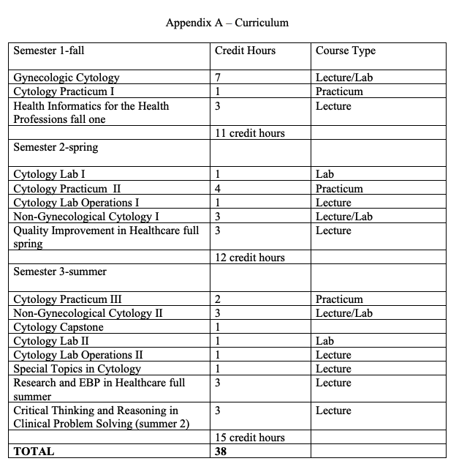
EXPEDITED: NA
NOTIFICATIONS
Program Expansion
This memo serves as a notification of interest to expand the Bachelor of Science in Psychology program to OHIO’s five regional campuses: Chillicothe, Eastern, Lancaster, Southern, and Zanesville. After engaging in conversations with university leadership and the College of Arts & Sciences, reviewing student reported interest (via survey in Spring 2022), and considering student enrollment trends, we believe this program has potential to serve regional campus student and community interests while simultaneously supporting increased enrollment.

Program Suspension & Closure

The Patton College of Education Department of Teacher Education is requesting to suspend admissions and close the Master of Education, Teaching and Learning track ME6325. This suspension only includes this major code within the Curriculum and Instruction program area. The other M.Ed. program areas are not included in this suspension.

Rationale: This program has enrolled only 1 student since it was created. The program was developed to cater to students who don't have a license, wish to receive a graduate degree in education, and/or are international. However, the Curriculum and Instruction program is meeting these needs at this time, except for international students who are funded by their countries and not allowed to take online courses. Effective date: Fall semester, 2022

Impact on current students: There are no students currently enrolled in this major code, so no teach-out plan is needed. Impact on current faculty: As there are no students enrolled in this program code, it has no impact on the current faculty.
Department Name Change
Russ College of Engineering and Technology
We propose to change the name of the department “Civil Engineering” to “Civil and Environmental Engineering.” This is long overdue. Most Civil Engineering departments in the country have made this change over the past few decades. Of the 158 Civil Engineering departments in the US, only 14% are still called “Civil Engineering,” while 58% are called “Civil and Environmental Engineering” and the remaining 29% use another name (e.g. “Department of Civil, Architectural and Environmental Engineering”). In Ohio, only two departments use the name “Civil Engineering” (including OHIO), while three use “Civil and Environmental Engineering” and three use another name (e.g. “Civil, Environmental, and Geodetic Engineering”). This change will help us better compete for students on a regional and national level, and we expect an increase in enrollments with the name change.
In our 2021 7-Year Review, changing the name of the department to bring OHIO more in-line with universities nationwide was one of the final recommendations
We would like this change to be effective January 2023.
OCEAN realignment for University College Department of Applied Sciences and Professions
A notification update for the Department of Applied Sciences and Professions (ASP) programs. At this time, the programs and associated courses within ASP need to be realigned under OCEAN1.9 and OCEAN3.0. The following five programs that should be aligned for curricular/program approval processes to flow into the ASP Department are:
- Law Enforcement Technology (LET)
- Office Administration Technology (OAT)
- Real Estate (REAL)
- Associate of Technical Studies
- Technical and Applied Studies (TAS)

