SECOND READINGS – PROGRAM CHANGES
MS1214, CTFNPG, CTPMHN are tabled until February UCC meeting.

SECOND READINGS – NEW PROGRAMS
NA

PROGRAM CHANGES
- College of Business
Program Code: AA5006
Program Name: Business Management Technology
Department: Management
Contact: Brian Hoyt; Katie Hartman

The BMT program is proposing changes to meet Ohio Guaranteed Transfer Pathways (OGTP) requirements for Associate Degrees and to meet College of Business requirements for AACSB accreditation as Pre-Major requirement for new Bachelor of Science in Business (BSB).

Additional changes included changing the program structure to accommodate removal of sunsetted courses and prerequisite constraints. These changes constitute less than 50% change to the program. Proposed changes have been assessed for TAG compliance and prepared with the new Ohio University general education curriculum.

The BMT program was originally designed and updated to prepare students for a specific exit point for students who desired to only complete an Associate Degree. The program now encourages students to continue into a Bachelor Degree in Business. These changes are proposed to prepare students for exiting at the Associate Degree or Bachelor Degree.

Full details are included in corresponding document.

- College of Business
Program Code: BB6126
Program Name: Management & Strategic Leadership
Department: Management
Contact: Ashley Metcalf

The management department seeks two changes to the current “Management & Strategic Leadership” Major to update the major to current marketplace trends and guidance of the Department Advisory Board. (1) First change is re-arranging the title to “Strategic Leadership & Management”. (2) Second change is the addition of tracks in the major, to provide targeted job opportunities to students. The new tracks are: supply chain management; human resources management; and consulting. There are no new classes, but instead we are re-arranging and clarifying course sequences in the major for particular job outcomes for students. There are required classes and electives in each track. In addition to the major classes, students will still need to complete the remaining requirements for the BBA degree in the College of Business.

- College of Business
Program Code: MB6146 & MB6155
Program Name: Professional MBA & Online MBA
Department: Management
Contact: Ashley Metcalf

The College wishes to reduce the number of letters of recommendation from three to two for the admissions requirements in these programs (OMBA and PMBA). The College of Business (CoB) is also proposing a new concentration called Project Management within our Online MBA and Professional MBA programs. Students within our MBA programs are required to take 9 core courses and 3 concentration courses

The Project Management concentration focuses on the Project Management Body of Knowledge (PMBOK®), as identified by the Project Management Institute (PMI). This concentration serves as a graduate-level option for working professionals to pursue a graduate educational experience and can augment other graduate experiences at Ohio University.
Details of Concentration
• PM 6100 Project Management 1 (3 credits)
• PM 6200 Project Management 2 (3 credits)
• PM 6500 Change and Risk Management 1 (3 credits)

- College of Business
Program Code: BS8167
Program Name: Sport Management
Department: Sport Administration
Contact: Jim Strode

The proposed changes to the program align the BSM program with the new BRICKS general education requirements. Additionally, it has been seven years since the program was assessed There is no impact on program learning outcomes or assessment plans.
SASM 2920 will be renamed “The Sport Experience: Practicum”.
• SASM 3400 – Sport Data Strategy and Innovation (3 cr), is a new course and is added to the Major Coursework
• SASM 2250 – History of the Sport Industry (3 cr), will no longer be included in Major Coursework and will drop to an elective
• SASM 3220 – Leadership and Sport Management (3 cr), will no longer be included in Major Coursework and will drop to an elective
• SASM 4000 – Diversity and Inclusion in Sport (3 cr), is added to Major Coursework and will be coded for BRICKS: Bridge: Diversity and Practice
• SASM 4400 – Sport Ticket Sales and Systems (3 cr), will no longer be included in Major Coursework and will drop to an elective
• SASM 4450 – Marketing and Revenue Streams in Sport Management (3 cr), will be renamed to Sport Ticket Sales and Revenue Streams and kept in the Major Coursework
• SASM 4500 (3 cr) will be renamed “Bobcat Sport Consulting” and will be coded for BRICKS: Capstone and BRICKS: Bridge: Ethics and Reasoning
• SASM 4910 will be renumbered SASM 3910 – Internship in Sport Management, to align with BA 3910 in the CoB
• SASM 4200 Sport Analytics (3 cr) should be added to the Sport Management Elective component

• Experiential learning requirements will include options for Global Consulting Project, or an approved international experience through the Office of Global Opportunities or the Global Leadership Center 3
• Students will be required to take two electives from a SASM/BUSL/MGT list
• In the “Specialization Components”, Business Disciplines were eliminated, Minors and Certificates were combined to one section.
• The following minors were added:
Advertising and Public Relations, Business Analytics.
• The following certificates were added:
Consumer Research, Esport, Festivals, Events, and Entertainment Management, Financial Planning, Human Resources Management, and Supply Chain Management.
• Business Economics (BBA) was added as a Business Major specialization

- College of Health Sciences & Professions
Program Code: CTNEDG
Program Name: Nurse Educator Post-Master’s Certificate
Department: Nursing
Contact: Char Miller

The proposed changes are the result of the 2018-19 curriculum mapping update completed as part of the CHSP program evaluation activities. Additionally, student feedback from course evaluations and program evaluations as well as Student Exit Surveys (administered to graduating students in the final semester) were analyzed to inform the curricular revisions. The proposed changes represent a realignment of curriculum content and clinical hours based on national accreditation standards and contemporary practice. The proposed changes result in:
• A reduction from 15 credit hours to 10 credit hours.
• Change in admission requirements to reflect current national standards.
• Renaming of 3 Nurse Educator major courses to better reflect course focus and align with national standards and contemporary practice.
• Reduction of 3 Nurse Educator major courses from 3 credits to 2 credits each via elimination of overlap and re-alignment of content.
• Elimination of pre-requisites from track option courses (NRSE 6621, 6622, 6630) to facilitate students being able to take the courses in any order.

- College of Health Sciences & Professions
Program Code: CTDIAG
Program Name: Graduate Diabetes Certificate
Department: Applied Health Sciences and Wellness
Contact: Jennifer Yoder-Clevidence

The purpose of this proposed change is to add courses to the current list of approved electives for the Diabetes Certificate, add program learning outcomes, and to remove the following language from the admissions criteria: “Students must be enrolled in a degree seeking program at Ohio University in order to obtain the Graduate Diabetes Certificate.” Elective courses were selected to be added as electives based on the following criteria: 1) online accessible and 2) can be applied to diabetes treatment, management, and/or prevention. There is NO change in required courses. There is NO change in required credit hours.

- Patton College of Education
Program Code: OR6380
Program Name: Retail Merchandising and Fashion Product Development
Department: Human and Consumer Sciences
Contact: Lisa Williams

We are proposing to change the name of the minor from Retail Merchandising and Fashion Product Development (RFPD) minor to Retail and Fashion Merchandising (RFM) minor to align with the new major name for the Retail and Fashion Merchandising program that was approved in AY 2019-20. The current minor does not include all the prerequisites for every upper level course in the required elective course options. This has led to a lot of confusion among students and the necessity of faculty allowing students to add a class with permission when the Retail and Fashion Merchandising majors are still required to meet the prerequisites for the course. This proposed change will require that both RFM majors and minors must have the prerequisites completed to enroll in upper level courses.

The proposed minor would reduce the minor from 21 to 15 credit hours.

- Patton College of Education
Program Code: BS6384
Program Name: Retail and Fashion Merchandising
Department: Human and Consumer Sciences
Contact: Lisa Williams

We are proposing that RFM 4910 be offered for 3, 6, 9 or 12 credit hours to allow students to register for credit hours that fit with the work hours that are available during their internships. This proposed change will allow students to take the number of credit hours that is closest to what they need to finsh 120 hours for graduation. This will make it easier for students to graduate in 4 years and to not have to take more credit hours than they need for graduation. Students would fulfill this requirement by taking at least 3 credit hours.

We propose that RFM 1500: Design and Illustration Techniques and RFM 1600: Color Theory for Visual Merchandising be combined into a new course (RFM 2600: Foundations of Aesthetics). We are proposing to expand on our Business, Comunication and Visual (BCV) electives to provide a wider variety of options to represent the minors and certificates that our students commonly complete and change the title of this section to Interdisciplinary Course Options. RFM students need to complete 6 credit hours so two courses from a minor or certificate completes the requirement.

- Patton College of Education
Program Code: ME6870
Program Name: Middle Childhood Math & Social Studies
Department: Teacher Education
Contact: Lisa Harrison

Program Code: ME6871
Program Name: Middle Childhood Science & Social Studies

Program Code: ME6872
Program Name: Middle Childhood Math & Science

Program Code: ME6873
Program Name: Middle Childhood Language Arts & Social Studies

Program Code: ME6874
Program Name: Middle Childhood Language Arts & Science

Program Code: ME6875
Program Name: Middle Childhood Language Arts & Math

As part of the Graduate Catalog Cleanup, the following changes have been made. These changes were made to support a shorten path to teacher licensure and align to a clinical based teacher preparation program. All programs were previously consulted on the changes.

Listed in OCEAN | Current Program | Comment
EDRE 5010: Introduction to Research Methods (3) | EDTE 6670: Teaching as Action Research (3) | Course was replaced to align specifically to teacher-based research and to support students in doing a master research project that specifically uses teacher action research methodology. This was a department based discussion and aligns with the research course required for all teacher education master programs.
EDCS 5010: History & Philosophy of Education (4) | Removed | As the transition to the one year master program occurred, there was a discussion to integrate topics discussed in this course throughout the program of study.
EDTE 6120: Middle Childhood Curriculum (3) | Removed | removed as requirements as the program transitioned to a one-year program
EDCT 5011: Technological Applications in Education (3) | Removed | removed as requirements as the program transitioned to a one-year program
EDTE 6980L: Lab in content methods (1) | Removed | removed as requirements as the program transitioned to a one-year program
EDTE 5100L: Principles of Curriculum - Laboratory | EDPL 6920 Internship: Theory into Practice (3) | Change to align with clinical model
EDTE 5230: Reading Laboratory (3) | EDTE 5220 Diagnosis: Reading/Languages (3) | Course was changed as part of reading program change.

- College of Arts and Sciences
Program Code: MA4201
Program Name: Political Science
Department: Political Science
Contact: Myra Waterbury

In view of the state requirements that MA credit hours should not exceed 32 credits, we propose to reduce the current minimum required credit hours from 58 to 32 credits. The only other department that would be affected is ELIP/AGC, as we currently use ELIP/AGC for two of the required courses in the existing program. The proposed program changes will no longer require ELIP courses, though we will still encourage students who may struggle with writing to take ELIP/AGC courses or their equivalent. No other resources or faculty are required.

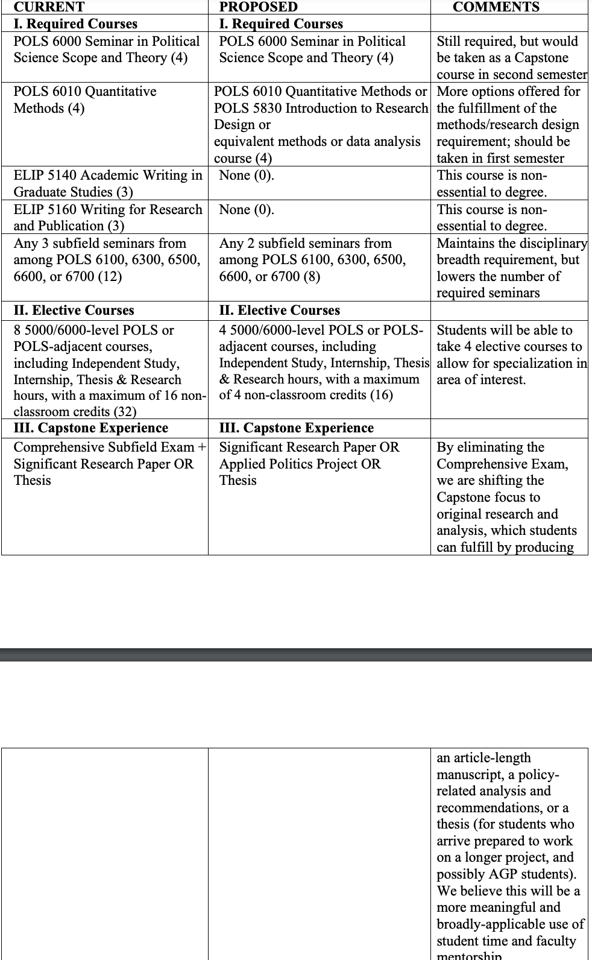

FIRST READING- NEW PROGRAM/ CERTIFICATE
- Scripps College of Communication
Program Code: CTX23G
Program Name: Communication & Change
Department: Communication Studies
Contact: Brittany Peterson

The certificate consists of three (3) courses totaling 12 credit hours, and can potentially be completed in three semesters (enrolling in one course per semester). All courses already exist.
• COMS 6270 – Instructional Training & Development in Communication (4 credits)
• COMS 6300 – Communication and Persuasion (4 credits)
• COMS 7230 – Communication and Information Diffusion (4 credits)

The courses do not need to be taken in sequence. Courses will all be delivered online. This certificate is targeted to current or aspiring leaders and organizational members who have an interest in understanding and enhancing skills associated with effectively communicating about organizational change or innovations. In addition to exploring theories and research focusing on innovation and change, students will develop competencies that include: identifying strengths of various communication channels for communicating about change, developing communication and leadership skills for implementing change, understanding influence strategies to secure support and buy-in of change efforts, exploring strategies for soliciting feedback about innovations, and developing effective training seminars to prepare organizations for adapting and integrating change.

- Scripps College of Communication
Program Code: CTX22G
Program Name: Team Leadership & Communication
Department: Communication Studies
Contact: Brittany Peterson

The certificate consists of three (3) courses totaling 12 credit hours, and can potentially be completed in three semesters (enrolling in one course per semester):
• COMS 5200 - Cross-Cultural Communication (4 credits)
• COMS 6200 – Communication in Social Conflict (4 credits) •
COMS 7210 – Communication Process in Small Groups (4 credits)

Courses do not need to be taken in sequence. All classes will all be delivered online. All courses already exist. This certificate is targeted to current or aspiring organizational leaders who seek advancement to roles requiring effective leadership, team building, and group facilitation skills. Specific competencies developed in this program include initiating and maintaining relationships, identifying individual strengths, assessing team performance, utilizing effective communication skills, managing social conflict, and developing team-building skills.

EXPEDITED
- Russ College of Engineering and Technology
Program Code: BB7262
Program Name: Chemical Engineering- Materials Track
Department: Chemical and Biomolecular Engineering
Contact: Darin Ridgway

- Russ College of Engineering and Technology
Program Code: BB7263
Program Name: Chemical Engineering- Biological Track

- Russ College of Engineering and Technology
Program Code: BB7264
Program Name: Chemical Engineering- Energy & Environment Track

Due to accreditation changes and the way the various tracks appear on the transcript, we have the need to roll the three specialized tracks (major codes BS7262, BS7263 and BS7264) into the general major code (BS7251). The BS in Chemical Engineering has 4 major codes which all receive the same degree, a general track, and three specialized tracks that only differ in elective courses (about 15- 20% of the curriculum). All Chemical Engineering degrees require an equal number of Technical Electives hours. The specialized tracks recognize when a student focuses a significant portion of these credits in a technical subfield of chemical engineering.

Our Accreditation organization (ABET) says that the way the major code appears on the transcript will result in drastic changes to our accreditation procedure. We do not want that to occur. Documentation of the details can be provided if deemed necessary.

The ability of a student to focus their Tech Electives in a subfield will not change, as the accepted Technical Elective list is not changing. They will just do this under the general major code BS7251. Because of this there is no effect on total hours, required resources, or patron departments. Note: The same changes are being made to the other two specialized Chemical Engineering tracks, BS7263, and BS7264.

- College of Business
Program Code: OR6127
Program Name: Marketing Minor
Department: Marketing
Contact: Mick Andzulis

The change in the marketing minor program will more seamlessly align with the new Bachelor of Science in Business (BSB) online program with the marketing minor. The learning outcomes will not change and assessment planning will coincide with AACSB assessment requirements. All changes are withing COB.
Add course options to marketing minor requirements to include courses taught on the RHE campus: • BMT 1400 Concepts of Marketing (3)
• SAM 3020 Consumer Marketing (3)
Add course options to marketing minor electives:
• MKT 4600 New Product Development (3)
• MKT 4650 Brand Management (3)

NOTIFICATIONS
Program Relocation
Diversity Studies Certificate CTDIVU

The Department of Educational Studies (ES) in The Patton College of Education (PCOE) in concert with the Office of Diversity and Inclusion and the Center for International Studies (CIS) is submitting this formal notification informing UCC that the undergraduate Diversity Studies Certificate (DSC) is being relocated from The Patton College to the Center of International Studies, effective Summer 2021. Following the retirement of the Certificate Director, beginning in fall 2020, The Patton College began a partnership with the Director of the Office of Multicultural Student Access and Retention (OMSAR), Dr. Marlene De La Cruz to serve as Certificate Director as well as assist in the staffing of the two required courses, EDCS 1011 Introduction to Diversity Studies and EDCS 4001 Democracy, Diversity and Education. To ensure the continued success of the DSC, we thought it would be best to have it associated with an academic unit comprised of interdisciplinary faculty capable and willing to staff the Certificate courses.

