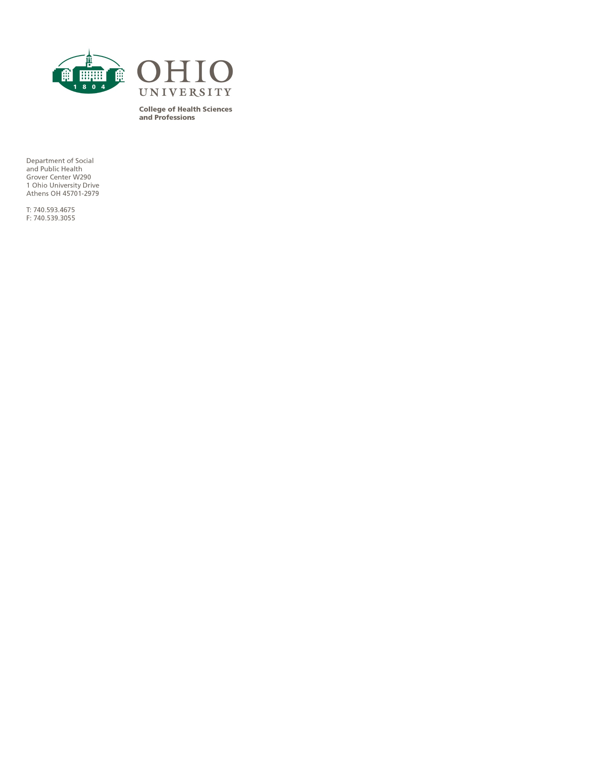

TO: Connie Patterson, Chair, UCC Programs Committee

FROM: Michele Morrone, Chair Department of Social and Public Health

RE: Long Term Program inactivation

Date: January 13, 2021

We are proposing to inactivate the Long Term Care program (BS6386) and are suspending admissions immediately in anticipation of approval of this request.

The LTC program has been functioning with adjunct instructors for several years. No current faculty will be affected by this program closure.

There are currently 6 students in the program, and they will all be able to complete the degree because courses, or substitutions, will be available. Four of the 6 students will graduate at the end of Summer 2021 once they complete their final practicum.

