Resolution on the Implementation of Arches
First Reading
General Education Committee
University Curriculum Council
Ohio University

Whereas BRICKS is the program of general education for Ohio University and is therefore a subset of the degree requirements for all undergraduate students.

Whereas the Arch component of BRICKS was originally designed to provide an interdisciplinary experience by requiring that each student devote 9.0 credit hours of general education to topically linked courses across three breadth-of-knowledge domains.

Whereas the original design of the Arch component was too restrictive for viable implementation and thus required UCC to pass a temporary policy (November 17, 2022) relaxing some of the requirements.

Whereas UCC was tasked with revisiting these policy changes during AY2022-23 to determine if they should be made permanent, and the General Education Committee studied the issue during AY2021-22 and presented recommendations to UCC in October, 2022.

Be it resolved that the following changes be made to policies governing the Arch component of BRICKS:

- Courses that are approved for Arches should be approved by the General Education Committee for at least one of the following topics:
  - Health and Wellness
  - Society and Justice
  - Global Perspectives
  - Science and Technology
  - Sustainability
Courses may be approved for multiple topics if merited. The Breadth-of-Knowledge Arch will be deprecated as it is not in use.

- Students may complete the Arch requirement of BRICKS by taking at least one course from each of the following components:
  - Constructed World
  - Natural World
  - Connected World
The courses do not have to be linked by the same topic to satisfy BRICKS requirements, but the completion of topical Arches will be incentivized.

Be it further resolved UCC and the General Education Committee are responsible for fleshing out the course approval processes implicit in the above changes.
Be it further resolved that this change in policy should be reviewed by UCC (University Curriculum Council) and the General Education Committee no later than the end of the fall semester 2025-26 to determine if it should be revised.
Appendix A. Implementation Notes

- Arch topics should be coded in PeopleSoft as attributes attached to courses, rather than being maintained in OCEAN 1.9 or DARS.

- Arch courses should be searchable by topic as well as by component on the registrar’s site.

- Arches topics should be used to ground certificates associated with the various Arch topics. The list of associated certificates should be linked to the topical search to allow students and advisors to explore the possibility of obtaining one.

Note: The registrar’s office has already implemented the capability of searching for courses by arch topic, and a group of faculty have compiled a list of certificates at the university that fit will with the Global Perspectives arch. This process of incentivizing topical arches by way of associating them with certificates would continue through AY2023-24.

Appendix B: Recommendations presented to UCC
MEMO - informational
To | UCC
From | Todd Eisworth, Chair
Subject | Arch Requirements for BRICKS, revisited
Date | October 11, 2022

This document outlines several recommendations for the ongoing implementation of the Arches component of BRICKS. They are based on the experience gained since Fall 2021 and are presented to UCC for consideration as part of the review of Arches and associated requirements mandated to occur Fall 2022 (see the policy “Arches Requirements for BRICKS” in Appendix A). The intent is to have a policy drafted for first reading at the November UCC. The content of this document was presented to UCC in preliminary form at the March 2022 meeting.

Background

Original Version of Arches
The original implementation of OHIO BRICKS conceived of the Arch component as an opportunity for students to fulfill a portion of their lower-level general education requirements in a coherent manner. The idea was that three courses (9.0 credit hours) from the portion of BRICKS devoted to meeting the requirements of the Ohio Transfer 36 (OT-36) would be reserved and have an additional structure imposed on them. The three courses would still be used to meet the breadth-of-knowledge requirements for OT-36, but they were also to be thematically connected. The intent was to make the general education experience more meaningful for students by having them engage with a topic of interest through work in multiple disciplines.

The courses designated for Arches were to be classified by two attributes: a primary classification based on disciplines (Natural World, Constructed World, and Connected World) and a secondary classification based on topic (the associated “Arch”). In addition, courses in the Arches were to address the OHIO Common Goals of Critical Thinking and/or Teamwork.

The list of courses for each Arch was to be maintained in OCEAN 1.9 and coded in DARS, and the Arch requirement was to be satisfied once a student completed at least one course from each of the three “worlds” within a single topic.

Implementation of Arches
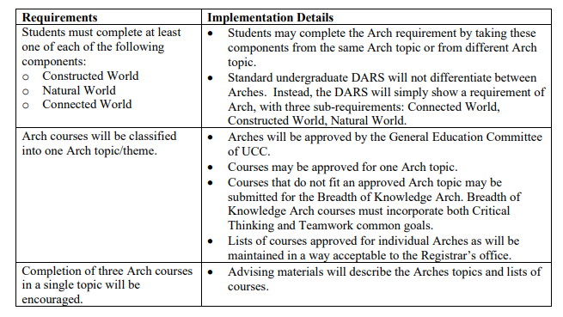
In November 2020, UCC approved a scaled back implementation for Arches, summarized in the table below:

The key point is that the requirement that the three Arch courses must come from a single topic was removed, and the Arch topics were instead presented in the Undergraduate Catalog as recommendations. This was done for pragmatic reasons, as implementation arches in their original form was not viable given the sparse menu of courses available at the time and the challenges associated with combining this effort with Guarantee+ in the middle of the COVID-19 disruption. UCC did however mandate that Arch structure and requirements should be reviewed in Fall 2022 in preparation for AY 2023-24. The recommendations presented below result from consultations done on behalf of the General Education Committee during Spring 2022 in anticipation of this deadline. These were presented to UCC in preliminary form at the March 2022 meeting.

Recommendations
The following recommendations are submitted to UCC. These arose out of work done on behalf of the General Education Committee during Spring 2022
Policy Recommendations
- Students should continue to satisfy the Arch requirement by completing at least one course from each of Constructed World, Natural World, and Connected World without the requirement that the courses should belong to a single topic.
- The Breadth of Knowledge Arch should be removed.
- Remove the restriction that Arch courses can belong to at most one Arch.
- UCC should revisit the structure and implementation of Arches in Fall 2024 in preparation for AY 2025-26.

Implementation Recommendations
- Arch topics should be coded in PeopleSoft as attributes attached to courses, rather than being maintained in OCEAN 1.9 or DARS. Arch courses should be searchable by topic as well as by component on the registrar’s site.

- Arch courses should be searchable by topic as well as by component on the registrar’s site.

- Arches topics should be used to ground certificates associated with the various Arch topics. The list of associated certificates should be linked to the topical search to allow students and advisors to explore the possibility of obtaining one.

Rationale
The approach outlined above allows topical arches to gain a more concrete existence while avoiding the logistical problems arising with DARS implementation. This approach also eases the path through BRICKS for students with haphazard transfer credit.
In addition, it would provide a way of integrating certificates (in particular, 12-credit hour certificates made up of lower division courses) with paths through BRICKS. This also provides a mechanism for non-OT-36 courses that fit with an arch topic to maintain a link to BRICKS and incentivizes the completion of topical arches by using them as gateways to certificates.
This seems to provide a natural stable point between where we are now and what was originally envisioned. We are not forcing departments to choose a single destination for boundary courses. The implementation of the original version of Arches could be revisited in the future.

See Appendix B
See Appendix A

