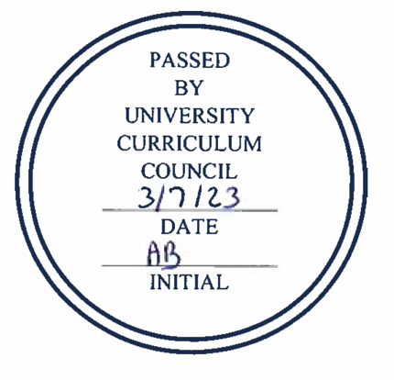
University Curriculum Council
Approved Programs
March 7, 2023

PROGRAM CHANGES
Second Reading
- Russ College of Engineering and Technology
Program Code: BS7273
Program Name: Technical Operations Management
Department/School: Engineering Technology and Management
Contact: Yuqiu You (youy@ohio.edu)
Desired Start Date: Fall 23

The changes in this proposal are needed to convert this program to better adapt to the current market need for project managers. No impact on any other departments and staffing requirements.
The following changes are proposed:
a. Program Name Change from Technical Operations Management (BSTOM) to BS in Project Management (BSPM)
b. Course Option Change: five courses have course name/credit hour changes:
ETM 3001 Course Name
ETM 3625 Course Name
ETM 3820 Course Name
ETM 4005 Course Name
ETM 4600 Course Name, Credit Hour
c. New Course Added: ETM 4100 Data Visualization, ETM 4500 Advanced Project Management
d. Program Required Courses Removed: CHEM1210 or 1500, PHYS 2001 or 2051
e. Removed Pre-Major (PM) Requirement
f. Change admission requirement from "Technical associate degree" to "Any associate degree" is also requested

There is no change in credit hours.

First Reading
- Center for International Studies
Program Code: CTWARU
Program Name: War and Peace Studies Certificate
Department/School: Center for International Studies
Contact: Cat Cutcher (cutcher@ohio.edu)
Desired Start Date: Fall 23

We are deleting core and elective courses that have not been offered frequently in the last eight years. We are adding new core and elective courses. We are changing the requirements to 6 hours of core courses from two disciplines, and 12 hours of elective courses from three disciplines. This certificate program has not changed significantly since 2015 and these changes will not impact on program learning outcomes or credit hour requirement.

The total requirements will include
CORE: Complete 6 hours from two disciplines of the following courses:
Add to Core Courses: HIST 2200, MGT 4640
Delete from Core Courses: CAS 1425, PHIL 4460, SOC 4680

ELECTIVES: Complete 12 hours from three disciplines from the following courses:
Add electives: CARS 2160, HIST 3162, HIST 3164, HIST 3291, HIST 4770, INST 3700, POLS 4225, POLS 4415, POLS 4465, POLS 4640, POLS 4738
Delete electives: ANTH 4620, HIST 3320, HIST 3371, HIST 3420, HIST 3640, HIST 3868

- College of Health Sciences and Professions
Program Code: BS6340/BS6357
Program Name: Bachelor of Science in Integrated Healthcare Studies
Department/School: Interdisciplinary Health Studies
Contact: Tobe Gillogly (gilloglt@ohio.edu)
Desired Start Date: Summer 23

IHS is proposing two program changes in this document. (1) We propose to change the admissions GPA from a 2.67 to a 2.0 keeping all other admissions criteria the same as this is a completion degree. (2) Due to the growth in enrollment in the Bachelor of Science in Integrated Healthcare Studies (BSIHS), along with the changes in general education requirements, it is necessary to include course offerings to offer students optimal opportunities to select the courses that best meet their educational journey. By adding the courses below, the courses will automatically appear on the student’s DARS thus making the transition from their previous degree more seamless. This proposal increases the number of course options both on campus and online, facilitates a smooth transition for students changing their degree, and addresses general education requirements. There is no impact on program learning outcomes and no change in credit hours.

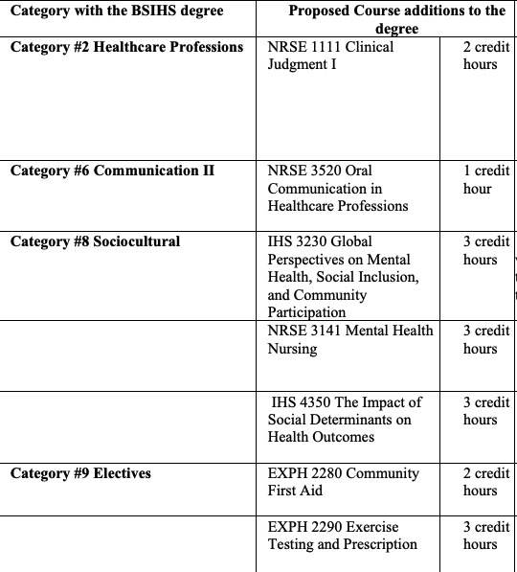

- College of Health Sciences and Professions
Program Code: MS1224
Program Name: Family Nurse Practitioner
Department/School: School of Nursing
Contact: Sherleena Buchman (buchmans@ohio.edu), Margie Vogt (vogtm@ohio.edu)
Desired Start Date: Fall 23

The American Association of Colleges of Nursing (AACN) and the National Organization of Nurse Practitioner Faculties (NONPF) have established new accreditation standards for nursing education with a move to competency-based education and an increase in clinical practice hours from 500 to a minimum of 750 at the Graduate level. The proposed program change reflects the new accreditation standards including the new required clinical hours. Although some of the courses have revised titles, course descriptions and learning outcomes based on the new accreditation standards, the content, assessments and evaluations have remained consistent (see Table I: Comparison of Current Programs of Study versus Proposed Programs of Study). The courses have been reorganized and content redistributed in a revised scope and sequence based off our accrediting bodies’ requirements. The overall Program Outcomes have also been revised to reflect these changes. The Programs of Study for the AG-ACNP certificate have also been revised.
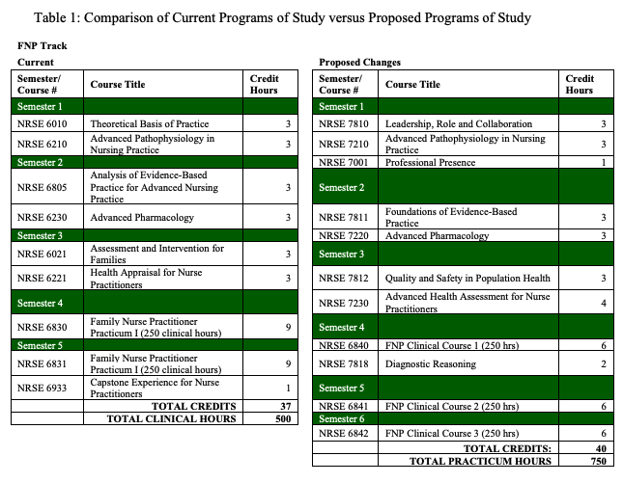

- College of Health Sciences and Professions
Program Code: DN1235
Program Name: Doctor of Nursing Practice (BSN-DNP)
Department/School: School of Nursing
Contact: Margie Vogt (vogtm@ohio.edu)
Desired Start Date: Fall 23

The American Association of Colleges of Nursing (AACN) and the National Organization of Nurse Practitioner Faculties (NONPF) have established new accreditation standards for nursing education with a move to competency-based education and an increase in clinical practice hours from 500-750 at the master's level while continuing to require 1000 clinical hours at the Doctor of Nursing Practice (DNP) level. National professional organizations have also recommended the DNP be entry to practice for Advanced Practice Registered Nurses (APRNs) and Nurse Leaders. In the BSN-to-DNP program, students take an APRN clinical specialty focus track such as the Family Nurse Practitioner (FNP), Adult-Gerontology Acute Care Nurse Practitioner (AGACNP), Psychiatric Mental Health Nurse Practitioner (PMHNP), or an indirect specialty focus track such as the Nurse Leader (NL), and Nurse Leader/Nurse Educator (NL/NE). This has required changes in program codes leading to some inconsistencies and confusion when meeting graduation requirements. Ohio University Registrar has requested new program codes that reflect the DNP Program with the clinical specialty focus of Family Nurse Practitioner (FNP), Adult-Gerontology Acute Care Nurse Practitioner (AGACNP), Psychiatric Mental Health Nurse Practitioner (PMHNP), Nurse Leader (NL), and Nurse Leader/Nurse Educator (NL/NE). Ohio University has also decreased the required credit hours for a clinical doctorate to 70 credit hours. The proposed program change reflects the new accreditation standards, the new program codes, and the new required credit hours. Although some of the courses have revised titles, course descriptions, and learning outcomes based on the new accreditation standards, the content, assessments, and evaluations have remained consistent overall. The Programs of Study for all the BSN-to-DNP specialty focus tracks have also been revised (see Table II: Comparison of Current Programs of Study versus Proposed Programs of Study).

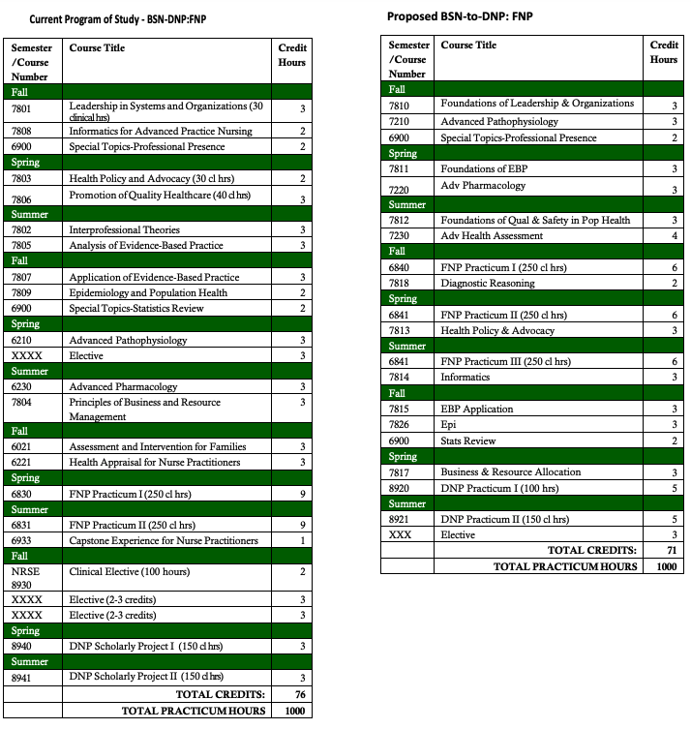
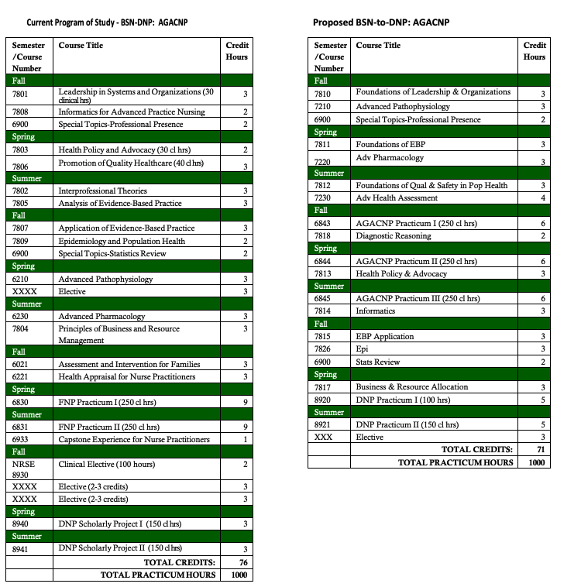
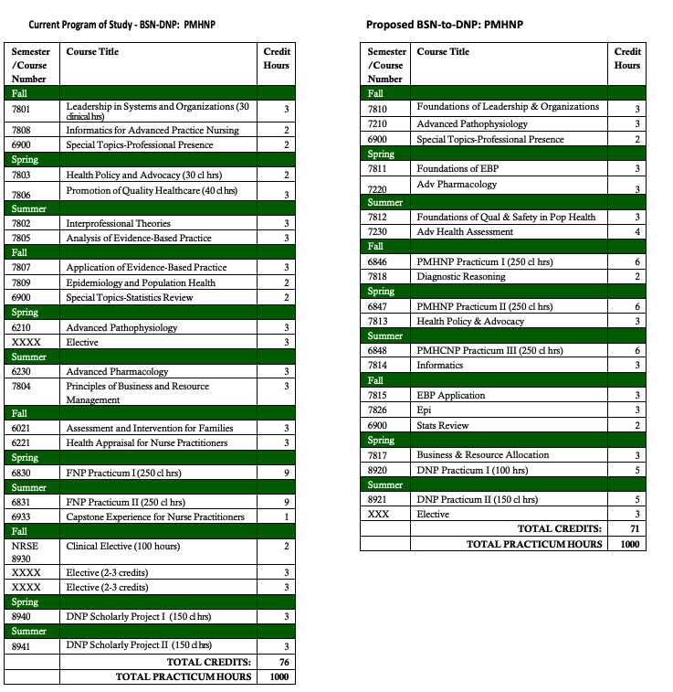
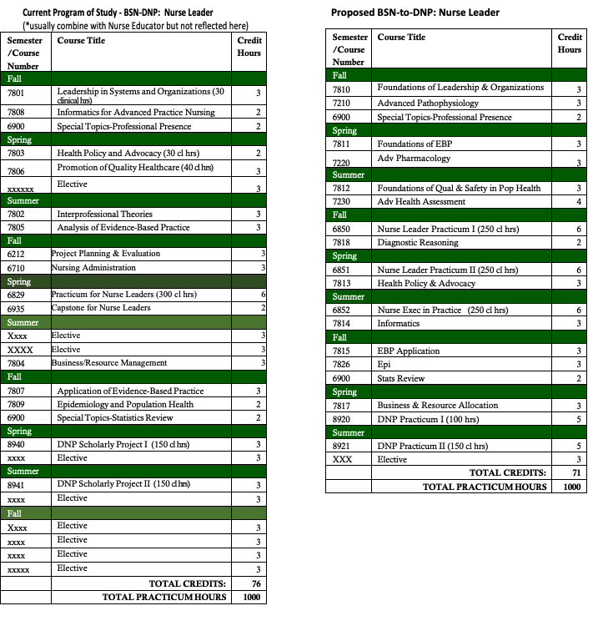
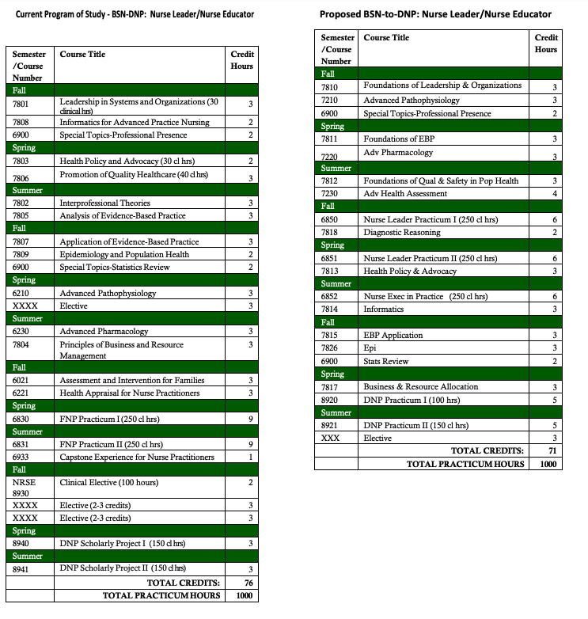
- College of Health Sciences and Professions
Program Code: DN1234
Program Name: Doctor of Nursing Practice (MSN-DNP)
Department/School: School of Nursing
Contact: Margie Vogt (vogtm@ohio.edu)
Desired Start Date: Fall 23

The American Association of Colleges of Nursing (AACN) and the National Organization of Nurse Practitioner Faculties (NONPF) have established new accreditation standards for nursing education with a move to competency-based education and an increase in clinical practice hours from 500-750 at the master's level while continuing to require 1000 clinical hours at the Doctor of Nursing Practice (DNP) level. National professional organizations have also recommended the DNP be entry to practice for Advanced Practice Registered Nurses (APRNs) and Nurse Leaders. In the MSN-to-DNP program, students are admitted with a Master of Science and an APRN clinical specialty focus track such as the Family Nurse Practitioner (FNP), Adult-Gerontology Acute Care Nurse Practitioner, Psychiatric Mental Health Nurse Practitioner, or indirect specialty focus track such as the Nurse Leader, Nurse Educator or a combination of these specialty focused tracks. A gap analysis is done, according to the national accreditation standards on each individual student to determine the additional required clinical hours needed to meet the 1000 hours at the DNP level. Most students come with a minimum of 500 clinical hours from their previous master's program. The proposed program change reflects the new accreditation standards, the new program outcomes, and the revised courses. Although some of the courses have revised titles, course descriptions, and learning outcomes based on the new accreditation standards, the content, assessments, and evaluations have remained consistent overall. This resulted in a credit reduction from 37 to 36 credit hours. The Programs of Study for all the MSN-to-DNP have also been revised (see Table II: Comparison of Current Programs of Study versus Proposed Programs of Study).
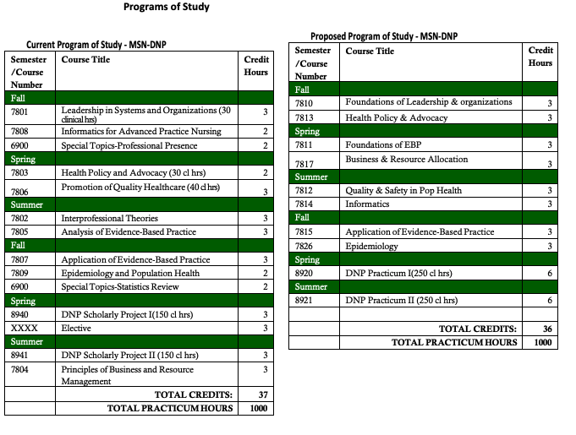
- College of Health Sciences and Professions
Program Code: CTPMHN
Program Name: Post-Graduate Psychiatric Mental Health Nurse Practitioner
Department/School: School of Nursing
Contact: Sherleena Buchman (buchmans@ohio.edu) Margie Vogt (vogtm@ohio.edu)
Desired Start Date: Fall 23

The American Association of Colleges of Nursing (AACN) and the National Organization of Nurse Practitioner Faculties (NONPF) have established new accreditation standards for nursing education with a move to competency-based education and an increase in clinical practice hours from 500 to a minimum of 750 at the Graduate level. The proposed program change reflects the new accreditation standards including the new required clinical hours. Although some of the courses have revised titles, course descriptions, and learning outcomes based on the new accreditation standards, the content, assessments, and evaluations have remained consistent (see Table I: Comparison of Current Programs of Study versus Proposed Programs of Study). The courses have been reorganized and content redistributed in a revised scope and sequence based on our accrediting bodies’ requirements. The overall Program Outcomes have also been revised to reflect these changes. The Programs of Study for the AG-ACNP certificate have also been revised.
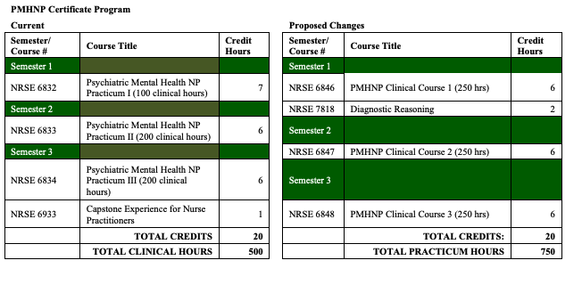
- College of Health Sciences and Professions
Program Code: CTFNPG
Program Name: Post-Graduate Family Nurse Practitioner
Department/School: School of Nursing
Contact: Sherleena Buchman (buchmans@ohio.edu) Margie Vogt (vogtm@ohio.edu)
Desired Start Date: Fall 23

The American Association of Colleges of Nursing (AACN) and the National Organization of Nurse Practitioner Faculties (NONPF) have established new accreditation standards for nursing education with a move to competency-based education and an increase in clinical practice hours from 500 to a minimum of 750 at the Graduate level. The proposed program change reflects the new accreditation standards including the new required clinical hours. Although some of the courses have revised titles, course descriptions, and learning outcomes based on the new accreditation standards, the content, assessments, and evaluations have remained consistent (see Table I: Comparison of Current Programs of Study versus Proposed Programs of Study). The courses have been reorganized and content redistributed in a revised scope and sequence based on our accrediting bodies’ requirements. The overall Program Outcomes have also been revised to reflect these changes. The Programs of Study for the AG-ACNP certificate have also been revised. The Programs of Study for the FNP track have also been revised.

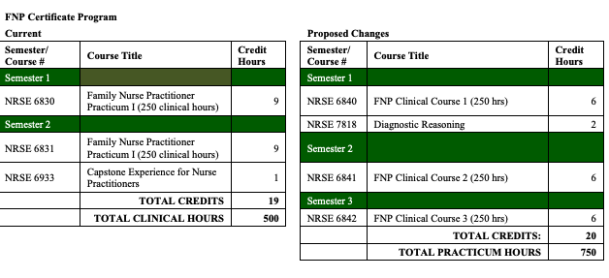
- College of Health Sciences and Professions
Program Code: CTNEDG
Program Name: Nurse Educator Certificate
Department/School: School of Nursing
Contact: Sherleena Buchman (buchmans@ohio.edu)
Desired Start Date: Fall 23

The American Association of Colleges of Nursing (AACN) and the National Organization of Nurse Practitioner Faculties (NONPF) have established new accreditation standards for nursing education with a move to competency-based education and an increase in clinical practice hours to 500 at the master's level. In the BSN-to-MSN program, students take an indirect specialty focus track such as the Nurse Leader, and Nurse Educator. The proposed program change reflects the new accreditation standards including the new required clinical hours. Although some of the courses have revised titles, course descriptions, and learning outcomes based on the new accreditation standards, the content, assessments, and evaluations have remained consistent (see Table I: Comparison of Current Programs of Study versus Proposed Programs of Study). The overall Program Outcomes have also been revised to reflect these changes. The Programs of Study for all the BSN-to-MSN Nurse Educator track has also been revised.
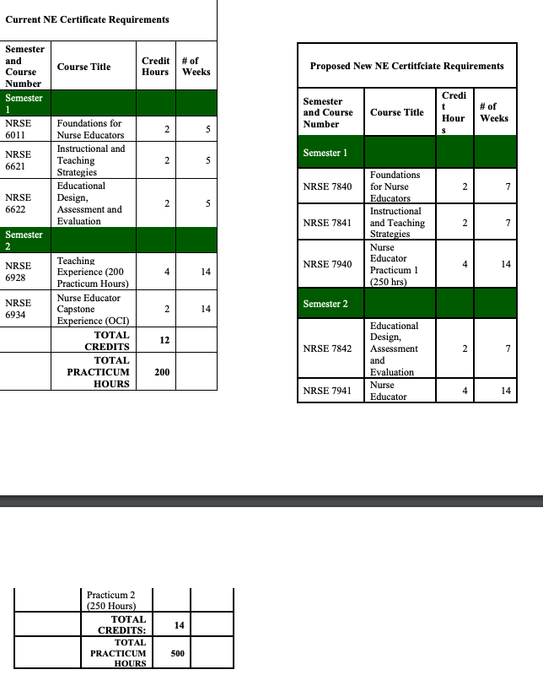
- College of Health Sciences and Professions
Program Code: MS1213
Program Name: Nurse Educator
Department/School: School of Nursing
Contact: Sherleena Buchman (buchmans@ohio.edu)
Desired Start Date: Fall 23

The American Association of Colleges of Nursing (AACN) and the National Organization of Nurse Practitioner Faculties (NONPF) have established new accreditation standards for nursing education with a move to competency-based education and an increase in clinical practice hours to 500 at the master's level. In the BSN-to-MSN program, students take an indirect specialty focus track such as the Nurse Leader, and Nurse Educator. The proposed program change reflects the new accreditation standards including the new required clinical hours. Although some of the courses have revised titles, course descriptions, and learning outcomes based on the new accreditation standards, the content, assessments, and evaluations have remained consistent (see Table I: Comparison of Current Programs of Study versus Proposed Programs of Study). The overall Program Outcomes have also been revised to reflect these changes. The Programs of Study for all the BSN-to-MSN Nurse Educator track has also been revised.
- College of Health Sciences and Professions
Program Code: MS1240
Program Name: Nurse Leader
Department/School: School of Nursing
Contact: Margie Vogt (vogtm@ohio.edu)
Desired Start Date: Fall 23

The American Association of Colleges of Nursing (AACN) and the National Organization of Nurse Practitioner Faculties (NONPF) have established new accreditation standards for nursing education with a move to competency-based education and an increase in clinical practice hours to a minimum of 500 at the master's level. In the BSN-to-MSN program, students take an indirect specialty focus track such as the Nurse Leader, and Nurse Educator. The proposed program change reflects the new accreditation standards including the new required clinical hours. Although some of the courses have revised titles, course descriptions, and learning outcomes based on the new accreditation standards, the content, assessments, and evaluations have remained consistent overall (see Table I: Comparison of Current Course Offerings versus Proposed Course Offerings). The overall Program Outcomes have also been revised to reflect these changes. The Programs of Study for all the BSN-to-MSN Nurse Leader track have also been revised (see Table II: Comparison of Current Programs of Study versus Proposed Programs of Study).
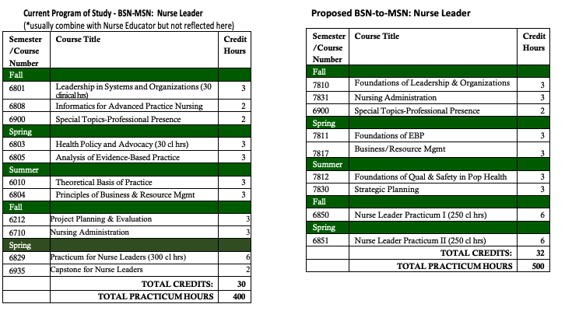
- College of Health Sciences and Professions
Program Code: MS1238
Program Name: Psychiatric Mental Health Nurse Practitioner
Department/School: School of Nursing
Contact: Margie Vogt (vogtm@ohio.edu)
Desired Start Date: Fall 23

The American Association of Colleges of Nursing (AACN) and the National Organization of Nurse Practitioner Faculties (NONPF) have established new accreditation standards for nursing education with a move to competency-based education and an increase in clinical practice hours from 500 to a minimum of 750 at the Graduate level. In the BSN-to-MSN program, students take an indirect specialty focus track such as the FNP, and AG-ACNP. The proposed program change reflects the new accreditation standards including the new required clinical hours. Although some of the courses have revised titles, course descriptions and learning outcomes based on the new accreditation standards, the content, assessments and evaluations have remained consistent (see Table I: Comparison of Current Programs of Study versus Proposed Programs of Study). The courses have been reorganized and content redistributed in a revised scope and sequence based off our accrediting bodies’ requirements. The overall Program Outcomes have also been revised to reflect these changes. The Programs of Study for the PMHNP certificate have also been revised.
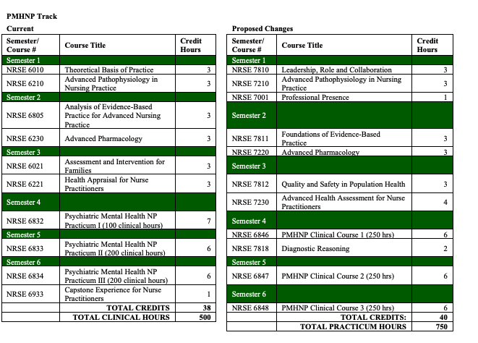
- College of Health Sciences and Professions
Program Code: MS1236
Program Name: Adult Gerontology-Acute Nurse Practitioner
Department/School: School of Nursing
Contact: Sherleena Buchman (bucmans@ohio.edu) & Margie Vogt (vogtm@ohio.edu)
Desired Start Date: Fall 23

The American Association of Colleges of Nursing (AACN) and the National Organization of Nurse Practitioner Faculties (NONPF) have established new accreditation standards for nursing education with a move to competency-based education and an increase in clinical practice hours to a minimum of 500 at the master's level. In the BSN-to-MSN program, students take an indirect specialty focus track such as the Nurse Leader, and AG-ACNP. The proposed program change reflects the new accreditation standards including the new required clinical hours. Although some of the courses have revised titles, course descriptions, and learning outcomes based on the new accreditation standards, the content, assessments and evaluations have remained consistent (see Table I: Comparison of Current Programs of Study versus Proposed Programs of Study). The overall Program Outcomes have also been revised to reflect these changes. The Programs of Study for the AG-ACNP track have also been revised.
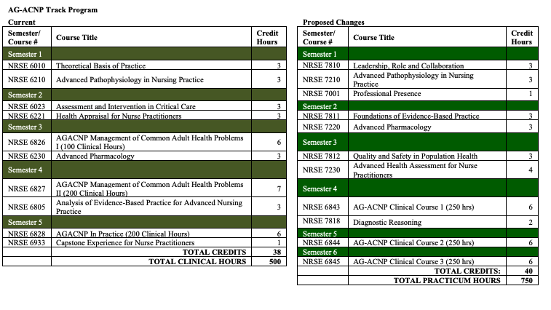
- College of Health Sciences and Professions
Program Code: BS1221
Program Name: Bachelor of Science in Nursing (BSN)
Department/School: School of Nursing
Contact: Char Miller (millerc3@ohio.edu), Molly Johnson (johnsom4@ohio.edu), Sherleena Buchman (bucmans@ohio.edu) & Lindsey Shotts (shottsl@ohio.edu)
Desired Start Date: Fall 23

The Bachelor of Science in Nursing curriculum changes are based on new professional guidelines and standards which have been set forth by the American Association of Colleges of Nursing (AACN), an accrediting body. Names, descriptions, and outcomes for every nursing course in the program have been updated to reflect “The Essentials: Core Competencies for Professional Nursing Education”, which outlines the educational framework required to prepare professional nurses. Additionally, program outcomes have been updated and changes have been made to our required general education courses. Many of the changes were simply a clean-up of the terminology and language with some minor shifting of content in the biggest courses. The overall credit hours increased by one and we amended our general education required courses.
Overall credit hours for the BS1221 program increased by one credit hour, now total of 121 credits (previously 120 credits).

Starting with the current curriculum- 120 credit hours- Due to updated general education guidelines, two student elective courses were removed from the curriculum. This decreased the total by four credit hours, resulting in a total of 116.

One of the remaining student elective courses on the current curriculum was listed as two credit hours. Elective courses needed by students in the program under specific general education components are currently offered as three credit hours or more. One credit hour was added to that elective requirement, resulting in total credit hours of 117.

Nursing has elected to require IHS 2215 and IHS 2220, each three credit hours in place of two elective courses. This change is credit neutral. Nursing Excellence was decreased by one credit hour. This resulted in a total of 116. The School of Nursing removed NUTR: 1000 as a required course (3 credit hours). This resulted in a total of 113 credit hours.

The School of Nursing faculty identified the need for students to receive specific dosage calculation instruction in the BSN program to support safe medication administration. One credit hour was added to the Foundations nursing course. This resulted in a total of 114 credit hours.

Due to general education guidelines through OHIO, one credit hour was added to the Community / Populations course to ensure coverage of “Bridge Diversity and Practice”. This resulted in a total of 115 credit hours.

The School of Nursing added a Health Promotion Across the Lifespan course (2 credit hours). This course will be taught by nursing faculty. This resulted in a total of 117 credit hours.

The School of Nursing realigned topics being covered in several current courses to create more succinct content delivery. The “Professional Essentials and Applications of Clinical Judgment” series was created to support this content realignment as well as add any additional topics required to meet new professional standards in the updated BSN Essentials. One credit was added to each of the year three Professional Essentials courses that are replacing the Clinical Judgment courses. An additional Professional Essentials course was added to year four of the program. The increase for the course series was four (4) credits. This resulted in a total of 121 credit hours.

- College of Health Sciences and Professions
Program Code: CTANPG
Program Name: Post-Graduate Adult Gerontology-Acute Care Nurse Practitioner Certificate
Department/School: School of Nursing
Contact: Sherleena Buchman (bucmans@ohio.edu) & Margie Vogt (vogtm@ohio.edu)
Desired Start Date: Fall 23

The American Association of Colleges of Nursing (AACN) and the National Organization of Nurse Practitioner Faculties (NONPF) have established new accreditation standards for nursing education with a move to competency-based education and an increase in clinical practice hours from 500 to a minimum of 750 at the Graduate level. The proposed program change reflects the new accreditation standards including the new required clinical hours. Although some of the courses have revised titles, course descriptions and learning outcomes based on the new accreditation standards, the content, assessments and evaluations have remained consistent (see Table I: Comparison of Current Programs of Study versus Proposed Programs of Study). The courses have been reorganized and content redistributed in a revised scope and sequence based off our accrediting bodies’ requirements. The overall Program Outcomes have also been revised to reflect these changes. The Programs of Study for the AG-ACNP certificate have also been revised.
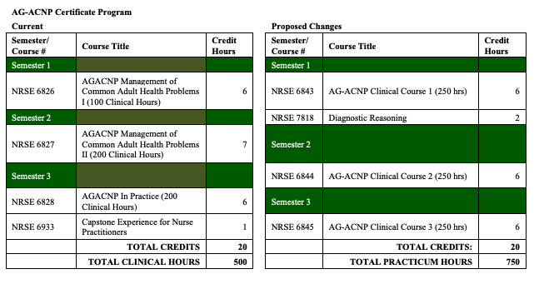
- College of Health Sciences and Professions
Program Code: CTEPCG
Program Name: Epidemiology Graduate Certificate
Department/School: School of Social and Public Health
Contact: Alexander Sergeev (sergeev@ohio.edu)
Desired Start Date: Fall 23

The change is for a modality addition only. We would like to open the certificate to e-campus students. All the certificate courses have been offered in the past as Athens online.

- College of Health Sciences and Professions
Program Code: CTATRG
Program Name: Athletic Training Residency in Pediatrics
Department/School: School of Applied Health Sciences and Wellness
Contact: Laura Harris (harrisl2@ohio.edu)
Desired Start Date: Fall 23

This change will have no impact on program learning outcomes or the assessment plan. However, it will change how students are determined eligible for graduation. Currently, the minimum requirement is a “B” in all courses. The proposed change would amend the minimum requirement to allow at least a “C” in program courses. Our program data from the past two cohorts indicates that we typically have 1-2 residents earn a “C” in one course, while maintaining a 3.00 GPA throughout the program. Based upon this data, I believe a minimum of a “C” allows students more flexibility. Mathematically this would allow residents to earn no more than two “Cs” in the program. This change seems reasonable, especially considering the academic rigor of the program.

- College of Arts and Sciences
Program Code: BS4232
Program Name: Geography-Environmental Geography
Department/School: Geography
Contact: Gaurav Sinha (sinhag@ohio.edu)
Desired Start Date: Fall 23

We are proposing five types of changes in response to changing course offerings both within Geography and other units, and to streamline the major for students. The changes include:
1) TRACK NAME CHANGE: Since our curriculum prioritizes analysis of human environment interactions affecting our climate and physical environments, we will change the track name from Environmental Geography to Climate, Environment and Society to clearly inform students about the scope of the major. The program will be Geography- Climate, Environment and Society.
2) CHANGE COURSE GROUPINGS TO HIGHLIGHT THEMATIC CONTRIBUTIONS: We will reorganize the required and elective courses under thematic categories to improve students’ understanding of which courses are related and how they collectively address different pedagogical components of the major’s curriculum.
3) CORE COURSES: GEOG 2060 The Physical and Global Dimensions of Climate Change will be added as a required core course.
4) CORE ELECTIVES: GEOG 3260 Urban Geography will be added to the list of core electives. 5) EXTRA-DEPARTMENTAL SUPPORTING COURSES: We want to simplify our curriculum by replacing extra-departmental requirements with a curated list of extra-departmental courses for fulfilling BRICKS and CAS distribution requirements.

REQUIRED CREDIT HOURS: The total number of required hours will be reduced from the current total of 65 credit hours (44 in Geography + 21 extra-departmental courses) to only 48 to 52 required credit hours (all in Geography). This proposal does not represent a greater than 50% change in the program requirements. Most students will continue to enroll in similar extra-departmental courses as before, the proposed changes will not substantially affect enrollment in a particular course or department.

EXPEDITED REVIEW- NA
NOTIFICATIONS
Program Suspension/Closure
- College of Health Sciences & Professions
Program Code: AA5019
Program Name: Medical Assisting Technology (MAT)
Contact: Tobe Gillogly (gillogt@ohio.edu)

The Medical Assisting Technology (MAT) program has been identified as low-enrolled on regional campuses. Applications to the MAT program were closed after Fall 2022 admission cycle which means no new applications or admissions will occur for this program. The purpose of this proposal is to submit the teach-out plan for the program, which will close at the end of the Spring semester, 2023-24. Currently, the MAT program has 6 students enrolled in cohort one (admitted fall 2021) who will graduate spring 2023 and 9 students in cohort 2 (admitted fall 2022) who will graduate in spring 2024.

New Course Prefix

- University College
To: Connie Patterson, UCC Programs Committee Chair
From: David Nguyen, Dean, University College
Re: Data Prefix
Date: February 16, 2023
A new undergraduate program in Data Analytics (BDA) within University College is undergoing the approval process by the University.
We plan to get the process moving forward with OCEAN submissions and updates of the proposed courses. We already have a temporary program code, BDXX02. We’d like to request the “DATA” prefix for this major (short for BDA), based on which the new courses will be named and input into the OCEAN system.

Exemption Approval

The formal exemption request for two standalone, financially-aid eligible, undergraduate certificates, CTX46U Mechatronics Technician and CTX47U Automation Technician, was approved by Provost Sayrs on February 6, 2023.

