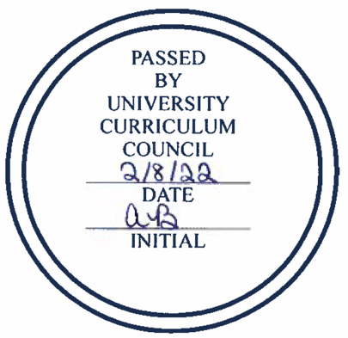

University Curriculum Council
Approved Courses
February 8, 2022

NEW COURSES
College | Course | BRICKS
Fine Arts | ART 2110: Digital Art + Technology I
 | ART 3110: Digital Art + Technology II
 | THAR 3810: Musical Theater Workshop I
 | THAR 3811: Musical Theater Workshop II

COURSE CHANGES
College | Course | Changes | BRICKS
Arts & Sciences | MATH 1060: Quantitative Reasoning | Desc, prereqs | [FQR]
Fine Arts | THAR 2710: Theater and Performance History I | LOs, topics; add BRICKS component | [PHA]/FIE
 | THAR 2711: Theater and Performance History II | LOs, topics; add BRICKS component | [PHA]/FIE
University College | LET 1050: Ethics and Legal Issues | LOs; add summative exp, BRICKS component | BER
 | LET 2600: Multicultural Policing: Cultural Perspectives in Criminal Justice | LOs; add BRICKS component | FIE

II. Prefix change: CSD to HSLS
This is to change “Communication and Speech Disorders” back to the more accurate “Hearing, Speech, and Language Sciences”

