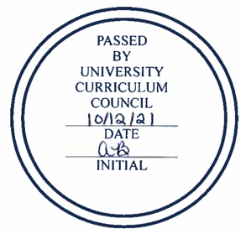
University Curriculum Council
Approved Courses
October 12, 2021

NEW COURSES
College | Course | BRICKS
Arts & Sciences | SOC 3620: Ethics in Law, Crime, and Justice | BER
Fine Arts | MUS 2634: Choral Methods Lab Choir
 | MUS 5631: Choral Techniques and Materials
Health Sciences and Professions | IHS 6303: Clinical Implementation I
 | IHS 6304: Perfusion Theory II
 | IHS 6305: Clinical Implementation II
 | IHS 6307: Mechanical Support
Scripps | ECT 6501: MFA Teaching Practices I
 | ECT 6502: MFA Teaching Practices II

COURSE CHANGES
College | Course | BRICKS | Changes
Arts and Sciences | ECON 2130: Current Economic Problems | PSBS | LOs; added BRICKS component, T2SS designation
 | ECON 2890: Economic Data Analysis with Excel and SAS | ACNW | Added T2SS designation
Health Sciences & Professions | CSD 8949: Research Practicum in Audiology |  | Change from fixed 3 hr to variable 2-4 hr

Expedited COURSE CHANGE

CLWR 3310 to CARS 3000: The Hebrew Bible (Christian Old Testament, Jewish Tanakh)

DEACTIVATIONS

CLAR 2130: Near Eastern and Egyptian Archaeology
CLAR 3620: The Archaeology of Roman Cities
CLAR 4900: Special Topics in Classical Archaeology
CLAR 4930: Independent Study in Classical Archaeology
CLAS 3110: Gods and Heroes in Ancient Epic
CLAS 3120: Greek Tragedy and Comedy
CLAS 4900: Special Topics in Classics
CLAS 4930: Independent Study in Classical Literature
CLWR 3610: American Religions
CLWR 3850J: Writing on Religion
CLWR 4931H: Departmental Honors Thesis
EDCE 7245: Counseling Children and Adolescents

