MEMO
Second reading
From  Subject Date | UCC General Education Committee
 | Undergraduate Catalog Language for Associate Degrees and BRICKS
 | October 11, 2022

The purpose of this memo is to document a proposed amendment to the Undergraduate Catalog language concerning BRICKS requirements for academic associate degrees.

Background

The OHIO University Curriculum Council endorsed language for the Undergraduate Catalog regarding BRICKS requirements for undergraduate degrees at their January 2020 meeting. The approved language for associate degrees reads as follows:

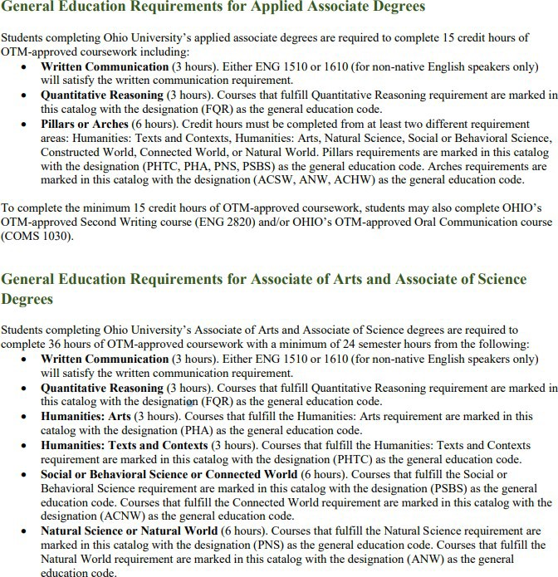

The concluding paragraph for the Applied Associate Degrees is the translation into BRICKS language of
ODHE’s description of minimal requirements for Applied Associate Degrees. The corresponding
1
paragraph for A.A. and A.S. degrees was left out of our language. The proposed amendment rectifies the situation.

Amended Language
The following language should be appended to the General Education Requirements for Associate of Arts and Associate of Science degrees in the undergraduate catalog, and the resulting change implemented by the registrar’s office:

To complete the minimum 36 credit hours of OTM-approved coursework, students may also complete OHIO’s OTM-approved Second Writing course (ENG 2800) and/or OHIO’s OTM-approved Oral Communication course (COMS 1030).

Note: The approved catalog language (included above) incorrectly lists ENG 2820 as the approved 2nd writing course, rather than ENG 2800. The actual catalog does contain the correct course number.
2

