UNIVERSITY CURRICULUM COUNCIL
Tuesday, September 11, 2018, 3:05p.m.

Alden Library, Room 319

First Meeting of 2018-2019

ATTENDANCE:

Present: Childers, Cotton, Ensign, Hartman, Hatch (representing Frank), Helfrich, Ingram, Kanwar, Kruse, Kuruppalil, Lamb (representing Shaftel), LeRiche, McAvoy (representing Irwin), Moberg (representing Sherman), Quitslund (representing Shields), Rogus, Sayrs, Such, Taylor, Thomas, Tuck, Yang

Excused: Broughton, Sindelar

Absent: Brown, Cutcher, Frith, Goheen, Jadwisienczak, Jeffries, Loudner-Maffin, Palmer, Patterson, Sandal, Smith, White

Guests: Benton, DeWald, Thomas, Whitnable

CHAIR'S REPORT: Sara Helfrich, Chair

Helfrich welcomed the members to the first meeting of the 2018-2019 Academic Year of the University Curriculum Council and thanked them for their agreement to serve. Helfrich introduced herself as the new Vice-chair of Faculty Senate and Chair of the University Curriculum Council.

Helfrich called for approval of the April 24, 2018 minutes. Moved and seconded. Minutes unanimously approved by voice vote.

Helfrich turned the floor over to Howard DeWald, Associate Provost for Faculty & Academic Planning.

DeWald introduced Loralyn Taylor who is the interim in Institutional Research.

DeWald informed the Council that the Ohio Department of Higher Education worked on General Education during the summer.

Ohio Guaranteed Transfer Pathways Committee was busy this summer. Numerous templates were sent out to the Universities to be approved. There is still much work to be done.

Dewald informed the Council that Beth Quitslund, Associate Dean for Graduate College is the contact person for creating or changing graduate programs. Quitslund asked that if you are changing a program to contact her first to save work. If you are suspending a program, she needs to know.

PROGRAM REVIEW COMMITTEE – John Cotton, Chair

Cotton presented the Program Review Committee update.

AY15
- Mathematics – review received. Awaiting dean and department chair’s comments.
AY16
- Aviation – self-study received, waiting for external reviewer suggestions
AY17
- Electronic Media – review and RHE response received.
- Tier I Quantitative Skills – developing plan for review (David Ingram, lead.)
AY18
- Center for International Studies – review and responses received.
- Department of Geography – Review and responses received. To Graduate Council.
- Department of Political Science – Externals approved. Awaiting self-study due 9/15/2018
- Department of Interdisciplinary Healthcare Studies – review delayed until Fall 2021
- Honor's Tutorial College – delay until Fall 2019
AY19
Self-studies due September 15, 2018, unless noted otherwise
- Counseling and Higher Education – Externals approved
- Educational Studies – Externals approved
- Teacher Education – Externals approved
- School of Rehabilitation and Communication Studies - Negotiating a review date for three separate programs aligned with accreditation
- Voinovich School – Externals approved
- Office Tech – Awaiting bios of proposed reviewers
- Technical and Applied Studies – External approved
- Accounting Tech / Business Mgmt – Externals approved
- Computer Science Technology – Externals approved
- Medical Assisting Technology – Externals approved
- Sport and Lifestyle Studies – New program to be reviewed 2021-22
- Applied Management – Externals approved

PROGRAMS COMMITTEE: Connie Patterson, Vice Chair

Patterson presented the agenda.

SECOND READINGS – PROGRAM CHANGES
- The Patton College of Education
Unanimously Approved by Voice Vote
Program Code: BS6361
Program Name: Restaurant, Hotel and Tourism
Contact: Beth VanDerveer

The program is proposing deleting NUTR 3300: Principles of Quantity Food Production and Purchasing (3 credit hours) from the Major Requirements. The students receive the necessary content in other program major courses (i.e., RHT 3340). This will decrease the total program hours by 3 credit hours and will not impact the department resources.

- Arts & Sciences
Unanimously Approved by Voice Vote
Program Code: CTMENA
Program Name: Middle East and North Africa Studies Certificate
Contact: Ziad Abu-Rish

The proposed changes are three-fold:
(1) Remove POLS 4420 from the list of core requirement courses.
(2) Increase the number of required courses within the interdisciplinary requirement from one (1) to two (2) and add POLS 4420 as an option in that category of courses. [Note: students must pick two courses, each from a different discipline]
(3) Add the following courses to the list of elective course options n HIST 2270: The Middle East and the World (3 CR) n HIST 3293: World of Late Antiquity (3 CR) n HIST 3372: Protests, Rebellions, & Revolutions in Modern Middle East (3 CR) n HIST 3562: Muslims, Christians, & Jews in History of Medieval Spain (3 CR) n POLS 4420: Middle East Politics (3 CR)
These changes do not have an impact on total program hours, resource requirements, or faculty.

SECOND READINGS – NEW PROGRAMS
- Honors Tutorial College
Unanimously Approved by Voice Vote
Program Code: BAXX20
Program Name: Global Studies
Contact: Nukhet Sandal

The proposed HTC- Bachelor of Arts in Global Studies is designed to offer an opportunity for highly motivated students to study Global Studies and follow any of its interdisciplinary tracks: African Studies; European Studies; Asian Studies; War and Peace Studies and Latin American Studies. This program aims to challenge students at every phase of study and promote high-quality interdisciplinary undergraduate research addressing global issues and challenges. The curriculum includes one-on-one tutorials with professors affiliated with the Center for International Studies. Implementation of the program would begin with the application process in December 2018 with the first HTC students beginning their study in August 2019.
*Correction- HTC programs do not require 120 hours. This is incorrect in the program proposal.

- The Patton College of Education
Unanimously Approved by Voice Vote
Program Code: MSXX15
Program Name: Tennis Professional Management
Contact: Dave Carr

This Professional Tennis Management (PTM) master's degree program is a track within the Master of Science in Recreation and Sport Sciences. It will support a broad professional initiative to help prepare the next generation of tennis providers including tennis professionals, coaches and program administrators. The courses will provide content knowledge in coaching, event and facility management, and sport science. This 30 credit-hour PTM program is jointly developed through the Department of Recreation and Sport Pedagogy in The Patton College of Education and the Department of Sports Administration in the College of Business. The curriculum provides the necessary resources and instruction leading to successful management of tennis programs both on and off the court. Courses will be offered in an online format with an opening face to face residency course held at the National Tennis Center in Orlando. This joint effort will enhance professional development for current and future tennis professionals and coaches and will provide the latest educational and coaching resources. Faculty will come from Ohio University and The United States Tennis Association (USTA).
Courses include:
COED 6100 Coaching Workshop I (3)
COED 6110 Foundations of Coaching I (3)
COED 6140 Psychology of Coaching (3)
COED 6160 Performance and Conditioning for Athletic Coaches (3)
COED 6170 Ethics and Diversity for Sport Coaches (3)
COED 6330 Analyzing Performance in Sport (3)
REC 5330 Event Planning in Recreation and Leisure Services (3)
REC 5430 Marketing for Recreation and Leisure Services (3)
SASM 6110 Foundations of Sport Business (3)
SASM 6570 Sponsorships in Sport (3)

- The College of Fine Arts
Unanimously Approved by Voice Vote
Program Code: BFXX03
Program Name: Film
Contact: Steven Ross

Last spring, the Programs Committee received a communication from the Deans of CoFA and Scripps committing to a collaboration between Film and MDIA to work out the remaining details of the curriculum over the summer. The Dean of CoFA asked that PC recommend the program to UCC for first reading due to time sensitive state approvals and faculty hiring obligations.

Currently, the Film Division offers an MFA in Film, an MA in Film Studies, and a BFA in Film Tutorial degree as part of the Honors Tutorial Program. Throughout its history, the film program has stressed creativity, diversity, and a personalized academic experience for graduate and undergraduate students. The current proposal aims to continue this long history by creating a BFA in Film that will draw on and expand the already existing undergraduate education to allow students to pursue future careers in film production and related fields. The BFA in Film is a unique curriculum providing professional training in all major aspects of filmmaking alongside a solid foundation in film studies. The program prepares students to succeed in careers in the film and television industry, in professional areas utilizing time-based media (i.e., the web, advertising), and/or as independent artists.

Required Curriculum for a BFA in Film: 46 hours in Core Curriculum and 24 credit hours in additional requirements = 70 total credit hours.
Core Curriculum:
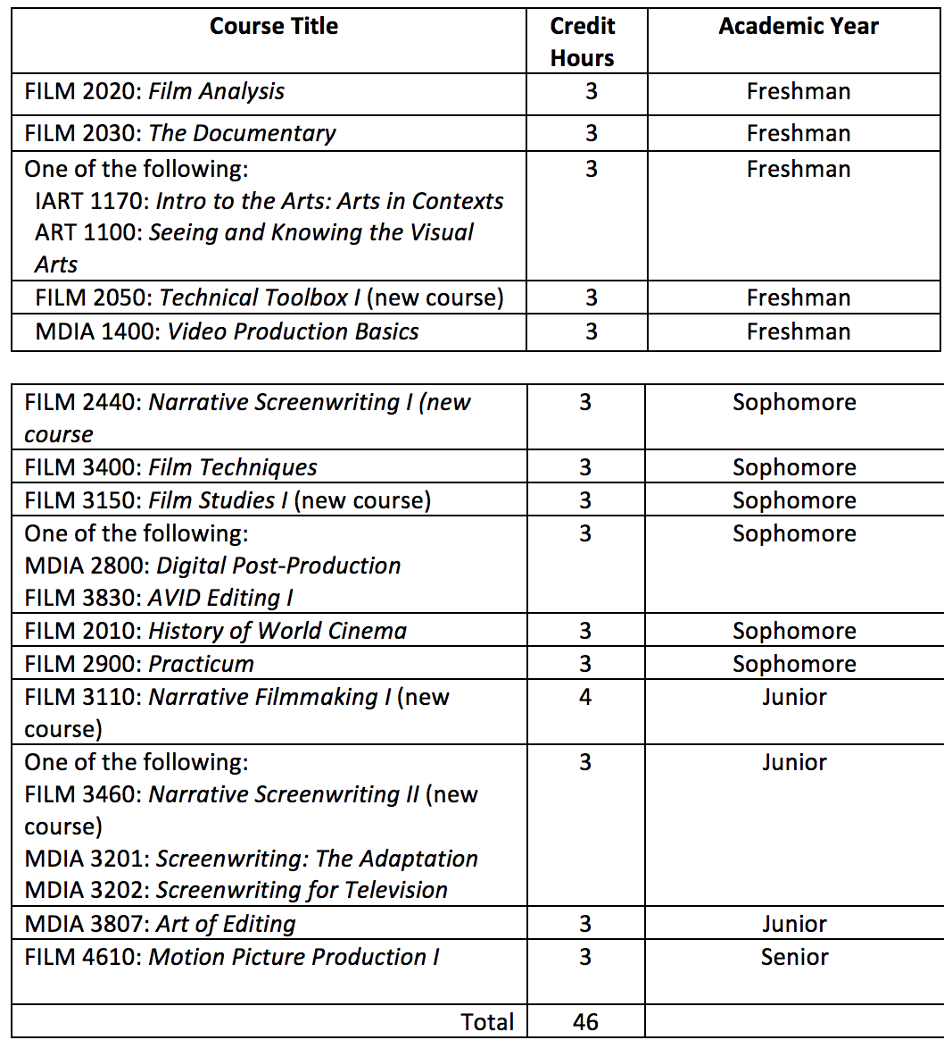

Additional requirements:
• 12 credit hours of FILM or MDIA electives (3000/4000 level classes)
• 3 credit hours of additional film studies classes after sophomore year from the following:
1. FILM 4310: Film History I
2. FILM 4320: Film History II
3. FILM 4510: Film Theory I
4. FILM 4520: Film Theory II
5. FILM 4710: Film Topics Seminar I
6. FILM 4720: Film Topics Seminar II
• 3 credit hours of FILM 4910: Internship or MDIA 4911: Los Angeles Internship
• 6 additional credits hours in COFA classes (IART, MUS, ART, AH, THAR, DAN)
Total = 24 credit hours

- The College of Fine Arts
Unanimously Approved by Voice Vote
Program Code: ORXX20
Program Name: Stage Management
Contact: Jeanette Buck

This proposal seeks to establish a 21-credit hour undergraduate Minor in Stage Management. This minor program introduces the student to the craft of stage management and develops techniques in personnel management and leadership. Through both classroom learning and hands-on experience stage managing a show in the Theater Division in the School of Dance, Film and Theater students develop skills in collaboration, communication, process and leadership. No additional resources are required for this minor.
Required courses are:
THAR 1392 Fundamentals of Lighting, Sound, and Stage Management (3)
THAR 3605 Stage Management (3)
THAR 3610 Stage Management Seminar (3)
THAR 2600 Practicum in Stage Management (4)
THAR 3600 Practicum in Stage Management (6)
EXPH 2280 Community First Aid, and CPR/AED for the Professional Rescuer (2)

- The College of Fine Arts
Unanimously Approved by Voice Vote
Program Code: ORXX19
Program Name: Conducting
Contact: Andrew Trachsel

This minor will give music students an opportunity to study conducting at a greater depth than what is required of them in their respective degree programs.
The Undergraduate Conducting Minor program requires a minimum of 15 hours.
Core Required Courses 1: Complete the following courses (4 hours):
MUS 3040 Instrumentation Credit Hours: 2.0
MUS 4550 Basic Conducting Credit Hours: 2.0

Core Required Courses 2: Complete a minimum 4 hours from the following courses:
MUS 4560 Instrumental Conducting Credit Hours: 2.0
MUS 4561 Choral Conducting Credit Hours: 2.0 M
US 4590 Advanced Instrumental Conducting (approved 2018) Credit Hours: 2.0
MUS 4591 Advanced Choral Conducting (in proposal process) Credit Hours: 2.0

Core Literature Courses 3: Complete a minimum 2 hours from the following courses:
MUS 4210 Literature of Choral Music Credit Hours: 2.0 M
US 4213 Literature of Orchestral Music Credit Hours: 2.0
MUS 4216 Literature of Band Music Credit Hours: 2.0

Elective Courses 4: Complete a minimum 5 hours from the following courses:
MUS 2511 Wind Symphony Credit Hours: 1.0-2.0
MUS 2514 Symphonic Band Credit Hours: 1.0-2.0
MUS 2520 Symphony Orchestra Credit Hours: 1.0-2.0
MUS 2530 University Singers Credit Hours: 1.0-2.0
MUS 2531 Choral Union Credit Hours: 1.0-2.0
MUS 4942H Honors Recital (ex. Student Conductors Honors Recital) Credit Hours: 1.0- 2.0
MUS 3700 Applied Conducting (in proposal process) Credit Hours: 1.0-4.0

Prerequisite Courses: These courses must be completed for admission into the program:
MUS 1250 Introduction to Music History and Literature
MUS 2020 Music Theory IV with minimum grade of C
MUS 2420 Class Piano IV
MUS 2040 Dictation and Sight Singing IV – accidentally not included in OCEAN proposal

- College of Health Sciences & Professions
Unanimously Approved by Voice Vote
Program Code: CTX22G
Program Name: Family Nurse Practitioner Certificate
Contact: Char Miller

This 19-credit hour post-master’s certificate requires three clinical courses to fulfill eligibility criteria for national certification as an FNP. These courses are:
NRSE 6820: Advanced Care of Women and Children (6 credit hours)
NRSE 6821: Care of Adults and Older Adults (8 credit hours)
NRSE 6720: FNP Practicum for post- master’s Certificate (5 credit hours)

- College of Health Sciences & Professions
Unanimously Approved by Voice Vote
Program Code: CTX23G
Program Name: Adult Gerontology Acute Care Nurse Practitioner Certificate
Contact: Char Miller

Acutely ill patients increasingly dominate the inpatient population, and research has shown that in these settings nurse practitioners provide quality care, decrease length of stay, and improve patient and family satisfaction. Adult-Gerontology Acute Care Nurse Practitioners (AG ACNP) are needed to help assess and manage acutely ill patients within the inpatient/hospital setting and across hospital-to-clinic settings, including the emergency department, intensive care unit, specialty labs, acute and sub-acute care wards, specialty clinics, or any combination of the above.
The Post-Master's AGACNP certificate is designed for those who already hold a Master's degree in nursing and wish to expand their knowledge to the advanced practice role of the AGACNP. This proposed certificate program has a total of 26 semester credits leading to specialized advanced practice certification eligibility. The proposed program of study includes 20 credit hours of track-specific content designed to meet the core competencies and clinical hour requirements for AGACNP's set forth by the Commission on Collegiate Nursing Education (CCNE), our accrediting body.
- NRSE 6826, AGACNP Management of Common Adult Health Problems I (200 hours practicum) (7ch)
- NRSE 6827, AGACNP Management of Common Adult Health Problems II, (200 hours of practicum) (7ch)
- NRSE 6721, AGACNP Practicum, (50 hours of practicum) (6ch)
Pre-requisites to admission:
Students must have completed the following courses or the equivalent with a minimum of a B:
- NRSE 6231, Applied Clinical Pharmacology for the AGACNP
- NRSE 6232, Advanced Diagnostics and Procedures for Clinical Decision-Making
- NRSE 6221 Health Appraisal for Nurse Practitioners
- NRSE 6230 Advanced Pharmacology
- NRSE 6210 Advanced Pathophysiology

FIRST READING- PROGRAM CHANGES
- The Patton College of Education
Program Code: BS6854
Program Name: Early Childhood Education
Contact: Gene Geist

The Early Childhood Program is changing the intro course requirement from EDEC 1001 to EDTE 1000 because the State of Ohio TAG requires that we make this class a 3 hour course. The program also seeks to clarify the math requirement to read that any math above the MATH 1101 will fulfill the requirement. This change is to fix an irregularity between the documents in OCEAN and the catalog. OCEAN program sheet lists that students must take MATH 1101 and 1102 as their mathematics courses which was not the intent and must have been missed during the semester transition. We would like language in all documents to read “6 hours of mathematics at the MATH 1101 level or higher”. We have students with AP credit and we also have students (including students in our Honors programs) who choose to take higher levels of mathematics. We also transfer in a number of students from other programs that have different mathematics requirements but that are still at an acceptable level of rigor. Limiting students to taking just 2 courses would put an undue burden on their prospects of graduating in a reasonable length of time and would only mean more waivers and substitution forms to have to be processed by the advisors.

- The Patton College of Education
Program Code: AA1106
Program Name: Child Development
Contact: Gene Geist

Clarify the math requirement to read that any math above the MATH 1101 will fulfill the requirement. We propose changing this language to match the current DARS and would like language in all documents to read “3 hours of mathematics at the MATH 1101 level or higher”.

- Arts & Sciences
Program Codes: BA3311
Program Name: Chemistry
Contact: Corey Beck

The proposed change will make the current requirement of Calculus II (MATH 2302) a possible option out of the following list:
Calculus II, MATH 2302
Intro to Statistics, MATH 2500
Statistics for the Behavioral Sciences, PSY 2110

The proposed change will offer our students more flexibility and does not have an impact on the total program hours. The proposed changed does not affect any prerequisite requirements of the current B.A. program.

- Regional Higher Education- OHIO Lancaster
Program Codes: AA5023
Program Name: Engineering Technology
Contact: Gina Orr

The Engineering Technology program offered at the Lancaster campus needs to be revised to meet current needs in the manufacturing industry. Manufacturing is moving towards the use of more automated equipment and there is a need for graduates capable of programming, trouble shooting and working with this automated equipment (electromechanical technicians). We are finding electronics and robotics as well as Lean practices (quality control) and safety knowledge are more in demand. In order to satisfy these needs, and to stay within our current total program hours of 61, the new Engineering Technology curriculum will be reduced to only one track. The majority of all previous ‘track’ courses are covered in the curriculum, however, the mechanical trait course content may not be as in-depth as before. Some new courses need to be developed and pre-requisites have been added to ensure courses are taken in proper sequence. The Chair of Engineering Technology and Management at the OHIO Athens campus is supportive of this change. A detailed chart of the revised curriculum is in OCEAN 1.9.

- Arts & Sciences
Program Codes: BS3310
Program Name: Forensic Chemistry
Contact: Rebecca Barlag

Upon our reaccreditation inspection by the Forensic Science Education Programs Accreditation Commission (FEPAC), several curriculum issues were identified making the program noncompliant with FEPAC standards. The changes proposed are to address these issues. Changes are as follows:
- Remove Tox/Trace and DNA Analyst tracks from the curriculum. Rationale: For our current Tox/Trace track, FEPAC did not approve BIOS 2060 as it was not 3000 level or above and ANTH 4470 is taught too infrequently. FEPAC also did not agree with the names of the tracks and felt they were misleading.
- Make UC 1900 a required course (there will be two sections of UC 1900 with the “Forensic Chemistry LC” designation. Rationale: FEPAC requires a freshman “seminar” course. Impact on total program hours: This will add 1 credit hour to the major.
- Make LET 4950 a required course. Rationale: FEPAC requires a Forensic Science Capstone experience for graduating seniors. Impact on total program hours: This will add 3 credit hours to the major.
- Make CHEM 4880, BIOS 3100, and BIOS 3105 required courses Rationale: This will bring the total credit hours in the students’ area of specialization to 21 in compliance with the minimum of 19 required by FEPAC. Impact on total program hours: This will only add 3 credit hour to the major, as BIOS 3100 and 3105 were already required for one of the tracks.

As all of these courses are already offered, there are no changes to the requirements for resources or faculty and no other department is affected.

FIRST READING- NEW PROGRAM/ CERTIFICATE
- Arts & Sciences
Program Codes: MAXX10
Program Name: War and Peace Studies
Contact: Nukhet Sandal

The Center for International Studies proposes the development of an innovative new interdisciplinary 30-credit (one-year) MA degree in War and Peace Studies (WPS). The degree will focus on international security and peace issues including dynamics of cooperation and conflict, war, terrorism, peacebuilding and peacekeeping among others. WPS has an undergraduate program, which is the largest major at the Center for International Studies. The proposed MA degree will be open to students from any background, and the graduates will find employment at the state and federal level, in addition to non-governmental organizations, businesses and military.

There is no need for additional facilities and staff to launch and sustain this program. Since the Center for International Studies already has five graduate programs, there is a solid infrastructure in place for the MA in War and Peace Studies. There will be a War and Peace Studies Director, who will oversee the undergraduate and graduate program (similar to the Latin American Studies, Asian Studies, and African Studies directors).

Students have to take INST 6500 Research in War and Peace Studies (4 credit hours);
one area studies elective (4 credit hours);
one methodology elective (4 credit hours);
four elective courses from among the designated electives; and
two 1-credit professional development courses (INST 5700 and INST 5701 – both currently under review on OCEAN).

Through the elective War and Peace focused courses, the students will be expected to identify diverse policy challenges and gaps in the academic literature related to War and Peace Studies, and propose solutions, and they will conduct a sophisticated literature review and original research paper (either as part of a class, or bridging insights from multiple courses under the guidance of the faculty advisor) to be submitted as part of the culminating experience. The culminating experience will be an exit exam that will be prepared and evaluated by the director of the War and Peace Studies program, and two faculty members whom the student has taken courses from and who agree to be on the exam committee. As part of the culminating experience, the student also needs to provide a significant research paper written during their time as an MA student in War and Peace Studies. The significant paper will be evaluated and approved by the Director of War and Peace Studies and the other members of the exam committee

EXPEDITED REVIEW
- Arts & Sciences
Program Codes: OR4201, BA4203, BA4201
Program Name: Political Science Minor, BA in Political Science – Pre-Law, Political Science
Contact: Michael Burton

Currently the Department of Political Science has a requirement for majors and minors such that students may take no more than one of the following types of courses in fulfillment of requirements: Special Topics, Independent Study, and Research. While the original rationale has become somewhat lost to history, currently the restriction is impeding some students' academic plans for graduation. We are proposing a removal of this restriction so as to better serve both the students involved and the academic goals established by the Department.

The current list of requirements includes the following line: "No more than six hours of the following courses may count: POLS 4900, 4901, 4902, 4903, 4904, 4905, 4931, 4932, 4933, 4934, 4944, 4935, 4941, 4942, 4943, 4944, or 4945."
Each of these courses represents Special Topics, Independent Study, and Research.
We propose to delete this line.

- College of Fine Arts
Program Codes: BM5105
Program Name: Music Composition
Contact: Robert McClure

Change the course offerings for composition major students whose primary instrument is piano and therefore must select from Instrumental Methods courses. Due to the recent approved adjustments to our music education curriculum, several courses have been consolidated and therefore the music composition major must be updated to reflect the new course changes. There is ultimately no change to total program hours or resource requirements.

The current catalog for Music Composition requires students to complete four of the following courses under “Secondary Instrument – If Principal Instrument IS Piano,” #2:
MUS 2610 - Upper Strings Methods and Materials
MUS 2611 - Lower Strings Methods and Materials
MUS 2630 - Percussion Methods and Materials
MUS 2631 - Horn and Trumpet Methods and Materials
MUS 2632 - Trombone/Euphonium/Tuba Methods and Materials
MUS 2635 - Flute, Saxophone & Clarinet Methods and Materials
MUS 2636 - Double Reed Methods and Materials

We propose that the catalog should list the following four courses, and also change the wording to read “Complete all of the following courses.” MUS 2630 Percussion Methods, MUS 2640 Brass Methods, MUS 2641 Woodwind Methods, MUS 2642 String Methods

INDIVIDUAL COURSE COMMITTEE: Hans Kruse, Chair/Mary Rogus, Vice Chair

Kruse presented the agenda.

Agenda (appended to the minutes) unanimously approved by voice vote.

GENERAL EDUCATION COMMITTEE, Katie Hartman, Chair

No report.

NEW BUSINESS

Helfrich informed the Council that this was Laura Tuck’s last meeting. She thanked her for her service and presented her with beautiful flowers in appreciation of her hard work.

Meeting adjourned at 4 p.m.

