SECOND READINGS – PROGRAM CHANGES
- The Patton College of Education
Program Code: BS6396
Program Name: Physical Science- Physics
Contact: Danielle Dani

All changes maintain program alignment with requirements for licensure and accreditation. Currently the program requires a total of 132 credit hours, including 10 credits hours of GEOL courses. The proposed changes do not affect the total number of program hours or the total number of required GEOL course hours.

Replace GEOL 2110 with GEOL 2080. GEOL 2110 has been indefinitely suspended.
Replace GEOL 2550 with GEOL 2550 OR GEOL 2210. GEOL 2210 uses active learning strategies that may be transferable to K12 teaching settings.

- The Patton College of Education
Program Code: BS6309
Program Name: Integrated Science
Contact: Danielle Dani

All changes maintain program alignment with requirements for licensure and accreditation. Currently the program requires a total of 129 credit hours, including 16 credits hours of GEOL courses. The proposed changes do not impact the total number of program hours or the total number of required GEOL course hours.

Replace GEOL 2110 with GEOL 2310 OR GEOL 2170. GEOL 2110 has been indefinitely suspended.
Replace GEOL 1200 with GEOL 1350 OR GEOL 2150. It duplicates the required GEOL 1010 requirement.
Replace GEOL 2550 with GEOL 2550 OR GEOL 2210. GEOL 2210 uses active learning strategies that may be transferable to K12 teaching settings.

- College of Health Sciences & Professions
Program Code: CTGERO
Program Name: Gerontology Certificate
Contact: Julie Brown

The Department of Interdisciplinary Health Studies (IHS) proposes that the undergraduate certificate be restructured to provide a gerontology foundation that consists of select, required gerontology courses. Currently, certificate students are required to select any five courses from a pre-approved list. However, almost a quarter of the courses are no longer available as course options, a third pertains specifically to long-term care (and have pre-requisites), and the remaining courses are a mixture of age-related courses from different disciplines (only three are actual gerontology courses). Thus, it is possible for students to meet the current requirements without ever taking a gerontology course. In addition, there is a practicum/internship requirement that 1) varies in the amount of credits required (3 to 15 credits) and 2) is only readily available to those students enrolled within the major of those internship course listings.

The proposed structure will provide a true gerontology foundation with the requirement of three gerontology courses (9 credits) and two student-selected courses that reflect aging (i.e., older adulthood) within its content. These two related courses may stem outside of the current course options but selected with the guidance of an advisor and approved by the coordinator. In addition, the internship will not be required since two of the required courses (CFS 4070 and CFS 4660) involve varying levels of community engagement within a gerontological context. There are no anticipated impacts on resources or other departments/colleges.

*Additional electives to those listed in the proposal are listed in the Discussion tab.

- College of Health Sciences & Professions
Program Code: CTCING
Program Name: Clinical Informatics
Contact: Sally Marinellie

Following the acquisition of some market research information, we are proposing revisions to the clinical informatics certificate. Please see the table below for the current and revised programs. The three primary courses in the revised program (IHS 5513, HLTH 6801, and IHS 6803) provide a strong foundational start to clinical informatics. The revisions to this certificate will not have any impact on resources. This is a specialized certificate. The MPA program (Jason Jolley, Director) was informed of this change and did not express concerns. In addition, the BME program director (Doug Goetz) was informed and did not respond with any concerns.

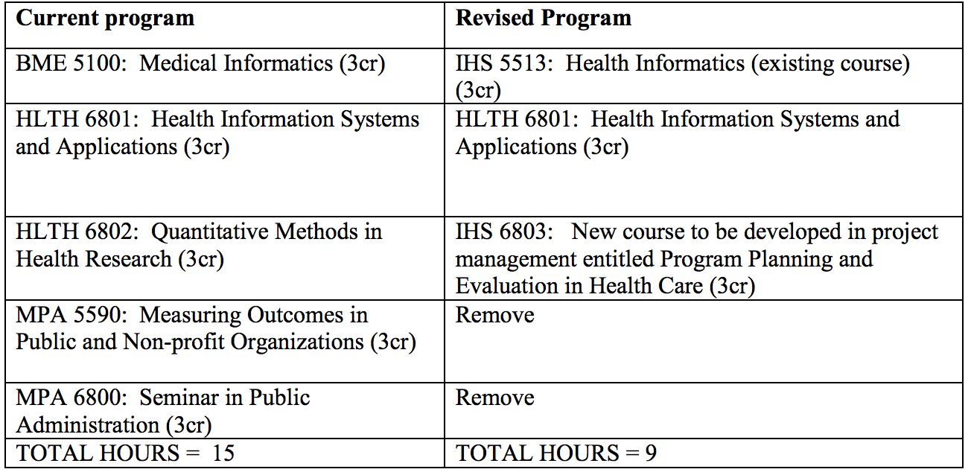

SECOND READINGS – NEW PROGRAMS
- College of Health Sciences & Professions
Program Code: CTX44G
Program Name: Veterans Health Certificate
Contact: Sally Marinelle

While Ohio University prepares a large number of health and healthcare professionals with vast clinical roles, e.g., nurses, physician’s assistants, physical therapists, social workers, clinical psychologists, hearing and speech professionals, and physicians, there are no specific academic programs of foci on the special needs of veterans and their families. In fact, there are few academic programs nationwide that provide this focus, and those that do exist are relatively new. The purpose of this certificate is to provide students and/or post-professional health and healthcare workers with a background in advanced and specific knowledge for work with veterans in health and healthcare settings. The topics will include, United States military history and culture as it pertains to the individuals' health, the Veteran’s Affairs system and common and current medical conditions associated with the military service.

This specialized certificate includes three existing courses for a total of nine credit hours:

IHS 5400: Emphasize the importance of healthcare providers understanding of military culture and history, in order to be effective providers for this population.

IHS 5401: This course examines the current literature and epidemiological data on numerous biological, psychological, social diseases and conditions in military veterans and their families. This course also investigates the challenges regarding diagnosis and treatment of current and former military personnel and their families in comparison to civilian patients.

IHS 5402: The United States Department of Veterans Affairs (VA); including mission, organizational structure, history and evolution are explored with an emphasis placed on veterans' health and healthcare services

- Russ College of Engineering and Technology
Program Code: CTX71G
Program Name: Electronic Navigation
Contact: Jeffrey Dill

For nearly 50 years, Electrical Engineering (EE) faculty associated with the Avionics Engineering Center at Ohio University have taught graduate courses in electronic navigation. However, other than a handful of non-degree graduate students, these courses have been available solely to degree-seeking graduate students in EE. Over the past few years, interactions with colleagues and sponsors in industry have brought to light a need for structured training in electronic navigation at the graduate level without a full Master’s degree program. A certificate program in Electronic Navigation would enable engineers in the workforce to gain valuable training in the theory and practice of the field.

A certificate program in Electronic Navigation of 12 credit hours is proposed.
1) Inertial Navigation Systems: EE 6033 (3 hrs, required)
2) Satellite-Based Navigation Systems: EE 6053 (3 hrs, required)
3) Integrated Navigation Systems: EE 6063 (3 hrs, required)
4) ELECTIVE (3 hrs):
May choose from:
a. Aviation Standards, Software Design and Certification: EE 6083
b. Microwave Theory and Devices: EE 5403
c. Electronic Navigation Systems: EE 5853

EXPEDITED REVIEW
- College of Arts & Sciences
Program Code: OR4221
Program Name: Economics Minor
Contact: Shamila Jayasuriya

We propose to add one economics elective, ECON 2020 Gender in the Economy to the list of electives we currently have in the program. Students will continue to choose three classes from the list of electives so there will be no impact on total program hours or resource requirements.

- College of Arts & Sciences
Program Code: BA4221
Program Name: Economics
Contact: Shamila Jayasuriya

We propose to add one economics elective, ECON 2020 Gender in the Economy to the list of electives we currently have in the program. Students will continue to choose four classes from the list of electives so there will be no impact on total program hours or resource requirements.

- College of Arts & Sciences
Program Code: BS4225
Program Name: Economics
Contact: Shamila Jayasuriya

We propose to add two economics electives, ECON 2020 Gender in the Economy and ECON 2130 Current Economic Problems
to the list of electives we currently have in the program. Students will continue to choose six classes from the list of electives so there will be no impact on total program hours or resource requirements.

- College of Business
Program Code: BB6127
Program Name: Marketing
Contact: Chris Moberg

Marketing majors are required to complete two three-credit hour electives in addition to the required courses in the major. With the recent approval of several new courses, the department would like the following courses added to the list of electives available to Marketing majors:
MKT 3440 Consumer Research
MKT 3600 Entrepreneurial Sales
MKT 4100 Sustainability
MKT 4600 Brand Management
MKT 4650 New Product Development
MKT 4780 Sales Strategy & Technology
MKT 4900 Special Topics in Marketing

- College of Business
Program Code: OR6127
Program Name: Marketing
Contact: Chris Moberg

With the recent approval of several new courses, the department would like the following courses added to the list of electives available to Marketing minors:
MKT 3440 Consumer Research
MKT 3600 Entrepreneurial Sales
MKT 4100 Sustainability

- College of Fine Arts
Program Code: BF5161
Program Name: Acting
Contact: Brian Evans

- College of Fine Arts
Program Code: BF5158
Program Name: Playwriting

- College of Fine Arts
Program Code: BF5200
Program Name: Acting- Musical Theater

- College of Fine Arts
Program Code: BF5168
Program Name: Stage Management

- College of Fine Arts
Program Code: BF 5194
Program Name: Theater

- College of Fine Arts
Program Code: BF 5162
Program Name: Production Design & Technology

The Division of Theater wishes to change courses in the shared component, Theater Core. This proposal is the same for 6 programs:
BF 5158 Playwriting
BF 5161 Acting
BF 5200 Acting—Musical Theater
BF 5167 Production Design and Technology
BF 5168 Stage Management
BA 5194 Theater

Change #1: Remove THAR 1720 (3 credit hours) from the Theater Core requirements. Rationale: All of the learning outcomes for THAR 1720 are currently covered by courses specific to each degree.
Change #2: Substitute two new production design and technology courses for the three courses that currently deliver this part of the curriculum in the theater core. These new courses have been proposed to ICC and further explain how the combined outcomes more efficiently deliver this curriculum. THAR 1390, 1391 and 1392 will be deleted.

Current | Proposed
THAR 1390 (3 credits) | THAR 1393 (4 credits)
THAR 1391 (3 credits) | THAR 1394 (4 credits)
THAR 1392 (3 credits)

Currently:
BFA FOUNDATION CORE PART 1 - COMPLETE 5 COURSES. THAR 1390, THAR 1391, THAR 1392, THAR 1720, THAR 1730
Proposed: BFA FOUNDATION CORE PART 1 - COMPLETE 3 COURSES. THAR 1393, THAR 1394, THAR 1730

Total credit hour change for all programs will be a reduction of 4 credits of major requirements.

