SECOND READINGS – PROGRAM CHANGES
- The Patton College of Education
Program Code: BS6854
Program Name: Early Childhood Education
Contact: Gene Geist

The Early Childhood Program is changing the intro course requirement from EDEC 1001 to EDTE 1000 because the State of Ohio TAG requires that we make this class a 3-hour course. The program also seeks to clarify the math requirement to read that any math above the MATH 1101 will fulfill the requirement. We would like language in all documents to read “6 hours of mathematics at the MATH 1101 level or higher”.
*Amendment (noted in the Discussion tab)- We would like the wording to read "that 6 hours of mathematics at the MATH 1101 or above (with the exception of MATH 1200, MATH 1300, MATH 1321 and MATH 1322) will fulfill the mathematics requirement for early childhood.

- College of Arts & Sciences
Program Code: MS4103
Program Name: Experimental Psychology
Contact: Bruce Carlson

The Department of Psychology intends once again to admit students to its terminal master’s degree program, rather than only admit students to the master’s degree program as a step to completion of the doctoral degree. The Department of Psychology requests permission to change the name of the master’s degree to Psychological Science and to add a requirement that students complete 6 credit hours in substantive or content courses in Psychology.

The proposed changes (see below) have no impact on any other department in the university, no impact on total program hours, and minimal impact on department resources, including faculty, although it may generate a modest amount of revenue for the department and college.

- College of Business
Program Code: MY6163
Program Name: Master of Accountancy
Contact: David Stott

This change essentially streamlines the process for admittance into our program. The
differing undergraduate backgrounds of the potential applicants to this program creates
different potential entry points into the program and causes confusion in the admittance
process to these prospective students as well as additional administration issues that can
be eliminated by making this change.

The underlying number of hours required to earn the degree will not be affected by this
change. Essentially, a student with an undergraduate degree in Accounting will still be
required to take the same 30 hours of graduate Accounting and Business Analytics
coursework and a student with an undergraduate degree in Business will still need to take
those same 30 hours plus the 12 additional graduate hours that satisfy the equivalency to
an undergraduate degree in Accounting, this change simply allows for one entry point
into the program (proposed to be 42 hours) and then the waiver of up to 12 of those hours
depending on the undergraduate background of the applicant.

- College of Communication
Program Code: BC5363
Program Name: Communication Studies
Program Contact: Jerry Miller

We are making the proposed changes to both of our B.S.C. programs, Athens and Regional Campus. The proposed change is simply removing the 1- hour COMS 1020 Introduction to Communication Studies Course as it has become irrelevant since most of our COMS students are taking or have taken UC 1900.

- College of Communication
Program Code: BC5364
Program Name: Communication Studies Regional Campuses
Program Contact: Jerry Miller

We are making the proposed changes to both of our B.S.C. programs, Athens and Regional Campus. The proposed change is simply removing the 1- hour COMS 1020 Introduction to Communication Studies Course as it has become irrelevant since most of our COMS students are taking or have taken UC 1900.

- College of Health Sciences & Professions
Program Code: MS8174
Program Name: Athletic Training
Program Contact: Sally Marinellie

We are requesting revisions to the new professional Master’s of Science in Athletic Training. After meeting with various stakeholders for our program including medical centers, future employers, and the program medical director, we identified some minor changes for the program that will make the program stronger. These changes will benefit the student’s clinical preparation and didactic experiences while maintaining a proper credit load. The changes include:
PT 7400 Evidence-Based Practice in PT instead of AT 5030 Evidence-Based Practice in AT. Repeating AT 5910 Clinical Immersion in the spring semester
Dropping the interprofessional education (IPE) elective and the general elective from spring semester year two of the program.

Current hours = 59
AT 5030 replaced with PT 7400 (+1 credit hour)
AT 5910 will repeat (+ 6 credit hours)
Remove IPE elective (-2 credit hours)
Remove elective in spring of year 2 (-3 credit hours)

Net increase = 2 credit hours (61)

- College of Health Sciences & Professions
Program Code: MA5326
Program Name: Speech-Language Pathology
Program Contact: Joann Benigno

The faculty members in Communication Sciences and Disorders (CSD) are proposing to increase the minimum credit hours associated with our Speech-Language Pathology Externship course, CSD 6910. The proposed change in this course will increase the minimum number of credit hours to earn the degree from 67 to 69, a total of 2 credit hours if taken one semester, or an increase from 67 to 71, a total of 4 credit hours if taken two semesters. There will be no anticipated impact on resource requirements, faculty, or other departments.

The minimum credits depend on whether students are pursuing Track A or Track B. The vast majority of our students pursue Track B (two externships--one in the schools and one in an adult facility). Students pursuing Track A only complete one externship because they also complete a master's thesis. The proposed change in this course will increase the minimum number of credit hours to earn the degree from 67 to 69, a total of 2 credit hours if taken one semester (Track A), or an increase from 67 to 71, a total of 4 credit hours if taken two semesters (Track B).

- College of Health Sciences & Professions
Program Code: BS6260
Program Name: Environmental Health Science
Program Contact: Michelle Morrone

There are four reasons for these changes:
1. The Environmental Health Science (EH) program is accredited by the National Environmental Health Science and Protection Accreditation Council (EHAC). In 2016, EHAC revised its requirements and we are redesigning the EH major to align with the new requirements.
2. The existing program does not match the needs of the EH profession. The revised program includes cross-cutting environmental health topics that are more relevant for contemporary EH professionals.
3. The existing program does not offer students much flexibility in course selection. The revised program gives students more choices to fulfill the degree.
4. Several of the courses in the existing program are no longer offered and new courses have been created, so the revisions refresh the curriculum.

The revisions will increase the minimum credit hours required for the major from 107 to 108. (A comprehensive list of the changes can be located in OCEAN 1.9.)

SECOND READINGS – NEW PROGRAMS
- College of Arts & Sciences
Program Code: ORXX15
Program Name: Urban Planning & Sustainability
Contact: Edna Wangui
The Urban Planning and Sustainability minor will provide students with a basic understanding of urban environments and how communities can support the three main components of sustainability: environmental quality, economic development, and social equity. This minor is 18 hours.

Foundations: GEOG 2500 Planning and the City

THREE of the following core courses (9 credits)
GEOG 3260 Urban Geography
GEOG 3500 Land Use Planning
GEOG 4560 The City and the Environment
GEOG 4520 Environmental and Sustainability Planning

TWO electives (6-8 hours) Courses used to complete your core course requirements cannot also be used as an elective.

We would like students to be able to share a maximum of 2 courses, or 7 credits, between Geography minors (including ORXX15, ORXX16, OR4231, and OR4233).

- College of Arts & Sciences
Program Code: ORXX16
Program Name: Globalization & Development
Contact: Edna Wangui

The globalization and development minor provide students with an understanding of contemporary global issues and a framework for key issues in national and international development especially as it relates to developing countries. The minor emphasizes an integrated approach to studying the relationship of global change to individual and community well-being. This minor is 18 hours.

Foundation Courses: Take one of the following: (3 credits)
GEOG 1200 Intro to Human Geography
GEOG 1310 Globalization and the Developing World
GEOG 2400 Environmental Geography

Regional Geography: Take one of the following: (3 credits)
GEOG 3310 Geography of Africa
GEOG 3330 Appalachia: Land and People
GEOG 3350 Geography of Latin America
GEOG 3380 Geography of Asia

Core Requirement: Take one of the following: (3 credits)
GEOG 3290 World Economic Geography
GEOG 3400 Geographies of Development

Electives: Take 3 from a list of electives (see OCEAN 1.9 for complete list)- Courses used to complete regional or core requirements cannot be used as an elective.

We would like students to be able to share a maximum of 2 courses, or 7 credits, between Geography minors (including ORXX15, ORXX16, OR4231, and OR4233).

FIRST READING- PROGRAM CHANGES
- The Patton College of Education
Program Code: BS6396
Program Name: Physical Science- Physics
Contact: Danielle Dani

All changes maintain program alignment with requirements for licensure and accreditation. Currently the program requires a total of 132 credit hours, including 10 credits hours of GEOL courses. The proposed changes do not affect the total number of program hours or the total number of required GEOL course hours.

Replace GEOL 2110 with GEOL 2080. GEOL 2110 has been indefinitely suspended.
Replace GEOL 2550 with GEOL 2550 OR GEOL 2210. GEOL 2210 uses active learning strategies that may be transferable to K12 teaching settings.

- The Patton College of Education
Program Code: BS6309
Program Name: Integrated Science
Contact: Danielle Dani

All changes maintain program alignment with requirements for licensure and accreditation. Currently the program requires a total of 129 credit hours, including 16 credits hours of GEOL courses. The proposed changes do not impact the total number of program hours or the total number of required GEOL course hours.

Replace GEOL 2110 with GEOL 2310 OR GEOL 2170. GEOL 2110 has been indefinitely suspended.
Replace GEOL 1200 with GEOL 1350 OR GEOL 2150. It duplicates the required GEOL 1010 requirement.
Replace GEOL 2550 with GEOL 2550 OR GEOL 2210. GEOL 2210 uses active learning strategies that may be transferable to K12 teaching settings.

- College of Health Sciences & Professions
Program Code: CTCING
Program Name: Clinical Informatics
Contact: Sally Marinellie

Following the acquisition of some market research information, we are proposing revisions to the clinical informatics certificate. Please see the table below for the current and revised programs. The three primary courses in the revised program (IHS 5513, HLTH 6801, and IHS 6803) provide a strong foundational start to clinical informatics. The revisions to this certificate will not have any impact on resources. This is a specialized certificate. The MPA program (Jason Jolley, Director) was informed of this change and did not express concerns. In addition, the BME program director (Doug Goetz) was informed and did not respond with any concerns.

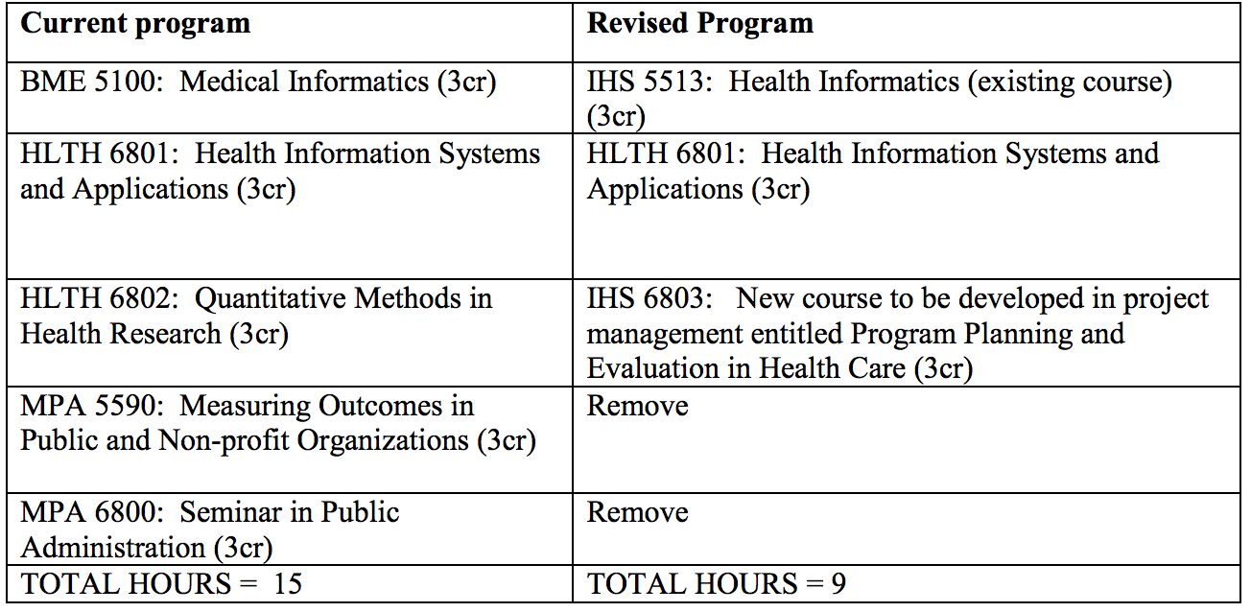

- College of Health Sciences & Professions
Program Code: CTGERO
Program Name: Gerontology Certificate
Contact: Julie Brown

The Department of Interdisciplinary Health Studies (IHS) proposes that the undergraduate certificate be restructured to provide a gerontology foundation that consists of select, required gerontology courses. Currently, certificate students are required to select any five courses from a pre-approved list. However, almost a quarter of the courses are no longer available as course options, a third pertains specifically to long-term care (and have pre-requisites), and the remaining courses are a mixture of age-related courses from different disciplines (only three are actual gerontology courses). Thus, it is possible for students to meet the current requirements without ever taking a gerontology course. In addition, there is a practicum/internship requirement that 1) varies in the amount of credits required (3 to 15 credits) and 2) is only readily available to those students enrolled within the major of those internship course listings.

The proposed structure will provide a true gerontology foundation with the requirement of three gerontology courses (9 credits) and two student-selected courses that reflect aging (i.e., older adulthood) within its content. These two related courses may stem outside of the current course options but selected with the guidance of an advisor and approved by the coordinator. In addition, the internship will not be required since two of the required courses (CFS 4070 and CFS 4660) involve varying levels of community engagement within a gerontological context. There are no anticipated impacts on resources or other departments/colleges.

*Additional electives to those listed in the proposal are listed in the Discussion tab.

FIRST READING- NEW PROGRAM/ CERTIFICATE
- College of Health Sciences & Professions
Program Code: CTX44G
Program Name: Veterans Health Certificate
Contact: Sally Marinelle

While Ohio University prepares a large number of health and healthcare professionals with vast clinical roles, e.g., nurses, physician’s assistants, physical therapists, social workers, clinical psychologists, hearing and speech professionals, and physicians, there are no specific academic programs of foci on the special needs of veterans and their families. In fact, there are few academic programs nationwide that provide this focus, and those that do exist are relatively new. The purpose of this certificate is to provide students and/or post-professional health and healthcare workers with a background in advanced and specific knowledge for work with veterans in health and healthcare settings. The topics will include, United States military history and culture as it pertains to the individuals' health, the Veteran’s Affairs system and common and current medical conditions associated with the military service.

This specialized certificate includes three existing courses for a total of nine credit hours:

IHS 5400: Emphasize the importance of healthcare providers understanding of military culture and history, in order to be effective providers for this population.

IHS 5401: This course examines the current literature and epidemiological data on numerous biological, psychological, social diseases and conditions in military veterans and their families. This course also investigates the challenges regarding diagnosis and treatment of current and former military personnel and their families in comparison to civilian patients.

IHS 5402: The United States Department of Veterans Affairs (VA); including mission, organizational structure, history and evolution are explored with an emphasis placed on veterans' health and healthcare services

- Russ College of Engineering and Technology
Program Code: CTX71G
Program Name: Electronic Navigation
Contact: Jeffrey Dill

For nearly 50 years, Electrical Engineering (EE) faculty associated with the Avionics Engineering Center at Ohio University have taught graduate courses in electronic navigation. However, other than a handful of non-degree graduate students, these courses have been available solely to degree-seeking graduate students in EE. Over the past few years, interactions with colleagues and sponsors in industry have brought to light a need for structured training in electronic navigation at the graduate level without a full Master’s degree program. A certificate program in Electronic Navigation would enable engineers in the workforce to gain valuable training in the theory and practice of the field.

A certificate program in Electronic Navigation of 12 credit hours is proposed.
1) Inertial Navigation Systems: EE 6033 (3 hrs, required)
2) Satellite-Based Navigation Systems: EE 6053 (3 hrs, required)
3) Integrated Navigation Systems: EE 6063 (3 hrs, required)
4) ELECTIVE (3 hrs):
May choose from:
a. Aviation Standards, Software Design and Certification: EE 6083
b. Microwave Theory and Devices: EE 5403
c. Electronic Navigation Systems: EE 5853

EXPEDITED REVIEW
- College of Arts & Sciences
Program Code: CTGISU
Program Name: Geographic Information Systems (GISc) Certificate
Contact: Edna Wangui

We would like to include BIOS 3760 Field Ecology as “Specialized Elective”. This course focuses on quantitative analysis of field problems in ecology. It covers design of field experiments and hypothesis testing as well as statistical analysis. It meets the content and analytical expectations of our Specialized Electives.

