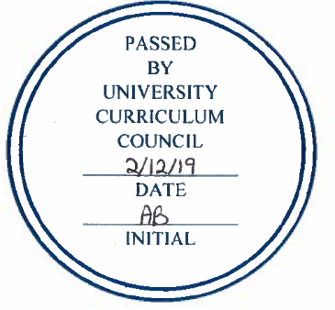
APPROVED PROGRAMS
UNIVERSITY CURRICULUM COUNCIL
February 12, 2019

SECOND READINGS – PROGRAM CHANGES
- College of Health Sciences and Professions
Program Code: BS5327
Program Name: Communication Sciences and Disorders
Contact: Chao-Yang Lee

Faculty in Communication Sciences and Disorders (CSD) proposes to add one course (PSC 1051- Color, Light, and Sound) to the list of Physical Sciences options, and remove two courses
(CSD 4410 Pre-Professional Service II & MATH 1300 Pre-Calculus) from the CSD major program. These changes are proposed to address several obstacles to student learning and program administration. The changes will also allow more flexibility for students to take advanced/elective CSD courses.

The proposed changes will result in a reduction of four (4) total program hours. No impact is expected on faculty or resources. Patron departments include Physics & Astronomy and Mathematics. Consultations with both departments are appended below.

analytics and terminology from the PMBOK lexicon to calculate earned value metrics as well as developing change management plans, a risk register and a risk management plan.

SECOND READINGS – NEW PROGRAMS
- Russ College of Engineering
Program Code: CTX49G
Program Name: Certificate in Project Management
Contact: Neil Littell

The 9-credit hour certificate program (both online and face-to-face) is available to both degree and non-degree seeking students and will equip individuals with various soft and hard skills and modern tools to manage projects and keep them within stakeholders budget and schedule, while meeting specifications, quality and achieving customer satisfaction. Built upon the widely recognized Project Management Institutes (PMIs) Project Management Body of Knowledge (PMBOK®), the program will provide students with the knowledge and expertise to meet the intense global competition demands that new projects and business development require. This certificate will also serve as an option for working project management professionals to pursue a graduate educational experience.

The curriculum includes 9 credits:

- PM 6100 Project Management 1: This course exposes students to the fundamentals of project management practices and is augmented with data analytics and technical writing. Students will investigate the Initiation and Planning phases of the project management process as well as learning terminology from the PMBOK lexicon.
- PM 6200 Project Management 2: This course continues the exposure of students to the fundamentals of the project management processes. Students will leverage data analytics and technical writing skills augmented with terminology from the PMBOK lexicon to pursue knowledge within the execution, monitoring and controlling and closing phases of the project management process.
- PM 6500 Change and Risk Management: This course addresses the fundamental tasks of project managers concerning change and risk management. Students will leverage data analytics and terminology from the PMBOK lexicon to calculate earned value metrics as well as developing change management plans, a risk register and a risk management plan.

EXPEDITED REVIEW
NA

