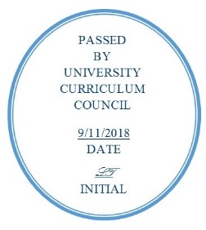
INDIVIDUAL COURSE COMMITTEE
COURSES APPROVED
UNIVERSITY CURRICULUM COUNCIL
SEPTEMBER 11, 2018

Course Changes:

CAS 4911 to CAS 4911 / CAS 5911 | Internship in How Food Works in the Community | Add graduate dual list
CHEM 3510 / CHEM 5510 | Physical Chemistry | Change requisites, Update Outcome Goals
CONS 4915 | Internship: Customer Service Leadership | Update Outcome Goals
CS 2650 | Professional and Ethical Aspects of Computing | Update Course Description, OG, requisites
CS 3200 / CS 5200D | Organization of Programming Languages | Update Course Description, OG, change/add requisites
CS 3560 | Software Engineering Tools and Practices | Update OG, Add requisite
CSD 6910 | Clinical Externship | Change variable credit hours
NRSE 6221 | Health Appraisal for Nurse Practitioners | Update OG, Change requisites
OCOM 7003 | The Osteopathic Approach to Patient Care 3 - Chronic Illness | Change Course Level, Update OG
OCOM 7004 | The Osteopathic Approach to Patient Care 4 - Return to Wellness | Change Course Level, Course title, Update OG
PBIO 2050 | Biotechnology: From the Lab to Daily Life | Update OG, Change text and key grade factors
RHT 1200 | Food and Culture | Update OG
RHT 1330 | Food Sanitation and Safety | Update OG
RHT 4400 | Beverage Management | Update OG

New Courses:

LJC 6800 | Research Capstone in Law, Justice & Culture
ME 4780 / ME 5780 | Missiles guidance systems and rocket design
MUS 4000 | Classroom Assessment and Management for Music Educators
MUS 5002 | Tonal Theory Review
WGSS 6010 | Medicine, Science & Sexuality
AAS 4500 | The History of Black Women in Popular Culture
CE 5390 | Computer Aided Structural Design
HLTH 3850 | Quality Improvement in Healthcare Organizations
CAS 4413 / CAS 5413 | The Art of Craft Brewing: The Athens Case Study
ME 4141 / ME 5141 | Mechanics of Composite Materials
ME 4680 / ME 5680 | Mechanics of Polymers
PSY 3640 | Occupational Health Psychology

