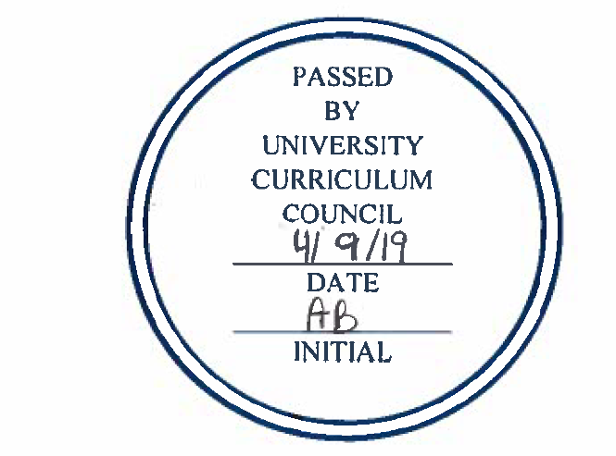
INDIVIDUAL COURSE COMMITTEE
COURSES APPROVED
UNIVERSITY CURRICULUM COUNCIL
April 9, 2019

Course Changes:

EDEC 4200 | Course Change: EDEC 4200 | Philosophy and Theories of Child Development and Education | Update course description, OG, Fill-in topics section
RHT 2420 | Course Change: RHT 4420 / RHT 5420 to RHT 2420 | Accounting Principles for Hospitality Operations
RHT 4920 | Course Change: RHT 4920 | Hospitality Practicum
CHEM 1205 | Course Change: CHEM 1205 | Survey of Chemistry for Health Sciences | Change requisites
CHEM 1205L | Course Change: CHEM 1205L | Survey of Chemistry for Health Sciences Laboratory | Change requisites
CHEM 4810 | Course Change: CHEM 4810 / CHEM 5810 | Medicinal Chemistry and Drug Discovery | Make T3 Equivalent, Update requisites
COMS 1010 | Course Change: COMS 1010 | Fundamentals of Human Communication | OG updated, Topics Section filled in
COMS 1030 | Course Change: COMS 1030 | Fundamentals of Public Speaking | OG updated, Topics Section filled in
EDEL 4370 | Course Change: EDEL 4370 to EDEL 4370 / EDEL 5370 | Teaching Mathematics to Fourth and Fifth Graders | Course Refresh: Short name, Description, OG, Topics Section; Also make Dual List
EXPH 2290 | Course Change: EXPH 2290 | Exercise Testing and Prescription | Course Description updated, OG updated, Topics Section filled in
EXPH 2295 | Course Change: EXPH 2295 | Exercise Testing and Prescription Lab | Minor update to Course Description, OG updated, Textbook info added
EXPH 2900 | Course Change: EXPH 2900 | Special Topics in Exercise Physiology | Course Description updated, OG updated, Topics Section filled in
EXPH 4620 | Course Change: EXPH 4620 | Pediatric Exercise Physiology | OG updated, Topics Section updated
IHS 4400 | Course Change: IHS 5400 to IHS 4400 / IHS 5400 | Veterans Health: United States Military Culture and History | Add undergrad Dual List, Update OG
LING 4750 | Course Change: LING 4750 / LING 5750 | Language Learning | Update OG, Change requisites in grad course, Expand Dual List differences, Update Topics section
LJC 6965 | Course Change: LJC 6965 | Legal Practice Workshop | Change to variable credit
MGT 4910 | Course Change: MGT 4910 | Internship | Update OG
NUTR 3000 | Course Change: NUTR 3000 / NUTR 5080 | Nutrient Metabolism | OG updated, Topics section updated
PBIO 4941 | Course Change: PBIO 4941 | Undergraduate Research/Written Presentation | Make T3 Equivalent, Update OG, Course Decription, Topic Section filled in,
REC 4850 | Course Change: REC 4850 | Concepts & Issues in Adventure Programming | Coure Refresh: Course description, OG, Topics, Requisites, All Updated
SASM 3760 | Course Change: SASM 3760 | Sport Facility and Event Management | Update OG, Course Description, Topics; Changed requisite
VICO 3394 | Course Change: VICO 5394 to VICO 3394 / VICO 5394 | Small Systems Lighting for Communication Photography | Add undergrad Dual List, Update OG

New Courses:

ART 1800 | New Course: ART 1800 | Art + Design Pre-College
ART 3960 | New Course: ART 3960 | Student Design Agency: OU Design Collaborative in the Community
ART 5130 | New Course: ART 5130 | Art Worlds: Intersections & Modalities
BUSL 2600 | New Course: BUSL 2600 | Business Regulation and Compliance
FILM 1800 | New Course: FILM 1800 | Film Experience
IHS 2820 | New Course: IHS 2820 | Interprofessional Healthcare Through Creative Arts
IHS 6280 | New Course: IHS 6280 | Integrated Health Studies Capstone
SASM 4020 |  | Advanced Sport Facility Management
SASM 4915 |  | Sports Management Expedition
THAR 1394 | New Course: THAR 1394 | Fundamentals of Lighting and Sound Design Principles and Stage Management
THAR 1800 | New Course: THAR 1800 | Theater Experience
THAR 5372 |  | Sound and Lighting Shop Management
THAR 5410 |  | Introduction to Theater Management
ACCT 3200 |  | Forensic Accounting
CHEM 4610 |  | Nuclear Magnetic Resonance Spectroscopy Training
DANC 5210 | New Course: DANC 5210 | Graduate Modern Dance Technique
MGT 5024 | New Course: MGT 5024 | Purchasing and Supply Management
MUS 1800 | New Course: MUS 1800 | Music Experience
SASM 4010 |  | Advanced Sport Event Management
ART 5125 | New Course: ART 5125 | Working with Artists & Publics
COED 6240 | New Course: COED 6240 | Social Dynamics in Sports Coaching
DANC 1800 | New Course: DANC 1800 | Summer Dance Experience
ES 4730 | New Course: ES 4730 / ES 5730 | Environmental Entrepreneurship
MUS 3751 | New Course: MUS 3751 / MUS 5751 | Italian for Singers
EDSP 2300 | New Course: EDSP 2300 | Teaching Mathematics for Diverse Learners

Course Deactivation
COED 5210 | Course Deactivation: COED 5210 | The Olympic Movement
MKT 4880 | Course Deactivation: MKT 4880 | Global Sales

Expedited (For Information Only)
MKT 3580 | Foundations of Professional Sales
MKT 4040 | Logistics and Supply Chain Management
MKT 4780 | Sales Strategy & Technology
MKT 2400 | Introduction to Marketing Management
MKT 2900 | Special Topics in Marketing
MKT 3020 | Consumer Marketing
MKT 3919 | Internship
MKT 4200 | Services Marketing
MKT 4250 | Business to Business Marketing
MKT 4440 | Consumer Behavior
MKT 4500 | Management of Promotion
MKT 4550 | Achieving Customer Satisfaction and Service Excellence
MKT 4300 | Digital Marketing and Sales Strategies
MKT 4580 | Sales Management
MKT 4410 | International Marketing
MKT 4680 | Consultative Sales
MKT 4910 | Sales Internship
MKT 4919 | Marketing Internship
MKT 6900 | Special Topics in Marketing
MKT 4930 | Independent Study
MKT 4940 | Independent Research
MKT 6910 | Internship
MKT 6930 | Independent Study
MKT 6940 | Independent Research
MKT 4900/5900 | Special Topics in Marketing
MKT 4630 | Marketing Strategy
MKT 3790 | Marketing Research
SASM 4000 | Diversity and Inclusion in Sport
MKT 2020 | Marketing Principles

