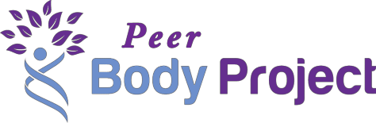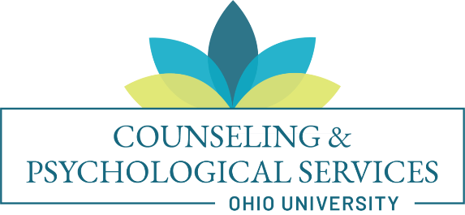

Leadership Opportunity
Gain valuable experience while helping young female identified students with body image concerns discuss the benefits of a healthier perspective

Who we are:
Ohio University Counseling and Psychological Services are working with a group of researchers located in Oregon and Texas who are collaborating with Body Project trainers located around the United States. They have been researching and improving the Body Project for about 15 years, and we are very excited to offer this opportunity for Ohio University to receive free training to conduct these groups.

About the Peer Body Project:
This study (called the Peer Body Project) is taking place at 60 colleges and universities around the country. We will be training faculty/staff Supervisors and student Peer Educators to lead small groups of undergraduate students in a program called the Body Project. The Body Project is a group-based prevention program designed to help young female identified students feel better about their bodies and prevent eating disorders.

What the Body Project is like:
As a Peer Educator, you will recruit and lead small groups of 6-8 female identified students in discussions designed to help everyone develop healthier views about societal beauty ideals. You will talk about how we unintentionally feed into the myths that give rise to body image concerns and unhealthy eating habits, even when many of these beliefs are unhealthy and unattainable. Body Project groups are designed to be fun and interactive, with role-play activities and opportunities for group members to engage with the material and form meaningful connections with each other.

Many people find the themes discussed during Body Project groups to be very personally relevant and eye opening. By leading these groups, you will learn more about how our society perpetuates these unhealthy beauty ideals and how we as individuals can act as role models for change.

How you can get involved:
We are currently looking for students interested in receiving our free 1.5-day virtual training and working in small teams to lead these body image groups! Talk to the faculty/staff member who gave you this information to learn more about participating or contact Kate Hibbard-Gibbons, PhD (740-593-1616, OUBodyProject@ohio.edu) for an application (Due Sept 4). Fall Semester training will be October 3 and 4, 2020.

Thank you for your interest in the Peer Body Project! We are very excited to be able to offer this opportunity. We hope you will consider helping us promote body acceptance at Ohio University!

Feel free to reach out to Kate, OU’s Peer Body Project coordinator, at OUBodyProject@ohio.edu with any questions and to express your interest.

