Survey Competition Rules
Updated February 21, 2018

Overview
A total of five surveying competition events have been designed for college level engineering students who are studying surveying methods and analysis of error. Licensed, practicing surveyors have developed the events such that student survey teams will not necessarily have an advantage if they have more superior equipment than another team. The events have been developed so that teams can achieve the desired results with a minimal amount of surveying equipment and supplies. The survey events will include:
- Instrument Set-up
- Profile Leveling
- Differential Leveling
- Traverse
- Resection
Each of the events will be performed at the Lake Snowden venue on Friday, April 13th, in the immediate vicinity of the concrete canoe competition.

Permitted Equipment
The following equipment will be permitted at the surveying competition: total stations, prisms, automatic levels, leveling rods, turning points, tapes, rules, and calculators with trigonometry functions. Teams should note that the competition events can be successfully completed with other types of levels, theodolites, and taping techniques. Drawing supplies such as pencils, engineer scales, protractors, timley templates are also permitted.
The following equipment will not be permitted at the surveying competition: data collectors, GPS, computers (laptops, tablets, phone, or otherwise), programmable calculators, robotic total stations, and digital levels.

Rules
Registration forms for each of the five events are enclosed below, and for each event the school name and crew member names should be completed. Each team is required to bring a printed version of registration forms to the event and submit it to OVSC survey staff at the morning survey meeting at 8:00 am the day of the event at the Lake Snowden stage area. Each school shall send two representatives to the morning survey meeting along with their completed registration materials. After registration these forms will serve as your field notes for each event and will be submitted by your crew immediately upon the completion of each event to the Post Judge at the stage area.

Each school will be limited to one team per school, and schools will determine their own crews for each event. A maximum of three persons to a crew are permitted, and individual teams will decide who will participate in which events. Each event is scheduled for one hour, and they will begin promptly at 8:30 am. At the end of each hour, teams will be directed to end their event, submit their survey results on their form to the Post Judge at the stage area, and then move onto the next event immediately.

Coaching by instructors or others once the surveying event begins is an unfair advantage. Once on the site students are on their own. Safety equipment used and required will be left up to each school.

Scoring
Scoring is provided on each event form below. Results for each individual event will be provided, but the team with the highest overall number of points at the end of the competition will be the overall winner of the surveying competition.

Questions
Teams may submit questions to ovsc@ohio.edu no later than March 31, 2018. Please include “OVSC 2018 Surveying Competition Question” in the subject heading. All questions and answers will be provided to all of the teams participating in the competition.

Acknowledgements
These rules and procedures are based on previous OVSC and other environmental competitions, modified as appropriate for the specifics of this year’s challenge.

Survey Area
The approximate area shown below in red at Lake Snowden will be utilized for the survey events. Judges reserve the right to modify the area between now and the day of the event to accommodate any changing conditions or OVSC coordination needs.

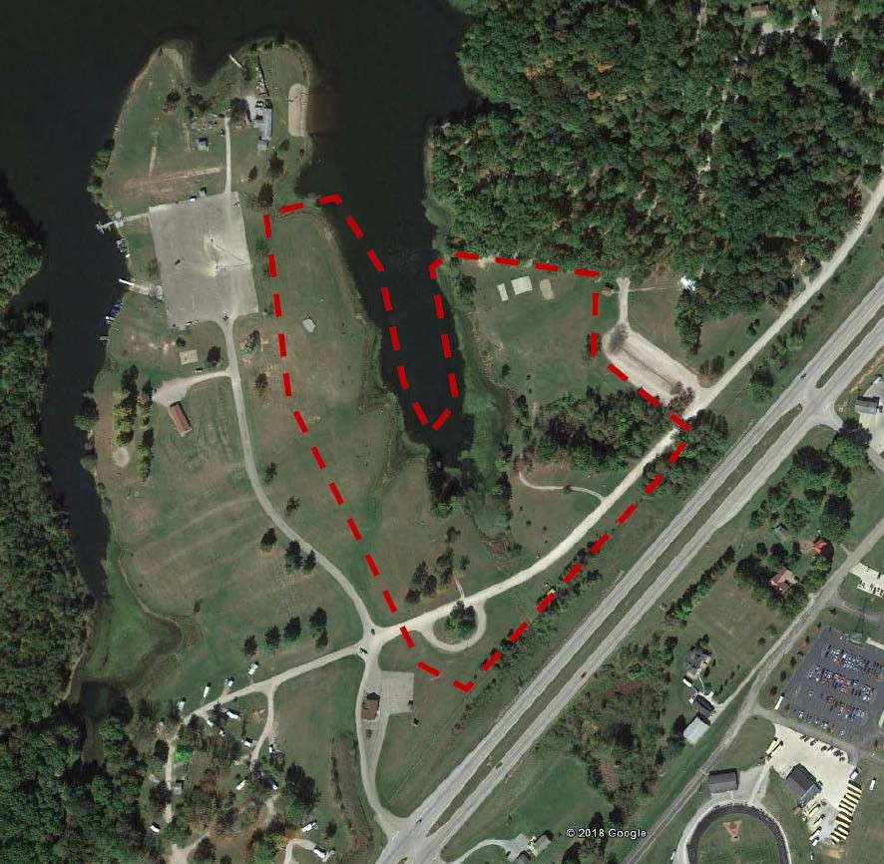

INSTRUMENT SET-UP EVENT (Timed)
Objective: To set-up a total prism or theodolite over a point and meeting the plummet and leveling requirements in a minimum amount of time. All members of the schools are encouraged to participate. An average of the crew times will be used for final scoring.
Route Site: location of the Set-up Site can be found by referring to the aerial photo provided on the day of the event.
Crew Size: Instrument Set-Up Crews will consist of a maximum of three members.
Survey Instruments: Total Station with prisms preferred or Theodolite with plummet.
Maximum Time: (1) Hour Scheduled. Participants’ elapsed times will be recorded by judge.
Scoring: At the initial of start by the judge the participant will be clocked and a time recorded by judge after completion.
Judge will check instrument for plumbness over point and levelness of instrument. If the set-up of the instrument does not meet the judging requirement, the clock will restart and the participant may continue. Judges will subtract time from 200 to compute your score. A Team Score will be an average of the participants’ scores.

Submit Set-up time results to Post Judge at the Stage Area.

College School Name:
Dept. E-Mail

College Faculty Member:
Faculty E-Mail

Crew Member 1 E-Mail Time

Crew Member 2 E-Mail Time

Crew Member 3 E-Mail Time

Final Averaged Time from those above:

Final Averaged Score:

PROFILE LEVELING EVENT
Objective: Beginning at a known benchmark #1 (USGS MONUMENT), with a given elevation of 757.20 feet, follow the Profile Leveling Survey as marked along a strip 10’ from EP. Along the strip (4) stations will be marked. Using the notes below enter the stations and elevation values of those designated stations recording your measured elevations. A total of (4) elevations will be evaluated. Use the field notes form below and circle on your notes and label those (4) results to help those evaluating. When submitting a time is recorded.
Leveling Site: location of the Profile Sites (2) can be found by referring to an aerial photo posted on the day of the event.
Crew Size: Profile Leveling Crews will consist of a maximum of three members.
Survey Instruments: Automatic Level, Level Rod, Stable Turning Points or Devices, and Rule.
Maximum Time: (1) Hour Limit; Beginning times and submission times are of record and will be used to help evaluate teams that might tie.
Scoring: Elevation values will be scored according to how many one-hundredths your results vary from the correct elevations. Prefect Score equals 200 points
Submit Profile Leveling Field Notes below to the Post Judge at the Stage Area.

College Name:

Crew Member Crew Member
Crew Member

Start Time: site judge recorded Submission Time: submission judge recorded

PROFILE LEVELING FIELD NOTES for SITE

STATION | BS (+) | HI | FS (-) | SS | ELEVATION
BM #1 (USGS) |  |  |  |  | 757.20

DIFFERENTIAL LEVELING EVENT
Objective: Beginning at a known benchmark #1, (USGS Monument) with a given elevation of 757.20 feet, complete a leveling circuit (loop) to a point #4 (Monument) where an elevation needs to be determined and recorded. Along the way other points, point #3 and point #4 (Low water marks) will need to have their elevations determined and recorded. Use the field notes form below and submit to the post judge at the stage area where a time will be recorded. Circle and label your (4) results on the Field Leveling Notes to help the evaluators.
Leveling Sites: location of the (1) Leveling Site can be found by referring to the aerial.
Crew Size: Crews will consist of a maximum of three members.
Survey Instruments: Automatic Level, Level Rod, Stable Turning Point Devices
Maximum Time: (1) Hour Limit; Beginning times and submission times are of record and will be used to help evaluate teams that might tie.
Scoring: Elevation values will be scored according to how many one-hundredths your results vary from the correct elevations. A perfect score equals 200 points.
Submit Differential Field Notes below to the Post Judge at the Stage Area.

College:

Crew Member Crew Member Crew Member

Start Time: sites judge recorded Submission Time: Submission judge recorded

LEVELING FIELD NOTES for SITE

POINT # | BS (+) | HI | BS (-) | ELEVATION | DESCRIPTION
 |  |  |  | 757.20’ | USGS BM

TRAVERSE EVENT
Objective: To measure 4 angles and 4 distances around a closed polygon course course by occupying the (4) points provided on the ground.
Traverse Site: location of the Traverse Sites can be found by referring to the aerial the morning of the event. You will be measuring 1 of 3 traverse sites: the BRANNER SURVEYING SITE, the BUCKLEY GROUP SURVEYING SITE, or the CANTER SURVEYING SITE.
Crew Size: Crews will consist of a maximum of three members.
Survey Instruments: Total Station with prisms preferred or Theodolite and Taping Tools.
Maximum Time: (1) Hour Limit; Beginning times and submission times are of record and will be used to help evaluate teams that might tie.
Scoring: Angle values will be scored according to how many seconds your results vary from the correct values. Distance values will be scored, and a point deducted for each .01’ of error. Perfect score equals 200 points.
Submit Traverse Field Notes below to the Post Judge at the Stage Area.

College:

Crew Member Crew Member
Crew Member

Start Time: site judge recorded Submission Time: submission judge recorded

You will be assigned to one of the three traverse sites on the day of the event:
“BRANNER SURVEYING” “THE BUCKLEY GROUP” “CANTER SURVEYING” TRAVERSE NOTES for TRAVERSE
Backsight No. | Occupation No. | Foresight No. | Interior Angle | Horiz. Distance | FS Description
4 | 1 | 2
1 | 2 | 3
2 | 3 | 4
3 | 4 | 1

Scope:
RESECTION EVENT

Resection Site: location of the Resection Sites (2) can be found by referring to the aerial.
Crew Size: Crews will consist of a maximum of three members.
Survey Instruments: Total Station with prisms preferred or Theodolite and Taping Tools.
Maximum Time: (1) Hour Limit; Beginning times and submission times are of record and will be used to help evaluate teams that might tie.
Scoring: Each correct northing and easting value will have a total value of 50 points for a total of 200 points. Error of .01’ is subtracted.
Objective: To perform a 2-point resection calculating northing and easting coordinates for the point of occupation. From there turn to a designated point calculating a new set of northing and easting coordinates for said point and recording. Teams will set-up on a designated point #3 with unknown northing and easting coordinates, sight point #1 and Point #2 having their known northing and easting coordinates, and then apply and calculate northing and easting coordinates for the point of occupation
#3. Record your results on the Resection Notes Form. Next, teams will turn an angle and distance to the 2nd designated point #4 and again calculate a set of northing and easting coordinates, recording these on the Resection Submission Form.
Submit Differential Field Notes below to the Post Judge at the Stage Area.

College:

Crew Member Crew Member
Crew Member

Start Time: site judge recorded Submission Time: submission judge recorded

Option: Site “A” or Site “B”
Nothing and Easting Coordinates will be handed-out on the day of the event at the sites.

Resection Coordinates for SITE “A”

Point Number | Northing | Easting | Description
#1 |  |  | IPF
#2 |  |  | IPF
#3 OCCUPATION |  |  | Monument
#4 |  |  | IPF

Resection Coordinates for SITE “B”

Point Number | Northing | Easting | Description
#5 ON DAM |  |  | IPF
#6 ON DAM |  |  | IPF
#3B OCCUPATION |  |  | Monument
#4 |  |  | IPF

SURVEYING EVENT SCHEDULE
Each Event is Scheduled for ONE HOUR

UNIVERSITY | INSTRUMENT | PROFILE | DIFFERENTIAL | TRAVERSE | RESECTION
Akron University | 1st Event | 2nd Event | 3rd Event | 4th Event | 5th Event
Cincinnati State Community College | 1st Event | 2nd Event | 3rd Event | 4th Event | 5th Event
Cleveland State | 2nd Event | 3rd Event | 4th Event | 5th Event | 1st Event
Ohio State University | 2nd Event | 3rd Event | 4th Event | 5th Event | 1st Event
Ohio University | 3rd Event | 4th Event | 5th Event | 1st Event | 2nd Event
University of Cincinnati | 3rd Event | 4th Event | 5th Event | 1st Event | 2nd Event
University of Dayton | 4th Event | 5th Event | 1st Event | 2nd Event | 3rd Event
University of Kentucky | 4th Event | 5th Event | 1st Event | 2nd Event | 3rd Event
University of Louisville | 5th Event | 1st Event | 2nd Event | 3rd Event | 4th Event
University of Pittsburgh | 5th Event | 1st Event | 2nd Event | 3rd Event | 4th Event
Western Kentucky University
Youngtown State University
There are 2 schools left intentionally blank. If any of the schools do not show, transfer their numbers to the (2) schools missing their schedule. If all schools show, then repeat row 1 and row 3.

SURVEYING COMPETITION SCORES

UNIVERSITY | INSTRUMENT | PROFILE | DIFFERENTIAL | TRAVERSE | RESECTION | TOTAL  & PLACE
Akron University
Cincinnati State College
Cleveland State
Ohio State University
Ohio University
University of Cincinnati
University of Dayton
University of Kentucky
University of Louisville
University of Pittsburgh
Western Kentucky University
Youngtown State University

