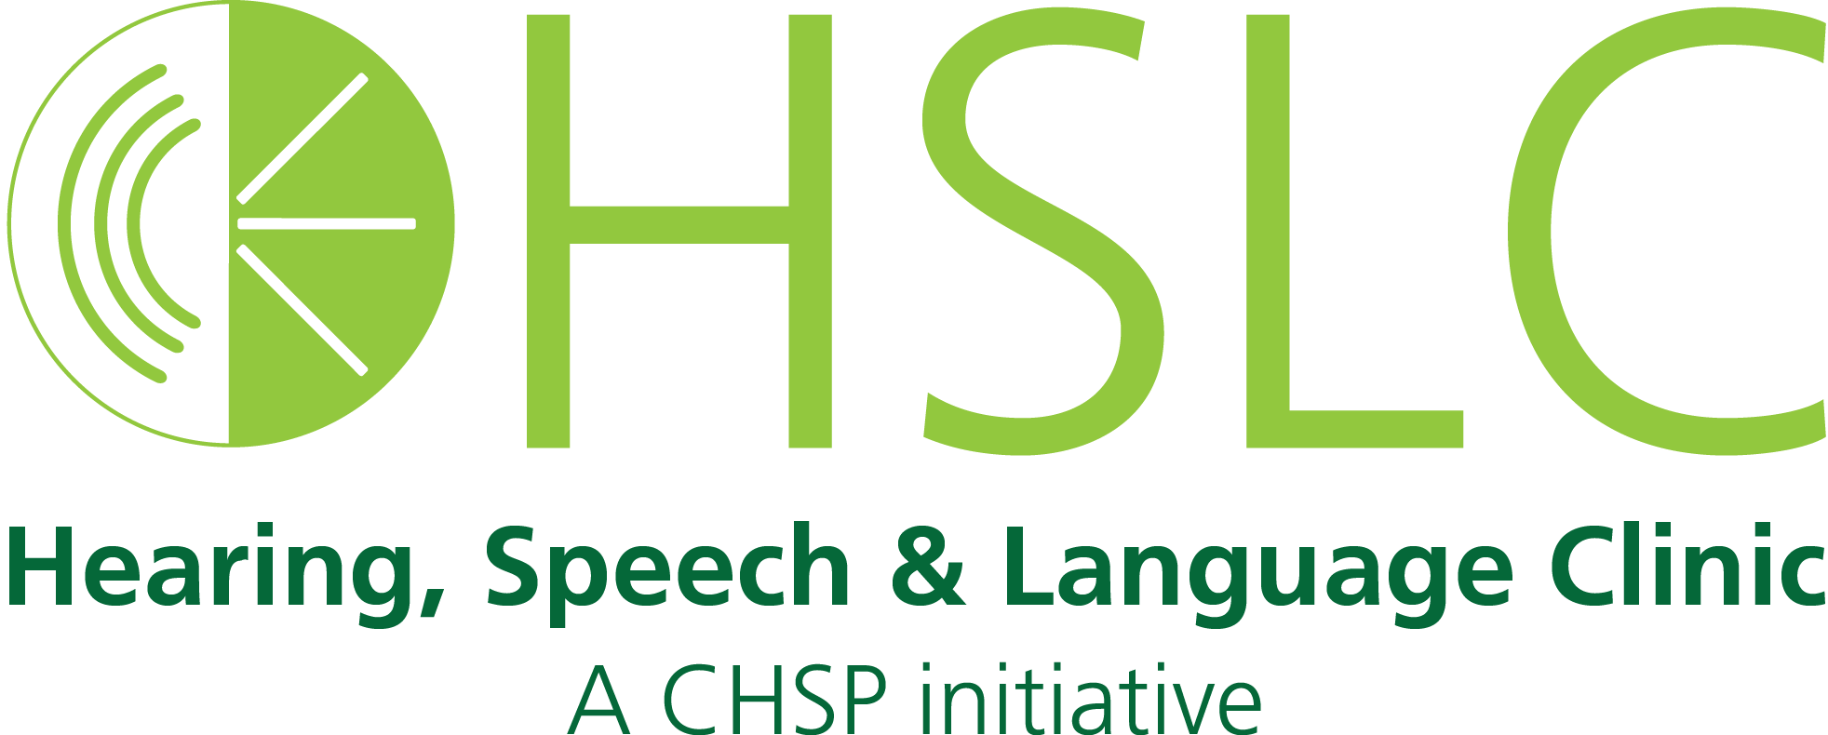

2017 brought many changes and exciting opportunities for students and faculty in the Ohio University Hearing, Speech and Language Clinic. Graduate speech-language pathology and audiology students joined together to provide healthcare services for not only our community but also an underserved community in the heart of Africa! These opportunities provided meaningful experiences for our clinicians as well as needed services and education for communities.

**Some of our 2017 highlights include:**

* Free speech and hearing screenings reached approximately ***264*** individuals on campus.
* Free speech and hearing screenings in local schools served over ***330*** students in Southeast Ohio.
* Botswana, Africa, Rehabilitation Service Experience: ***9*** CSD graduate students participated in an educational experience that provided healthcare services to Batswana in the community resulting in the assessment and treatment of over ***180*** patients.

* ***4,043*** individualsreceived various hearing, speech and language services offered through the clinic**. *55%*** of those individuals are Medicaid eligible recipients who would otherwise not have access to needed services within the community.
* Established as a diverse regional resource for transgender individuals seeking therapy in voice and interpersonal communication. Provided services for ***8*** individuals throughout the year.

2017 Points of Pride­

­­

**Stay connected and up-to-date on events by going to**

**our clinic’s webpage at:**

ohio.edu/chsp/hsl

740.593.1404

Grover Center W174

Athens, OH 45701