Title: Tropical Biodiversity and Environmental Issues in Panama
Description: Tropical Biodiversity and Environmental Issues in Panama in Plant Biology at Ohio University
Tropical Biodiversity and Environmental Issues" in Panama (H2)
Nov. 28 – Dec. 13, 2008
An Incoming Freshman Program in Bocas del Toro region, Panama

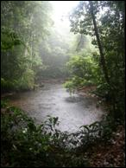
The Program
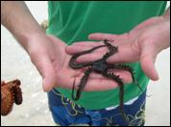
We have created a unique broadly defined environmental issues program focused on tropical ecosystems for you, as an incoming freshman to Ohio University. The program examines the natural biological diversity of marine and terrestrial ecosystems in coastal and montane Panama, the human cultures and their interactions with the natural environments there, and highlights environmental issues and conservation concerns affecting both people and biological diversity. Once you are accepted, we will enroll you in the fall quarter 2-credit student-led seminar (PBIO 284, Thursdays, 3-5 p.m.), which covers a broad range of topics concerning tropical biological systems, human cultures and environmental impacts; and the University College course (UC 190, Mondays, 3-5 p.m.), which covers all travel-related aspects of the program. Many of you will live in a Residential Learning Community developed around this program for the fall quarter, with other freshmen of diverse backgrounds and academic interests but all participating in this program and the two fall quarter courses (among others). The program culminates in an immersion field course in scenic Panama, beginning on Friday of Thanksgiving weekend. We will travel as a group from Columbus to Panama and spend the next two weeks gaining firsthand experience with the principles we have learned about Panamanian and Central American biodiversity, human cultures and environmental issues. We will arrive in Panama City then fly to a field station on an island near the town of Bocas del Toro to study the lowland forests and marine systems, and town life and tourism in the Bay region. We will end the field course with a three-day central mountain excursion on our return to Panama City and next-day departure to Ohio. The field course takes place during Winter Intersession, Friday, Nov. 28, to Saturday, Dec. 13, 2008.

Eligibility
Incoming freshmen of all backgrounds and academic interests are welcome to participate. The program is designed as a first-year study abroad experience to learn about tropical ecosystems and human-environment interactions.
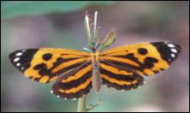
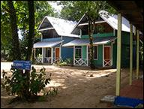
Living Arrangements
In Panama City we will stay at the very nice Hotel Acapulco, in a safe, quiet neighborhood with restaurants and cafes. In Bocas del Toro we will stay at the modern, well equipped Institute for Tropical Ecology and Conservation field station. We will stay in various small dormitory and double room accommodations at the station. During the three-day excursion we will live in double rooms in modest hotels in mountain villages in central Panama.
Costs of the Field Course
Billed by Ohio University
- Tuition—4 undergrad credits of OU Winter Intersession tuition; for cost of tuition see website at http://www.ohio.edu/finance/bursar/athenstuition.cfm [NOTE: credits DO NOT count toward your 20 Winter quarter credit hours, and are billed separately from your Winter quarter tuition]
- Estimated Program Fee--$1,500
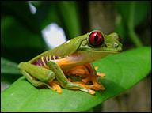
- EA Administrative Fee--$150
Out-of-Pocket Expenses
- Passport (if you don’t have one)--$205
- Vaccinations--$350
- Snorkeling Gear Rental (if you don't own gear)--$65
- Panama City & mountain excursion meals, incidentals--$250
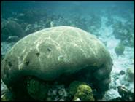
TOTAL STUDENT COST = $2,250 + OU tuition (4 credits)
Program fee includes all airfares, ground transport around Panama, special group meals, lodging at the Panama City and mountain village hotels, and room and board at the ITEC field station.Costs billed by OU for the field course (noted above) are separate from the Winter Quarter billing.
Faculty
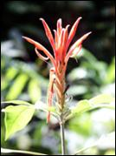
Dr. Harvey Ballard and Dr. Morgan Vis
Drs. Vis and Ballard have collectively developed and led 11 international biology-related programs to New Zealand, Hawaii and several countries in the Caribbean, mainland Latin America and Europe.

