Title: Neotropical Rainforest Ecology in French Guiana
Description: Seminar and field course on Neotropical Rainforest Ecology in French Guiana in Plant Biology at Ohio University
Neotropical Rainforest Ecology in Northern French Guiana (H2)
Aug, 8-12, 2002
Seminar: Neotropical Rainforest Ecology (H3)
PBIO 405 (#04510), PBIO 693 (#04522)
Spring 2002
Professors: Dr. Harvey Ballard, Dr. Morgan Vis
Textbook: Kricher, J. 1999. A Neotropical Companion. Princeton University Press, Princeton, NJ (ISBN 0691044333); $19.95 from Barnes & Noble, $17.59 from Amazon.com; required
Field Course: Neotropical Rainforest Ecology in French Guiana (H3)
PBIO 369, PBIO 693
Aug, 8-12, 2002
French Guiana is one of the smallest countries in Latin America and is perhaps the least likely to be visited by North Americans. It harbors some of the best remaining tracts of tropical rainforest in the South America outside the Amazon basin itself, prompting Dr. Scott Mori, botanist at the New York Botanical Garden and a key author in the developing flora project for French Guiana, to describe the pristine rainforest there as an underappreciated jewel. However, it is not a standard tourist destination for amateur naturalists, ecotourists or professional biologists, probably owing largely to the circuitous airplane connections from North America or Mesoamerica requiring "hop-scotching" through several French Caribbean islands to get there.
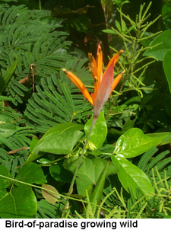
The field course will focus on the various communities that make up the broadly defined lowland rainforest comprising the easily accessible northern quarter of French Guiana. We will focus our attention on three different geographic areas in the country, devoting approximately one week to each: the region near Cayenne, the country's capital and the largest metropolitan area, in the northeastern portion; the northwestern corner around and to the south of St. Laurent du Maroni, an old port town sitting along the river which forms the international boundary with Suriname; and the central region of the country, near the coast in rich white-sand savannas and lowland gallery forests, eastward to Kourou, the modern city harboring the French aerospace program.
The Guianese people are friendly, but very few speak English (or at least admit to doing so); virtually no one speaks much of any language other than French, so don't expect to utilize Spanish or Portuguese. During our travels, we will use French constantly--which we will have learned during the language workshops in the Spring quarter. The field course will truly exemplify a "Study Abroad" experience, with a new language, new customs and cultural traditions, new foods and a new environment for all of us.
The Field Course
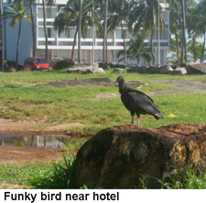
Purpose of the Course: To teach students about the vegetational ecology, flora, evolutionary processes and adaptations of plants in the broadly defined "Neotropical rainforest" biome, exploring aspects covered in the Spring quarter introductory seminar. Field studies will cover both terrestrial and aquatic systems. Stress will be placed on identification of common genera and families of flowering plants and algae, observations of vegetation structure, characteristic life forms and recurrent adaptations, and climatic and ecological influences maintaining aquatic systems and terrestrial vegetation.
Format: This intensive field course spans the last three weeks (9-31 August, 2002) of the Summer II Session, ending (in Columbus) a couple of days before classes begin again. We will fly from Columbus to Cayenne, French Guiana with brief airflight stops in Haiti, Guadeloupe and Martinique en route [there is not direct flight!] and will travel throughout the northern quarter of French Guiana by car, studying ecologically and floristically diverse communities that comprise the broad "rainforest" ecosystem. The course will utilize three cities and one inland ecolodge as "base camps" for several days to a week, spending one week in each of the northeastern, northwestern and central areas of the country's northern reaches, where the bulk of the country's residents live. We will make day trips into nearby natural areas--including nature reserves and other protected sites. We will start our journey in the lowland forests near the mouth of the Approuague River south and east of Cayenne, and will end our field course on the beautiful coast at Kourou, where we will hold a part-day study of coastal marine ecology.
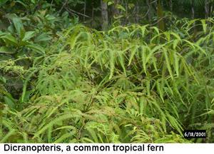
At each city, we will take some of the remainder of the first day following our drive to the site, to do an orientation hike through town to acquaint students with the location of markets and restaurants, post offices, medical facilities, and cultural and recreational opportunities for spare time pursuits. We will stay in safe and conveniently located local hotels (identified in a previous reconnaissance visit as the most suitable for the our group), in comfortable double rooms, eat breakfast at the hotel (where available) or at nearby restaurants, buy market foods for "sack" lunches on the road, and take supper in the local restaurants in the evening, following our review/discussion session. Our ground transportation to daily study sites and between base camps will consist of rental cars; our within-study site and within-village transportation will be our own feet.
A Typical Day: Day trips will depart at 8:00am immediately following breakfast, with short drives to nearby natural areas for the day's field studies (except where the lodgings are near a natural area), and then intensive in-the-field studies of the local stream or terrestrial biota (which may necessitate a mile or a few miles of intermittent hiking to reach different areas), stopping in the middle of the day to eat our "sack" lunch. We will return to our lodgings usually around 4:00-5:00pm and, immediately following a brief break to clean up and grab an in-room snack, we will conduct our 1-2 hour review/discussion session. We will review and share observations and events, and will pass around the algae and plants encountered, using Dr. Vis's field microscope and our hand lenses, and our identification manuals to review identifying features. At the end of the review session, we will press plants or prepare algal samples for voucher preservation, and preserve tissue samples of algae and/or violets for future genetic analysis. After the day's review/discussion session is over, we will disperse for supper at local restaurants (most restaurants don't open until 7-8pm anyway--the Guianese eat late!). Students will be encouraged to use evening time beyond meals to record significant field observations and personal reflections in their daily journal, and to purchase food for the next day's lunch "on the road".
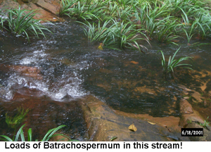
Field Activities: At each study area students (if there are more than, say, 7-8) will be broken into an aquatic ("Stream") Team to study and sample local stream reaches, and a terrestrial ("Scream") Team to study and sample terrestrial sites. The Stream Team will take water chemistry measurements of important water quality indicators for suitable freshwater streams, evaluate the local biotic and human influences determining the ecology of the stream and its algae, and study the genera of freshwater algae in the region. Where red algae of the Batrachospermum group are encountered, the team will do quadrat-based population sampling for future laboratory genetic investigations. The "Scream" Team will make observations on community structure and life forms of vegetation present, discuss evolutionary adaptations to the local environment, study characteristic woody and herbaceous genera and important Neotropical families, and conduct vegetation sampling of families and genera using point-quarter transect vegetation characterization methods. Where members of the Violaceae (violet family) are encountered, the team will also take light availability measures, sample soils, describe the habitat, record associated genera near the violets, and do population sampling for future genetic studies. Global positioning systems (GPS units) will be used to obtain latitude, longitude and elevation for all collection sites.
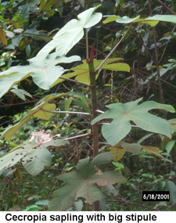
Course Demands: The field course is designed as an intensive immersion experience, and demands stamina, endurance, social skills and patience. We will study the algal and terrestrial plant life of the region for 12 or more hours per day and approximately 6 days per week, for 3 weeks. If you simply want a vacation, you will be very disappointed--don't bother to register for this course. But, if you want an intensive "Study Abroad" experience where you are a "foreigner", studying the terrestrial and aquatic life of a rich Neotropical area rarely visited by biologists, in a rigorous and hardcore group environment, this course is for you--to paraphrase someone else's motto, "it's the hardest course you'll ever love"! Eating well and properly, getting plenty of sleep, and generally taking good care of ourselves is essential, both for the benefit of the individuals and for the group as a whole.
Days Off: We will have a day off each week, generally on a week day because much is closed during weekends. Fun activities for you to consider in French Guiana--in addition to, say, sleeping or reading--might include swimming or sun-bathing on Cayenne's or Kourou's nice ocean shores, a boat trip to Devil's Island from Kourou and lunch at the former penal colony restaurant [not bread and water any longer], a pontoon boat ride down the Kaw River to the ocean to see riverine wildlife and wetland tropical forest "from the inside", or a visit to the French space center in Kourou.
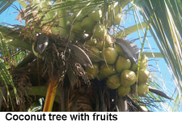
Travel Issues: We all must approach the travel experience with an open mind and a willingness to assimilate as much as possible into the local culture while we are in French Guiana. We should dress and act appropriately for the region--not for a "casual" day at the beach in northern Ohio (unless you're on your day off, going to the beach near the coast), or for a weekend vacation. Both the instructors and the students will represent Ohio University to the people of French Guiana, and we are called upon to behave in ways appropriate to "ambassadors" from another country. Piercing jewelry and very scanty clothing (including halter tops) are discouraged and may invoke considerable attention of the undesired kind (think "assimilation", not "humiliation"). As with Parisian peoples, or those of French-speaking territories, one's clothing conveys one's personal pride and status. The Guianese dress well and fashionably for city life (even for an ecuatorial tropical region!). In addition, sandals and short pants are fine for days off or for evening wear after we return from field work, but these will be entirely unsuitable and even downright unsafe for field attire. Protection from the intense sun, from mosquitoes (which could conceivably carry malaria), against snakes of various kinds and thorny plants or rash-inducing plants, is important to consider when packing for the trip.
The national language is French, and although a VERY few people in the cities speak some English, you are not likely to get by in most situations with English alone. We will get alot of use out of our conversational French. If you know some French, make sure to review your speaking skills and vocabulary before the field course. We will have two fluent French speakers, Dr. Vis and eminent fish biologist Wayne Chiasson (who is also Dr. Vis's husband); but if you have fluency with French yourself, please share your skills with the rest of the group.
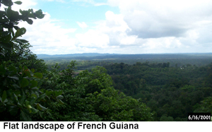
Main meals such as lunches or suppers are, at least in Cayenne and certain portions of other cities, commonly French cosmopolitan fare which you might expect to see on the streets of Paris (crepes are fun and commonly encountered), but seafood is common and reasonably inexpensive so near the coast; Caribbean, Indonesian and Vietnamese cuisine is also pretty common. If you are vegan or more strictly vegetarian, you will have an extremely difficult time obtaining adequate nutrition, and you must prepare to "relax" your strict diet to include at least some poultry, seafood or dairy products in order to gain adequate nutrition.
The climate will be very warm to hot, as the southern end of French Guiana is bisected by the equator. You will be most comfortable most of the time in light clothing, but long-sleeved shirts and long-legged pants are best for field work, to keep off insects and strong sun. You will be grateful for a rain poncho, portable umbrella or rain suit during frequent late afternoon showers. Finally, one or two sweatshirts or a windbreaker would be wise to bring, in the uncommon event that evening temperatures fall a bit (after a week of very high daytime temperatures, even an evening in the high 70s with a stiff ocean breeze feels cool!).
Field Course Itinerary and Content
Date, Location/Lodging, Activity/Focus
Aug. 8, US Airways #865/895, Columbus-Miami, 2:05 p.m.-6:58 p.m.; lodging (1 night) at Quality Inn, Miami airport
Aug. 9, Air France #3747, Miami-Cayenne, 8:40 a.m.-6:45 p.m.; lodging (7 nights) at Motel Beauregard in Remire (suburb of Cayenne); first supper of traditional Guianese delicacies at Cric Crac Restaurant
Aug. 10-14, Day trips in Cayenne region; Field studies; visit to Cacao (immigrant Laotian village's farmer's market and insectarium) en route to field sites
Aug. 15, Cayenne; DAY OFF
Aug. 16-20, St. Laurent du Maroni (4 hour drive); lodging (5 nights) at Hotel La Tentiaire; day trips in region south and east of SLM; Field studies; EXAM 1: terrestrial plants
Aug. 21-22, Chutes Voltaire (5 hour drive); lodging (3 nights) at Auberge Chutes Voltaire ecolodge; day trips in areas near lodge; Field studies
Aug. 23, Chutes Voltaire area; DAY OFF
Aug. 24-28, Kourou (7 hour drive); lodging (6 nights) at Hotel Des Roches; day trips in region south and west; Field studies; EXAM 2: terrestrial plants, EXAM 3: freshwater algae and stream ecology
Aug. 29, Kourou; DAY OFF
Aug. 30, Air France #3748, Cayenne-Miami, 1:40 p.m.-10:05 p.m.; lodging (1 night) at Quality Inn, Miami airport
Details of the Course
Enrollment/Credits: 10 undergraduate and graduate students; 6 credit hours, with students pre-registered by the Education Abroad Office for Summer II Session before the end of Spring quarter.
Eligibility: Open to all undergrad natural sciences majors meeting the prerequisites, and PBIO/BIOS/MSES grad students; eligibility must be approved during the first week of Spring quarter by the instructors.
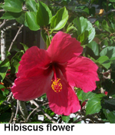
Prerequisites: PBIO 111 or its equivalent [determined by instructors], PBIO 405/693 (Neotropical Rainforest Ecology Spring quarter seminar), additional mandatory workshops concurrent with the seminar, preferably at least sophomore standing in Spring, and instructor permission through an interview; Plant Systematics (PBIO 309/509) or Plant Ecology (PBIO 425/525) are strongly recommended.
Texts and Other Resources
- Required texts--Entwisle, T. J., J. A. Sonneman, and S. H. Lewis. 1998. Freshwater algae: A guide to conspicuous genera. Royal Botanic Gardens, Melbourne, Australia (available directly from Morgan Vis, $25.00); and Gentry, A. L. 1996. A field guide to the families and genera of woody plants of Northwest South America. University of Chicago Press, Chicago, IL (Barnes & Noble, $36.00; Amazon.com, $45.00--students must order themselves)
- Hand lens [available in local university bookstores, ca. $10]
- Other resources--this web site, and other links, covering travel issues, preparation details, images of communities and characteristic plants, information on the region
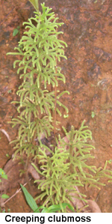
Exams and Course Products: Three field exams will be administered in French Guiana during the field course. The first one will take place during the middle of the course, covering terrestrial plant families, common genera, characteristics, evolutionary adaptations, and ecological processes and patterns; the second one will take place early in the third week, covering more terrestrial plant families and similar issues as the first; the third will be held later in the third week, covering freshwater algae and stream ecology. Students will turn in their daily journals and complete and return course evaluations during the flight back to Columbus.
Activities and Points (400 points possible)
- Three field examinations (300 points, 100 points each), completed during field course
- Participation in daily field lessons and research project, and in evening review of site observations, research data and plants identified (50 points); accomplished during field course
- Daily journal (50 points); with field observations, plant illustrations and identifying features, and personal experiences; accomplished during field course
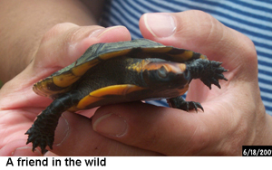
Expenses for the Field Course: Tuition, 6 undergraduate credit hours; plus domestic and travel expenses itemized below. Financial aid can be applied to field course expenses and tuition, with advance planning. The Bursar's Office will automatically send out bills for tuition and the program fee (=airfare and lodging), before the end of Spring quarter, upon pre-registration of students by the Education Abroad office. All expenses required for the trip, both domestic and travel, to be paid during the Spring quarter (and Summer, if tuition and program fee bills carry over) by students intending to participate in the field course, are the student's responsibility. NO DELAYS ARE ALLOWED FOR PAYMENT of time-sensitive components such as passports and their associated items [photographs, birth certificates, etc.], and NO REFUNDS OR CANCELLATIONS ARE PERMITTED once the airline tickets are purchased and lodging and other arrangements are made (perhaps as early as fifth week of Spring quarter).
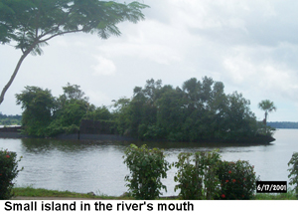
NOTE: Major financial commitments to the French Guiana field course will be required of all students--no exceptions--throughout the Spring quarter. All students intending to participate in the field course must have cash or check funds available during the first few weeks, in order to pay for the domestic expenses (passport, vaccinations and malaria pills) in the short time frame we face before summer begins. Students who are not prepared to send checks for passports during the 2nd week passport workshop [if they do not yet have a passport], purchase vaccinations in cash at Hudson Medical Center by the end of the 9th week, and be prepared to cover the tuition and program cost fee bills, cannot participate in the field course. In addition, the French Guiana field course cannot be held if fewer than 5 undergraduate students are prepared to make a full financial commitment to it in the first 5 weeks of Spring quarter.
Domestic expenses (ca. $440 worst case, plus 6 credits of tuition [$1056 for resident, $2256 for non-residents; this is not included in comprehensive fee!]):
- Passport (if you don't already have one), including photos—ca. $80
- Vaccinations & pills (Yellow Fever, typhoid, tetanus, hepatitis A, mefloquine malaria pills) —ca. $250
- Textbooks—ca. $65
- Hand lens—ca. $10
- International Student Identity Card (through Education Abroad office; required), including photo—$35
Travel expenses (ca. $2450 worst case, plus spending money):
- Program fee—ca. $1950 [includes roundtrip airfare, lodging per person in double room, Education Abroad fee]; billed by bursar automatically when student is pre-registered by Education Abroad office
- Meals and incidentals—ca. $500 [$20/day for food, $20/week for laundry, phone cards and rare Internet access]; student brings this
- Recommended spending money—$100-150
Prepared by Harvey Ballard and Morgan Vis 12 April, 2001; revised by Harvey Ballard 4 June, 2002.

