The PDPI Program at Ohio University
Programa de Desenvolvimento Profissional
para Professores de Lingua Inglesa nos EUA (PDPI)

Hosted by the Ohio Program of Intensive English (OPIE)
January 21 to March 4, 2023

Sponsored by CAPES/Fulbright & the Institute of International Education IIE

Welcome Letter from OPIE Director

Dear PDPI Grantees,

Warm Greetings from Ohio University!

We are excited that you are coming to study with us and look forward to welcoming you to Athens, Ohio – our home and a place we hope you will consider your “home away from home.”

For the six-week PPDI Program, we have designed a combination of classes and activities that we hope you will find stimulating and enriching. Please take time to review the following information and feel free to email me any questions at krzic@ohio.edu

Congratulations on being selected for the program. We look forward to meeting you soon!

Best regards (and abraços),

Gerry Krzic, PhD
Director, OPIE

1. PDPI Calendar (subject to change)
Below is the schedule of orientation, academic and professional activities for the six-week period sequence & times subject to change.

Spring Semester 2023
Monday | Tuesday | Wedn’sdy | Thursday | Friday | Saturday  (1/21) Day 1  Arrival from Dallas Am. Air | Sunday  Day 2 (1/22)  Orientation Part I. Program Introduction
Week 1  Day 3 (1/23)  Orientation Part II: Community Introduction | Day 4 (1/24)  Daily Sessions  Begin  Evening:  Conversation Hour 6-7 pm (optional)  Ohio Univ. BBall 7 pm | Day 5 (1/25)  Daily Sessions  Evening: Free  (Study, Sports, Other) | Day 6 (1/26)  Daily Sessions  AM: HS Visit  Evening: Free  (Study, Sports, Other) | Day 7 (1/27)  Daily Sessions  Evening: Free  (Study, Sports, Other) | Day 8 (1/28)  Am. Culture Trip (1):  Ohio Statehouse & Easton Town Center | Day 9 (1/29)  Free
Week 2  Day 10 (1/30)  Daily Sessions  Evening: Free  (Study, Sports, Other) | Day 11 (1/31)  Daily Sessions  Evening:  Conversation Hour(optional)  6-7 pm | Day 12 (2/1)  Daily Sessions  Evening: Free  (Study, Sports, Other) | Day 13 (2/2)  Daily Sessions  AM: IS Visit  Evening: Free  (Study, Sports, Other) | Day 14 (2/3)  Daily Sessions  Evening: Free  (Study, Sports, Other) | Day 15 (2/4)  Free Weekend 1 for Participants | Day 16 (2/5)  Free Weekend 1 for Participants
Week 3  Day 17 (2/6)  Daily Sessions  Evening: Free  (Study, Sports, Other) | Day 18 (2/7)  Daily Sessions  Evening:  Conversation Hour(optional)  6-7 pm | Day 19 (2/8)  Daily Sessions  Evening: Free  (Study, Sports, Other) | Day 20 (2/9)  Daily Sessions  AM: IS Visit  Evening: Free  (Study, Sports, Other) | Day 21 (2/10)  Am. Culture Trip (2):  Depart for Homestay in Cleveland | Day 22 (2/11)  Homestay in Cleveland | Day 23 (2/12)  Return to Athens from Homestay
Week 4  Day 24 (2/13)  Daily Sessions  Evening: Free  (Study, Sports, Other) | Day 25 (2/14)  Daily Sessions  Evening:  Conversation Hour 6-7 pm)  Ohio University Men’s BBall 7 pm (optional) | Day 26 (2/15)  Daily Sessions  AM Middle School Visit  Evening: Free  (Study, Sports, Other) | Day 27 (2/16)  Daily Sessions  AM: IS Visit  Evening: Free  (Study, Sports, Other) | Day 28 (2/17)  Daily Sessions  Afternoon: Fulbright Cultural Showcase with Honors College | Day 29 (2/18)  Am. Culture Trip (3): Building Bridges to Careers Program, Marietta (O.) | Day 30 (2/19)  Free or Am. Culture Trip (4):  Hiking in Hocking Hills State Park
Week 5  Day 31 (2/20)  Daily Sessions  Evening: Free  (Study, Sports, Other) | Day 32 (2/21)  Daily Sessions  Evening:  Conversation Hour(optional)  6-7 pm | Day 33 (2/22)  Daily Sessions  Evening: Kingdom Choir Concert | Day 34 (2/23)  Daily Sessions  AM: IS Visit  Evening: Free  (Study, Sports, Other) | Day 35 (2/24)  Attend OLAC Conference in Athens | Day 36 (2/25)  Free Weekend 2 for Participants | Day 37 (2/26)  Free Weekend 2 for Participants
Week 6  Day 38 (2/27)  Daily Sessions  Evening: (Free  Study, Sports) | Day 39 (2/28)  Daily Sessions  Evening:  Conversation Hour(optional)  6-7 pm | Day 40 (3/1)  Final Project Presentations | Day 41 (3/2)  Final Project Presentations  Graduation Banquet | Day 42 3/3)  Packing Day  & Evaluation | Day 43 (3/4)  Departure Day  Leave Athens

2. Some Highlights of the Calendar (subject to change)

a) Jan. 24 (Tues.) 7:00 PM. Ohio University Men’s Basketball Game. Watch the Ohio “Bobcats” battle the Western Michigan University “Broncos” in an NCAA basketball game.

b) Jan. 24 (Tues.) 6-7 PM. International Conversation Hour. On Tuesdays, come and chat with Ohio University students. Continues on Tuesdays throughout the program.

c) Jan. 28 (Sat.). We will travel to Columbus, Ohio to visit the Ohio Statehouse and either the Easton Shopping Mall or Tanger Outlet Mall

d) Feb. 10 (Fri.) to Feb. 12 (Sun.). Enjoy a weekend homestay with a family in Cleveland, Ohio. We will leave Athens on Friday. Grantees will meet their homestay families later that same day and return to Athens in time for dinner on Sunday. Please note: PDPI participants should take a COVID Test in Athens prior to going on the homestay.

e) Feb. 17 (Fri.) Presentations by PDPI Brazilian Participants. Prepare a mini-poster presentation with some of your Brazilian colleagues about any aspect of Brazilian culture or about your school. The audience will be Ohio University students and faculty/staff.
Bring pictures of Brazil or your school or any cultural items that you think would be interesting to share.

f) Feb. 18 (Sat.) Travel off-campus to learn about the Building Bridges to Careers Program
(BB2C). BB2C fosters school, business, and community relationships to inspire career choice through experience, entrepreneurship, and education.

g) Feb. 19 (Sun.) Optional Travel off-campus to Ohio’s Hocking Hills Region for a short hike at Old Man’s Cave and a stop at the Visitors Center.

h) Feb. 22 (Wed.) 7:30 PM. Attend the Kingdom Choir Concert at Ohio University

i) Feb. 24 (Fri.). Attend the Ohio Latin Americanist Conference in Athens and network with people interested in issues related to Latin America. Conference organizers have reserved three times for PDPI participants to give panel presentations. If you and some colleagues would like to give a panel presentation, email Gerry Krzic at krzic@ohio.edu

j) 3/1 & 3/2 (Wed. & Thurs.). Final Project Presentations. PDPI participants will present final projects that they prepared. The final project can be some curriculum material
related to a specific student learning objective, theme or topic – _which can be digitally uploaded, promoted, and disseminated to other teachers through a sponsor-provided online platform.

3. Free Weekends

There are two free weekends for you while you are here. The dates are February 4 & 5 and February 25 & 26. PDPI participants are required to report any overnight travel during the two free weekends.

4. Optional Activities.

While you are at Ohio University, there will be a variety of optional activities on campus that you can attend. Most of these are free (sports events are not). These events are not an official part of the program during the program so it is optional to attend. Below is a current list (others will be available at the start of the spring semester).

a) Jan. 29 (Sun.) 4:00 PM. Trombone Concert. Yu Tamaki Hoso. A Japanese solo trombonist active worldwide, Yu Tamaki Hoso is a chamber and orchestra musician, educator, entrepreneur, published author, and producer. Yu currently resides in Denmark and serves asan official artist for Pro Arte Musicae of Tokyo, S.E. Shires Company of Boston, as well as Music Director of FukuTama Festival in Shimane.

b) Feb. 22 (Wed.) 3-4 PM. Lecture. Author Stephanie Land will discuss her best selling Maid: Hard Work, Low Pay, and a Mother's Will to Survive. This recounts her harrowing saga as a single mom navigating the poverty trap. Her unflinching testimony exposes the physical, economic, and social brutality that domestic workers face, all while radiating a parent’s hope and dedication.

c) Feb. 9 (Wed.) 7:30 – 8:30 PM. Lecture. Michael Munger discusses "Is Capitalism Sustainable in a Democracy?" in Galbreath Chapel on the College Green. He is a Professor of Political Science and Director of the PPE Certificate Program at Duke University.

d) Feb. 22 (Wed.) 7:30 – 8:30 PM. Lecture. Elbridge Colby discusses "America’s Rivalry with China and Why It’s Vital to Confront Beijing" on Wednesday, Feb. 22, at 7:30 p.m. in the Galbreath Chapel on the College Green. Colby is co-founder of The Marathon Initiative, a policy initiative focused on developing strategies to prepare the United States for an era of sustained great power competition. His most recent book is The Strategy of Denial: American Defense in an Age of Great Power Conflict (2021).

e) Feb. 14 (Tues.) 7:00 PM. Ohio University Men’s Basketball Game, 24. Watch the Ohio “Bobcats” battle the University of Buffalo “Bulls” in an NCAA basketball game.

5. Sample Weekly Schedule

a) The following is a sample of a weekly schedule during the six weeks.
The sequence & times are subject to change. The program will total 180 hours.
The 180 hours will appear on your end-of-program Ohio University certificate.

 | Monday | Tuesday | Wednesday | Thursday | Friday
7:30 – 9:00 | Breakfast/ Getting to School | B Breakfast/ Getting to School | Breakfast/ Getting to School | Breakfast/ Getting to School | Breakfast/ Getting to School
9:00 – 11:00 | TEFL Methods A  Gordy 015  Korpi  -----  Technology Section B  Gordy 115  Schwartz | TEFL Methods A  Gordy 015  Korpi  -----  Project; Self-Access Time  Group B | TEFL Methods A  Gordy 015  Korpi  -----  Technology Section B  Gordy 115  Schwartz | School Visits* in Morning  Followed by Debriefing  or  TEFL Methods A | TEFL Methods A  Gordy 015  Korpi  -----  Technology Section B  Gordy 115  Schwartz
11:00  -1:00 | TEFL Methods B  Gordy 012  Challenger  -----  Technology Section A  Gordy 115  Schwartz | TEFL Methods B  Gordy 012  Challenger  -----  Project; Self-Access Time  Group A | TEFL Methods B  Gordy 012  Challenger  -----  Technology Section A  Gordy 115  Schwartz | School Visits* in Morning  Followed by Debriefing  or  TEFL Methods B | TEFL Methods B  Gordy 012  Challenger  -----  Technology Section A  Gordy 115  Schwartz
1:00 – 2:30 | Lunch | Lunch | Lunch | Lunch | Lunch
2:30 – 3:00 | Admin  Time | Admin  Time | Admin  Time | Admin  Time | Admin  Time
3:00 – 5:00 | Fluency Class  Section A  Gordy 012  Miller  -----  Section B  Gordy 015  Rodriguez | Fluency Class  Section A  Gordy 012  Miller  -----  Section B  Gordy 015  Rodriguez | Fluency Class  Section A  Gordy 012  Miller  -----  Section B  Gordy 015  Rodriguez | Fluency Class  Section A  Gordy 012  Miller  -----  Section B  Gordy 015  Rodriguez | Fluency Class  Section A  Gordy 012  Miller  -----  Section B  Gordy 015  Rodriguez
5:00 – | Dinner | Dinner | Dinner | Dinner | Dinner
Evening | Free Time for Evening Activities | Conversation Hour 6-7 pm | Free Time for Evening Activities | Free Time for Evening Activities | Free Time for Evening Activities

* School Visitation Days in the AM.
6. Residence while in Athens.

All PDPI participants will reside in double occupancy rooms at the Quality Inn in Athens. The address is 20 Home Street, Athens, Ohio (on the east side of Athens). For participants who like to walk, the hotel is about a 25-30 minute walk to Gordy Hall on the OU campus. The hotel is served by two Athens city bus lines nearby (lines 2 & 3). An additional bus line runs in the afternoon (line 4). Note: Athens is a relatively safe community. Many of our faculty who live on the east side of town, walk or take the bus to campus.

The Athens Public Library is also a five-minute walk from the hotel.

Here are some pictures of the Quality Inn.

Outdoor View Breakfast Area Lobby
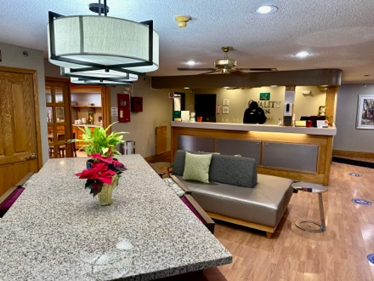
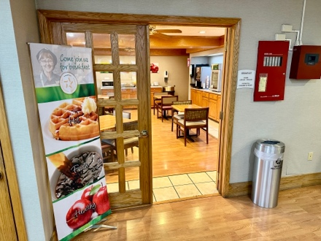
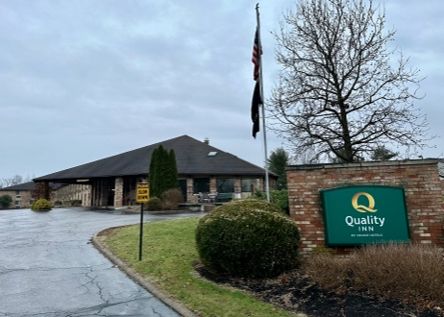

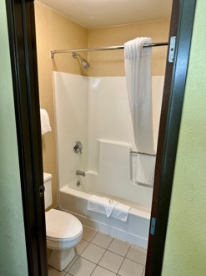
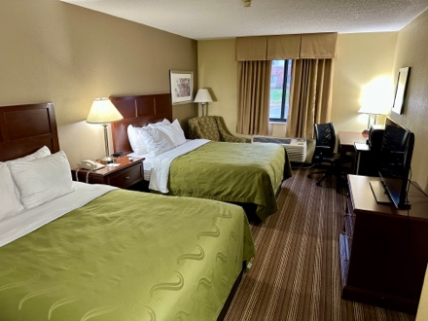
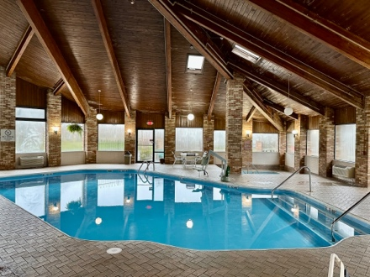
Indoor Pool Double Occupancy Room Bathroom in Room

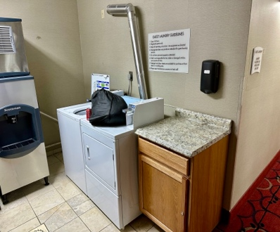
Microwave/Mini-fridge/TV in Room. Exercise Room Laundry
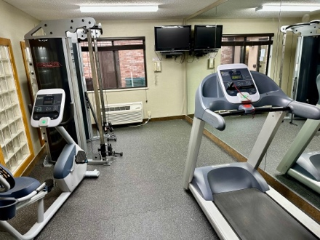
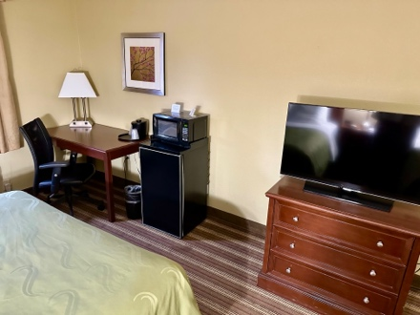

7. Meals During Program

The Quality Inn has a breakfast area that offers coffee, toast, etc. You can choose to eat there in the morning. Also, you can eat breakfast, lunch and dinner at the two dining halls on the OU campus. These are Nelson Court and the District on West Green. Nelson is the one closest to Gordy Hall, where most of your classes will be.
Here are typical dining hall hours:
Breakfast: 7 – 10 AM (Mon. to Friday); 9-10 AM (Sat.); No Breakfast on Sunday
Lunch: 11 AM – 2:30 PM (Everyday). This includes a Sunday Brunch
Dinner: 4:30-8:30 PM

8. Facilities on Campus

PDPI Participants have access to all facilities on the Ohio University Campus. Some of the facilities you may use the most are:
a) Alden Library b) Ping Center c) Hudson Health Center
d) Baker University Center e) Aquatic Center

9. Program Objectives and Rules

a) The objectives for the program are as follows:
- to improve the general English fluency (aural and oral) skills of the participants;
- to relate theory to practice as it can be applied to diverse teaching environments in Brazil;
- to examine relevant issues in language development, language teaching best practices, language learning, and language assessment;
- to produce a final project in a digital format with items such as teaching materials, training resources, and curriculum for use at schools in Brazil;
- to address methodological issues relating to teaching English in Brazil and under difficult circumstances;
- to explore possible uses of technology in language learning and teaching;
- to expose the Brazilian educators to various aspects of American life, history and thought and provide opportunities to interact with a cross-section of Americans; and
- to arrange opportunities for travel and visits to educational and historic points-of-interest in the region.

a) The rules for the program are as follows:
- Family members, significant others, and friends are not permitted to accompany PDPI participants during the program.
- Participants are not allowed to travel internationally during the program.
- Participants are expected to attend classes, participate actively in courses and meet all coursework requirements, complete any self-access/lab/project time hours, and attend required cultural activities.
10. COVID Policies
We will follow Ohio University Covid-19 policies. Click here for the information.
11. Travel to Athens
Your sponsor has made arrangements to fly into the Columbus, Ohio, airport. The official name for the airport is John Glenn Columbus International Airport (CMH). We will make arrangements for someone to pick you up at the airport and bring you to Ohio University in Athens, Ohio. In case of an emergency or change in travel plans, you can call Gerry Krzic’s cell phone at 740-591-8367. Please do not share this number beyond the group members.
12. Athens, Ohio & Ohio University
To learn more about Ohio University and Athens, click here: Athens, Ohio.
Brazilian participants who have attended PDPI programs in the past have enjoyed the charm of small-town Athens. We hope you will, too.

13. Communication in Athens
You can use either the hotel or the university mailing addresses while you are in Athens.

Hotel Ohio University

Your Name Your Name
Quality Inn OPIE/Ohio University, Room 155 Gordy Hall
20 Home Street 51 Park Place
Athens, Ohio 45701 Athens, Ohio 45701

Phone: 740-594-3000 Phone: 740-591-8367 (Gerry Krzic’s Cell)

You will also be given an Ohio University ID card and email after you arrive. You can use the ID card when you use the University facilities. Your teachers will correspond via your university email and also via Microsoft Teams.

14. Suggestions Before Leaving Brazil

Here are some suggestions before you leave Brazil.

a) Bring comfortable shoes. You will probably walk more than you do in Brazil. If you have some boots, bring them also. It will likely snow while you are here.

b) Bring the warmest clothing you have. Think about “layering” your clothing. For example, you can wear a long sleeve shirt with a sweater on top of the shirt with a jacket on top of the sweater. That reason is two thin layers can be warmer than just one thick layer because
the air between layers acts as insulation.

Also, the heating in the university buildings can sometimes be unpredictable because it is controlled centrally. Sometimes the rooms will be very hot, sometimes very comfortable and sometimes cold. If you wear layered clothing you can adjust your clothing according to the temperature of the classroom.

Bring a scarf, gloves, and hat if you have one.

If you like to swim, bring your swimsuit and a bathing cap. The indoor University aquatic center features and Olympic-size swimming pool you can use.

During orientation, we will take you to Walmart so you can buy things you might need.

c) Bring some small, inexpensive souvenirs. You can use them for friends you might make and for your homestay. Souvenirs from your region are always interesting. They don’t have to be expensive. Also, bring pictures of your family, school or city. These are always fun for people in the U.S. to look at and are great conversation starters.

15. Survey

Please complete this pre-program survey by Thursday, January 19n if you have not done so already. It will give us more information about you and help us with our final program preparation.
https://ohio.qualtrics.com/jfe/form/SV_d6Th9qQ5w3Ou8Ae

16. Questions

Remember you can email questions, to Gerry Krzic, OPIE, Director at krzic@ohio.edu

