- Go to www.ohio.edu
- Click on Log In in the top right of the screen and click on MyOHIO Student Center in the drop-down menu.
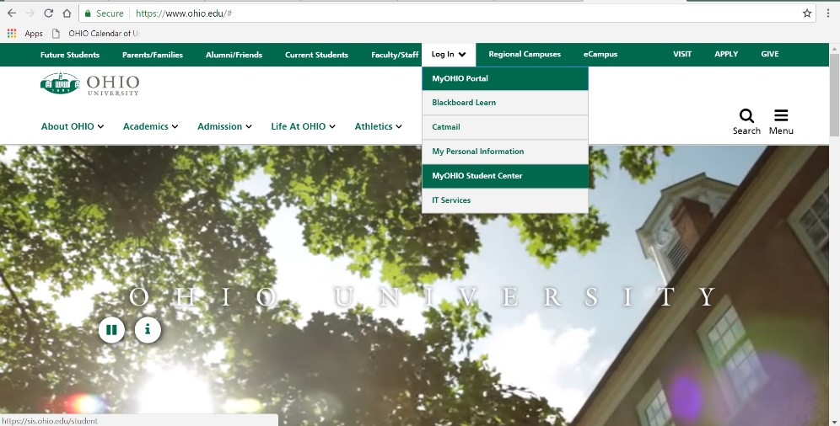
- Login using your Ohio ID (example: yx123456) and password.
- Click on the drop down “Favorites” menu and select “Student Center”
- Scroll down to the Personal Information box.
- Click the drop-down menu that says Other Personal Information and scroll down to Addresses; click the blue arrow next to the box.
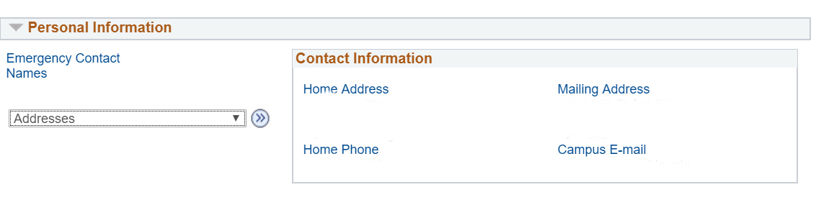
- Click Add New Address (do not click edit)
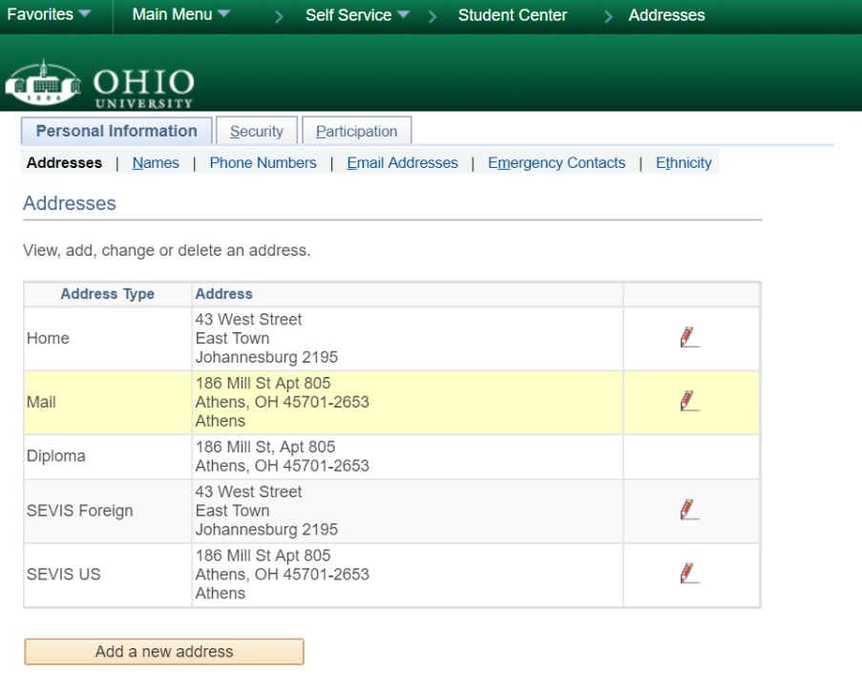

- Click the QuickAddress button on the right side of the screen and enter in your current Athens address; you do not need to capitalize or put in the county. Click Search.
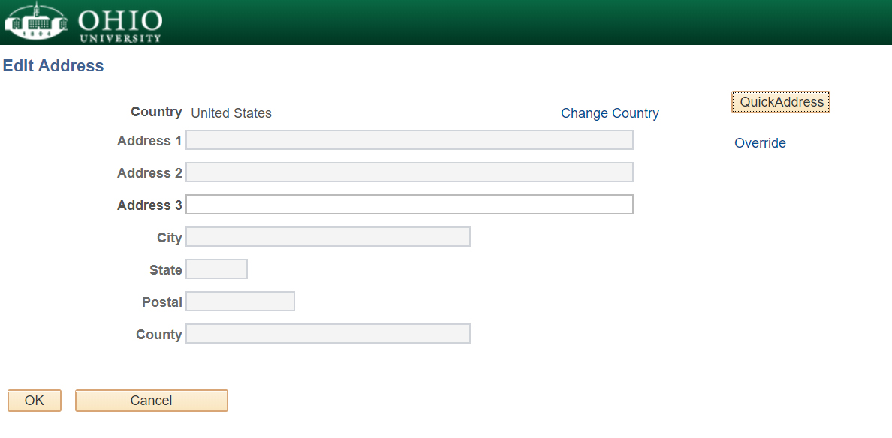
- Double check that the address is correct and click OK.
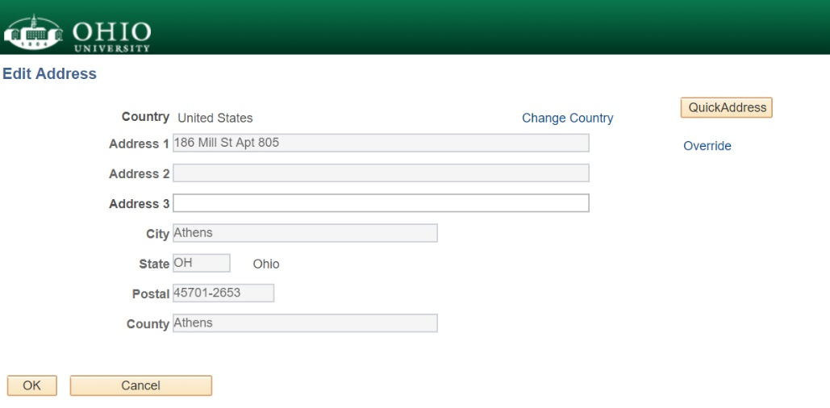
- Check the boxes that say SEVIS US and Mail.
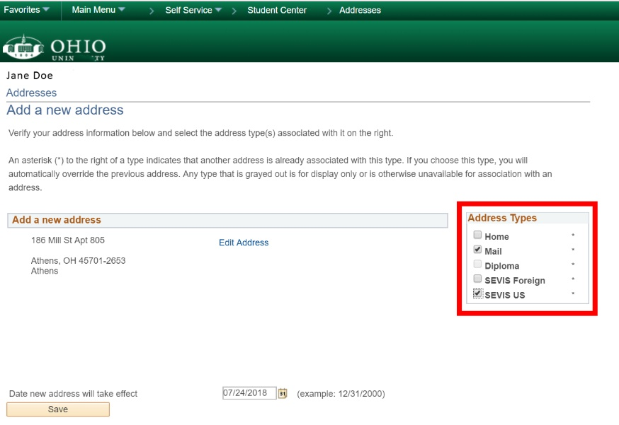
- Click Save. Click OK.
- Complete this process again within 10 days of any address changes.

