- You may only do this step if you have a US phone number.
- Log into your MyOHIO Student Center and find the Personal Information box.
- Click on the drop down “Favorites” menu and select “Student Center”
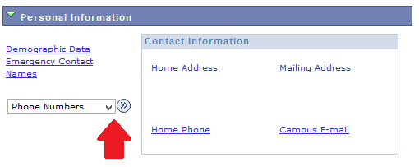
- Click the drop-down menu that says Other Personal Information and scroll down to Phone Numbers; click the blue arrow next to the box.

- Click on Add A Phone Number.
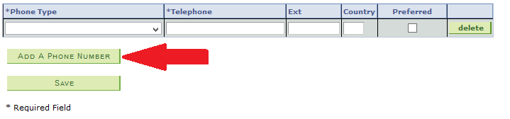
- Select Cell Private in the Phone Type drop-down menu.
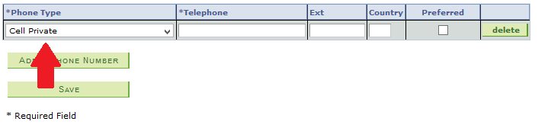
- Type your US phone number in the telephone box. DO NOT include the country code, or +1. ONLY enter numbers into the box (no symbols or dashes). The number must be 10 digits long.
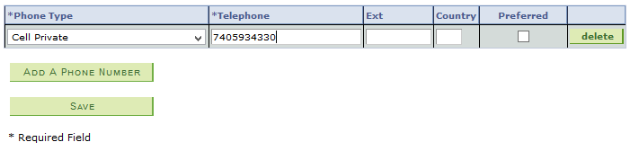
- Check the Preferred check box. Leave the Ext and Country boxes blank.
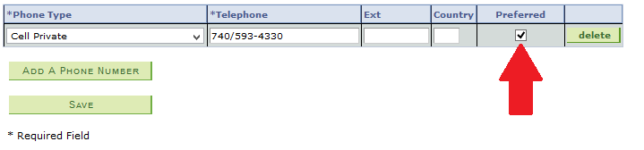
- Click Save.

